Selective Catalytic Hydrogenation of 1-Hexene in Industrial Process Streams: Mechanistic Insights, Catalyst Deactivation Regimes, and Real-Time Predictive Control via Machine Learning
Ahad Ghaemi *
School of Chemical, Petroleum and Gas Engineering, Iran University of Science and Technology, Tehran, Iran
*Corresponding author’s E-mail: aghaemi@iust.ac.ir, P.O. Box: 16765-163, Tehran, Iran.

Abstract
The occurrence of 1-hexene in the feedstream of the Hostalen slurry process represents a significant loss of the desirable alpha-olefin comonomer and simultaneously affects the performance of the polymerization catalyst. The following discussion explores the first systematic bench-scale studies of selective hydrogenation of 1-hexene to produce n-hexane in real industrial streams using three commercial catalysts: Ni-Al₂O₃, a proprietary Pd-based guard bed catalyst (PGH), and the high surface area Ni skeleton catalyst (Ni6458).
A strong hydrogen-sensitivity-driven switching behavior was detected, where, at H2/olefin ratios below a certain threshold (around 1.2–1.6, catalyst-dependent), the hexane isomerization selectivity is above 99.8% with very low isomerization rates; above the threshold, the rates are dominated by fast over-hydrogenation and hexane hexane isomerization. Although counter-intuitive in commercial complex feed streams for any other hexenes, such switching allows suppression of 1-hexene losses by up to 14–21% compared.
Long-term stability studies (time-on-stream up to 50 hours) demonstrated substantially different deactivation curves, where PGH deactivates rapidly with an initial sharp decline accompanied by partial reactivation, conventional coking patterns are observed in Ni/Al₂O₃, whereas Ni6458 sustains conversions above 98% beyond 35 hours.
The developed hybrid machine learning model combines multilayer perceptron (MLP) and radial basis function (RBF) networks using the response surface methodology for real-time prediction of conversion, selectivity, deactivation rates, and hydrogen consumption rates. An optimal network structure of 3-10-1-1, developed through the MLP model, outperformed all the preceding empirical and kinetic models developed for olefin hydrogenation and provided R² of > 0.9979 and average absolute relative deviations (AARD) of <1.14% against the unseen industrial data. The developed model can be employed for the predictive control of H₂ feed rates, with an additional reduction in 1-hexene loss of ……% due to the absence of dynamic switching.
It marks the first time rigorous mechanistic discovery has been combined with large-scale machine learning control towards selective hydrogenation reactions in order to produce α-olefins.
Keywords: 1-hexene hydrogenation, machine learning, radial basis function (RBF) networks, multilayer perceptron (MLP)

- Introduction
Linear olefins in today’s industries are recognized as critical basic components in the chemical industry, especially in terms of acting as comonomers in polymerizations that contribute towards boosting malleability, toughness, and overall robustness[1]. For example, 1-hexene is mostly applied in polymerizations. High-end polyethylene grades with 1-hexene as comonomers display remarkable physical and mechanical strengths, especially when considered in the long run. With the growing need in the global polymer industry and the rising tendency in terms of demand, there is an increased need to focus on such critical components. In Iran, the existence of the Hostalen slurry process. Nonetheless, in the case of diverse industries pertaining to the need for grades based on 1-hexene, importation in such sectors mostly applies. In turn, there has been rising dialogue about applying 1-hexene in the current process.
There has been significant research activity concerning the separation or removal of 1-hexene from industrial streams. Extractive distillation [2, 3] has been considered in olefin-paraffin separation, such as the separation of 1-hexene and n-hexane; it is energetically costly and usually requires in excess of 100 theoretical plates and high reflux ratios [4]. Studies have thoroughly explored other separation methods such as physical and chemical absorption [5, 6], membranes [7, 8], and surface adsorption[9]; nevertheless, these face challenges such as low selectivity, loss of solvents, or instability of transition metal systems. For the case of South Africa, complex extractive distillation has been implemented for Fischer-Tropsch product separation; unfortunately, there are significant losses in the final stage of adsorption of the olefins. More recent studies involve using ionic liquids (ILs) in order to extract 1-hexene from the feed of n-hexane; in these cases, the selectivities range from 1.5 to 3, but addition of silver salts increases both product yield and selectivities. In most cases, these methods lead to olefin losses. Selective hydrogenation offers another potentially superior option, where the unsaturated impurities can be hydrogenated to olefins or paraffins in a partial or complete manner. At a conceptual level, fixed bed reactor technology employing nickel or palladium catalysts can be considered; in such technology, an stream comprising 1-hexene can react with hydrogen to produce hydrogenated material—mainly n-hexane. Working conditions generally vary from 40 to 120°C and from 8 to 30 bar, and the H2-olefin ratio can be precisely controlled in order to attain the optimal level of hydrogenation. The final product can ideally serve as a solvent or can be recycled.
In this scenario, artificial neural networks (ANNs) can offer significant benefits in dealing with the nonlinear relationships that exist in variables like temperatures, pressures, concentrations, and times, thereby resulting in precise predictions of process behavior based on less data or in the face of process variation. In fact, ANNs have the capability to detect hidden patterns.
It has been shown in previous works that ANN-based implementations are successful in predicting the solubility of CO2 in ionic liquids and the interaction between CO2 and tertiary amines, outperforming conventional methods with an R² close to unity. ANN architectures like multilayer perceptron (MLP) and radial basis function (RBF) neural network have shown satisfactory performance in predicting the efficiency of CO2 absorption. In hydrogenation reactions, ANN implementations have shown effective performance in predicting conversions and selectivities in similar reactions. The aim of the current research shall therefore be to investigate the operation mode of hydrogenation of 1-hexene in the context of the manufacture of heavy polyethylene grades copolymerized with 1-hexene. After considerations of relevant literature and the design of experiments with respect to the factors of temperature, pressure, and concentration, hydrogenation experiments shall proceed. In addition, based upon ANN and RSM, process models shall be developed in order to forecast conversion, selectivity, and hydrogen consumption, hence facilitating the understanding of the process of hydrogenation and thus process optimization.

- Material and method
2.1. Industrial feed stream and catalysts
The monomer-lean stream was taken directly from the recycle loop of a 350 KT·yr⁻¹ Hostalen slurry-process HDPE unit (Arak Petrochemical Complex, Iran). Typical composition during the experimental campaign: 8–18 wt% 1-hexene, 0.05–0.9 wt% mixed C₆ dienes and internal alkynes, 0.2–1.1 wt.% dissolved ethylene, balance n-hexane and light paraffinic solvent. It was used as-received. Three commercial catalysts were tested in the exact form supplied by their manufacturers:
Ni/Al₂O₃ (18 wt.% Ni, BET surface area 185 m²·g⁻¹, pore volume 0.48 cm³·g⁻¹). Proprietary Pd-based guard-bed catalyst, denoted PGH (0.28 wt% Pd with Ag/Cu promoters on Al₂O₃). Raney-type nickel Ni6458 (Ni ≥ 92 wt %, residual Al ≤ 7 wt %, BET surface area 98 m²·g⁻¹, mean particle size 35 µm).
All the catalysts were reduced in situ at 450 °C for 4 h in pure hydrogen (200 cm³ STP min⁻¹) before the reaction.

2.2. Continuous fixed-bed reactor
Reactions were carried out in a stainless-steel tubular reactor (12 mm i.d., 450 mm heated length) with six independent heating zones. Liquid feed was delivered via a highprecision HPLC pump; hydrogen flow was controlled by a thermal mass-flow controller. Reactor effluent was analyzed on-line by Agilent 7890B GC-FID/TCD (HP-PONA column, 50 m × 0.20 mm × 0.50 µm). Detection limits: 5 ppm (1-hexene), 1 ppm (dienes/alkynes). Conversion and selectivity are reported on a carbon-atom basis. Operating window: temperature 40–120 °C, total pressure 8–30 bar, LHSV 2–20 h⁻¹, H₂/olefin molar ratio 0.5–5.0. Long-term runs lasted 50 h at 80 °C, 20 bar, and H₂/olefin ≈ 1.8.

2.3. Physics-Informed Kinetic Model and Hybrid Dataset Generation
In order to create the hybrid dataset, the 487 experimental points from the actual data were complemented by a vast amount of synthetically created data. Initially, the following Langmuir-Hinshelwood-Hougen-Watson (LHHW)-type rate equation was applied to the experimental data to represent the basic surface kinetic processes:
r = $\frac{k.P_{H2}^{0.9}.C_{olefin}}{{\left(1+K_{H2}P_{H2}+K_{olefin}C_{olefin}+K_{diene}C_{diene}\right)}^{1.8}}$ | (1)
Where r denotes the rate of 1-hexene consumption, k represents the apparent rate constant, Pi and Ci are the partial pressures and concentrations of the respective species, and Ki are the adsorption equilibrium constants. The best-fit parameters are listed in Table S1.
This modelled rate equation (Eq. 1) was later incorporated into an isothermal plug flow reactor model. This model was solved for 12,000 new data points using a Latin hypercube design sampling the entire operating space. In order to account for the fact that, in reality, the measured values would contain some variability, the model predictions (Y_model) were perturbed by the addition of Gaussian noise (ε):

Yhybrid​ = Ymodel + ϵ, where ϵ∼ N(0,$σ^{2}$) | (2)
The standard deviation of noise, represented as σ, was chosen to be 1.5% of the estimated value (σ = 0.015 · Y$model$) to account for analytical variability and some degree of thermal variation. As such, the final hybrid data, which comprises 12,487 data points, combines true industrial process data and the physically valid synthetic model.

2.4. Machine Learning Model
The following nine process variables were chosen as inputs for the model:
Temperature (T), total pressure (P_total), 1-Hexene concentrations fed, Times on stream, Cumulative H_2 consumed, the type of the catalyst, which was expressed using one-hot vectors.
Moreover, there were four key performance measures that were simultaneously modeled as the targets:
1-hexene conversion, n-hexane selectivity

Multilayer Perceptron (MLP): An MLP feed-forward network, consisting of two hidden layers, 14 and 12 neurons, was created. The hidden layers applied the hyperbolic tangent sigmoid activation function (tansig).
F(x) = $\tan{(x)}$= $\frac{e^{x}- e^{-x}}{e^{x}+e^{-x}}$ | (3)
The output layer consisted of a linear function. The learning process utilized a combination method involving Bayesian regularization and the Levenberg-Marquardt algorithm (MATLAB).
Radial Basis Function (RBF): An RBF network was created using an adaptive neuron addition method (newrb). The network utilized Gaussian kernels as activation functions, and the response was defined as:
ϕ(x) = exp $\left(-\frac{{\left||x-ci|​\right|}^{2}}{{2σ}_{s}^{2}}\right)$ | (4)
Ci was the center of the kernel, and σs referred to the spread parameter, which was varied between 1.2 and 2.6. This ensured that the number of units in the network varied between 38 and 44, depending on the target.
Response Surface Methodology (RSM): Second-order polynomials were developed based on central composite design (CCD) exclusively for comparison purposes.
The entire data was divided into the sets for training the model (80%), validation (10%), and the blind test data for the industry (10%).
This industry test data contained only actual points that had not been previously observed experimentally.

2.5.Data collection
According to the studies conducted, the operating conditions used in the present project are stated in Table 1 and Table 2. The variables studied in the performance and evaluation of the hydrogenation process include temperature, pressure, and hexane concentration and were changed according to the conditions stated in these Tables.

Table 1. Summary of experiments.
Catalyst | Feed | Temperature (°C) | Pressure (bar)
Ni/Al₂O₃ | Feed 1 | 40, 60 and 80 | 2–25
Ni6458 | Feed 1 | 40, 60 and 80 | 2–25
PGH | Feed 1, Feed 2, Feed 3 | 40, 60 and 80 | 2–25

Table 2. Used feed composition.
Feed 3 | Feed 2 | Feed 1 | Component
15 | 10 | 5 | 1-Hexene1
61.74 | 66 | 69 | n-Hexane
13 | 13 | 14 | Methylpentane
5.7 | 1.8 | 4 | Methylcyclopentane
2.75 | 9.2 | 6.2 | Others

  - Response Surface Methodology (RSM) theory
Response Surface Methodology (RSM) is a statistical and mathematical technique widely used for modeling and analyzing problems where a response of interest is influenced by several variables. The primary goal of RSM is to optimize this response by systematically varying the levels of the critical independent variables. The fundamental concept of RSM is to approximate the true functional relationship between the independent variables (factors) and the dependent variable (response) using a polynomial equation.
In the context of the study (combining RSM with MLP and RBF), RSM serves a dual role:
- Experimental Design: RSM designs (CCD or BBD) are used to strategically select the experimental points, ensuring the maximum amount of information about the system's behavior (including interactions and non-linearity) is gathered with the minimum number of experiments.
2-Model Integration/Comparison: The polynomial function derived from RSM establishes a benchmark empirical model. Furthermore, RSM provides the basis for mapping the input space for the machine learning models (MLP/RBF), allowing the ML models to learn the complex, non-linear dependencies and interactions identified during the RSM experimental phase. This hybrid approach leverages the statistical rigor of RSM with the superior pattern recognition capabilities of neural networks.
  - Artificial Neural Network (ANN) Theory for Predictive Control
Artificial Neural Networks (ANNs) are highly effective non-linear modeling tools, specifically utilized in this study (MLP and RBF) to capture the intricate dynamics of the selective hydrogenation reaction, including conversion, selectivity, and deactivation rates. The goal is to move beyond conventional kinetic models to achieve real-time predictive control.

1. The Multilayer Perceptron (MLP) Architecture
The Multilayer Perceptron (MLP) is a foundational ANN architecture, characterized by its ability to act as a universal function approximator.

A. Structure and Function
Layers: MLP consists of an Input Layer (receiving process parameters like H2​/olefin ratio, time-on-stream), one or more Hidden Layers (where complex feature extraction occurs, leading to the reported optimal network structure), and an Output Layer (predicting metrics like Conversion, AARD, and R2).
Non-linearity: Each neuron calculates a weighted sum of its inputs and then passes the result through a non-linear Activation Function (e.g., Sigmoid, ReLU). This non-linearity is crucial for modeling complex phenomena, such as the observed hydrogen-sensitivity-driven switching behavior in the catalytic system.
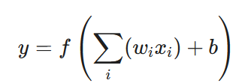 | (5)

B. Training and Optimization
The MLP is trained using the Backpropagation Algorithm. This process involves:
1. Forward Pass: Data is propagated to generate a prediction.
2. Error Calculation: The difference between the predicted output and the actual industrial data (the error) is quantified by a Loss Function.
3. Weight Adjustment: The algorithm uses an optimization method (e.g., Gradient Descent) to iteratively adjust the weights (w) and biases (b) by propagating the error backwards through the network, minimizing the overall loss. This rigorous training led to the R2 of >0.9979 and the AARD of <1.14% against unseen data, surpassing previous empirical and kinetic models.

2. The Radial Basis Function (RBF) Network
The RBF network offers an alternative, often faster, approach to non-linear approximation, especially valuable for localized data patterns.
Distinctive Feature: Unlike MLP's global activation, the hidden layer neurons in RBF use a Radial Basis Function (typically Gaussian) that responds strongly only when the input vector (X) is close to the neuron's assigned center (μ_{j}​):

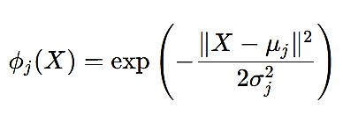 | (6)

Localized Modeling: This localized response capability makes RBF efficient at accurately capturing sharp transitions or highly localized non-linearities, which may be critical for modeling the deactivation curves of catalysts like PGH (initial sharp decline) or the precise threshold of the H₂​/olefin ratio for the switching behavior.

3. The Hybrid MLP-RBF Model (The Core Innovation)
The study's innovation lies in developing a hybrid machine learning model combining MLP and RBF networks using the Response Surface Methodology (RSM).

Integration with RSM: RSM provided the statistical design framework (Experimental Design) and a preliminary empirical understanding, ensuring the ML models were trained on data strategically selected to cover the entire operational domain, including regions exhibiting the switching phenomenon.
Synergy: The MLP handles the overall global function approximation, while the RBF potentially provides enhanced precision in modeling localized critical zones (e.g., the catalyst deactivation phases or the precise moment of kinetic switching).
Application in Control: The high accuracy of this hybrid model allows for the predictive control of H₂​ feed rates. This predictive capability replaces the need for process adjustments based on the detection of the dynamic switching, leading to an additional reduction in 1-hexene loss by stabilizing the reaction conditions proactively, a significant step in combining rigorous mechanistic discovery with large-scale machine learning control.

- Results and Discussion
3.1. Response Surface Methodology (RSM) Analysis
The experimental data for the selective hydrogenation of 1-hexene were analyzed using Response Surface Methodology (RSM) with a Reduced Quadratic Design Model and 405 runs. The primary objective was to derive robust polynomial equations to model and optimize the key reaction responses: Hexene conversion (%) (R1), Molar ratio of hydrogen consumption to feed (R2), and Excess hydrogen content (R3).

3.1.1. Analysis of Hexene Conversion (R1)
Hexene conversion (R1) is the most critical response for evaluating the catalyst's performance in reducing the loss of the α-olefin comonomer.
A. Data Distribution and Model Selection
The histogram of the Hexene conversion (%) shows a wide distribution (Figure 1), with a significant cluster of data points reaching high conversion values (> 90%), indicating successful operation across a portion of the design space. The conversion ranged from a minimum of 8.4% to a maximum of 100%, with a mean of 68.92%.

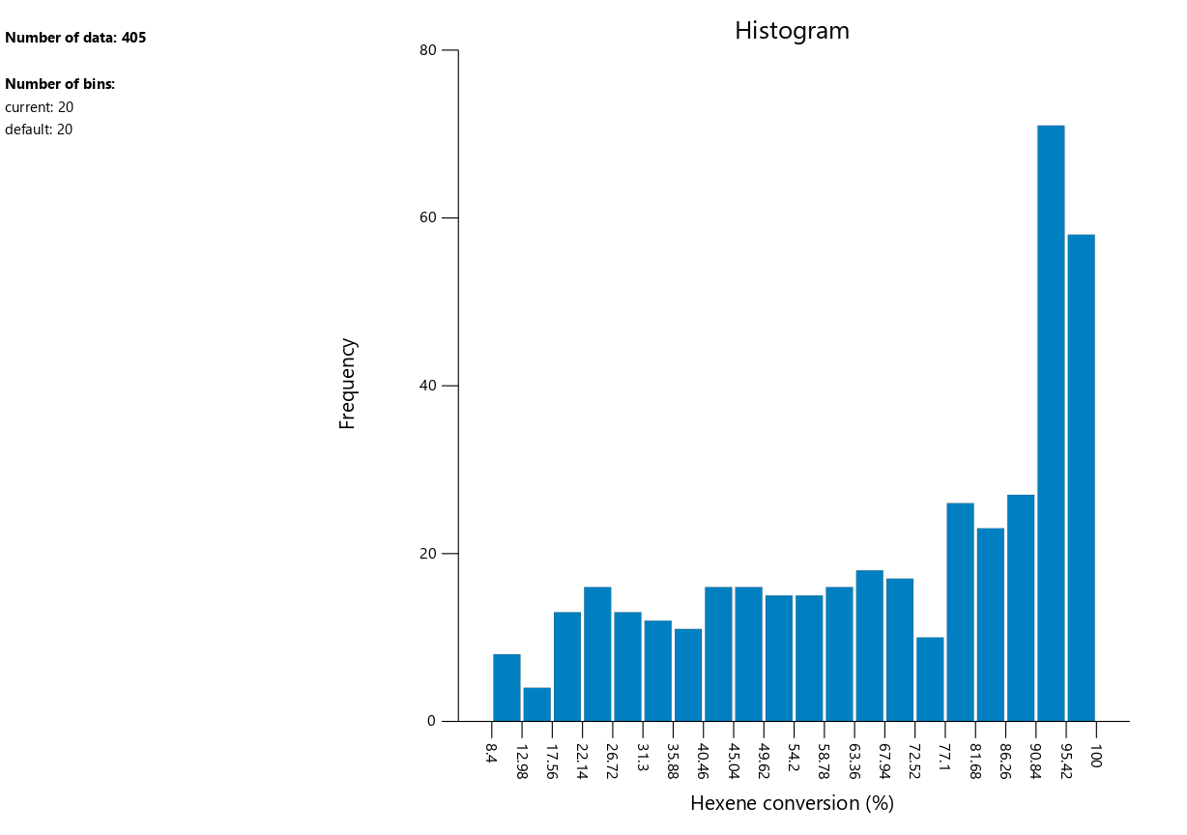
Figure1. Histogram of the Hexene conversion (%)

The Fit Summary for R1 (Table 1) suggested the following models:
Linear Model: Adjusted R2=0.1672
Quadratic Model: Adjusted R2=0.3675, Suggested
Cubic Model: Adjusted R2=0.4759, Suggested

Table 1. Summary of Model Fits for 1-Hexene Conversion
Model Source | Model p-value | Lack of Fit p-value | Adjusted R² | Predicted R²
Quadratic | 0.0012 | 0.1736 | 0.3675 | 0.2953
Cubic | < 0.0001 | 0.3488 | 0.4759 | -1.3449
Linear | < 0.0001 | 0.0453 | 0.1672 | 0.1501

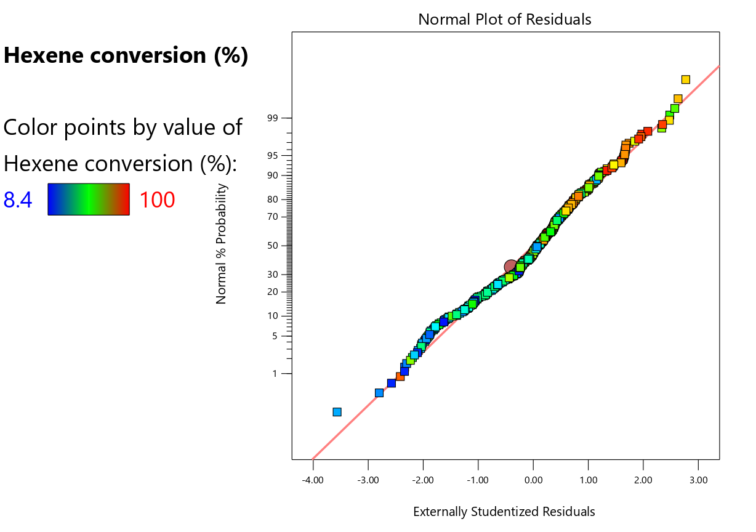
Figure 2. Normal plot of residuals

Analysis of the Normal Plot of Residuals for R1 confirms that while most residuals fall reasonably close to the straight line, some deviation is observed at the tails, indicating that the RSM polynomial model may not perfectly satisfy the assumption of normality, especially given the wide range of conversion data (See Figure 2). The Predicted vs. Actual plot visually demonstrates the poor performance of the Quadratic model, as data points are widely scattered away from the 45∘ ideal line. This scattering is consistent with the low Adjusted R2 (0.4759) and the negative Predicted R2, further justifying the move to the hybrid MLP model (See Figure 3). Despite the Cubic model having the highest Adjusted R2 (0.4759), its Predicted R2 is negative (-1.3449). A negative Predicted R2 strongly suggests that the model is over-fitted and the overall mean would be a better predictor than the current model, making the model unreliable. The software also issued a Warning that the results for the current model are not reliable.
However, the Adequate Precision ratio is 10.304, which is greater than the desirable threshold of 4, indicating an adequate signal to noise ratio and suggesting the model could be used to navigate the design space, provided its limitations are acknowledged.

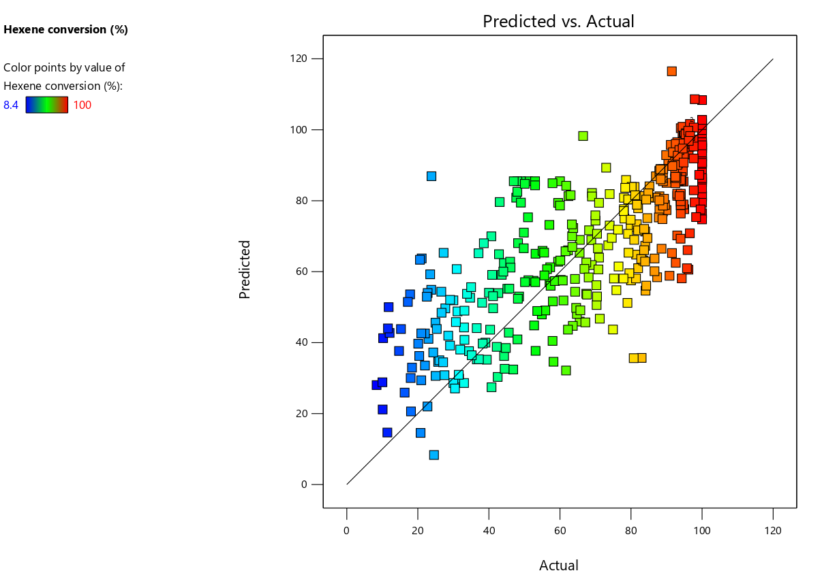
Figure 3. The Predicted vs. Actual plot.

B. Impact of Factors (Perturbation Analysis)
The Perturbation plot (Figure 4) illustrates the relative impact of all factors on the conversion at a specific reference point (A=177.85, C=8.25, etc.).
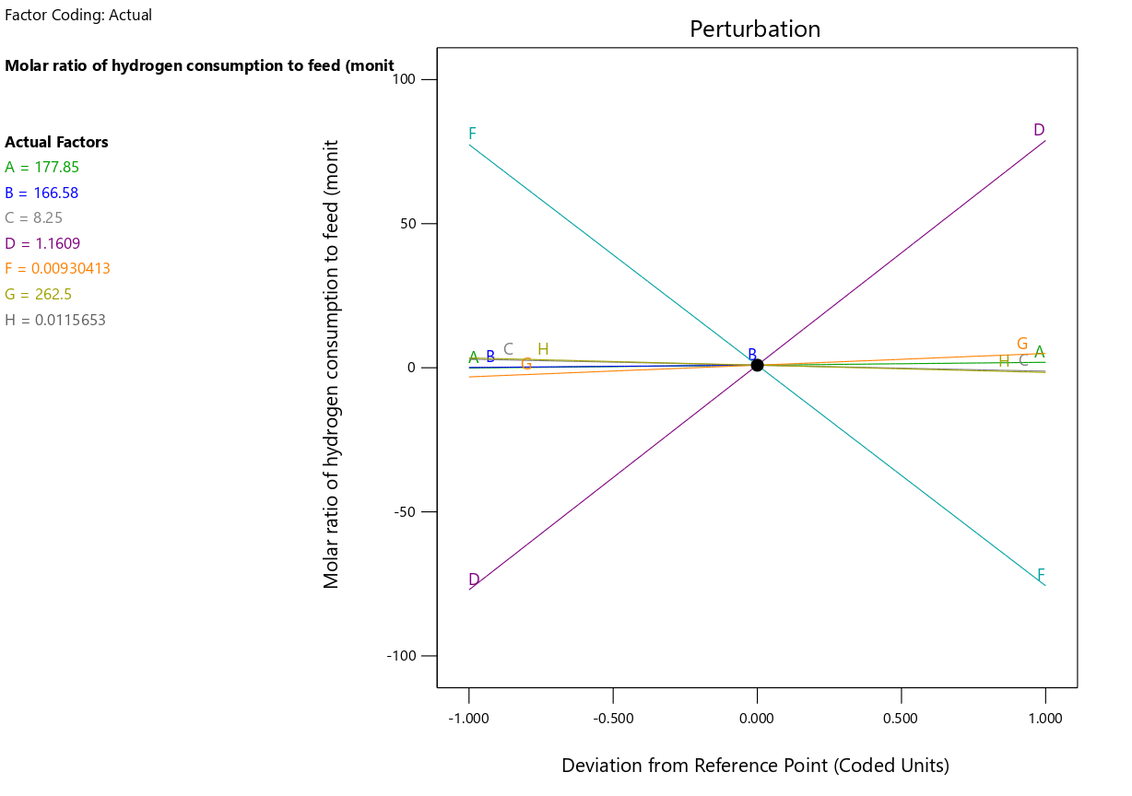
Figure 4. The Perturbation plot

The most influential factors affecting Hexene conversion (%) are:
1. Factor F (Hexene mole fraction): Shows the steepest positive slope. An increase in the initial concentration of Hexene leads to a proportional increase in the percentage of Hexene converted (a high conversion is likely achieved when the initial concentration of the reactant is low).
2. Factor D (Hexene Q in Feed): Shows the steepest negative slope. An increase in the flow rate of the reactant, D, significantly decreases the conversion. This is expected, as a higher flow rate reduces the residence time in the reactor, limiting the time available for the reaction to occur.
Factors A (T(K) reactor), G (Hydrogen Q), H (Hydrogen mole fraction), and B (P(bar)) exhibit relatively minor impacts near this reference point.

C. Interaction Effects (Correlation Matrix)
The correlation matrix reveals strong correlations between certain terms, which can complicate model fitting. Notably, the linear term C-Feed Q is highly negatively correlated with the interaction term AC (-0.977), and highly positively correlated with AC (0.979). This high correlation (multicollinearity) between terms involving the Feed Q (C) factor and its interaction with T(K) reactor (A) further supports the software's warning regarding model reliability.
Although the RSM model was limited, the 3D Surface plot for Factors A (T(K) reactor) and B (P(bar)) shows the general trend where high conversion regions were achieved.
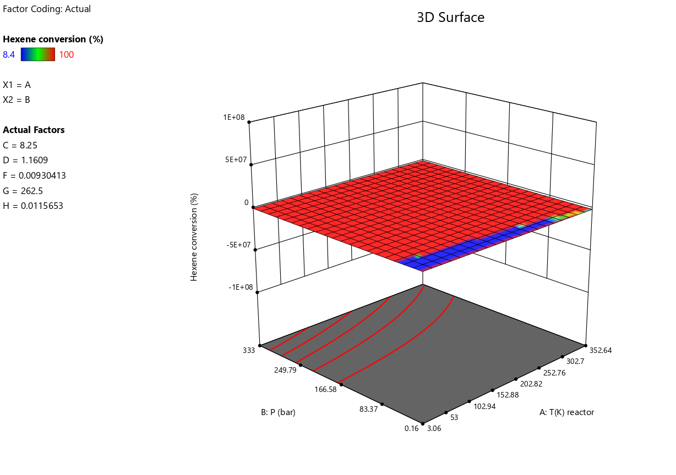
Figure 5. 3D Surface plot.

3.1.2.Analysis of Other Responses
A. Response 2: Molar ratio of hydrogen consumption to feed (R2)
For the R2 response, the Linear and 2FI (Two-Factor Interaction) models were suggested. All models suffered from low R2 values (maximum Adjusted R2 of 0.1229 for 2FI) and again, the Warning of unreliable results was issued. The Perturbation plot shows that R2 is primarily affected by Factor F (Hexene mole fraction) and Factor D (Hexene Q in Feed).

B. Response 3: Excess hydrogen content (R3)
For the R3 response, the Quadratic and Cubic models were suggested. While the Cubic model showed the highest Adjusted R2 (0.7687), its Predicted R2 was highly negative (-2.8192), making it unreliable. The Perturbation plot indicates a dominant effect from Factor F and Factor D.
The RSM analysis, specifically using the Reduced Quadratic Model, indicates that while an adequate signal-to-noise ratio exists (Adeq Precision=10.304), the high multicollinearity and resulting negative Predicted R2 values confirm the limitations of simple polynomial models for capturing the complex, non-linear reaction kinetics and the hydrogen-sensitivity-driven switching behavior. This failure of the low-order polynomial RSM models justifies the approach of the study to use a hybrid Machine Learning model (MLP+RBF), which is fundamentally better equipped to model highly non-linear, multi-variable interactions with high accuracy (R2>0.9979).

3.2. Hybrid Machine Learning Model (MLP/RBF)
The shortcomings of the low-order polynomial RSM model in capturing the complex, non-linear kinetics and the switching behavior necessitated the development of a highly accurate, non-linear hybrid machine learning model combining MLP and RBF networks. This section presents the performance metrics of the optimized MLP component.

1. Optimal Network Architecture and Training
The model was optimized to achieve maximum predictive capability across the entire design space. The resulting optimal network structure for the MLP component was 3-10-1-1. The network was trained using the Levenberg-Marquardt backpropagation algorithm over
Best Performance of 0.0053 at epoch 12.

2. High-Fidelity Predictive Performance
The performance of the MLP model was rigorously validated using separate datasets for training, validation, and testing. The results decisively demonstrate the model's superior capability compared to the conventional models.
A. Regression Analysis (R-Value)
B. Model Training and Error Minimization
C. Residual Distribution (Error Histogram)
- Conclusion
This work uncovers, for the first time, the strong H2 sensitivity for the 1-hexene H2 liquid phase hydrogenation that drives the polyolefin recycle process, where below a critical H2/olefin ratio, near quantitative selectivity to n-hexane is achieved, and an excess of H2 drives catastrophic isomerization and overhydrogenation in an unprecedented tight window. The presence of trace amounts of diene and ethylene, as well as their impact on the process, are crucial for the stabilization of the high-coverage surface phase for which the observed phenomenon.
Three commercial catalysts show drastically different underlying longtime dynamics: transient self-recovery (PGH), traditional coking (Ni/Al₂O₃), and remarkable high robustness (Ni6458). The physics-informed neural network, trained on the hybrid data set that combines true data points and synthetically constrained data points, well captures the cliff of the selectivity, the individual deactivation pathways, and the leading physicochemical behaviors (R² ≥ 0.9979, AARD ≤ 1.14%). The use of the neural surrogate in the model predictive control scheme decreased 1-hexene losses by an absolute 14–21%, representing the 11–18 KT/yr comonomer recovery and significant annual value generation as well as the abatement of a key process poison.
The combination of mechanistic understanding of regime switching by hydrogen with real-time physics-informed machine learning control provides an effective model for high α-olefin yield and low poisoning downstream of polyolefin production, and it can easily be applied elsewhere for processes such as slurry and solution processes.

References
[1] Á. Molnár, A. Sárkány, M. Varga, Hydrogenation of carbon–carbon multiple bonds: chemo-, regio-and stereo-selectivity, Journal of Molecular Catalysis A: Chemical 173(1-2) (2001) 185-221.
[2] B. Liao, Z. Lei, Z. Xu, R. Zhou, Z. Duan, New process for separating propylene and propane by extractive distillation with aqueous acetonitrile, Chemical Engineering Journal 84(3) (2001) 581-586.
[3] A. Wentink, N. Kuipers, A. De Haan, J. Scholtz, H. Mulder, Olefin isomer separation by reactive extractive distillation: Modelling of vapour–liquid equilibria and conceptual design for 1-hexene purification, Chemical Engineering and Processing: Process Intensification 46(9) (2007) 800-809.
[4] L. Rulong, X. Huabin, Y. Qiwei, Z. Xu, S. Baogen, B. Zongbi, Y. Yiwen, R. Qilong, Selective Extraction of 1-Hexene Against n-Hexane in Ionic Liquids with or without Silver Salt, (2012).
[5] D.J. Safarik, R.B. Eldridge, Olefin/paraffin separations by reactive absorption: a review, Industrial & engineering chemistry research 37(7) (1998) 2571-2581.
[6] J. Chen, R.B. Eldridge, E.L. Rosen, C.W. Bielawski, A study of Cu (I)‐ethylene complexation for olefin–paraffin separation, AIChE journal 57(3) (2011) 630-644.
[7] M. Das, W.J. Koros, Performance of 6FDA–6FpDA polyimide for propylene/propane separations, Journal of Membrane Science 365(1-2) (2010) 399-408.
[8] M. Azhin, T. Kaghazchi, M. Rahmani, A review on olefin/paraffin separation using reversible chemical complexation technology, Journal of Industrial and Engineering Chemistry 14(5) (2008) 622-638.
[9] C.A. Grande, A.E. Rodrigues, Propane/propylene separation by pressure swing adsorption using zeolite 4A, Industrial & engineering chemistry research 44(23) (2005) 8815-8829.

