**Strategic Design of Biodiesel Supply Chains from Organic Waste: A Robust Stochastic Model**

Bita Ebrahimi1, Alireza Goli1*

1 Department of Industrial Engineering and Futures Studies, University of Isfahan, Isfahan, Iran

*Corresponding Author Email: [Goli.A@eng.ui.ac.ir](mailto:Goli.A@eng.ui.ac.ir)

**Abstract**

This research addresses the challenge of increasing fossil fuel consumption by developing an optimization model for designing a biodiesel supply chain network using organic waste. The model focuses on determining the optimal locations for facilities and the logistics of shipments throughout the network to minimize total supply chain costs. Given the inherent uncertainty in demand over time, a robust stochastic optimization approach is employed. The proposed mathematical model is validated using GAMS software. The results indicate that the model effectively determines the optimal facility locations and shipment quantities across multiple periods, thereby minimizing total supply chain costs.

Additionally, a case study in South Korea is conducted to perform sensitivity analysis, exploring the impact of various parameters on the objective function. The findings indicate that considering demand uncertainty leads to increased network costs, but it aligns the model more closely with real-world scenarios. This study highlights the potential of the proposed approach to reduce reliance on fossil fuels and mitigate environmental impacts, ultimately emphasizing the importance of innovative and sustainable solutions in energy management.

**Keywords**: Supply chain network design; Organic waste; Biodiesel; Uncertainty; Robust optimization.

**1. Introduction**

Fossil fuels, which are non-renewable energy resources formed through geological processes over millions of years, continue to dominate the global energy landscape (Goli, 2024b). However, their excessive consumption contributes to severe environmental degradation, including greenhouse gas emissions and resource depletion, while also posing significant economic risks due to price volatility and supply chain instability (Özcan et al., 2022). These challenges underscore the urgent need to transition toward alternative energy sources. Biodiesel has emerged as a viable substitute for fossil fuels, particularly because it can be utilized in existing diesel engines without the need for major modifications (Habib et al., 2022). In parallel, rapid urbanization has exacerbated the complexity of organic waste (OW) management in large cities, especially in developing countries, leading to growing environmental and logistical concerns (Wang et al., 2023). For instance, data from Statista (2023) reveal a consistent year-on-year increase in municipal solid waste generation in South Korea, with projections indicating continued growth. This dual context of fossil fuel dependency and escalating OW accumulation presents a unique opportunity to integrate waste management with clean energy production by converting organic waste into biodiesel, thus addressing both sustainability and energy security goals.

Organic waste, comprising leftover food, food-soaked paper, and green waste, is utilized as a biomass source for compost production (Cesaro et al., 2015). The wood component of this waste can be utilized for Combined Heat and Power (CHP) generation (McKendry, 2002), while the remaining waste can be transformed into biogas through Anaerobic Digestion (AD). Following refinement, this biogas can be integrated into the natural gas grid (Silva dos Santos et al., 2018), or green methane can be utilized as transportation fuel (Byun et al., 2021).

Figure 1. Amount of municipal waste generated annually in South Korea

In this research, the design of the supply chain for converting organic waste to biodiesel in deterministic and stochastic conditions has been addressed. Initially, previous studies were reviewed, analyzed, and synthesized. Subsequently, supply chain modeling was conducted, and its validation was performed on a small scale. Following this, the model was extended to accommodate demand parameter uncertainty, and ultimately, it was implemented using data from South Korea.

A practical framework for designing the supply chain network for converting organic waste into biodiesel has been provided by the results of this study, and it can be utilized to support the implementation of renewable fuel development programs in countries such as South Korea. By implementing the model using real-world data, a better understanding of supply chain behavior under demand uncertainty has been achieved.

The remainder of the paper is structured as follows: Section 2 comprehensively reviews the relevant literature. Section 3 presents the proposed mathematical model and its robust counterpart formulation. The numerical results derived from implementing the mathematical model are discussed in Section 4, and Section 5 contains the discussion. Finally, Section 6 offers concluding remarks for the paper.

**2. Literature review**

The studies reviewed in this research are categorized into three main groups, including cost-oriented biofuel supply chain modeling, integration of uncertainty into supply chain design, and diversification of feedstocks with environmental and social sustainability assessments.

**2.1. Biodiesel Supply Chain with a Focus on Cost Optimization**

First, Ahn et al. (2015) proposed a mathematical model for optimal microalgae biodiesel supply chain design. This model, which is a Mixed-Integer Linear Programming (MILP) approach, is aimed at minimizing the total cost of the supply chain. The uncertainty surrounding the availability and price of microalgae is considered using a scenario approach. A MILP model for designing and optimizing biodiesel supply chain networks was presented by Babazadeh (2017). This model encompasses strategic and tactical decisions such as determining the number and location of facilities, facility capacity, transportation optimization, production technology, and production planning. The model was applied in a real case study in Iran, demonstrating its utility in designing and optimizing biodiesel supply chain networks. In another work, Babazadeh et al. (2019) introduced a multi-period, multi-product MILP model for designing and optimizing biodiesel supply chain networks. The model accounts for two non-edible raw materials, jatropha seeds and disposable cooking oil, and considers facility location, transportation methods, production capacity, and inventory levels. The objective was to minimize the cost of the entire biodiesel supply chain while ensuring the demand for biodiesel is met. Oseok Kwon et al. (2022) introduced a multi-period MILP model for designing supply chains that convert organic waste into biodiesel. The model’s objective was to minimize average annual costs while ensuring biodiesel demand fulfillment throughout the planning horizon. A case study aligned with South Korea's renewable energy standards validated the model’s effectiveness. It has been suggested by Panjehpour et al. (2025) that replacing fossil fuels with biofuels is essential for addressing environmental challenges. However, the production of biofuels also has negative effects on natural resources. A two-phase model for designing a canola-to-biodiesel supply chain has been proposed in this study. In the first phase, appropriate sites for canola cultivation are selected, and in the second phase, the optimization of water and energy consumption, as well as the reduction of climate change impacts, is addressed. It was found that by increasing crop yields and improving technologies, production costs can be reduced, and environmental impacts can be minimized.

* 1. **Considering Uncertainty in Biodiesel Supply Chain**

Ghelichi et al. (2018) introduced a two-stage stochastic programming model for designing an integrated green biodiesel supply chain network utilizing Jatropha curcas raw materials. Moreover, a flexible stochastic programming approach was developed and applied to this supply chain network model.

Babazadeh et al. (2019) proposed a probabilistic model to plan and design a second-generation biodiesel supply chain network. This model incorporates uncertainties in various input parameters, including the availability of feedstocks such as waste cooking oil and jatropha plants, biodiesel demand, and associated cost factors. The primary objective was to achieve cost minimization across the supply chain, spanning supply centers to the distribution points for biodiesel and glycerin. Rezaei et al. (2020) developed a scenario-based robust optimization framework for designing biodiesel supply chain networks. This approach addressed uncertainties related to supply, cost variations, and environmental implications, demonstrating its applicability through a practical case study conducted in Iran. Rahmani and Goli (2023) highlighted the necessity of developing sustainable supply chains independent of laboratory-scale production for large-scale biodiesel manufacturing. They proposed a multi-objective Mixed-Integer Non-linear Programming (MINLP) model to design a biodiesel supply chain based on canola oil, considering uncertainties in both supply and demand. Kalhor et al. (2023) devised a multi-period Mixed-Integer Programming (MIP) model to create a biofuel supply chain network for two high-capacity energy products. Employing a two-stage stochastic programming approach, the model aimed to minimize overall costs and reduce environmental impacts associated with transportation and biofuel production. To address the uncertainty, a robust optimization technique was integrated into the model.

In their research, Zarrinpoor et al. (2025) have focused on the design of a biodiesel supply chain using microalgae. Their proposed model is aimed at economic optimization and natural resource management with the goal of reducing costs, water consumption, emissions, and food loss, while maximizing clean energy production. In this model, sewage and saline water are employed as alternative water sources, and sewage is used as a nutrient source to reduce competition with agricultural production. Additionally, uncertainties related to costs, resource availability, and demand are managed through robust optimization, possibilistic programming, and flexible programming. A case study in Iran has been conducted to validate the model. Salamian et al. (2025) proposed a supply chain model for biodiesel and bioethanol production that incorporates torrefaction under uncertain conditions. The model minimizes costs and maximizes social benefits like reducing unemployment, using a three-stage approach to handle uncertainties. A case study in Iran identified optimal locations for plant cultivation and refineries, offering a sustainable and socially beneficial framework for bioenergy supply chain management.

**2.3. Environmental and Social Sustainability**

Habib et al. (2021) introduced an optimization model tailored for biodiesel supply chains utilizing animal fat as feedstock. The model aimed at minimizing operational costs while concurrently reducing carbon emissions, incorporating uncertainties such as fluctuating animal fat availability, biodiesel demand, and cost and emission factors through fuzzy logic. Geng and Sun (2021) presented a multi-objective optimization model for a sustainable biodiesel supply chain that utilizes kitchen waste. This model focuses on reducing costs and carbon emissions while increasing the use of kitchen waste for biodiesel production. Mohd Johari et al. (2022) investigated the potential of dairy waste as a cost-effective feedstock for biodiesel production. Their findings highlighted the presence of suitable components like free fatty acids, triglycerides, and fats in dairy waste, emphasizing its feasibility for biodiesel synthesis. They also noted that catalysts derived from waste materials, such as eggshells and cow bones, can further enhance the sustainability of the biodiesel production process. Singh et al. (2023) developed a multi-objective framework to optimize biodiesel supply chains by reducing costs, mitigating environmental effects, and enhancing social benefits. Additionally, they proposed a comprehensive sustainability assessment framework, which evaluates the environmental and social impacts based on life cycle assessment principles. Singh et al. (2024) proposed a model to optimize the biodiesel supply chain using animal fat as feedstock. The model aims to minimize costs, reduce environmental impacts, and enhance social benefits. Multiple supply and production sites were considered to ensure sustainability and efficiency.

In Table 1, the most important research items in the field of biofuel supply chain network design have been reviewed.

Table 1. Summary of the reviewed literature

|  |  |  |  |  |  |  |  |  |
| --- | --- | --- | --- | --- | --- | --- | --- | --- |
| **Author(s)** | **Type of feed stock** | **sustainability** | | | **Objective function type** | **Uncertainty** | **Case study** | **Multi-feedstock** |
| **EV[1]** | **EC[2]** | **SO[3]** |
| Babazadeh (2017) | Jatropha, WCO[4] | ✓ | ✓ | ✓ | Min TC |  | Iran | ✓ |
| Babazadeh et al. (2017) | Jatropha, WCO | ✓ | ✓ | ✓ | Min TC |  | Iran | ✓ |
| Ghelichi et al. (2018) | Jatropha | ✓ | ✓ | ✓ | Min TC | TSSSBO[5] | Iran |  |
| Babazadeh et al. (2019) | Jatropha, WCO | ✓ | ✓ | ✓ | Min TC | PP[6] | Iran | ✓ |
| Hosseinalizadeh et al. (2019) | Soya, sunflower, rapeseed, WCO | ✓ | ✓ |  | Min (TC, Environmental Emission) |  |  | ✓ |
| Rezaei et al. (2020) | Jatropha, WCO, Salvia | ✓ | ✓ |  | Min TC | SBRO[7] | Iran | ✓ |
| Lim et al. (2020) | Palm oil, rapeseed, Soybean, Sunflower | ✓ | ✓ | ✓ | Min TC, Max Sustainability factors |  | China | ✓ |
| Habib et al. (2021) | animal fat | ✓ | ✓ | ✓ | Min(TC, Carbon Emissions) | RPP[8], PCCP | Pakistan | ✓ |
| Mohtashami et al. (2021) | Jatropha | ✓ | ✓ | ✓ | Min(TC, environmental impact),  Max Social impact |  | Iran |  |
| Geng et al. (2021) | WCO |  |  |  | Min(TC, Emission) | SBSP[9] | China |  |
| Geng and Sun (2021a) | WCO | ✓ | ✓ | ✓ | Min(Cost, Emissions, WCO) |  | China |  |
| Oseok Kwon et al. (2022) | Organic waste | ✓ | ✓ |  | Min cost |  | South Korea | ✓ |
| Rahmani et al. (2023) | canola oil | ✓ | ✓ | ✓ | Min cost | SBRO | Iran |  |
| Kalhor et al. (2023) | oilseeds | ✓ | ✓ | ✓ | Min(TC, environmental impacts of transportation) | SBRO | Iran |  |
| Singh et al. (2023) | Waste animal fat | ✓ | ✓ | ✓ | Min( TC, EV, SO impact) |  | India | ✓ |
| Singh et al. (2024) | animal fat | ✓ | ✓ | ✓ | Min (TC, EV Impact, SO Impact) Max (Sustainability, Economic Advantage) |  | India |  |
| Panjehpour et al. (2025) | Microalgae canola | ✓ | ✓ | ✓ | Max(HQA[10], profit) Min(LEV[11], water usage) |  | Iran | ✓ |
| Zarrinpoor et al. (2025) | microalgae | ✓ | ✓ |  | Min (TC, Water consumption, Emissions, Food loss) Max (Clean energy production) | SBRO, PP, FP[12] | Iran |  |
| Salamian et al. (2025) | Microalgae, crops | ✓ | ✓ | ✓ | Min(TC, EV impact) Max(SO impact, Employment reduction) | Fuzzy | Iran | ✓ |
| This study | Organic waste | ✓ | ✓ |  | Min TC | SBRO | South Korea | ✓ |

* 1. **Novelty and Research Contributions**

According to Table 1, the main innovations and distinctive features of the present study in comparison with previous research are briefly presented as follows:

* A comprehensive supply chain for production and distribution of biodiesel for OW is proposed.
* The simultaneous consideration of deterministic and robust models has been evaluated.
* Demand uncertainty has been modeled using a robust stochastic optimization approach.
* Real data from South Korea have been utilized in the case study.
* A detailed sensitivity analysis has been conducted on biodiesel supply chain parameters.

**3. Method**

In this research, a multi-period supply chain for converting organic waste into biodiesel is investigated. In this network, organic waste is first collected and subsequently conveyed to waste treatment centers, where it undergoes conversion into Butyric Acid (Ba) through the AD process. Next, the resulting Ba is transported via pipelines or trucks to refineries, where the final product is manufactured. The ultimate product is B3, which is obtained through a combination of diesel derived from oil and biodiesel. The overall structure of the network under investigation is depicted in Figure 2.

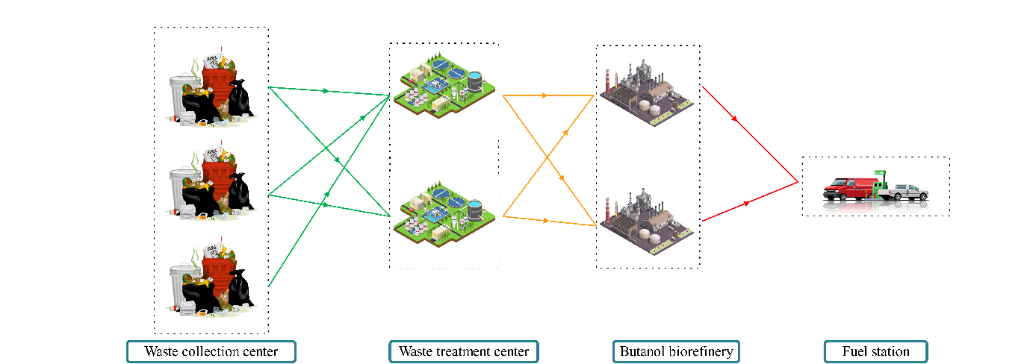

Figure 2. The general structure of the studied supply chain network

In order to design the network of this supply chain, a developed mathematical model is presented. The primary objective of this model is to determine the optimal waste treatment centers and to manage the distribution of different materials throughout the network. Moreover, this model determines the quantity of Butyric Acid (Ba) dispatched by the waste treatment center or B3 produced by the biorefineries, as well as the inventory levels in the warehouses.

**3.1 Mathematical Model Formulation**

This section begins with the introduction of the assumptions underlying the mathematical model. Subsequently, the notations, including sets, parameters and decision variables, are introduced. Finally, the objective function and the constraints are presented.

Assumptions:

* The capacity of biorefineries and waste treatment centers is constrained (Kwon et al., 2022).
* Inventory can be maintained in waste treatment centers (Geng & Sun, 2021b).
* For the construction of biorefineries, both initial investment is necessary and operational costs must be taken into account. Moreover, the required area for biorefineries has been examined (Kwon et al., 2022).
* The cost of loading and unloading is included in the transportation throughout the network (Kwon et al., 2022).

**Indices**

|  |  |
| --- | --- |
| $$k$$ | Index of waste production sites |
| $$i$$ | Index of potential locations for waste treatment center |
| $$j$$ | Index of potential locations to build biorefinery |
| $$m$$ | Index of demand cities |
| $$l$$ | Index of types of raw materials |
| $$e$$ | Index of types of utility |
| $$t$$ | Index of time periods |

**Parameters**

|  |  |
| --- | --- |
| $${FC}_{j}$$ | Fixed cost for establishing biorefinery $j$ |
| $${OC}_{j}$$ | Fixed operating cost for building biorefinery $j$ |
| $${CRM}_{l}$$ | Cost of raw material type $l$ ($/ton) |
| $${ER}_{e}$$ | Cost of energy type $e$ ($/kJ) |
| $$SCDD$$ | Cost of transportation dependent on distance ($/km) |
| $$TDCS$$ | Cost of transportation dependent on driving time ($/h) |
| $$v$$ | Average truck speed (km/h) |
| $${Dist}_{ij}$$ | Distance between waste treatment center $i$ and biorefinery $j$ (km) |
| $${Dist2}_{jm}$$ | Distance between biorefinery $j$ and demand city $m$ (km) |
| $${Dist3}_{ki}$$ | Distance between waste collection site $k$ and waste treatment center $i$ (km) |
| $$β_{l}$$ | Conversion coefficient of waste type $l$ to Ba |
| $$TCT$$ | Truck capacity (gallons) |
| $$LUF$$ | Loading and unloading cost ($/gallon) |
| $$TTG$$ | Conversion factor of ton to gallon (tons/gallon) |
| $${CAP_Min}_{j}$$ | Minimum operating capacity of biorefinery $j$ (gallons /yr) |
| $${CAP_Max}_{j}$$ | Maximum operating capacity of biorefinery $j$ (gallons /yr) |
| $${MER}_{lt}$$ | Consumption coefficient of raw material type $l$ required to produce each unit of Ba in period $t$ (tons/yr) |
| $${AER}_{et}$$ | Amount of primary energy required for type $e$ in period $t$ (kJ/yr). |
| $${ LR}_{j}$$ | Area required for the construction of biorefinery $j$ (${km}^{2}$). |
| $${ LA}_{j}$$ | Available area for constructing biorefinery $j$ (${km}^{2}$). |
| $${DEM}_{mt}$$ | Demand of city $m$ in period $t$ (gallons/yr). |
| $${MCAPB}_{it}$$ | Maximum capacity to produce Ba from organic waste at waste treatment center $i$ in period $t$ (tons/yr). |
| $${MCAP}_{kt}$$ | Maximum capacity to collect waste from point $k$ in period $t$ (tons/yr). |

**Decision variables**

|  |  |
| --- | --- |
| $${rm}_{lijt}$$ | Amount of raw material type $l$ transferred from waste treatment center $i$ to biorefinery $j$ in period $t$ (tons/yr) |
| $${ee}_{eijt}$$ | Amount of initial energy type $e$ transferred from location $i$ to biorefinery $j$ in period $t$ (kJ/yr) |
| $${TRB3}_{jmt}$$ | Amount of B3 transferred from biorefinery $j$ to demand city $m$ in period $t$ (gallons/yr) |
| $${ pro}_{jt}$$ | Amount of B3 produced at biorefinery $j$ in period $t$ (gallons/yr) |
| $${ca}_{jt}$$ | Capacity of biorefinery $j$ in period $t$ (gallons/yr) |
| $${es}_{jt}$$ | Binary variable and equal to 1 if biorefinery $j$ is established in period $t$, otherwise 0 |
| $${est}_{jt}$$ | Difference ${nr}_{jt}$ between periods $t$ and $t+1$ |
| ${KMC}_{kit}$ | Amount of waste sent from waste collection point $k$ to waste treatment center $i$ in period $t$ (tons/year) |
| $${IE}_{ilt}$$ | Inventory level of waste treatment center $i$ for each type of waste $l$ in period $t$ (tons/yr) |
| $$TC$$ | Total facility cost for converting organic waste into biodiesel |
| $$MC$$ | Total cost of raw materials for converting organic waste into biodiesel |
| $$EC$$ | Total cost of energy for converting organic waste into biodiesel |
| $${FR}^{tr}$$ | Total transportation cost from the waste collection center to the waste treatment center |
| $${FR}^{Ba}$$ | Total transportation cost from the waste treatment centers to the biorefineries |
| $${FR}^{B3}$$ | Total transportation cost from the biorefineries to the demand cities |

**Objective Function**

|  |  |
| --- | --- |
| $$\min{TAC=(TC +OC+MC+EC+FR+IC) }$$ | (1) |

According to Eq. (1), the objective function of this model is to minimize total costs, including facility cost, operating cost, total raw material cost, total energy cost, transportation cost, and holding cost, which are calculated in Eqs. (2)-(6).

|  |  |
| --- | --- |
| (2) | $$TC =\sum_{i}{ }\sum_{t}{ }\left(FC_{j}{es}_{jt} +OC_{j}{es}_{jt} \right)$$ |

As calculated in Eq. (2), the FC is associated with the total cost of facilities, which encompasses the sum of the fixed cost for each biorefinery and the operating costs required for the biorefinery.

|  |  |
| --- | --- |
| (3) | $$OC=MC+EC$$ |

As expressed in Eq. (3), the OC denotes the overall costs of materials and energy needed to operate biorefineries throughout the entire planning period, which are calculated in Eqs. (4)-(5).

|  |  |
| --- | --- |
| (4) | $$MC=\sum_{i}{ }\sum_{j}{ }\sum_{l}{ }\sum_{t}{ }\left( {CRM}_{l}{rm}_{lijt}\right)$$ |
| (5) | $$EC=\sum_{e}{ }\sum_{i}{ }\sum_{j}{ }\sum_{t}{ } {ee}_{eijt}{ec}_{e}$$ |
| (6) | $$FR={FR}^{Ba}+{FR}^{B3} +{FR}^{tr}$$ |

The TC, as calculated in Eq. (6), is the aggregate of the transportation costs of $TC^{Ba}$, $TC^{B3}$, and ${TC}^{tr}$ throughout the entire planned period, which are calculated in Eqs. (7)-(9). Moreover, Eq. (10) illustrates the inventory cost at each waste treatment center.

|  |  |  |
| --- | --- | --- |
| (7) | $${FR}^{Ba}=\sum_{j}{\sum_{i}{\sum_{i}{\sum_{t}{(\frac{(SCDD+\frac{TDCS}{v}){Dist}_{ij}}{TCT }}}}}+LUF)\frac{{rm}_{lijt}}{TTG}$$ | |
| (8) | $${FR}^{B3}=\sum_{j}{\sum_{m}{\sum_{t}{(\frac{(SCDD+\frac{TDCS}{v}){Dist2}_{jm}}{TCT }}}}+LUF){TRB3}_{jmt}$$ | |
| (9) | $${FR}^{tr}=\sum_{k}{\sum_{i}{\sum_{t}{(\frac{(SCDD+\frac{TDCS}{v}){Dist3}_{ki}}{TCT }+LUF){KMC}_{kit}}}}$$ | |
| (10)  مقدار کمبود  هزینه کمبود | | $$IC=\sum_{l}{\sum_{t}{\sum_{i}{h_{i}{IE}_{ilt}}}}$$ |

**Constraints**

Eq. (11) ensures that the biorefinery's demand for raw materials must be completely fulfilled.

|  |  |  |
| --- | --- | --- |
| (11) | $$∀j,t$$ | $${ pro}_{jt}=\sum_{l}{{MER}_{lt}}\sum_{i}{ }{rm}_{lijt}$$ |

Eq. (12) demonstrates the initial energy requirement of the biorefinery, which must be fully met.

|  |  |  |
| --- | --- | --- |
| (12) | $$∀j,e,t$$ | $${AER}_{et}{ pro}_{jt}=\sum_{i}{ } {ER}_{eijt}$$ |

Eq. (13) indicates that the production capacity of the biorefinery, once constructed, should fall within its maximum and minimum capacity limits.

|  |  |  |
| --- | --- | --- |
| (13) | $$∀j,t$$ | ${es}_{jt}{CAP_Min}_{j}≤{ca}_{jt}≤{CAP_Max}_{j}{es}_{jt}$ |

Eq. (14) stipulates that following the construction of the biorefinery, it must be operational in the subsequent period.

|  |  |  |
| --- | --- | --- |
| (14) | $$∀j,t=2,...,T$$ | ${es}_{jt-1}≤{es}_{jt}$ |

Eq. (15) computes the number of activated biorefineries in period $t$.

|  |  |  |
| --- | --- | --- |
| (15) | $$∀j,t=2,...,T$$ | ${est}_{jt} ={es}_{jt }-{es}_{jt-1}$ |

Eq. (16) specifies the possibility of constructing a new biorefinery in the first period.

|  |  |  |
| --- | --- | --- |
| (16) | $$∀j,t=1$$ | ${est}_{jt} ={es}_{jt}$ |

Eq. (17) ensures that the amount of B3 produced must be less than the capacity of the biorefinery.

|  |  |  |
| --- | --- | --- |
| (17) | $$∀j,t$$ | $${ pro}_{jt}≤{ca}_{jt}$$ |

Eq. (18) specifies that the area allocated for the construction of biorefineries should be less than the available area.

|  |  |  |
| --- | --- | --- |
| (18) | $$∀j,t$$ | $${LR}_{j}×{es}_{jt}≤{LA}_{j}$$ |

Eq. (19) ensures that the demand must be fully estimated.

|  |  |  |
| --- | --- | --- |
| (19) | $$∀m,t$$ | $$\sum_{j}{{TRB3}_{jmt}} ≥{DEM}_{mt}$$ |

Eq. (20) stipulates that the amount of Ba produced must be less than the maximum capacity.

|  |  |  |
| --- | --- | --- |
| (20) | $$∀i,t$$ | $$\sum_{j}{\sum_{l}{{rm}_{lijt}≤}}{MCAPB}_{it }$$ |

Eq. (21) ensures that the amount of B3 sent to the demand points must be equal to the B3 produced in the biorefineries.

|  |  |  |
| --- | --- | --- |
| (21) | $$∀j,t$$ | $$\sum_{m}{{TRB3}_{jmt}=}{ pro}_{jt}$$ |

Eq. (22) demonstrates that the amount of waste sent from level $k$ must be less than the capacity of the next level $i$.

|  |  |  |
| --- | --- | --- |
| (22) | $$∀i,t$$ | $$\sum_{k}{{KMC}_{kit}≤{MCAPB}_{it }}$$ |

Eq. (23) ensures that the quantity of waste dispatched from the waste-producing city must not exceed its capacity.

|  |  |  |
| --- | --- | --- |
| (23) | $$∀k,i,t$$ | $${KMC}_{kit}≤{WCAP}_{kt }$$ |

Eqs. (24)-(25) depict the flow balance in each waste treatment. Finally, Eqs. (26)-(27) determine the type of each decision variable.

|  |  |  |  |  |
| --- | --- | --- | --- | --- |
| (24) | | $$∀l,i,t$$ | | $$\sum_{k}{{KMC}_{kit}β_{l}+{IE}_{ilt-1}-{IE}_{ilt}=\sum_{j}{{rm}_{lijt}}}$$ |
| (25) | | $$∀l,i,t$$ | | $$\sum_{k}{{KMC}_{kit=1}β_{l}-{IE}_{ilt=1}=\sum_{j}{{rm}_{lijt=1}}}$$ |
| (26) | $$∀j,t,e,i,l,m$$ | | $${ca}_{jt},{ pro}_{jt},{ER}_{eijt},{rm}_{lijt},{TRB3}_{jmt}≥0$$ | |
| (27) | $$∀j,t$$ | | $${es}_{jt} ,{est}_{jt} =\{0.1\}$$ | |

**3.1. Dealing with Uncertainty**

Due to the increasing attention to renewable energies and efforts to replace fossil fuels with them, the production and marketing processes of these types of fuels have become extremely complex and require flexibility. To better align the proposed mathematical model with real conditions, it is necessary to consider uncertainty (Curto et al., 2022; Habib et al., 2022; Pishvaee et al., 2012; Rezaei et al., 2020).

The ambiguity and uncertainty in the parameters of the proposed model have made decision-making about the supply chain network design more challenging than ever. Various optimization mathematical programming models, including those proposed by Chen (2015), Mulvey et al. (1995), Ben-Tal (2009), and Dimitris Bertsimas (2004), have been introduced to address the uncertainties associated with the parameters.

The robust optimization approach considers multiple possible scenarios instead of assuming a specific future state. A model is then formulated to provide a solution that not only achieves a favorable average cost or performance but also maintains stability across variations among the scenarios. In other words, decisions are made in such a way that the risks arising from uncertainties are mitigated.

In the robust optimization approach, two fundamental parameters, namely model robustness and solution robustness, can be examined. If the obtained solution remains close to optimal for each scenario realization, the solution of the mathematical model is deemed optimally robust and referred to as model robustness. Similarly, if the solution is consistently acceptable across all realizations of every scenario, it is referred to as solution robustness. Therefore, it is necessary to assess and analyze the stability of both the model and the solution (Leung et al., 2007).

In this research, the robust stochastic optimization method has been employed due to the inadequate information regarding demand as a parameter. Moreover, based on the provided information, this section attempts to discuss and evaluate the application of the robust optimization method in the field of supply chain management from organic waste to biodiesel, under demand uncertainty. In this research, a robust stochastic optimization approach is utilized, which was first introduced by Mulvey et al. (1995). Eqs. (28)-(31) present the notations and mathematical equations of this approach.

|  |  |
| --- | --- |
| (28) |  |

|  |  |
| --- | --- |
| (29) | $$Wy+Rx≥b$$ |
| (30) | $$x≥0$$ |
| (31) | $$y∈[0,1]$$ |

where, variable $y$ represents the decision variable that must be determined by considering the uncertainty in the model parameters, and variable $x$ represents the mid-term or short-term decision variables; in other words, it represents control decision variables. Similarly, vector $b$ represents the right-hand side of the constraint. Moreover, if $ρ$ is the set of available scenarios (where $θ∈ρ$), and if each scenario has a probability of occurrence, the value of the objective function in the desired scenario can be calculated using Eq. (32).

|  |  |
| --- | --- |
| (32) | $$z_{θ}=αy+β_{θ} x_{θ}$$ |

On the other hand, $ρ_{s}$ represents the probability of occurrence of each scenario, where $\sum{ρ_{s}=1}$. The general form of the robust optimization model is expressed in Eqs. (33)-(36).

|  |  |
| --- | --- |
| (33) |  |

|  |  |  |
| --- | --- | --- |
| (34) | $$∀θ$$ | $$Wy+Rx_{θ}-ξ_{θ}=b_{θ}$$ |
| (35) |  | $$x≥0$$ |
| (36) |  | $$y∈[0,1]$$ |

Given that the objective function is a non-linear expression, the optimization process can be accelerated by transforming the problem into a linear one, along with the introduction of a non-negative auxiliary variable ($u_{θ}$), which is developed by Leung et al. (2007). This linear formulation is presented in Eqs. (37)-(42).

|  |  |
| --- | --- |
| (37) |  |

|  |  |  |
| --- | --- | --- |
| (38) | $$∀θ$$ | $$Wy+Rx_{θ}-ξ_{θ}=b_{θ}$$ |
| (39) | $$∀θ$$ | $$z_{θ }- \acute{\sum_{θ≠θ}{ρ_{\acute{θ}}z_{\acute{θ}}}}+u_{θ}≥0$$ |
| (40) | $$∀θ$$ | $$u_{θ}≥0$$ |
| (41) |  | $$x≥0$$ |
| (42) |  | $$y∈[0,1]$$ |

In this research, the demand parameter is considered as an uncertain parameter. In order to formulate a robust model under demand uncertainty, different values for this parameter are considered parameter scenarios. In this regard, index $s,\acute{s∈Ω}$ has been utilized. According to the structure of the robust optimization approach, the proposed mathematical model is developed as follows.

**New Parameters**

|  |  |
| --- | --- |
| $$ρ_{s}$$ | Probability of each scenario |
| $${ DEM}_{smt}$$ | Amount of biodiesel demand in city $m$ during period $t$ under scenario $s$ |
| $$λ$$ | Control parameter for optimality robustness |
| $$Ω$$ | Control parameter for feasibility robustness |

**New Decision Variables**

|  |  |
| --- | --- |
| ${rm}_{slijt}$ | Amount of raw material type $l$ transferred from waste treatment center $i$ to biorefinery $j$ in period t under scenario $s$ (tons/yr). |
| $${ee}_{seijt}$$ | Amount of primary energy type $e$ transferred from location $i$ to biorefinery $j$ in period $t$ under scenario $s$ (kilojoules/yr). |
| $${TRB3}_{sjmt}$$ | Amount of B3 transferred from biorefinery $j$ to demand city $m$ in period $t$ under scenario $s$ (gallons/yr). |
| $${KMC}_{skit}$$ | Amount of waste sent from waste collection point $k$ to waste treatment center $i$ in period $t$ under scenario $s$ (tons/yr). |
| $${IE}_{silt}$$ | Inventory level at waste treatment center $i$ for each type of waste $l$ in period $t$ under scenario $s$ (tons/yr). |
| $${ pro}_{sjt}$$ | Amount of B3 produced at biorefinery $j$ in period $t$ under scenario $s$ (gallons/yr). |
| $${MC}_{s}$$ | Total cost of raw materials for converting organic waste to biodiesel under scenario $s$. |
| $${EC}_{s}$$ | Total cost of energy for converting organic waste to biodiesel under scenario $s$. |
| $${FR}_{s}^{tr}$$ | Total transportation cost from the waste collection center to the waste treatment centers under scenario $s$. |
| $${FR}_{s}^{Ba}$$ | Total transportation cost from the waste treatment centers to the biorefineries under scenario $s$. |
| $${FR}_{s}^{b3}$$ | Total transportation cost from the biorefineries to the demand cities under scenario . |

|  |  |
| --- | --- |
| (44) | $$Min {TAC}^{Robust}=\sum_{i}{ }\sum_{t}{ }\left(FC_{j}{es}_{jt} +OC_{j}{es}_{jt} \right)+λ\sum_{s}{ρ_{s}} {TAC}_{s}+ (1-λ)[\sum_{s}{ρ_{s}} {TAC}_{s}-\sum_{ss}{ρ_{ss}} {TAC}_{ss}+2u_{s}]+Ω\sum_{s}{\sum_{m}{\sum_{t}{ρ_{s}{RS}_{s,m,t}}}}$$ |
| (43) | $${TAC}_{s}=\sum_{s}{ }\sum_{j}{ }\sum_{l}{ }\sum_{t}{ }\left( {CRM}_{l}{rm}_{slijt}\right)+\sum_{s}{ }\sum_{e}{ }\sum_{i}{ }\sum_{j}{ }\sum_{t}{ } {ee}_{seijt}{ec}_{e}+\sum_{s}{ }\sum_{j}{\sum_{i∈\{Ba\}}{\sum_{i}{\sum_{t}{(\frac{(SCDD+\frac{TDCS}{v}){Dist}_{ij}}{TCT }}}}}+LUF)\frac{{rm}_{slijt}}{TTG}+\sum_{s}{ }\sum_{j}{\sum_{m}{\sum_{t}{(\frac{(SCDD+\frac{TDCS}{v}){Dist2}_{jm}}{TCT }}}}+LUF){TRB3}_{sjmt}+\sum_{s}{ }\sum_{k}{\sum_{i}{\sum_{t}{(\frac{(SCDD+\frac{TDCS}{v}){Dist3}_{ki}}{TCT }+LUF){KMC}_{skit}}}}+\sum_{t}{\sum_{i}{h_{i}{IE}_{silt}}}$$ |

S.t

|  |  |  |  |  |  |  |  |  |  |
| --- | --- | --- | --- | --- | --- | --- | --- | --- | --- |
| (45) | | $$∀s,j,t$$ | | | | | $${ pro}_{sjt}=\sum_{l}{{MER}_{lt}}\sum_{i}{ }{rm}_{slijt}$$ | | |
| (46) | | $$∀s,j,e,t$$ | | | | | $${AER}_{et}{ pro}_{sjt}=\sum_{i}{ } {ER}_{seijt}$$ | | |
| (47) | | $$∀s,j,t$$ | | | | | $${ pro}_{sjt}≤{ca}_{jt}$$ | | |
| (48) | | $$∀s,m,t$$ | | | | | $$\sum_{j}{{TRB3}_{sjmt}}+{RS}_{s,m,t} ≥{DEM}_{smt}$$ | | |
| (49) | | $$∀s,i,t$$ | | | | | $$\sum_{j}{\sum_{l}{{rm}_{slijt}≤}}{MCAPB}_{it }$$ | | |
| (50) | | $$∀s,j,t$$ | | | | | $$\sum_{m}{{TRB3}_{sjmt}=}{ pro}_{jt}$$ | | |
| (51) | | $$∀s,i,t$$ | | | | | $$\sum_{k}{{KMC}_{s,k,i,t}≤{MCAPB}_{it }}$$ | | |
| (52) | | $$∀s,k,i,t$$ | | | | | $${KMC}_{skit}≤{WCAP}_{kt }$$ | | |
| (53) | | | $$∀s,l,i,t$$ | $$\sum_{k}{{KMC}_{skit}β_{l}+{IE}_{silt-1}-{IE}_{silt}=\sum_{j}{{rm}_{slijt}}}$$ | | | |
| (54) | | | $$∀s,l,i,t$$ | $$\sum_{k}{{KMC}_{skit=1}β_{l}-{IE}_{silt=1}=\sum_{j}{{rm}_{slijt=1}}}$$ | | | |
| (55) | | | $$∀s$$ | $${TCA}_{s}-\sum_{ss}{ρ_{ss}}{TCA}_{ss}+u_{s}≥0$$ | | | |
| (56) | $$∀j,t,s,i,e,m$$ | | | | $${ca}_{jt},{ pro}_{sjt},{ER}_{seijt},{rm}_{slijt},{TRB3}_{sjmt},u_{s},{RS}_{smt}≥0$$ | | |
| (57) | $$∀j,t$$ | | | | | $${es}_{jt} ,{est}_{jt} =\{0.1\}$$ | | |

Eq. (13)-(16) & Eq. (18)

**4. Numerical Results**

In this section, first, the model parameters and decision variables in deterministic mode have been analyzed in detail and on a small scale. Next, the results obtained from the robust model were comprehensively reviewed, and comparisons were made for each scenario. Finally, the sensitivity analysis of the model against changes in demands was evaluated.

**4.1. Model Validation in Deterministic Mode**

To evaluate the performance of the proposed model, the model parameters, which encompass information about 5 waste generators, 2 waste treatment centers, 4 biorefineries, and 2 demand points over 3 time periods, are provided. This information is presented in Tables 2-7.

|  |  |  |  |  |  |  |
| --- | --- | --- | --- | --- | --- | --- |
| Table 2. Capital data and capacities | | | | | | |
| The values of each parameter | Biorefinery 1 | Biorefinery 2 | | | Biorefinery 3 | Biorefinery 4 |
| $${FC}_{j}$$ | 110 | 150 | | | 160 | 102 |
| $${OC}_{j}$$ | 98 | 127 | | | 110 | 80 |
| $${RCAP_Min}_{j}$$ | 50 | 55 | | | 65 | 67.5 |
| $${RCAP_Max}_{j}$$ | 1000000 | | 1000000 | 1000000 | | 1000000 |
| $${LA}_{j}$$ | 1000 | 1110 | | | 980 | 1031 |

|  |  |  |  |  |  |  |  |  |  |  |  |  |  |  |  |  |  |  |  |  |  |  |  |  |  |  |  |  |  |  |  |  |  |  |  |  |  |  |  |  |  |  |  |  |  |  |  |  |  |  |  |  |  |  |  |  |  |  |  |
| --- | --- | --- | --- | --- | --- | --- | --- | --- | --- | --- | --- | --- | --- | --- | --- | --- | --- | --- | --- | --- | --- | --- | --- | --- | --- | --- | --- | --- | --- | --- | --- | --- | --- | --- | --- | --- | --- | --- | --- | --- | --- | --- | --- | --- | --- | --- | --- | --- | --- | --- | --- | --- | --- | --- | --- | --- | --- | --- | --- |
| | Table 4. Other parameters | | | --- | --- | | *v* | 90 | |  | 100 | |  | 200 | | *TDCS* | 250 | | *TCT* | 2000 | | *LUF* | 400 | | *TTG* | 3 | | Big *m* | 10000000 | | |  |  |  |  |  | | --- | --- | --- | --- | --- | | Table 3. Production data | | | | | |  | | Period 1 | Period 2 | Period 3 | |  | Waste collection center 1 | 700 | 700 | 600 | | Waste collection center 2 | 770 | 980 | 900 | | Waste collection center 3 | 550 | 698 | 988 | | Waste collection center 4 | 850 | 770 | 600 | | Waste collection center 5 | 740 | 900 | 887 | |  | Waste treatment center 1 | 900 | 870 | 678 | | Waste treatment center 2 | 870 | 1000 | 980 | |

|  |  |  |  |  |  |  |  |  |  |  |  |  |  |  |  |  |  |  |  |  |  |  |  |  |  |  |  |  |  |  |  |  |  |  |  |  |  |  |  |  |  |  |  |  |  |  |  |  |  |  |  |  |  |  |  |  |  |  |  |  |  |  |  |  |  |  |  |  |  |  |  |  |  |  |  |  |  |  |  |  |  |  |  |  |  |  |  |  |  |  |  |  |  |  |  |  |  |  |  |  |  |  |  |  |  |  |  |  |  |  |  |  |  |  |  |  |  |  |  |  |  |  |  |  |  |  |  |  |  |  |  |  |  |  |  |  |  |  |  |  |  |  |  |  |  |  |  |  |  |  |  |  |  |  |  |  |  |  |  |  |
| --- | --- | --- | --- | --- | --- | --- | --- | --- | --- | --- | --- | --- | --- | --- | --- | --- | --- | --- | --- | --- | --- | --- | --- | --- | --- | --- | --- | --- | --- | --- | --- | --- | --- | --- | --- | --- | --- | --- | --- | --- | --- | --- | --- | --- | --- | --- | --- | --- | --- | --- | --- | --- | --- | --- | --- | --- | --- | --- | --- | --- | --- | --- | --- | --- | --- | --- | --- | --- | --- | --- | --- | --- | --- | --- | --- | --- | --- | --- | --- | --- | --- | --- | --- | --- | --- | --- | --- | --- | --- | --- | --- | --- | --- | --- | --- | --- | --- | --- | --- | --- | --- | --- | --- | --- | --- | --- | --- | --- | --- | --- | --- | --- | --- | --- | --- | --- | --- | --- | --- | --- | --- | --- | --- | --- | --- | --- | --- | --- | --- | --- | --- | --- | --- | --- | --- | --- | --- | --- | --- | --- | --- | --- | --- | --- | --- | --- | --- | --- | --- | --- | --- | --- | --- | --- | --- | --- | --- | --- | --- | --- |
| |  |  |  |  |  |  | | --- | --- | --- | --- | --- | --- | | Table 6. Parameters related to distance | | | | | | |  |  | Waste treatment center. | | | | |  | 1 | 2 | | | | Waste collection center | 1 | 67 | 90 | | | | 2 | 73 | 35 | | | | 3 | 61 | 120 | | | | 4 | 90 | 65 | | | | 5 | 65 | 110 | | | |  | | 0.3 | 0.2 | | | |  |  | Biorefinery | | | | |  | 1 | 2 | 3 | 4 | | Waste treatment center | 1 | 62 | 80 | 67 | 90 | | 2 | 30 | 45 | 52 | 87 | |  |  | Demand city | | | | |  | 1 | 2 | 3 | 4 | | Biorefinery | 1 | 54 | 58 | 115 | 86 | | 2 | 83 | 120 | 65 | 30 | | 3 | 56 | 78 | 72 | 87 | | 4 | 90 | 66 | 54 | 110 | | |  |  |  |  |  | | --- | --- | --- | --- | --- | | Table 5. Period-related parameters | | | | | |  | | Period | | | | 1 | 2 | 3 | |  | Utility type 1 | 2 | 3 | 4 | | Utility type 2 | 1 | 3 | 5 | | Utility type 3 | 2 | 4 | 6 | |  | Raw material type 1 | 10 | 9 | 12 | | Raw material type 2 | 14 | 11 | 12 | | Raw material type 3 | 15 | 13 | 10 | |  | Demand city 1 | 1000 | 1100 | 1320 | | Demand city 2 | 1250 | 1060 | 1252 | | Demand city 3 | 1300 | 1999 | 1450 | | Demand city 4 | 1252 | 1200 | 1123 | |
| |  |  |  |  | | --- | --- | --- | --- | | Table 7. Data related to raw materials | | | | |  | Raw material type 1 | Raw material type 2 | Raw material type 3 | | 60 | 77 | 65 | |  | 0.3 | 0.4 | 0.3 | |  | Utility type 1 | Utility type 2 | Utility type 3 | | 55 | 42 | 34 | |

The model was implemented and executed using GAMS software with the CPLEX solver. Optimal values for the decision variables, including amounts of shipments, production, biorefinery capacity, and warehouse inventory level, were optimally determined. These results are depicted in Figure 3.

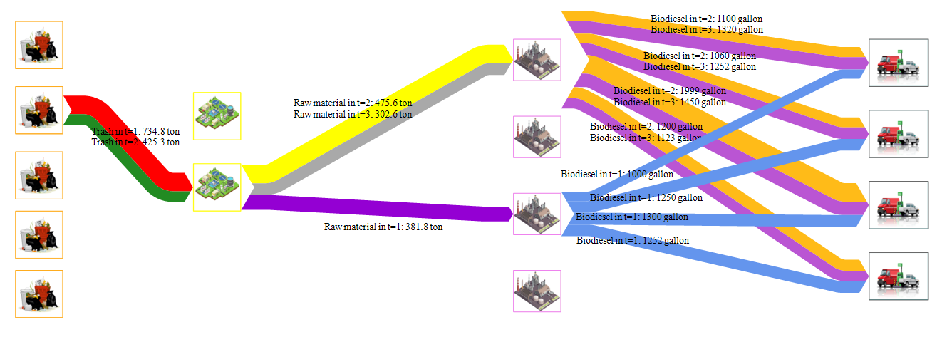

Figure 3. Transmitted values between levels in the deterministic mode

As depicted in Figure 3, only the second location has been selected among the five potential sites for the construction of waste collection centers. In the first and second periods, 734.8 and 425.3 tons of waste, respectively, were sent from this center to the next level. The second location was chosen among the two potential locations for the construction of the biorefinery. Moreover, the biodiesel production in the biorefineries and the volume sent to all points have been precisely determined. According to the calculated optimal values, the total cost amounts to TC = 20,161,400 dollars. This value indicates that by utilizing the optimal values for the decision variables, the total costs have been minimized, thereby improving the performance of the supply chain.

**4.2. Deterministic Model Analysis**

To evaluate the accuracy of the proposed model, sensitivity analysis was conducted on several key parameters, including required energy cost, speed changes, demand, amount of raw materials, required energy and transportation costs. These parameters were selected due to their complex interactions and the uncertainty regarding their impact, which requires further analysis to assess their influence on the model’s performance. Sensitivity analysis was performed to investigate the effect of changes in important parameters on model outputs. The changes in objective function values corresponding to changes in parameter values are presented in Tables 8 - 10 and Figures 4 - 6. By examining these tables and graphs, it is possible to more precisely observe the effect of each parameter on the optimal solution of the deterministic model. This aids in understanding how changes to model outputs are influenced by parameter variations.

|  |  |  |  |  |  |
| --- | --- | --- | --- | --- | --- |
| Table 8. Changes in the objective function concerning changes in V | | | | | |
| Percentage of parameter changing | -20% | -10% | 0% | 10% | 20% |
| Total cost | 20148870 | 20148590 | 20148360 | 20148180 | 20148030 |

Figure 4. The trend of the objective function concerning changes in V

A more detailed analysis of Table 8 and Figure 4 reveals that changes in the speed of trucks have a significant impact on costs, with costs decreasing significantly as speed increases. This trend arises because higher truck speeds result in shorter distances traveled, leading to reduced transportation costs due to the time-dependent nature of transportation expenses in the network.

|  |  |  |  |  |  |
| --- | --- | --- | --- | --- | --- |
| Table 9. Changes in the objective function concerning changes in MER | | | | | |
| Percentage of parameter changing | -20% | -10% | 0% | 10% | 20% |
| Total cost | 20324730 | 20226660 | 20148360 | 20084420 | 20031140 |

Figure 5. The trend of the objective function concerning changes in MER

The data in Table 9 and Figure 5 indicate that increasing the consumption factor of the required raw materials leads to a significant decrease in total costs. It should be noted that increasing the raw material consumption factor enables the supply chain to produce and sell the required B3 with less raw material. Therefore, as MER increases, the costs of collecting and sending waste decrease, resulting in a reduction in the total cost of the supply chain.

|  |  |  |  |  |  |
| --- | --- | --- | --- | --- | --- |
| Table 10. Changes in the objective function with respect to changes in AER | | | | | |
| Percentage of parameter changing | -20% | -10% | 0% | 10% | 20% |
| Total cost | 18737440 | 19442900 | 20148360 | 20853830 | 21559290 |

Figure 6. Changes in the objective function with respect to changes in AER

Through the analysis of Table 10 and Figure 6, it is evident that the amount of required energy directly impacts costs, as an increase in AER results in a higher amount of energy transferred, consequently leading to an upward trend in the overall supply chain costs.

|  |  |  |  |  |  |
| --- | --- | --- | --- | --- | --- |
| Table 11. Changes in the objective function concerning changes in $SCDD$ | | | | | |
| Percentage of parameter changing | -20% | -10% | 0% | 10% | 20% |
| Total cost | 20119160 | 20133760 | 20148360 | 20162970 | 20177570 |

Figure 7. Changes in the objective function with respect to changes in $SCDD$

As illustrated in Figure 7 and Table 11, an increase in the distance-based transportation cost parameter has resulted in a higher objective function value. This outcome can be attributed to the fact that, as this parameter increases, transportation costs are assigned a greater weight in the objective function. Consequently, when the distance-based transportation cost is increased, the total system cost is also elevated.

|  |  |  |  |  |  |
| --- | --- | --- | --- | --- | --- |
| Table 12. Changes in the objective function concerning changes in *TDCS* | | | | | |
| Percentage of parameter changing | -20% | -10% | 0% | 10% | 20% |
| Total cost | 20147960 | 20148160 | 20148360 | 20148570 | 20148770 |

Figure 8. Changes in the objective function with respect to changes in *TDCS*

As illustrated in Figure 8 and Table 12, the objective function value has increased with the rise in the time-dependent transportation cost parameter. This increase can be attributed to the fact that, as this parameter is elevated, transportation time between origins and destinations is assigned a greater weight in the total cost calculation. Consequently, routes requiring longer transportation times are associated with higher incurred costs for the system, leading to an overall increase in the objective function value.

**4.3. Sensitivity Analysis of Optimality Robustness (OR) and Feasibility Robustness (FR)**

In this section, the sensitivities of OR and FR, as conceptualized in the robust approach of scenario-based optimization, have been analyzed. The robust objective function comprises two control parameters, $λ$ and $Ω$, which dictate the significance of scenario variation and constraint violation, respectively.

To solve the robust model and obtain suitable values for $λ$ and $Ω$, a sequential process was followed. Since λ appears in the objective function along with $(1-λ)$, it was necessary to vary this parameter within the interval $[0, 1]$ to ensure consistency and feasibility. Therefore, $λ$ was varied from $0$ to $1$ in increments of $0.1$. Subsequently, $Ω$ was adjusted from $0$ to $100000$ in steps of $10000$. This range was selected because Ω must be non-negative, and higher values beyond this interval were found to have no further effect on the model results. The results of implementing the robust model are presented in Tables 13 and 14, along with Figures 9 and 10. Notably, Expected Value (EV) denotes the average of the objective function across different scenarios, Variance (Var) represents the variance of the objective function among scenarios, and Constraint Resolution (CR) signifies the expectation of constraint violations.

|  |  |  |  |  |  |  |
| --- | --- | --- | --- | --- | --- | --- |
| Table 13. Sensitivity analysis of parameter λ (Ω=100000) | | | | | | |
| λ | 0 | 0.3 | 0.5 | 0.7 | 0.9 | 1 |
| $$EV$$ | 2.542 ${10}^{7}$* | 2.316 ${10}^{7}$* | 2.014 ${10}^{7}$* | 1.984 ${10}^{7}$* | 1.984 ${10}^{7}$* | 1.984 ${10}^{7}$* |
| $$Var$$ | -1.235 ${10}^{-9}$* | 402966.142 | $$2216217.636$$ | $$2216217.636$$ | $$2216217.636$$ | $$2216217.636$$ |

Figure 9. Changes in variance and expected value concerning different values of λ

|  |  |  |  |  |  |  |
| --- | --- | --- | --- | --- | --- | --- |
| Table 14. Sensitivity analysis of parameter Ω (λ=0.38) | | | | | | |
| Ω | 0 | 10000 | 50000 | 70000 | 80000 | 100000 |
| $$EV$$ | 0 | 1.8131 ${10}^{7}$* | 2.0145 ${10}^{7}$* | 2.0145 ${10}^{7}$* | 2.0145 ${10}^{7}$* | 2.0145 ${10}^{7}$* |
| $$Var$$ | 0 | -1.253 ${10}^{-9}$* | 2216217.636 | 2216217.636 | 2216217.636 | 2216217.636 |
| $$CR$$ | 15076.41 | 1531.536 | 0 | 0 | 0 | 0 |

As depicted in Figure 9, the $CR$ value and variance are computed at each step. It is evident from Figure 10 that the intersection point of these two curves occurs at the value of λ=0.38. Similarly, in Figure 11, the point of intersection for these curves is determined as $Ω=10000$. Furthermore, the analysis of Figure 9 indicates that as the value of λ increases, the importance of the average also increases, leading to a gradual decrease in the $EV$. Additionally, with higher values of $λ$, the significance of the variance decreases, resulting in a gradual increase in the variance. Moreover, the examination of Figure 10 reveals that as $Ω$ increases, there is a greater emphasis on reducing constraint violations, leading to a downward trend in $CR$. Conversely, as $Ω$ increases, the focus on the mathematical expectation decreases, resulting in an increase in the constraints violation.

Figure 10. Variance and constraint violation changes concerning different values of Ω

**4.4. Numerical Results of the Robust Model**

In this study, five demand scenarios were considered to examine the impact of demand uncertainty. The corresponding demand fluctuated with the rates 0.7, 0.9, 1.0, 1.15, and 1.25. The rates 0.9, 1.0, and 1.2 were adopted based on the study conducted by Rahmani et al. (2023), which reflects normal and moderately fluctuating demand conditions. The remaining rates were determined through expert opinion and analysis of potential demand volatility in order to capture more extreme conditions of decreased and increased demand. This range of scenarios was developed to enable a more comprehensive evaluation of the model’s performance under various uncertainty conditions.

In this section, the proposed organic waste to biodiesel supply chain under demand uncertainty is optimized. The findings highlight the substantial influence of demand uncertainty on supply chain performance. The results of this study are illustrated in Figures 11-a to 11-d, showcasing the intricacies of the supply chain model and the values assigned to the decision variables.

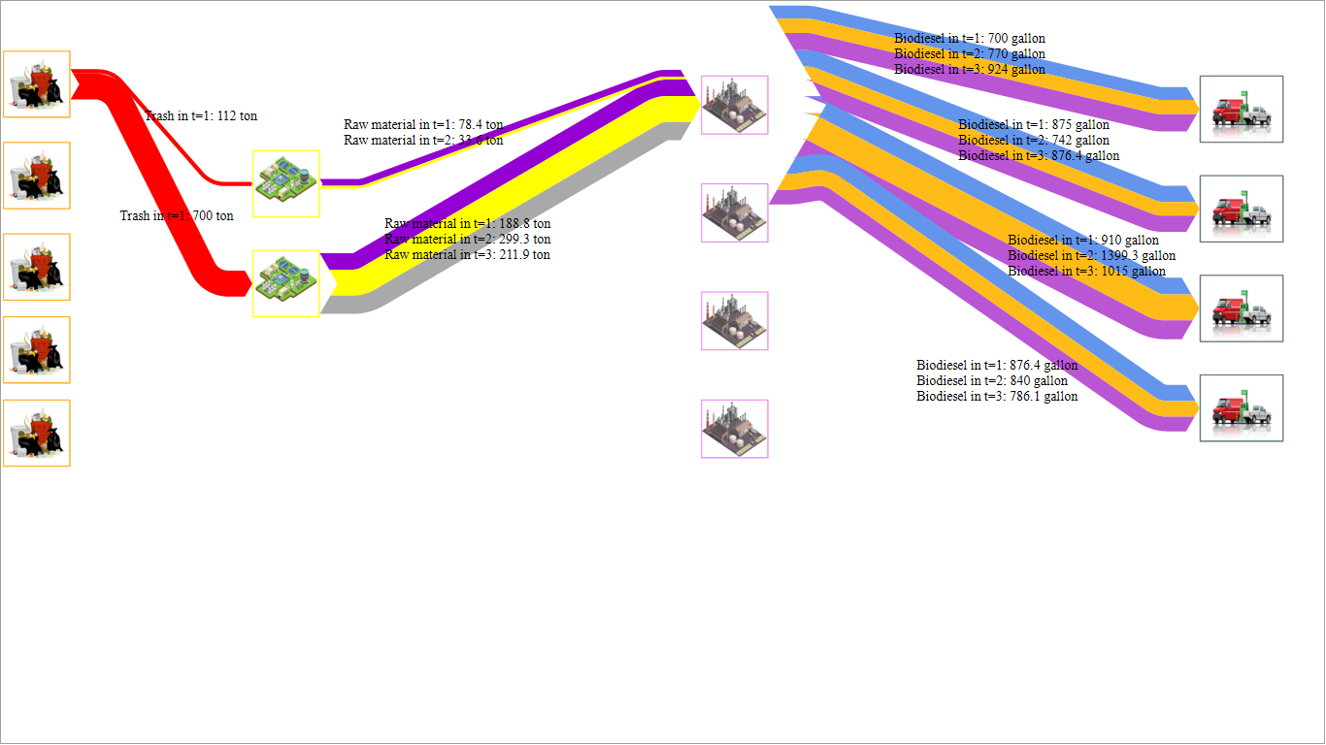

Figure 11-a. Shipment values throughout the supply chain under scenario 1

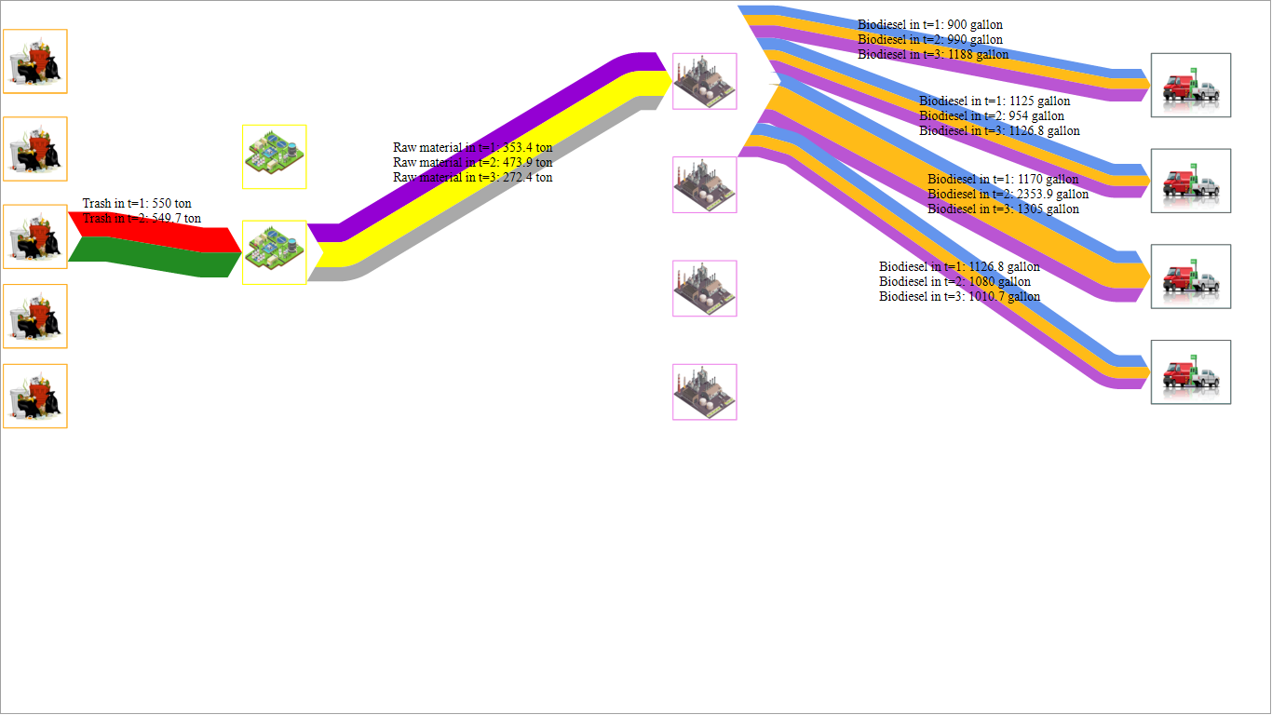

Figure 11-b. Shipment values throughout the supply chain under scenario 2

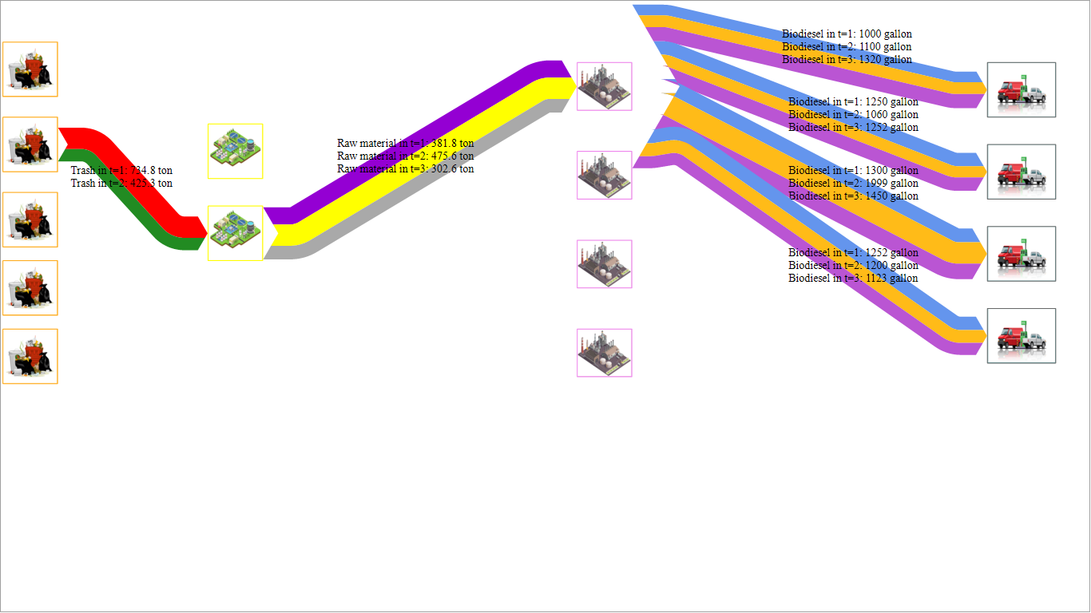

Figure 11-c. Shipment values throughout the supply chain under scenario 3

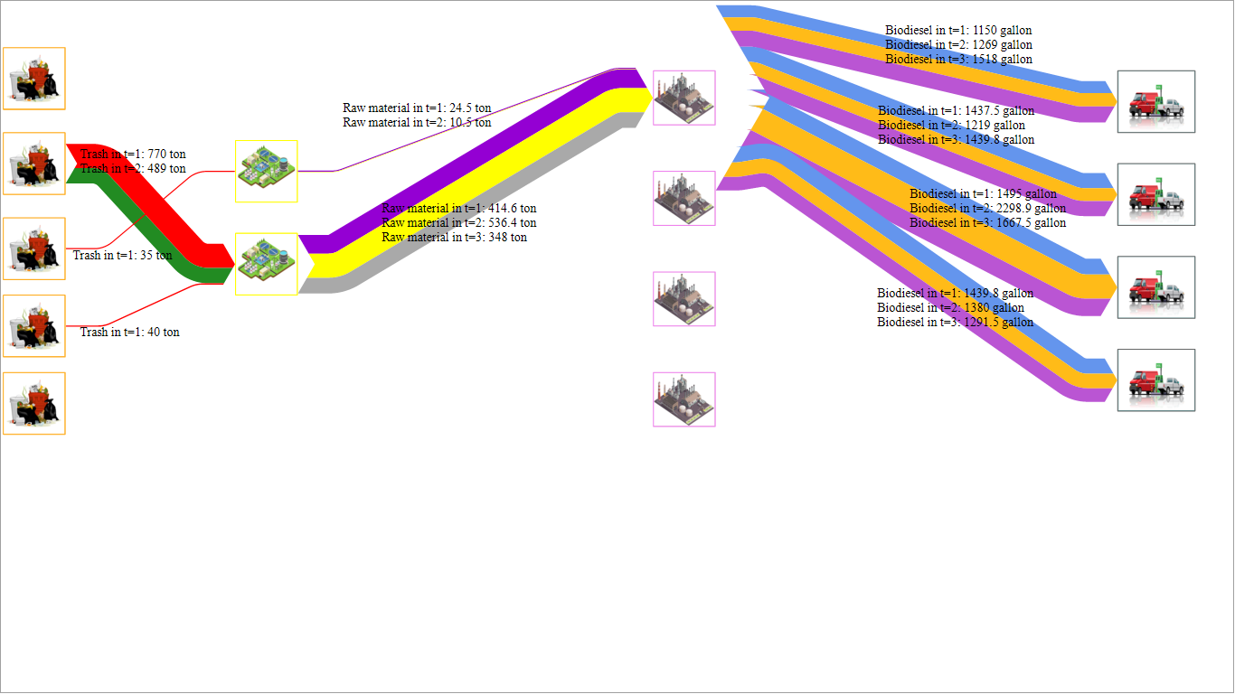

Figure 11-d. Shipment values throughout the supply chain under scenario 4

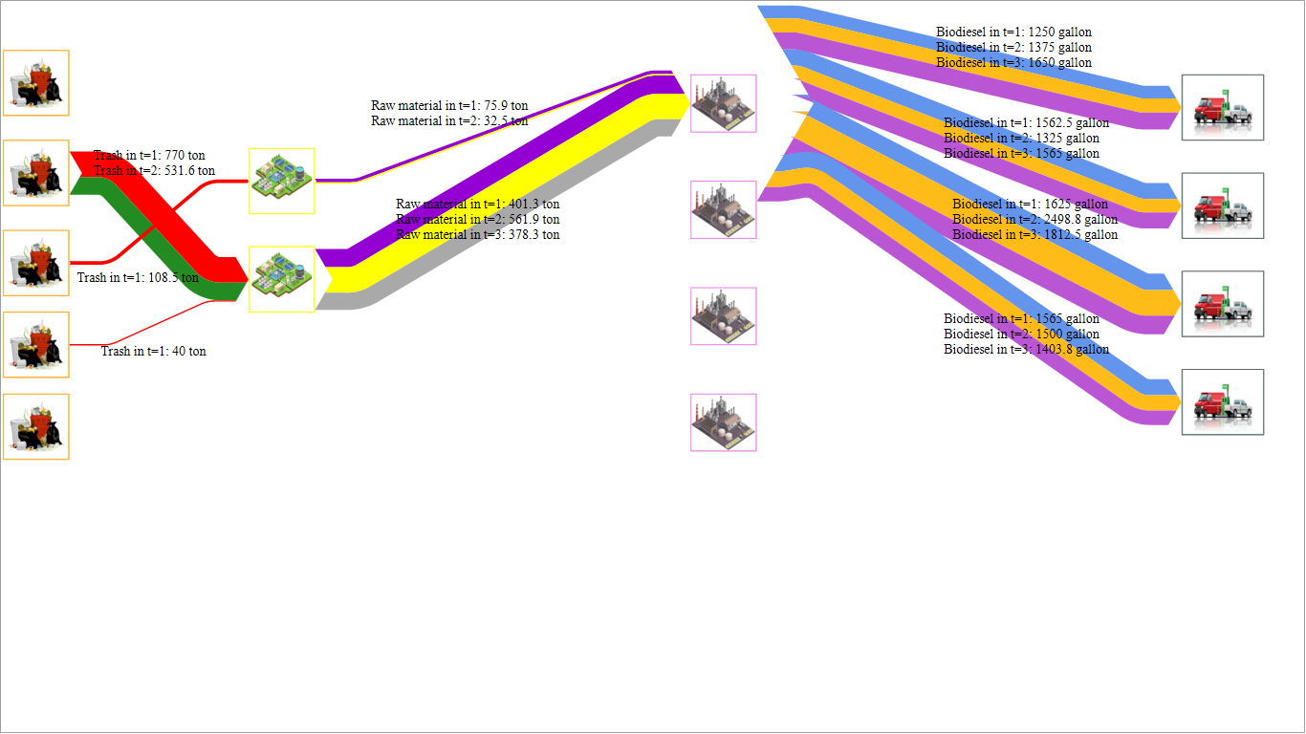

Figure 11-e. Shipment values throughout the supply chain under scenario 5

**4.5. Scenario Analysis in the Robust Model**

In this section, sensitivity analysis is undertaken. In this regard, for each execution, a specific coefficient is considered for each scenario. These coefficients are multiplied by the nominal value of the demand parameter, and finally, the robust model is optimized, and the value of the robust objective function is reported. The results are presented in Table 15 and Figure 12.

|  |  |  |  |  |  |  |  |  |  |
| --- | --- | --- | --- | --- | --- | --- | --- | --- | --- |
| Table 15. Sensitivity analysis of the objective function in each scenario | | | | | | | | | |
| scenario | Execution 1 | | Execution 2 | | Execution 3 | | Execution 4 | | Execution 5 | |
| Coefficient factor of scenario 1 (α) | 0.6 | 0.7 | | 0.8 | | 0.9 | | 1 | |
| Coefficient factor of scenario 2 (β) | 0.7 | 0.9 | | 1 | | 1.15 | | 1.25 | |
| Coefficient factor of scenario 3 (γ) | 0.8 | 1 | | 1.15 | | 1.25 | | 1.5 | |
| Coefficient factor of scenario 4 (δ) | 0.9 | 1.15 | | 1.25 | | 1.5 | | 1.75 | |
| Coefficient factor of scenario 5 (ζ) | 1 | 1.25 | | 1.5 | | 1.75 | | 2 | |
| The value of the robust objective function | 19594590 | 23200120 | | 24315680 | | 25818520 | | 27302920 | |

Figure 12. Sensitivity analysis of demand increase in the robust model

As shown in Figure 12, this rise in demand quantity has consequently elevated the fixed objective function. The extent of variations in the demand coefficient underscores its direct influence on the fixed objective function. Furthermore, these findings emphasize the sensitivity of the fixed objective function to changes in demand coefficients, highlighting the significance of carefully considering such factors in optimizing the robust model.

**4.6. Case Study**

In order to demonstrate the application of the proposed mathematical model, the model was implemented using data from South Korea. For this study, two cities were selected as demand points, four cities as potential locations for building biorefineries and waste treatment centers, and five cities as potential sites for waste collection, with five types of raw materials and six types of energy chosen. Other information related to this case study was extracted from the research of Kwon et al. (2022). The information related to feedstock and facilities is provided in Tables 16 and 17. The results of the model for scenario four and all time periods are depicted graphically in Figure 13.

Table 16. Feedstock and utility cost for biodiesel production

| **Feedstock** | **Cost ($/dry ton)** | **Utility** | **Cost ($/kJ)** |
| --- | --- | --- | --- |
| MtOH | 450 | HP | 0.0000051 |
| BA | 407 | LP | 0.0000044 |
| CNT | 150,000 | VLP | 0.0000041 |
| PtCO | 127,500 | TF | 0.0000146 |
| H2 | 2,400 | CW | 0.0000006 |
| - | - | Electricity | 0.0000192 |

Table 17. Facility cost and land parameters

| **Region** | **Facility cost** | |  | **Land parameters** | |
| --- | --- | --- | --- | --- | --- |
| **FC (106$/yr)** | **OC (106$/yr)** |  | **Land cost (106$/km2)** | **Available land size (km2)** |
| 1 | 3.77 | 3.74 |  | 1,210 | 30.25 |
| 2 | 3.65 | 3.62 |  | 164 | 38.20 |
| 3 | 3.64 | 3.61 |  | 89 | 44.20 |
| 4 | 3.64 | 3.62 |  | 116 | 49.70 |
| 5 | 3.64 | 3.62 |  | 114 | 25.05 |
| 6 | 3.64 | 3.61 |  | 95 | 27.00 |
| 7 | 3.63 | 3.61 |  | 31 | 52.85 |
| 8 | 3.63 | 3.61 |  | 65 | 506.55 |
| 9 | 3.63 | 3.60 |  | 6 | 830.65 |
| 10 | 3.63 | 3.61 |  | 14 | 371.55 |
| 11 | 3.63 | 3.61 |  | 13 | 430.05 |
| 12 | 3.63 | 3.61 |  | 13 | 402.75 |
| 13 | 3.63 | 3.60 |  | 9 | 603.65 |
| 14 | 3.63 | 3.60 |  | 8 | 951.30 |
| 15 | 3.63 | 3.61 |  | 17 | 526.05 |

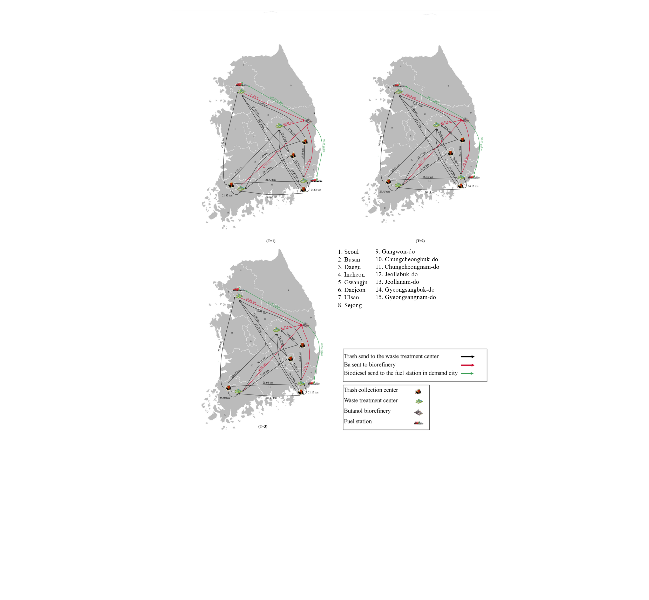

Figure 13. Model results in the fourth scenario and all periods

As depicted in Figure 13, the supply chain network configuration remains unchanged, with variations in the volume of shipments. These discrepancies are the primary drivers of alterations in the shipping and distribution processes. Put differently, the key locations remain fixed across different periods, with only variations in the quantity and type of materials dispatched between these centers exerting influence. Concerning transmissions throughout the network, it is noteworthy that no biodiesel supply occurs in the initial period, but this deficit is compensated for in the subsequent periods. This situation arises due to the possibility of biodiesel supply shortages within the robust model.

**4.7. Comparison of Deterministic and Robust Model**

In the forthcoming research stage, the distinction between the robust mathematical model and the deterministic mathematical model will be explored in relation to the results obtained. For this objective, scenario three is selected as the reference scenario, and the deterministic model is solved using the values of this scenario. It should be noted that in the first scenario, the demand is 0.7 times that of the reference scenario. In the second scenario, the demand is 0.9 times the reference scenario. Moreover, scenarios 4 and 5 are 1.15 and 1.25 times the reference scenario, respectively.

As demonstrated in Table 19, a decrease in the cost has been observed. To avoid shortages in the model, a greater amount of biodiesel has been produced, and the model has made a decision. It is evident that the model has encountered a shortage, resulting in an increase in cost. Furthermore, more biodiesel has been produced. The results of comparing the robust model with different scenarios are presented in Table 18.

Table 18. Changes in decision variables in each scenario

|  |  |  |  |  |  |  |
| --- | --- | --- | --- | --- | --- | --- |
|  | Deterministic solution | Scenario 1 | Scenario 2 | Scenario 3 | Scenario 4 | Scenario 5 |
| Number of waste collection centers | 5 | 5 | 5 | 5 | 5 | 5 |
| Number of waste treatment centers | 4 | 4 | 4 | 4 | 4 | 4 |
| Number of biorefineries | 1 | 1 | 1 | 1 | 1 | 1 |
| Average unmet demand (gallons/yr) | 0% | 35% | 35% | 35% | 35% | 35% |
| Total cost) dollars ( | 22,038,739 | 117,554 | 160,804 | 172,365 | 199,924 | 218,301 |
| Inventory in period 1 (tons/yr) | 273.574 | 452.96 | 492.96 | 492.96 | 492.96 | 492.96 |
| Inventory in period 2 (tons/yr) | 553.405 | 794.35 | 793.31 | 772.79 | 742.01 | 721.48 |
| Inventory in period 3 (tons/yr) | 842.227 | 1144.20 | 1102.47 | 1061.61 | 1000.31 | 959.45 |
| Biodiesel produced in period 1 (gallons/yr) | 175.509 | 0 | 0 | 0 | 0 | 0 |
| Biodiesel produced in period 2 (gallons/yr) | 164.171 | 114.919 | 147.754 | 164.171 | 188.796 | 205.214 |
| Biodiesel produced in period 3 (gallons/yr) | 162.745 | 113.921 | 146.47 | 162.745 | 187.156 | 203.431 |

Table 18 illustrates significant variations in total costs across different scenarios, with the deterministic solution showing a total cost of 220.38739. In contrast, the objective function value in the reference scenario is 172365. This discrepancy in total costs is primarily attributed to potential shortages in scenario 3, where 35% of the demand remains unmet in the optimal solution. In the deterministic model, stringent demand fulfillment leads to higher costs, as the entire demand is met, placing a substantial burden on the supply chain. Moreover, in the deterministic model, biodiesel production in the second and third periods mirrors that of the reference scenario. However, the initial period's biodiesel production differs at 175.5 units despite identical facility launches across all scenarios in the deterministic model.

Therefore, it can be inferred that relaxing the demand constraint in the robust model brings the solution closer to real-world conditions while reducing total network costs. Many supply chains opt to forego a portion of market demand to manage costs effectively.

This discrepancy suggests that the deterministic model may not adequately address real-world complexities in designing a biodiesel supply chain network. In contrast, the scenario-based approach and robust optimization tool yield results more aligned with real-world conditions, highlighting their suitability for practical applications.

Finally, the effect of the problem scale on the solution time is analyzed. In this regard, the number of periods is considered as the main aspect of the problem scale. As illustrated in Figure 14 and Table 19, the solution time increases with the number of periods. This upward trend indicates that the computational complexity of the proposed model grows as the planning horizon becomes longer. The increase in solution time can be attributed to the expansion of the decision space and the additional constraints that arise with more periods, which require greater computational effort.

|  |  |  |  |  |  |  |  |  |  |  |  |  |  |  |  |
| --- | --- | --- | --- | --- | --- | --- | --- | --- | --- | --- | --- | --- | --- | --- | --- |
| Table 19. Variation of solution time with respect to the number of periods | | | | | | | | | | | | | | | |
| Solution time (cs) | 85 | 94 | 102 | 94 | 94 | 94 | 11 | 86 | 105 | 115 | 107 | 133 | 141 | 142 | 15 |
| Number of periods | 1 | 2 | 3 | 4 | 5 | 6 | 7 | 8 | 9 | 10 | 11 | 12 | 13 | 14 | 15 |

Figure 14. Solution time vs. number of periods

**5. Discussion**

This study advances biodiesel supply chain modeling by incorporating robust stochastic optimization to account for demand uncertainty, setting it apart from prior deterministic models such as Kwon et al. (2022). While both models use similar case data from South Korea, our approach introduces greater flexibility by allowing for demand fluctuations and unmet demand where economically justified. Unlike earlier studies that assume strict demand satisfaction (e.g., Babazadeh et al., 2019; Rezaei et al., 2020), our model permits strategic shortfalls, enabling a more resilient and cost-effective design. Inventory and facility capacity are optimized across multiple periods, offering a practical representation of real-world planning horizons.

For instance, in Scenario 5, allowing a 35% unmet demand reduced total system costs to approximately $21.8 million, whereas enforcing full demand satisfaction would require investments pushing the cost above $27 million.

In addition, dynamic inventory buffering, rising from 273 tons in Period 1 to over 1140 tons in Period 3, helped absorb demand shocks without additional infrastructure. These results underline the robustness of the model in volatile conditions.

One of the key findings, up to 35% unmet demand in certain periods, should be interpreted not as a failure but as a practical design trade-off. In high-demand scenarios, fully satisfying demand would require significant over-investment in infrastructure, which may not be economically or environmentally sustainable. Allowing controlled unmet demand reflects real operational strategies where supply limitations, demand spikes, or budget constraints may lead firms to under-serve markets or rely on backup sources temporarily. This approach enhances system feasibility, reduces unnecessary costs, and avoids the environmental impact of idle overcapacity.

The structure and findings of our model also compare with those of Geng and Sun (2021), who investigated biodiesel supply chains using waste resources. Geng and Sun (2021) presented a multi-objective model for a waste cooking oil–to–biodiesel supply chain, aiming to minimize costs and emissions while maximizing waste utilization. While their work emphasizes environmental objectives alongside cost, it did not explicitly incorporate robust demand uncertainty in the same way.

On the other hand, the proposed model integrates scenario-based optimization with two control parameters (λ and Ω) to tune robustness, providing decision-makers with trade-offs between cost stability and feasibility violations, which is an analytical feature missing from most previous models.

Our model is focused on cost optimization, yet it inherently supports sustainability by using organic waste feedstock and by avoiding overproduction. In terms of supply chain structure, both Geng and Sun (2021a) framework and ours consider facility location decisions and allow for inventory storage to improve flexibility (indeed, inventory at waste processing centers was also a feature of Geng and Sun (2021a). A key difference is that our model introduces the possibility of unmet demand as a decision variable under uncertainty, whereas Geng and Sun (2021b) primarily sought to satisfy demand and balance objectives without shortfalls. Despite this difference, both approaches reflect real-world complexities: they acknowledge that feedstock availability can fluctuate and that logistical networks must be designed with flexibility.

Overall, our results show that even within a cost-driven framework, it is possible to achieve a sustainable and realistic biodiesel supply chain design by combining demand-side flexibility, adaptive infrastructure, and robust optimization.

**6. Conclusion**

Utilizing organic waste as a biodiesel production source offers promising potential, particularly in countries with high urban organic waste generation. Based on this motivation, this study developed and tested a mathematical model to design a cost-minimizing biodiesel supply chain under demand uncertainty.This research proposed a mathematical model for designing the biodiesel supply chain network. This mathematical model aims to minimize total costs, encompassing waste collection, waste treatment, biodiesel production, and distribution expenses. The model structure also allows the incorporation of multiple types of organic waste in a unified supply chain, assuming appropriate pre-treatment and conversion technologies are in place. On the other hand, the proposed model's analysis was discussed under demand uncertainty conditions. Subsequently, the sensitivity analysis of the model was conducted to determine the effect of parameters on the objective function accurately. Furthermore, the robust model was implemented using data from South Korea, and the results were graphically displayed across all periods.

From a managerial perspective, the model provides several key insights. First, allowing limited unmet demand and leveraging inventory can significantly reduce system costs without severely compromising service levels, highlighting a valuable trade-off for decision-makers operating under resource constraints. Second, the model helps prioritize infrastructure investments by identifying optimal facility locations and sizing based on both average and extreme demand scenarios. This can support long-term policy planning and investment decisions in the context of renewable energy and waste management. Moreover, the results demonstrate the importance of scenario-based planning to anticipate and adapt to fluctuations in organic waste availability and fuel demand, especially in urban regions where such uncertainties are common.

Despite its strengths, the study has some limitations that open avenues for future research. The model assumes static transportation networks and fixed technology parameters over the planning horizon, which may not fully capture long-term infrastructural or technological changes. Additionally, the analysis is based on aggregated demand and supply data; incorporating more granular spatial or temporal data could improve solution precision.

To further advance this research, it is recommended that additional objectives, such as reducing environmental pollution and enhancing social responsibility, be incorporated into the proposed mathematical model. Additionally, modern solution methods like the enhanced Benders decomposition and novel meta-heuristic algorithms such as the Color Harmony Algorithm can be considered to solve the model in larger scale cases and address other practical instances.

Moreover, to better address uncertainties and enhance the robustness of the proposed model, it is recommended to incorporate risk management approaches, such as those presented by Lotfi et al. (2024), Yang et al. (2025), and Lotfi et al. (2025). In addition, integrating various forms of uncertainty, including fuzzy (Gök et al., 2023; Özcan et al., 2022; Goli, 2024a; Goli, 2024b), data-driven (Goli and Golmohammadi, 2022), and stochastic approaches, can provide a more comprehensive representation of real-world complexities and improve the quality of decision-making.

**Reference**

* Ahn, Y.-C., Lee, I.-B., Lee, K.-H., & Han, J.-H. (2015). Strategic planning design of microalgae biomass-to-biodiesel supply chain network: multi-period deterministic model. *Applied Energy*, *154*, 528-542.
* Babazadeh, R. (2017). Optimal design and planning of biodiesel supply chain considering non-edible feedstock. *Renewable and Sustainable Energy Reviews*, *75*, 1089-1100.
* Babazadeh, R., Ghaderi, H., & Pishvaee, M. S. (2019). A benders-local branching algorithm for second-generation biodiesel supply chain network design under epistemic uncertainty. *Computers & Chemical Engineering*, *124*, 364-380.
* Babazadeh, R., Razmi, J., Rabbani, M., & Pishvaee, M. S. (2017). An integrated data envelopment analysis–mathematical programming approach to strategic biodiesel supply chain network design problem. *Journal of Cleaner Production*, *147*, 694-707.
* Ben-Tal, L. E. G., and Arkadi Nemirovski. (2009). *Robust Optimization*.
* Byun, J., Kwon, O., Park, H., & Han, J. (2021). Food waste valorization to green energy vehicles: sustainability assessment. *Energy & Environmental Science*, *14*(7), 3651-3663.
* Cesaro, A., Belgiorno, V., & Guida, M. (2015). Compost from organic solid waste: Quality assessment and European regulations for its sustainable use. *Resources, Conservation and Recycling*, *94*, 72-79.
* Curto, D., Acebes, F., González-Varona, J. M., & Poza, D. (2022). Impact of aleatoric, stochastic and epistemic uncertainties on project cost contingency reserves. *International Journal of Production Economics*, *253*, 108626.
* Dimitris Bertsimas, M. S. (2004). *The Price of Robustness*.
* Geng, N., Fu, Q., & Sun, Y. (2021). Stochastic Programming of Sustainable Waste Cooking Oil for Biodiesel Supply Chain under Uncertainty. *Journal of Advanced Transportation*, *2021*, 1-18.
* Geng, N., & Sun, Y. (2021a). Multi-objective optimization of sustainable WCO for biodiesel supply chain network design. *Discrete Dynamics in Nature and Society*, *2021*(1), 6640358.
* Geng, N., & Sun, Y. (2021b). Multi-objective Optimization of Sustainable WCO for Biodiesel Supply Chain Network Design. *Discrete Dynamics in Nature and Society*, *2021*, 6640358.
* Ghelichi, Z., Saidi-Mehrabad, M., & Pishvaee, M. S. (2018). A stochastic programming approach toward optimal design and planning of an integrated green biodiesel supply chain network under uncertainty: A case study. *Energy*, *156*, 661-687.
* Goli, A. (2024a). Efficient optimization of robust project scheduling for industry 4.0: A hybrid approach based on machine learning and meta-heuristic algorithms. International Journal of Production Economics, 278, 109427.
* Goli, A. (2024b). Optimization of renewable energy project portfolio selection using hybrid AIS-AFS algorithm in an international case study. Scientific Reports, 14(1), 17388.
* Goli, A., & Golmohammadi, A. M. (2022). Multi-objective Optimization of Location and Distribution in a Closed-loop Supply Chain by Considering Market Share in Competitive Conditions. International Journal of Supply & Operations Management, 9(4).
* Gök, S. Z. A., Ergün, S., Kırlar, B. B., Özcan, İ., & Tayman, A. (2023). Fuzzy perspective of online games by using cryptography and cooperative game theory. *International Journal of Uncertainty, Fuzziness and Knowledge-Based Systems*, *31*(06), 891-915.
* Habib, M. S., Asghar, O., Hussain, A., Imran, M., Mughal, M. P., & Sarkar, B. (2021). A robust possibilistic programming approach toward animal fat-based biodiesel supply chain network design under uncertain environment. *Journal of Cleaner Production*, *278*, 122403.
* Habib, M. S., Omair, M., Ramzan, M. B., Chaudhary, T. N., Farooq, M., & Sarkar, B. (2022). A robust possibilistic flexible programming approach toward a resilient and cost-efficient biodiesel supply chain network. *Journal of Cleaner Production*, *366*, Article 132752.
* Hosseinalizadeh, R., Khamseh, A. A., & Akhlaghi, M. M. (2019). A multi-objective and multi-period model to design a strategic development program for biodiesel fuels. *Sustainable Energy Technologies and Assessments*, *36*, 100545.
* Kalhor, T., Sharifi, M., & Mobli, H. (2023). A robust optimization approach for an integrated hybrid biodiesel and biomethane supply chain network design under uncertainty: case study. *International Journal of Energy and Environmental Engineering*, *14*(2), 189-210.
* Kwon, O., Kim, J., & Han, J. (2022). Organic waste derived biodiesel supply chain network: Deterministic multi-period planning model. *Applied Energy*, *305*, Article 117847.
* Leung, S. C. H., Tsang, S. O. S., Ng, W. L., & Wu, Y. (2007). A robust optimization model for multi-site production planning problem in an uncertain environment. *European Journal of Operational Research*, *181*(1), 224-238.
* Lim, C. H., Chua, W. X., Pang, Y. W., How, B. S., Ng, W. P. Q., Teng, S. Y., Leong, W. D., Ngan, S. L., & Lam, H. L. (2020). A diverse and sustainable biodiesel supply chain optimisation model based on properties integration. *Sustainability*, *12*(20), 8400.
* Lotfi, R., Bazregar, M., Ali, S. S., Farbod, E., Aghakhani, S., & Meymandi, Z. R. (2025). Synergistic Closed‐Loop Supply Chain Network Design by Considering Robustness, Risk: An Automotive Case Study. *Engineering Reports*, *7*(3), e70010.
* Lotfi, R., Mardani, N., Ali, S. S., Pahlevan, S. M., & Davoodi, S. M. R. (2024). A robust and risk-averse medical waste chain network design by considering viability requirements. *RAIRO-Operations Research*, *58*(2), 1473-1497.
* McKendry, P. (2002). Energy production from biomass (part 1): overview of biomass. *Bioresource Technology*, *83*(1), 37-46.
* Chen, M. (2015). Robust optimization for a multi-product integrated problem of planning and scheduling under products uncertainty. Journal of Applied Mathematics and Physics, 3(01), 16.
* Mohtashami, Z., Bozorgi-Amiri, A., & Tavakkoli-Moghaddam, R. (2021). A two-stage multi-objective second generation biodiesel supply chain design considering social sustainability: A case study. *Energy*, *233*, 121020.
* Mulvey, J. M., Vanderbei, R. J., & Zenios, S. A. (1995). Robust optimization of large-scale systems. *Operations research*, *43*(2), 264-281.
* Özcan, İ., & Aytar, S. (2022). Application of polygonal fuzzy numbers to the basic economic order quantity model. *Opsearch*, 1-12.
* Panjehpour, A., & Zarrinpoor, N. (2025). A network design of a canola-to-biodiesel supply chain by considering the water-energy-food-land-ecosystem-undesirable climate change nexus. *Computers & Industrial Engineering*, *199*, 110610.
* Pishvaee, M. S., Razmi, J., & Torabi, S. A. (2012). Robust possibilistic programming for socially responsible supply chain network design: A new approach. *Fuzzy Sets and Systems*, *206*, 1-20.
* Rahmani, S., & Goli, A. (2023). Robust sustainable canola oil-based biodiesel supply chain network design under supply and demand uncertainty. *Environmental Science and Pollution Research*, *30*(36), 86268-86299.
* Rezaei, M., Chaharsooghi, S., Husseinzadeh Kashan, A., & Babazadeh, R. (2020). Optimal design and planning of biodiesel supply chain network: a scenario-based robust optimization approach. *International Journal of Energy and Environmental Engineering*, *11*, 111-128.
* Salamian, F., Rabbani, M., & Paksaz, A. (2025). An Integrated Multi-Product Biodiesel and Bioethanol Supply Chain Model with Torrefaction Under Uncertainty. *Supply Chain Analytics*, *9*, 100092.
* Silva dos Santos, I. F., Braz Vieira, N. D., de Nóbrega, L. G. B., Barros, R. M., & Tiago Filho, G. L. (2018). Assessment of potential biogas production from multiple organic wastes in Brazil: Impact on energy generation, use, and emissions abatement. *Resources, Conservation and Recycling*, *131*, 54-63.
* Singh, S. K., Chauhan, A., & Sarkar, B. (2023). Strategy planning for sustainable biodiesel supply chain produced from waste animal fat. *Sustainable Production and Consumption*.
* Singh, S. K., Chauhan, A., & Sarkar, B. (2024). Strategy planning for sustainable biodiesel supply chain produced from waste animal fat. *Sustainable Production and Consumption*, *44*, 263-281.
* Statista. (2023). Yearly volumeof municipal solid waste generated in South Korea from 2015 to 2021.
* Wang, Q., Duan, H., Miao, Q., Li, H., Liu, J., Wang, N., & Xu, Q. (2023). Environmental and economic impact assessment of synergistic organic-waste treatment strategies in eco-industrial parks: A pilot-scale case study in Shenzhen, China. *Environmental Impact Assessment Review*, *103*,107250.
* Yang, M., Qu, S., Ji, Y., & Peng, Z. (2025). Risk management of the vaccine supply chain: Interactions of risk factors and control strategies. *Socio-Economic Planning Sciences*, *98*, 102153.
* Zarrinpoor, N., & Govindan, K. (2025). A supply chain design for creating microalgae-based biodiesel considering resources nexus and uncertainty. *Computers & Chemical Engineering*, 109047.

list of acronyms

|  |  |
| --- | --- |
| CHP | Combined Heat and Power |
| AD | Anaerobic Digestion |
| MILP | Mixed-Integer Linear Programming |
| MINLP | Mixed-Integer Non-linear Programming |
| MIP | Mixed-Integer Programming |
| EV | Environmental |
| EC | Economic |
| SO | Social |
| TC | Total Cost |
| WCO | Waste Cooking Oil |
| TSSSBO | Two Stage Stochastic Scenario Based Optimization |
| PP | Possibilistic Programming |
| SBRO | Scenario Based Robust Optimization |
| RPP | Robust Possibilistic Programming |
| SBSP | Scenario Based Stochastic Programming |
| Ba | Butyric Acid |
| HQA | Highest Quality Areas |
| LEV | Lost Ecosystem Value |
| FP | Flexible Programming |

1. . Environmental
2. . Eeconomic
3. . Social
4. . Waste Cooking Oil
5. .Two Stage Stochastic Scenario Based Optimization
6. . Possibilistic Programming
7. . Scenario Based Robust Optimization
8. . Robust Possibilistic Programming
9. . Scenario Based Stochastic Programming
10. . Highest Quality Areas
11. . Lost Ecosystem Value
12. . Flexible Programming