Studienleistung Assignment 2
There are five parts (0, 1, 2, 3, 4) to this assignment. For the first four parts, you can enter your answers and paste your plots directly into this document. Then you can upload the document (or a PDF or docx) to Ilias. For the final part, you will enter your answers directly into Ilias.

The places where you are supposed to enter your input are marked as grey boxes, like this:
This is an input box. Type or paste your answers into boxes like this.
The point values for each box are also marked.

The boxes where you are supposed to paste/import a plot have a placeholder image, as shown to the right. You can delete the placeholder, and placeholder text, when pasting your plot in. Please do not use the placeholder to create your plots.

Working in a group? If you are working in a group, be sure to register your group members in Ilias, and be sure that your group members list you!

Download the file Mininet_tutorial_1.pdf from StudIP. It contains instructions on getting started with Mininet. If you are already familiar with VMs and Mininet, that is great, but please still check this document for notes on Mininet version and additional software we use.

0 Run Mininet (4 pts)
In this experiment, we will use a custom topology with a router and a bottleneck link. The commands to create the topology in mininet are in the python script linuxrouter-bottleneck.py. With this type of script, we will start mininet simply by running the python script. The initial topology is visualized below.
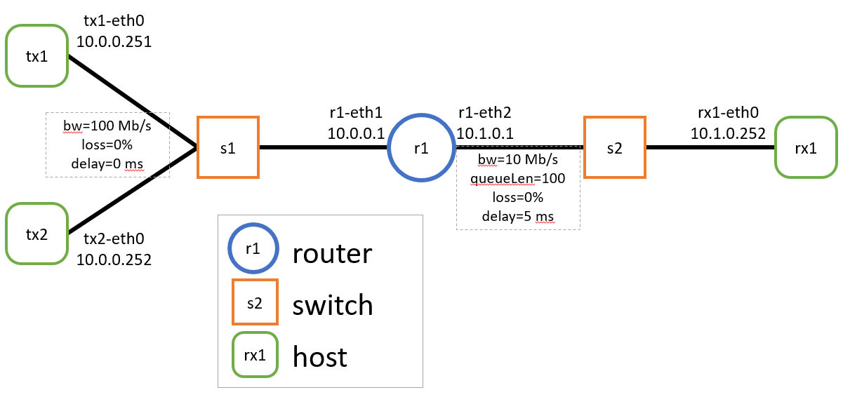
- Start mininet with the custom topology.
$ sudo python linuxrouter-bottleneck.py
- In the mininet shell, run the ‘net’ command and paste the output here. (1pt)
- List all the nodes in this topology, and the number of links each one has.
For example: “rx1, 1 link”. (1pt)
hosts | routers | switches
- In the mininet shell, run the command ‘iperf tx1 tx2’. Paste the output here. (1pt)
- In this topology, considering a flow between tx1 and rx1, which link is the bottleneck link? (1pt)
- Exit the Mininet shell:
mininet> exit

1 Create the network load/throughput plot (12 pts)
The network load/throughput plot has been mentioned in almost every lecture so far. It must be important.
We will use the DITG traffic generator for this exercise. It is nice because it will measure both throughput and latency, and all of the associated metrics. It also produces nice organized log files on both sides with a single command. It also can send UDP streams with exponentially distributed random inter-packet times, which is good for this experiment.
The arguments we give to ITGSend are:
-E <packet send rate (pkt/s)>
-c <packet size (byte)>
-t <runtime (ms)>
-l <sender-side logfile>
-x <receiver-side logfile>

- Start mininet with the custom network topology.
$ sudo python linuxrouter-bottleneck.py

- In the mininet terminal run:
mininet> rx1 ITGRecv &

mininet> tx1 ITGSend -T UDP -E 100 -c 1400 -t 10000 -l E100-tx.log -x E100-rx.log -a rx1

- Repeat this for rate parameters (-E) of your choice ranging from 100 to 5000 packets/second. Be careful not to overwrite your own datafiles.

- Then process receive-side log file:
mininet> tx1 ITGDec E100-rx.log

- Create a data file or spreadsheet with your results, recording at least these columns. You do not need to copy your data into this document. This is just an example.
tx pkt rate (pkt/s) | tx pkt rate (Kbit/s) | rx average packet rate | rx average bit rate | average delay (ms) | std dev delay (ms) | packet loss rate
100 | 1120
… | …
5000 | 56000

- There is no need to restart ITGRecv between experiments. When you are finished, you can kill it with:
mininet> rx1 killall ITGRecv

- Plot both receive rate (throughput, y-axis) vs transmit rate (network load, x-axis), and delay vs transmit rate. You can use either pks/s or Kbit/s as the units. For the delay plot, use the standard deviation data to plot error bars. Make sure to label the axes and data series, with the units used. (6pts)
(plot of network load vs throughput)
(plot of network load vs delay)

Questions:

- At what network load (transmit rate) do you see the knee in the throughput vs network load plot? If you do not see a knee, why not? (1pt)
- At what network load (transmit rate) do you see the cliff in the throughput vs network load plot? If you do not see a cliff, why not? (1pt)
- At what network load does the average delay start to increase? (1pt)
- At what network load do you first observe packet drops? (1pt)
- At what network load does the packet drop rate first exceed 20%? (1pt)
- At what network load does the packet drop rate first exceed 50%? (1pt)

2 Loss-based vs delay-based congestion control: buffering and delay (20 pts)
We will run a TCP flow over the bottleneck link and record the buffer usage at the bottleneck router as well as the round-trip-times. We will use iperf3 to generate traffic for this experiment because it allows us to set the TCP flow control algorithm on the command line. We will use ping to measure round-trip latency.

- Start mininet with the custom topology.
$ sudo python linuxrouter-bottleneck.py
- Start an iperf3 receiver on rx1.
mininet> iperf3 -s -i 1 &
- We will record the queue size at the bottleneck router, r1. We have a python script to do that. It will write its output to a file called "qlen.txt".
mininet> r1 python monitor_tcq.py &
- We will record RTTs by sending pings from tx1 to rx1. With the "-D" option we can add epoch timestamps to each line. We pipe the output to a file and put it in the background.
mininet> tx1 ping -i 0.1 -c 100 -D rx1 > pings-reno.log &
- Run iperf for 60 seconds with Reno congestion control.
mininet> tx1 iperf3 -C reno -c rx1 -t 60 -i 1
- Finally kill the ping and queue monitor processes, and rename the queue length data file.
mininet> tx1 killall ping
mininet> exit

$ mv qlen.txt qlen-reno.txt
- Plot the ping RTTs and queue lengths vs time. You will probably have to do some processing of the ping file. You can use a script, or open it in an editor and use find/replace to eliminate some of the garbage around the values you want. In order to make sure that the two plots line up, use the epoch time values. (6 pts)
- optional: you can pick a reference time and subtract it from all the other epoch time values to make the time values more legible (Note: if you do this, you have to subtract the same reference time from both the ping and queue length time values).
- optional: if you like, you can plot both data series on the same axes. Then you would only need to paste one plot below.
(plot of queue length vs time)
(plot of ping RTT vs time)
- Based on the plots, how does queue length relate to RTT? Are they independent or correlated? If they are correlated, does one lag behind the other? (2 pts)
- You should see the queue length rise and fall during the experiment. What causes the queue length to drop? (2 pts)
- Do the same experiment with Vegas congestion control.
$ sudo python linuxrouter-bottleneck.py

mininet> r1 python monitor_tcq.py &
mininet> tx1 ping -i 0.1 -c 100 -D rx1 > pings-reno.log &
mininet> tx1 iperf3 -C vegas -c rx1 -t 60 -i 1
// wait for it to finish

mininet> tx1 killall ping
mininet> exit

$ mv qlen.txt qlen-vegas.txt
- Plot the result. (6 pts)
(plot of queue length vs time)
(plot of ping RTT vs time)
- What can you say about how Vegas fills the queue vs how Reno fills the queue? What about the RTT under both congestion control algorithms. (2 pts)
- Do you see any large spikes in the queue length in the Vegas experiment? What causes it/them? (2 pts)

3 Loss-based vs delay-based congestion control: fairness (24 pts)
Here we will use iperf3 to send two competing TCP flows with different congestion control algorithms. Iperf3 will output the total data transferred by each flow (or the mean throughput). It also outputs the cwnd at fixed intervals. We will compare the fairness of Reno vs Vegas, and then plot the cwnd data for both. Then we will compare CUBIC vs BBR congestion control.

- Start mininet with the custom topology.
sudo python linuxrouter-bottleneck.py
- Start two instances of the iperf3 server on rx1. Each iperf3 process can only accept one client connection at a time, so we need two instances to handle the two competing flows. They will listen on ports 5001 (default) and 5002.
mininet> rx1 iperf3 -s -i 1 -p 5002& iperf3 -s -i 1 &
- Run two iperf3 clients simultaneously with different congestion control on tx1. Pipe the output of each command to an appropriate file. (Note: this entire command must be typed in on the same line. The "\" does not work in the mininet shell.)
mininet> tx1 iperf3 -C reno -c rx1 -i 0.1 -p 5002 > data/vs-reno.log & iperf3 -C vegas -c rx1 -i 0.1 > data/vs-vegas.log
- Look at the final lines of the resulting data files. What are the mean bitrates, measured at the sender and receiver, of the two flows over the entire period?
 | Reno | Vegas
sender bitrate (Mb/s)
receiver bitrate (Mb/s)
- Is the allocation of bandwidth between the two flows fair? (1pt)
- The running bitrate reported by iperf3 is nonsense for these small intervals, but it does report the cwnd (the final column of the data file), which is an accurate measure of the current send rate. Plot the cwnd of Reno and Vegas (from the log files you just created) on the same axes. (4 pts)
(plot of cwnd vs time for Reno and Vegas)
- Can you identify any slow-start, timeout, additive increase, multiplicative decrease periods for Reno? Give a time when each one occurs (at most one instance of each). If you see none, write "N/A" or something. (4 pts)
slow start | timeout | additive increase | multiplicative decrease
- Can you identify any time periods where the Vegas cwnd is increasing, decreasing, or constant? Give a time when each occurs. If you see none, write "N/A". (3 pts)
increase | decrease | constant
- It turns out that a buffer of 100 packets for a bit rate of 10 Mb/s and RTT of 10 ms (5 ms in each direction) is drastically oversized. What is the bandwidth-delay product in units of bytes, and units of 1500-byte packets? (2 pts)
BDP in bytes | BDP in packets
- Exit the mininet shell and edit the mininet python script, changing the buffer size to 10 packets. The max_queue_size parameter on line 32 is highlighted in the screenshot below. Then start mininet again with the edited custom topology.
mininet> exit
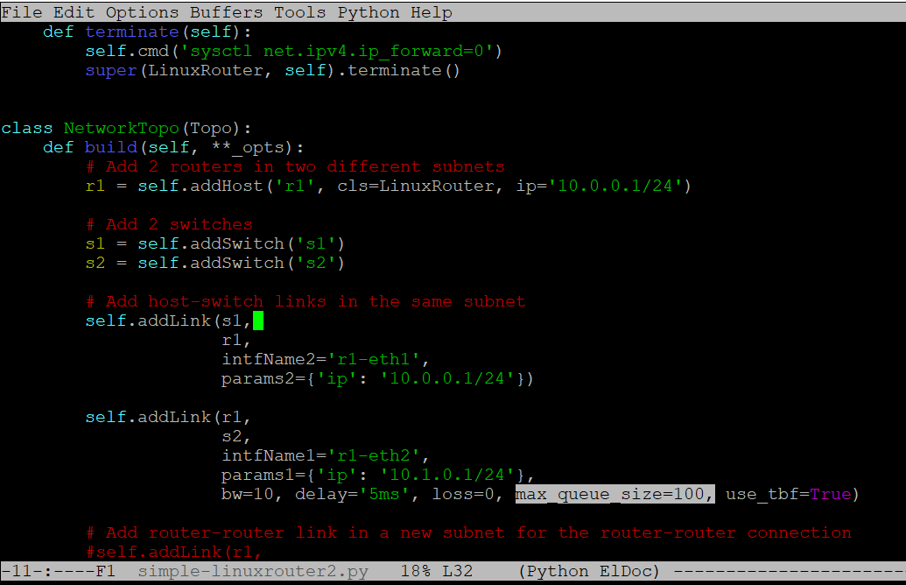
$ sudo python linuxrouter-bottleneck.py
- Run the same experiment with the smaller buffer, saving the results.
mininet> rx1 iperf3 -s -i 1 -p 5002 & iperf3 -s -i 1 &
mininet> tx1 iperf3 -C reno -c rx1 -i 0.1 -p 5002 > data/vs-reno-q10.log & iperf3 -C vegas -c rx1 -i 0.1 > data/vs-vegas-q10.log
- What average bitrates do you observe this time? (2 pts)
 | Reno | Vegas
sender bitrate (Mb/s)
receiver bitrate (Mb/s)

- Plot the cwnd data for the second Reno and Vegas experiments. (4 pts)
(plot of cwnd vs time for Reno and Vegas)
- Do the same experiment with CUBIC vs BBR (keeping max_queue_size=10). What average bitrates do you observe? (2 pts)
 | CUBIC | BBR
sender bitrate (Mb/s)
receiver bitrate (Mb/s)

4 MPTCP (20 pts)
This part of the exercise requires opening a pcap file in Wireshark, and answering some question about the MPTCP traffic it contains. The answers to this part will be entered directly into Ilias.

- (10 pts) Download lab2_mptcp.pcapng from StudIP. This file contains MPTCP traffic that was exchanged among two hosts.
Find out where in the headers the Data Sequence Number and the Subflow Sequence Number can be retrieved from and fill out the table.
Note down the Data Sequence Number and Subflow Sequence Number of packets 127, 129, 131.
- (10 pts) Fill out the following gap text.
The packets __________ and __________ belong to the same subflow. You can see this because their __________-Address and __________ are the same. Apart from this you can see this by the __________ sequence number because the distance between them is the packet __________.

