A study on personality patterns of software engineers
[Do not enter author information until after the paper is accepted.]
Name of the First Author* | Affiliation, City, Country | Email@Address
If there are additional authors, put names in separate rows | Affiliation, City, Country | email
* Corresponding author

Abstract [If a topic is not applicable, enter NA in the row]
Aim/Purpose | The study wanted to find patterns for professional software engineers, especially the Iranian ones to find out which personality trends were more and less common among them.
Background | [NA]
Methodology | This research not only used the big five and MBTI test simultaneously to indicate personality trends in Iranian software engineers who work professionally in this field but also used IBM SPSS software to calculate the t-test for results from this questionary and previous work to find significantly meaningful differences.
Contribution | This study wanted to fill the gap and comparison of cultural difference impact on personality tests by finding the personality patterns in Iranian software engineers. Also, global researches were mentioned and analyzed to find a more general pattern.
Findings | Analyzing previous MBTI works showed T, N, ISTJ, INTJ, ESTJ, and ENTJ are more and ISFJ, ISFP, ESFP, ENFP, ESFJ, and SJ are less common than the norm among software engineers. Based on this research, which had 102 participants from Iranian professional computer engineers, we found in MBTI, patterns were approximately the same as international ones with some differences. The MBTI patterns for Iranians were more ISTJ, I, T, SJ, and SP whereas INFP, ENFP, ESFJ, E, F, and NF are less than Iran norms. Additionally, The result of our big five test with two previous works led us to contemplate that openness to experience was higher, conscientiousness was lower, and neuroticism and agreeableness were equal to the norm.
Recommendations  for Practitioners | [NA]
Recommendations  for Researchers | These kinds of researches must conduct more on people whose occupation is in that field rather than the students who only study at a university. Also, for achieving better and more generalized results bigger sample with more Females and people who works in different roles is needed and those specified patterns can be lessen learning.
Impact on Society | Finding personality and sub-personality which effects success and being a well-performance software engineer is really important for people who want to employ great employees, choose this career, or develop correct features to become better engineers. With this research, that trend can be seen from different aspects to fulfill the needs.
Future Research | Self-reporting questionnaires have many problems. For example, people who involve in them may become bored or intentionally or unintentionally answer them incorrectly. For our future work, we want to solve this problem using computer technics to replace those questionaries in order to find personalities and make suggestions for personal improvement based on that. Besides that, for software engineers, we are going to research high-level characteristics that can be inferred from their personalities with a special focus on Iran.
Keywords | Personality pattern, Software engineer, Job Selection, Employment, Personality traits, Big five, MBTI

Introduction
One of the Questions Somebody asks themselves can be what is My personality type Matches with which kinds of occupations, or if I can be successful with my career or not. For employees, on the one hand, it is vital to find a faster but still more accurate selection manner to find the most suitable candidate to hire. On the other hand, it can be significantly expensive for them not selecting a person who can be improved in a short time by investment. Furthermore, in case of people who chose software engineering as their career might think about which personality features, they should develop to become a better workers.
According to Passmore and Netlibrary (2008), the Myers-Briggs Type Indicator (MBTI) suggests that personality type is something that was determined at born, but it still can be affected by learning and environment. Moreover, Isabel Briggs Myers (2003) indicated, MBTI personality is just unaware preferences so if somebody finds out a trait is not satisfying, they can change it through practice and self-awareness. Furthermore, age and experiences affect the way somebody represents a trait.
One of strait forward approach to answering these questions are psychological personality tests which offer what personalities are better for a job; however, it is not accurate to say one type is suitable for a position because that personality may be dominated Although it does not completely guarantee other types do not have good performance or do some parts better than default one.
Software engineering has many roles and each one has different requirements however researchers did not pay enough attention to it (Cruz et al., 2015), especially in working places.
In this research we tried to investigate:
- Finding out which personality types and factors are common among people working in the software field.
- Studying software engineers' Personality Types in Iran because personality traits Can be affected by many things. For example, every culture may have different dominant traits which can affect the test and its results (Isabel Briggs Myers (2003) and Cavallera et al. (2013)).
- Based on Falk and Hermle (2018) and Russo and Stol (2020), We can indicate that gender difference analysis was not mentioned in some studies which can change the result.
- Other research did not often have MBTI and Big five beside each other. In this paper, we tend to interview with standard questions that consist of both personality type tests.
- Modern cultures accept and grow up with different patterns of behavioral preference rather than the past, for example, being an Extrovert is more acceptable and can be seen in today's society so updating the patterns and seeing differences through time can be lesson learning.
- previous studies often select the sample from university students and not professionals which may lead to a less accurate result.

Literature review
In this section, we tried to show the normal personality score of the world, a country selected as a base, and other studies were compared with it, and Iran in order to see if differences exist in people who work in the software field or not. Then, we represented some of the studies which used the MBTI test. Also, at the end of this section, we show some Big 5 results too.

MBTI
It can be deduced from Isabel Briggs Myers and Myers (1995) and Jung and Herbert Edward Read (1974) that MBTI is a test that was originally related to the framework which is invented and introduced by Carl Jung. Jung's test was expanded by Myers-Briggs by adding J-P's pair This personality test, which name is MBTI, consists of 4-digit E-I, S-N, T-F, and J-P and with the cartesian product of them we rich to sixteen personality groups. These eight digits represent E as Extraversion, I as Introversion, S as Sensing, N as Intuition, T as Thinking, F as Feeling, J as Judging, and P as Perceiving. Also, it speaks about the preference of the people when they face a decision.
MBTI can be interpreted in many ways for example each letter can describe part of personality. In another view, being one of the sixteen personalities can be used. Moreover, another concept named Keirsey Temperament Sorter (KTS) exists which is closely related to MBTI. It says four temperaments exist - Guardians (XSXJ) who are Logistical, Artisan (XSXP) who are Tactical, Idealist (XNFX) who are Diplomatic, and Rational (XNTX) who are Strategic. KTS also can be divided into eight sub-partitions that are called roles according to Keirsey (1998).
On behalf of world MBTI, we used the US MBTI norm based on Lawrence and Martin (2001) and Capretz (2002) works. The US norms were used because most of the following researches we want to mention were from that country or countries which have a common culture. This data which includes common range percent and specific percentages for personalities can be seen in Table 1 and Table 2.
Table 1. US MBTI sixteen personality
TYPE | COMMON RANGE PERCENT | SPECIFIC PERCENT
ISTJ | 11-14 | 11.6
ISFJ | 9-14 | 13.8
INFJ | 1-3 | 1.5
INTJ | 2-4 | 2.1
ISTP | 4-6 | 5.4
ISFP | 5-9 | 8.8
INFP | 4-5 | 4.4
INTP | 3-5 | 3.3
ESTP | 4-5 | 4.3
ESFP | 4-9 | 8.5
ENFP | 6-8 | 8.1
ENTP | 2-5 | 3.2
ESTJ | 8-12 | 8.7
ESFJ | 9-13 | 12.3
ENFJ | 2-5 | 2.5
ENTJ | 2-5 | 1.8

Table 2. US MBTI eight letter's personalities
TYPES | COMMON RANGE PERCENT | SPECIFIC PERCENT
E | 45-53 | 49.3
I | 47-55 | 50.7
S | 66-74 | 73.3
N | 26-34 | 26.7
T | 40-50 | 40.2
F | 50-60 | 59.8
J | 54-60 | 54.1
P | 40-46 | 45.9

For the next step, we represented the MBTI of Iranian people in Table 3 and Table 4. This data is collected over three years and 62,519 Iranian People were Involved and it was based on data gathered by an online questionary (Iran Personality Profile | Country Personality Profiles | 16Personalities, n.d.). These tables show Iranians are more Extroverted and Intuitive than the world.

Table 3. Iran MBTI sixteen personality
TYPE | SPECIFIC PERCENT
ISTJ | 5.13
ISFJ | 4.8
INFJ | 5.29
INTJ | 6.49
ISTP | 2.74
ISFP | 3.88
INFP | 8.28
INTP | 8.38
ESTP | 3.84
ESFP | 4.78
ENFP | 9.25
ENTP | 7.22
ESTJ | 8.24
ESFJ | 8.65
ENFJ | 6.42
ENTJ | 6.56

Table 4. Iran MBTI eight letter's personalities
TYPES | SPECIFIC PERCENT
E | 52.8
I | 47.2
S | 46.47
N | 53.53
T | 51.03
F | 48.97
J | 51.43
P | 48.57

The big five
Another Personality test is the big five. this test has five letters O-C-E-A-N which represent openness to experience, conscientiousness, extraversion, agreeableness, and neuroticism. Also, each of these five categories are divided into six sub-categories.
Different formats of testing are available for the big five with a variable number of items and the results of these exams differ from each other as Roccas et al. (2002) mentioned. One of these tests is called NEO-FFI. According to A. Buie (1988), in Table V, British results can be seen and it was used as our base result for the world. Also, in Table VI, a similar thing was shown for ordinary people of Iran adopted from Manoochehr Azkhosh and Ali Asgari (2014).

Table 5. British NEO-FFI average mean results
GENDER | O | C | E | A | N
Male | 26.02 | 32.09 | 26.83 | 29.25 | 19.04
Female | 28.6 | 31.9 | 28.3 | 31.5 | 21.36
All | 26.5 | 32.1 | 27.1 | 32.1 | 19.5

Table 6. Iran NEO-FFI average mean results
GENDER | O | C | E | A | N
Male | 33.02 | 39.1 | 36.3 | 34.1 | 26.4
Female | 34.0 | 39.7 | 35.3 | 34.7 | 28.0

Studies that use MBTI as their methodology
Many studies used MBTI With different settings and numbers of items. Some of them divided software engineering into different roles but often, they did not consider the level of those people, which may lead them to different results. In table 7, personality percentages were shown separated by roles. Moreover, In Table 8, we inferred other factors, but inconsistency can be seen in total percentages for some of the studies due to rounding operations that they made.
For this study, we only review studies that were published after 1975 and have forty-five participants or more. One of our main factors in choosing was that the sample had a role or some real work experience. Also, it has been tried to avoid pure student, educational studies, and studies that do not have roles as much as possible. Studies with only students are not practical for us because many of these students not working in that field in the future or might not be keen on that field.

Table 7. Studies using MBTI as their Methodology
STUDY | ROLE | ISTJ | ISFJ | INFJ | INTJ | ISTP | ISFP | INFP | INTP | ESTP | ESFP | ENFP | ENTP | ESTJ | ESFJ | ENFJ | ENTJ | COUNT
Capretz  et al.  (2015) | Software engineer | 10 | 7 | 1 | 6 | 5 | 2 | 1 | 5 | 15 | 6 | 3 | 2 | 25 | 2 | 3 | 7 | 100
A. Schaubhut and C. Thompson (2008) | Software engineer | 17.3 | 3.6 | 2.2 | 9 | 8.1 | 1.6 | 3.9 | 11.5 | 4.7 | 2 | 3.8 | 9.7 | 12.7 | 2.1 | 2 | 6 | 1326
 | System analysts | 17.7 | 4.8 | 2 | 6.7 | 5.7 | 3 | 4.3 | 7.1 | 5.6 | 2.3 | 4.8 | 7.1 | 14.1 | 4.7 | 2.2 | 7.9 | 2493
 | Developer | 19.4 | 5 | 2.6 | 7.6 | 9.1 | 3.3 | 5.4 | 9.1 | 5 | 2.1 | 4.4 | 5.4 | 4.5 | 4.5 | 1.3 | 5.9 | 1719
Choi et al. (2008) | Developer | 21.1 | 5.5 | 0.8 | 3.9 | 3.1 | 6.3 | 7 | 7 | 5.5 | 5.5 | 5.5 | 3.1 | 14.8 | 5.5 | 2.3 | 3.1 | 128
Capretz (2002) | Software engineer | 19.5 | 3.3 | 3 | 10.1 | 8.2 | 2.9 | 4.3 | 9.9 | 5.4 | 2.4 | 3.6 | 6.8 | 10.9 | 2.5 | 2.3 | 5 | 1252
Barnes (1975) | Developer | 10.16 | 5.08 | 6.77 | 6.77 | 8.47 | 6.77 | 6.77 | 10.16 | 0 | 3.39 | 3.39 | 6.77 | 8.47 | 3.39 | 6.77 | 5.77 | 59
A. Buie (1988) | Scientific Computer Professionals | 19.2 | 4.3 | 8.5 | 12.8 | 8.5 | 0.0 | 6.4 | 14.9 | 2.1 | 6.4 | 4.3 | 0.0 | 6.4 | 0.0 | 2.1 | 4.3 | 47

Table 8. Studies using MBTI as their Methodology continue
STUDY | ROLE | E | I | S | N | T | F | J | P | SJ | SP | NT | NF | COUNTRY | COUNT
Capretz  et al.  (2015) | Software engineer | 63 | 37 | 72 | 28 | 75 | 25 | 61 | 39 | 44 | 28 | 20 | 8 | Cuba | 100
A. Schaubhut and C. Thompson (2008) | Software engineer | 42.8 | 57.2 | 52 | 48 | 78.9 | 21.1 | 54.8 | 45.2 | 35.7 | 16.4 | 24.6 | 23.5 | Multicultural | 1326
 | System analysts | 48.7 | 51.3 | 57.9 | 42.1 | 71.9 | 28.1 | 60.1 | 39.9 | 41.3 | 17.6 | 20.3 | 21.8 |  | 2493
 | Developer | 38.5 | 61.5 | 58.3 | 41.7 | 71.4 | 28.6 | 56.2 | 43.8 | 33.4 | 19.5 | 19.7 | 22 |  | 1719
Choi et al. (2008) | Developer | 45.3 | 54.7 | 67.3 | 32.7 | 60.8 | 39.2 | 57 | 43 | 46.9 | 20.4 | 16.3 | 16.4 | USA | 128
Capretz (2002) | Software engineer | 38.9 | 61.2 | 55.1 | 45 | 67.5 | 32.6 | 56.6 | 43.5 | 36.2 | 18.9 | 23.3 | 21.5 | Canada | 1252
Barnes (1975) | Developer | 38 | 61 | 45.73 | 53.17 | 54.18 | 44.72 | 45.72 | 53.18 | 27.1 | 18.63 | 27.08 | 26.09 | USA | 59
A. Buie (1988) | Scientific Computer Professionals | 25.6 | 74.6 | 46.9 | 53.3 | 68.2 | 32 | 57.6 | 42.6 | 29.9 | 17 | 53.3 | 21.3 | USA | 47

Studies that use the big 5 as their methodology
Some studies also used the big 5 to find personality patterns for software engineers however the number of these studies was less than MBTI because of difficulty and unpopularity among nonprofessional who works in this field. Additionally, according to Cruz et al. (2015), most of these kinds of researches were directed by software engineers themselves. Furthermore, it is less Interpretable than MBTI results for many people because the results were not in one format. In contrast, MBTI results have 4 letters to describe personality makes it faster to understand. Whereas many criticisms existed against MBTI's weaknesses and being unscientific as Gardner and Martinko (1996), Stein and Swan (2019), Randall et al. (2017, pp. 1–27), Schweiger (1985), and Pittenger (2005) mentioned, many researchers still prefer to use it. Although studies (Furnham, 1996 and 2022) showed some relation and mapping between the big five and MBTI, the big five is thought to be more accurate and prescribable demonstrated by Khan et al. (2005), Jeronimus et al. (2016), Widiger and Costa (2002), Clark (2007), and Mullins-Sweatt et al. (2006, pp. 39–70). Some of these studies can be seen in Table 9.

Table 9. Studies using big 5 as their Methodology
STUDY | ROLE | Test format | Country | O | C | E | A | N | COUNT
Acuña  et al.  (2009) | Developer (student) | NEO-FFI | Spain | Min= 19  Max= 40  Sd= 4.44  Mean= 29.43 | Min= 22  Max= 39  Sd= 4.42  Mean = 29.76 | Min= 24  Max= 42  Sd= 4.49  Mean = 32.38 | Min= 18  Max= 33  Sd= 3.72  Mean = 27.97 | Min= 9  Max= 26  Sd= 4.42  Mean = 18.11 | 105
Martínez et al. (2010) | Analyst (student) | Big 5 | Mexico | Sd=11.644  Mean= 50.615 | Sd= 9.502  Mean= 63.143 | Sd= 19.394  Mean= 51.571 | Sd= 12.688  Mean= 45.846 | Sd=11.472  Mean= 64.286 | 13
 | Architect (student) |  |  | Sd= 8.735  Mean= 54.154 | Sd=10.910  Mean= 67.231 | Sd= 16.317  Mean= 57.308 | Sd= 10.846  Mean= 52.154 | Sd= 7.978  Mean= 64.154 | 13
 | Developer (student) |  |  | Sd= 16.439  Mean= 51.667 | Sd= 10.429  Mean= 52.778 | Sd= 12.718  Mean= 44.111 | Sd= 11.737  Mean= 54.471 | Sd= 11.944  Mean= 59.222 | 17
 | Documenter (student) |  |  | Sd= 11.602  Mean= 55 | Sd= 8.361  Mean= 61.286 | Sd= 13.035  Mean= 51.929 | Sd= 8.302  Mean= 52 | Sd= 8.179  Mean= 58.857 | 14
 | Tester (student) |  |  | Sd= 15.066  Mean= 51.714 | Sd= 10.596  Mean= 66.133 | Sd= 20.340  Mean= 56 | Sd= 12.538  Mean= 47.857 | Sd= 16.189  Mean= 63.333 | 14
 | Presenter (student) |  |  | Sd= 15.279  Mean= 52.222 | Sd= 15.136  Mean= 60.889 | Sd= 12.534  Mean= 46.889 | Sd= 14.507  Mean= 55.778 | Sd= 9.871  Mean= 65.778 | 9
 | All (Software engineer) (student) |  |  | Mean= 52.625 | Mean= 61.125 | Mean= 50.513 | Mean= 51.250 | Mean= 62.525 | 80
Bell et al. (2010) | Software engineer (student) | NEO-FFI | UK | Min=31  Max=38 | Min=24  Max=30 | Min=25  Max=31 | Min=30  Max=36 | Min=15  Max= 23 | 128
Heiberg et al. (2003) | Software engineer (student) | NEO-PI | Estonia | Mean=113 | Mean=107 | Mean= 110 | Mean=112 | Mean=83 | 20
 |  |  |  | Mean=116 | Mean=96 | Mean=106 | Mean=112 | Mean=87 | 8
 |  |  |  | Mean=122 | Mean=104 | Mean=113 | Mean=123 | Mean=85 | 13
 |  |  |  | Mean=111 | Mean=107 | Mean= 109 | Mean=112 | Mean=83 | 82
Kanij et al. (2015) | Tester | IPIP | Multicultural | Sd=5.21  Mean= 37.54 | Sd= 6.03  Mean= 38.37 | Sd=7.62  Mean=32.91 | Sd= 5.53  Mean=38.51 | Sd= 6.98  Mean=25.07 | 82
 | Software engineer  (Exclude tester) |  |  | Sd=5.43  Mean=37.32 | Sd=5.79  Mean=36.19 | Sd=7.24  Mean=31.51 | Sd=5.21  Mean=37.55 | Sd= 7.3  Mean=25.71 | 100
 | Software engineer |  |  | Sd= 5.32  Mean= 37.42 | Sd= 5.98  Mean= 37.17 | Sd= 7.43  Mean= 32.14 | Sd= 5.36  Mean= 37.98 | Sd= 7.15  Mean= 25.42 | 182
Mendes et al. (2021) | Software engineer | IPIP-NEO | Brazil | Min= 54.00  Max= 104.00  Sd= 10.12  Mean = 81.00  Median= 81 | Min= 59.00  Max= 112.00  Sd= 11.28  Mean = 92.92  Median= 93 | Min= 46.00  Max= 96.00  Sd= 10.64  Mean = 76.11  Median= 78 | Min= 48.00  Max= 111.00  Sd= 10.89  Mean = 89.51  Median= 92 | Min= 36.00  Max= 93.00  Sd= 13.28  Mean = 65.90  Median= 67 | 63

Methodology
In our research, we tried not only to analyze other research, which can be seen in previous sections, but also we held a case study on Iranian software engineers. For case study purposes, a test was designed in Google form that includes twelve personal, eighty-eight standard MBTI, and sixty-item NEO-FFI questions in Persian. All of our participants were professionals who work in real companies in the private and public sectors in Iran. These Software engineers belonged to Golrang System, Iran Khodro (Sapco, Iseikco, Iran Khodro Diesel, Samand Trabar, Samand Raill), and some individuals from other companies. This test was sent to people and after answering and filtering corrupted random answers, we reached 102 responses. The personal questions were:
• What is your last educational certificate in the computer field?
• Are you change your field during your study? (From or to computer field)
• Which role do you have in the company?
• How many years do you work professionally in this field?
• What is your current company name?
• How much do you like the computer field?
• How much do you satisfy with your career in the computer field?
• What is your strength level in the computer role you work? (Final results were combined of expert and their self-choice)
After showing the result of our case study in the next section, the results of other study and our study was compared with bases via IBM SPSS software one sample t-test to see if the differences were significant or not, and the analysis part was limited to the MBTI test however the big 5 results were shown.

A case study in Iran

Demographic
At first, the sample demographics were illustrated from different views in order to get more familiarity with our data. To reach that cause, Table 10 showed the educational degree of people divided by their gender.

Table 10. Computer degree and gender population
GENDER | PHD | MASTER | BACHELOR | ASSOCIATE | DIPLOMA | NO | TOTAL
Male | 3 | 26 | 40 | 2 | 0 | 6 | 77
Female | 1 | 12 | 9 | 1 | 1 | 1 | 25
Total | 4 | 38 | 49 | 3 | 1 | 7 | 102

Also, years of work and their role can be seen in Table 11 (Some people can work in multiple roles so their sum was more than 102).
Table 11. Years of work based on roles
ROLE | <=3 | >3 AND  <=10 | >10  AND  <=30 | TOTAL
Developer | 12 | 36 | 24 | 72
Analyzer | 1 | 9 | 7 | 17
Tester | 2 | 4 | 0 | 6
Support | 3 | 6 | 1 | 10
Network/  Security/  Hardware | 1 | 11 | 5 | 17
Computer engineer  (Total) | 19 | 66 | 37 | 122

In addition, with self-reporting combined with expert tags we know seventeen people were weak, forty-nine people were average, and thirty-six people were strong. Moreover, based on their answers four people were low, frothy-seven were moderate, and fifty-one were highly satisfied.

MBTI test
In Table 12 and Table 13, percentages of MBTI personalities were exposed for all groups which were more than twenty-five(except the weak group) that were include computer engineer (all roles), software engineer (all roles except network and security, and hardware), and developers. Additionally, based on level of strength the personality percentages were shown (the percent of weak people was low and may be different when the participants are more than now big scenarios). Also, M represents Male, F represents Female, and M/F all people in these tables.

Table 12. MBTI results
ROLE/ STRENGTH | ISTJ | ISFJ | INFJ | INTJ | ISTP | ISFP | INFP | INTP | ESTP | ESFP | ENFP | ENTP | ESTJ | ESFJ | ENFJ | ENTJ | COUNT
Computer engineer | 19.61 | 2.94 | 3.92 | 14.70 | 7.84 | 2.94 | 2.94 | 14.70 | 3.92 | 1.96 | 0.98 | 3.92 | 11.76 | 0.98 | 0 | 6.86 | 102
 | 19.48 | 2.6 | 1.3 | 12.99 | 7.79 | 2.6 | 0 | 14.29 | 5.19 | 2.6 | 1.3 | 5.2 | 14.29 | 1.3 | 0 | 9.09 | 77
 | 20 | 4 | 12 | 20 | 8 | 4 | 12 | 16 | 0 | 0 | 0 | 0 | 4 | 0 | 0 | 0 | 25
Software engineer | 19.78 | 3.3 | 3.3 | 13.19 | 7.69 | 3.3 | 3.3 | 14.29 | 4.4 | 2.2 | 1.1 | 4.4 | 13.19 | 0 | 0 | 6.6 | 91
Developer | 20.83 | 2.78 | 4.17 | 12.5 | 8.33 | 4.17 | 0 | 13.89 | 5.56 | 2.78 | 1.39 | 4.17 | 15.28 | 0 | 0 | 4.17 | 72
Strong | 13.89 | 5.56 | 2.78 | 16.67 | 2.78 | 2.78 | 0 | 19.44 | 5.56 | 0 | 0 | 2.78 | 19.44 | 0 | 0 | 8.33 | 36
Average | 20.41 | 2.04 | 6.12 | 14.28 | 10.20 | 4.08 | 4.08 | 12.24 | 2.04 | 0 | 2.04 | 6.12 | 8.16 | 2.04 | 0 | 6.12 | 49
Weak | 29.41 | 0 | 0 | 11.76 | 11.76 | 0 | 5.88 | 11.76 | 5.88 | 11.76 | 0 | 0 | 5.88 | 0 | 0 | 5.88 | 17

Table 13. MBTI results continue
ROLE/ STRENGTH | E | I | S | N | T | F | J | P | SJ | SP | NT | NF | GENDER | COUNT
Computer engineer | 30.39 | 69.61 | 51.96 | 48.04 | 83.33 | 16.67 | 60.78 | 39.22 | 41.18 | 28.43 | 40.2 | 7.84 | M/F | 102
 | 38.96 | 61.04 | 55.84 | 44.16 | 88.31 | 11.69 | 61.04 | 38.96 | 36.36 | 24.68 | 41.56 | 2.6 | M | 77
 | 4 | 96 | 40 | 60 | 68 | 32 | 60 | 40 | 56 | 40 | 36 | 24 | F | 25
Software engineer | 31.87 | 68.13 | 53.85 | 46.15 | 83.52 | 16.48 | 59.34 | 40.66 | 39.56 | 28.57 | 38.46 | 7.69 | M/F | 91
Developer | 33.33 | 66.67 | 59.72 | 40.28 | 84.72 | 15.28 | 59.72 | 40.28 | 40.28 | 26.39 | 34.72 | 5.56 | M/F | 72
Strong | 36.1 | 63.9 | 50 | 50 | 88.89 | 11.11 | 66.67 | 33.33 | 38.89 | 25 | 47.22 | 2.78 | M/F | 36
Average | 26.53 | 73.47 | 48.98 | 51.02 | 79.6 | 20.41 | 59.18 | 40.82 | 42.86 | 30.61 | 38.78 | 12.24 | M/F | 49
Weak | 29.41 | 70.58 | 64.71 | 35.29 | 82.35 | 17.64 | 52.94 | 47.06 | 41.18 | 29.41 | 29.41 | 5.88 | M/F | 17

The big 5 test
For the next step, the big five results were displayed in table 14. In our study, we used the NEO-FFI with sixty items to examine participants after taking the MBTI test. The numbers that showed for O, C, E, A, and N were the average of their results.

Table 14. The big five average results
ROLE/ STRENGTH | O | C | E | A | N | GENDER | COUNT
Computer engineer | 34.70 | 33.53 | 23.88 | 34.6 | 21.65 | M/F | 102
Analyst (student) | 35.68 | 36.62 | 25.40 | 34.29 | 22.29 | M | 77
Architect (student) | 31.68 | 33.6 | 19.2 | 35.52 | 19.68 | F | 25
Software engineer | 35.08 | 35.21 | 24 | 34.43 | 35.22 | M/F | 91
Developer | 35.33 | 35.33 | 24.67 | 34.83 | 21.83 | M/F | 72
Strong | 36 | 36 | 24.33 | 34.33 | 23.33 | M/F | 36

Result and findings

Analyzing other works which used MBTI
In this part, we tended to extract some roles from previous section tables. As the base personality table, we used US personality, Table 1, and Table 2. however, this was an approximate approach but the trend could be seen roughly. In Fig 1, we had studies of Table 7, which was the personality of software engineers in different roles, and the US average personality in red (the other ones are black because it does not matter, but the order of them can indicate which one belongs to which study). ISTJ was the personality type that had more than the US average in many of these studies with a considerable difference. INFJ, INTJ, ISTP, INTP, ENTP, ESTJ, and ENTJ also were higher than average in most studies. In contrast, ISFJ, ISFP, ESFP, ENFP, and ESFJ were predominantly or completely below average in the way that could be detected obviously.
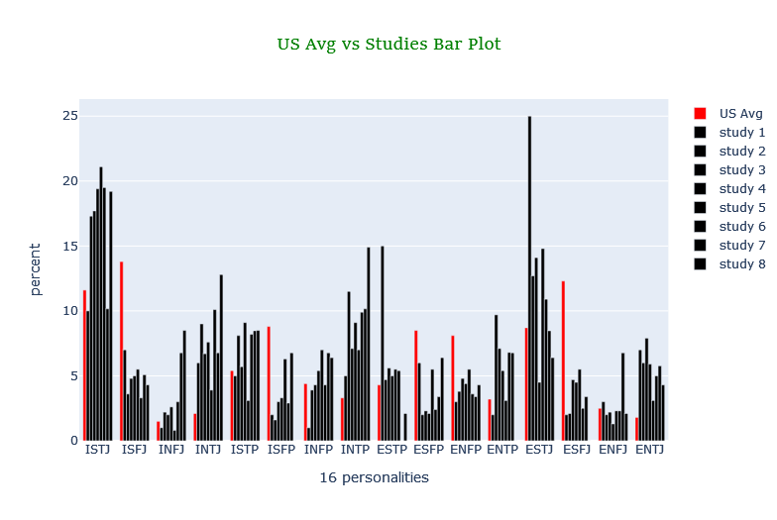
Figure 1. sixteen personality types of Table 7 and US average personality (Table 1)
In Fig 2, we had studies of Table 8, which was personality letters of software engineers in different roles, and the US average personality in red. T and N were higher than average in all of these studies. Also, I and J are higher in most cases. F, S, E, and P were average or below average in most cases.

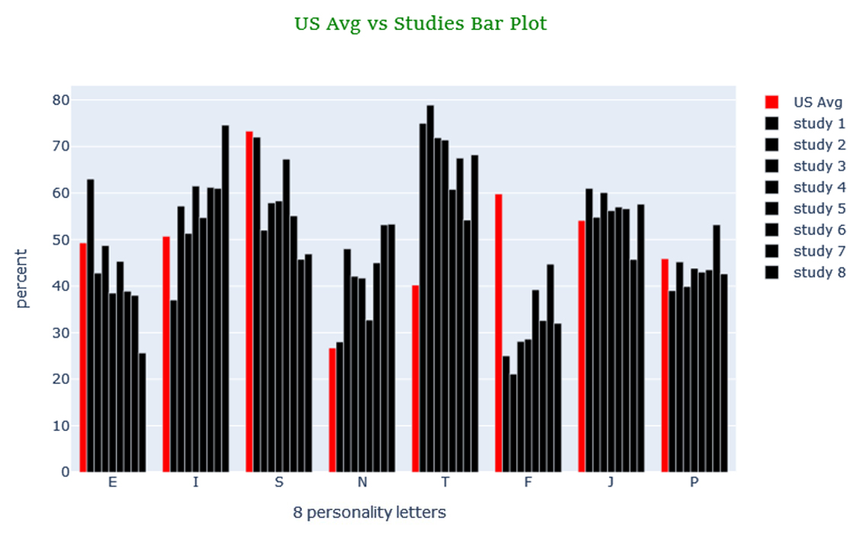
Figure 2. eight personality letters (Table 8) and US average personality (Table 2)

In Fig 3, we had studies of Table 6, which was KTS of software engineers in different roles, and the US average personality in red. NT and NF were higher than average in most of these studies. In contrast, SP and SJ were below average.
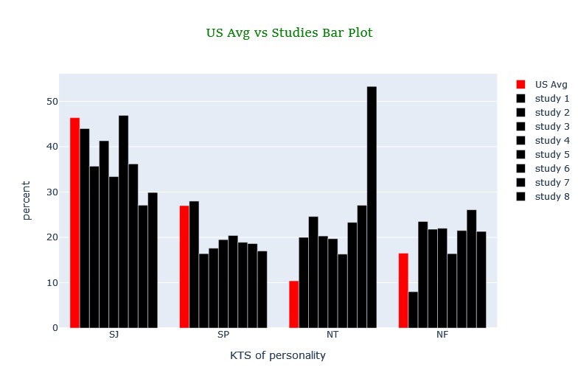
Figure 3. KTS (Table 8) and US average KTS personality (inferred from Table 1)

For being more accurate to see which differences were meaningful we had to see if they were statistically significant or not. We used the one-sample t-test to satisfy this cause and the result was reported in table 15 and table 16.

Table 15. P-value and differences of studies using MBTI as their methodology
STUDY | ROLE | ISTJ | ISFJ | INFJ | INTJ | ISTP | ISFP | INFP | INTP | ESTP | ESFP | ENFP | ENTP | ESTJ | ESFJ | ENFJ | ENTJ | COUNT
Capretz  et al.  (2015) | Software engineer | _ | _ | _ | _ | _ | <0.001  Dif - | <0.001  Dif - | _ | <0.001  Dif + | _ | <0.001  Dif - | _ | <0.001  Dif + | <0.001  Dif - | _ | <0.001  Dif + | 100
A. Schaubhut and C. Thompson (2008) | Software engineer | <0.001  Dif + | <0.001  Dif - | _ | <0.001  Dif + | <0.001  Dif + | <0.001  Dif - | _ | <0.001  Dif + | _ | <0.001  Dif - | <0.001  Dif - | <0.001  Dif + | <0.001  Dif + | <0.001  Dif - | _ | <0.001  Dif + | 1326
 | System analysts | <0.001  Dif + | <0.001  Dif - | _ | <0.001  Dif + | _ | <0.001  Dif - | _ | <0.001  Dif + | =0.004  Dif + | <0.001  Dif - | <0.001  Dif - | <0.001  Dif + | <0.001  Dif + | <0.001  Dif - | _ | <0.001  Dif + | 2493
 | Developer | <0.001  Dif + | <0.001  Dif - | =0.003  Dif + | <0.001  Dif + | <0.001  Dif + | <0.001  Dif - | <0.001  Dif + | _ | _ | <0.001  Dif - | <0.001  Dif - | <0.001  Dif + | <0.001  Dif + | <0.001  Dif - | <0.001  Dif - | <0.001  Dif + | 1719
Choi et al. (2008) | Developer | _ | <0.001  Dif - | _ | _ | _ | _ | _ | _ | _ | _ | _ | _ | _ | <0.001  Dif - | _ | _ | 128
Capretz (2002) | Software engineer | <0.001  Dif + | <0.001  Dif - | =0.002  Dif + | <0.001  Dif + | <0.001  Dif + | <0.001  Dif - | _ | <0.001  Dif + | _ | <0.001  Dif - | <0.001  Dif - | <0.001  Dif + | =0.014  Dif + | <0.001  Dif - | _ | <0.001  Dif + | 1252
Barnes (1975) | Developer | _ | =0.003  Dif - | _ | _ | _ | _ | _ | _ | _ | =0.036  Dif - | _ | _ | _ | <0.001  Dif - | =0.002  Dif + | =0.003  Dif + | 59
A. Buie (1988) | Scientific Computer Professionals | =0.02  Dif + | _ | _ | =0.035  Dif + | _ | _ | _ | =0.032  Dif + | _ | _ | _ | _ | _ | _ | _ | _ | 47

Table 16. P-value and differences of studies using MBTI as their methodology continue
STUDY | ROLE | E | I | S | N | T | F | J | P | SJ | SP | NT | NF | COUNTRY | COUNT
Capretz  et al.  (2015) | Software engineer | _ | _ | _ | _ | <0.001  Dif + | <0.001  Dif - | _ | _ | _ | _ | _ | _ | Cuba | 100
A. Schaubhut and C. Thompson (2008) | Software engineer | <0.001  Dif - | <0.001  Dif + | <0.001  Dif - | <0.001  Dif + | <0.001  Dif + | <0.001  Dif - | _ | _ | <0.001  Dif - | <0.001  Dif - | <0.001  Dif + | <0.001  Dif + | Multicultural | 1326
 | System analysts | _ | _ | <0.001  Dif - | <0.001  Dif + | <0.001  Dif + | <0.001  Dif - | <0.001  Dif - | <0.001  Dif + | <0.001  Dif - | <0.001  Dif - | _ | <0.001  Dif + |  | 2493
 | Developer | <0.001  Dif - | <0.001  Dif + | <0.001  Dif - | <0.001  Dif + | <0.001  Dif + | <0.001  Dif - | _ | _ | <0.001  Dif - | <0.001  Dif - | _ | <0.001  Dif + |  | 1719
Choi et al. (2008) | Developer | _ | _ | _ | _ | <0.001  Dif + | <0.001  Dif - | _ | _ | _ | _ | _ | <0.001  Dif - | USA | 128
Capretz (2002) | Software engineer | <0.001  Dif - | <0.001  Dif + | <0.001  Dif - | <0.001  Dif + | <0.001  Dif + | <0.001  Dif - | _ | _ | <0.001  Dif - | <0.001  Dif - | <0.001  Dif + | <0.001  Dif + | Canada | 1252
Barnes (1975) | Developer | _ | _ | <0.001  Dif - | <0.001  Dif + | =0.036  Dif + | =0.036  Dif - | _ | _ | _ | _ | _ | _ | USA | 59
A. Buie (1988) | Scientific Computer Professionals | <0.001  Dif - | <0.001  Dif + | _ | _ | =0.017  Dif + | =0.017  Dif - | _ | _ | 0.018  Dif - | _ | <0.001  Dif + | =0.032  Dif + | USA | 47

For interpreting Table 15 and Table 16 we used voting, win condition occurs when something has more than fifty percent, and if a column had Dif + and Dif – combined, subtraction would be used. From these results we could find out:
- being T or not being F (100%)
- being N or not being S (62.5%)
- not being SJ (62.5%)
- being ISTJ (62.5%)
- not being ISFJ (75%)
- being INTJ (62.5%)
- not being ISFP (62.5%)
- not being ESFP (62.5%)
- not being ENFP (62.5%)
- being ESTJ (62.5%)
- not being ESFJ (87.5%)
- being ENTJ (62.5%)

And border results:
- being I or not being E (50%)
- not being SP (50%)
- being NF (50%)
- being INTP (50%)
- being ENTP (50%)

Analyzing other works which used NEO-FFI
Researches using the big five was done with various formats and it leads to different results. Comparing those which used NEO-FFI with Table 5 showed O was more than the norm in both Acuña et al. (2009) and Bell et al. (2010), while C was less than the norm in them. Also, N was equal to the norm in both of them. In addition, E was more and A was less in one and they were equal in the other. It was good to be mentioned, the one which had A and E equal to the norm was from the UK, and with the British table had a better match than the others.

Analyzing Iranian computer engineers' MBTI profile
In fig 4, the bar chart of MBTI personality of Iranian computer engineers, software engineers, and developers vs Iran norms was shown for visual comparison. ISTJ, INTJ, INTP, ISTP, and ESTJ had a considerable positive difference from the norm. In contrast, ISFJ, INFP, ESFP, ENFP, ENTP, ESFJ, and ENFJ had differences from the norms negatively.
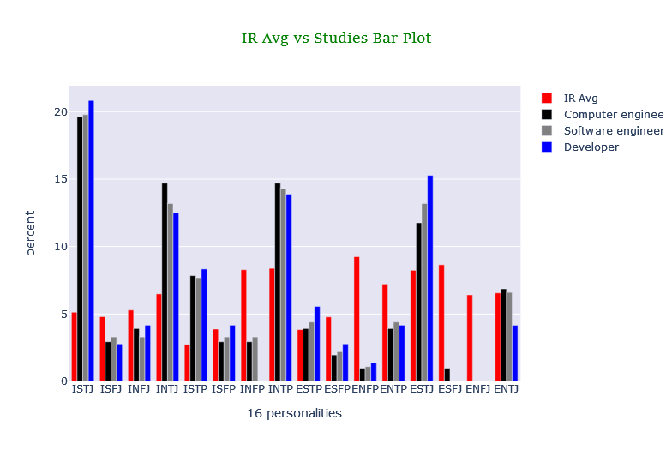
Figure 4. personality types of Tables 5 and Iranians' average personalities (Table 3)

In fig 5, the bar chart of MBTI's eight personality letters of computer engineers, software engineers, and developers vs Iran norm was shown. I, S, T, and J were more than norms and their complementary letters were less than norms.
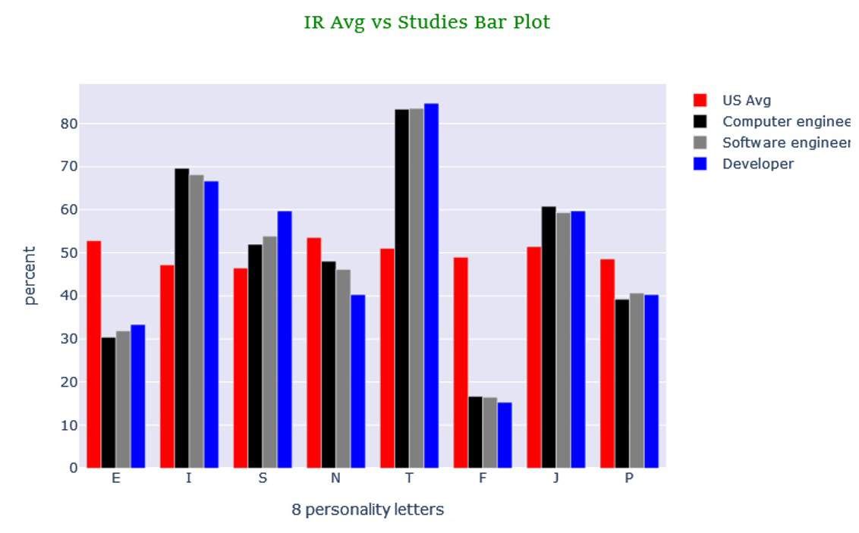
Figure 5. eight personality letters (Table 6) and Irans' average personality (Table 4)

In fig 6, the bar chart of KTS personality of computer engineers, software engineers, and developers vs Iran norm was displayed. SJ, SP, and NT were above the norm and NF is below it.

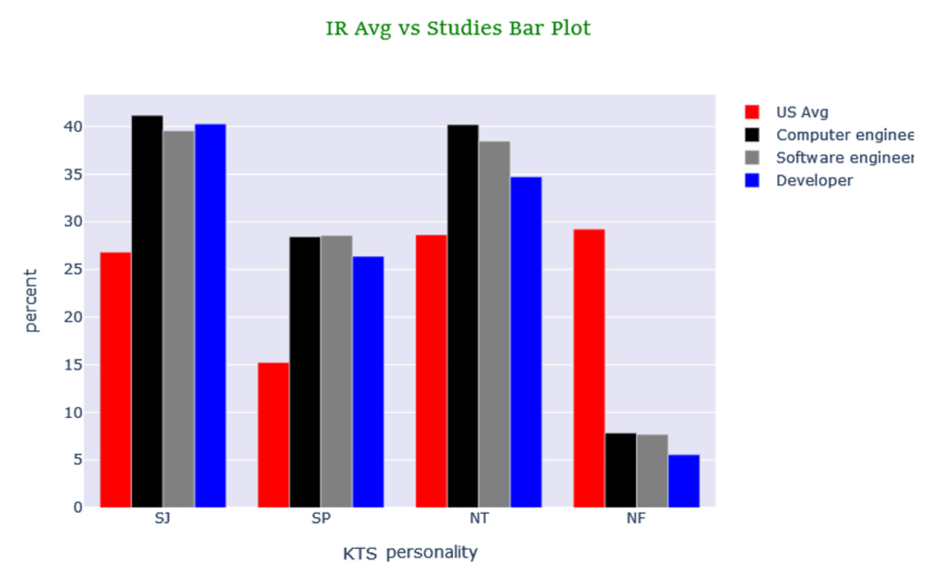
Figure 6. KTS (Table 6) and Iran's average KTS personality (inferred from Table 3)

For further analysis, we endeavored to see which results were statistically significant so these evaluations were shown in Table 17 and Table 18. The base table of comparison for Table 17 and Table 18 were different from Table 15 and Table 16 and they were Table 3 and Table 4 which were Iran norms.

Table 17. P-value and differences of MBTI results
ROLE/ STRENGTH | ISTJ | ISFJ | INFJ | INTJ | ISTP | ISFP | INFP | INTP | ESTP | ESFP | ENFP | ENTP | ESTJ | ESFJ | ENFJ | ENTJ | COUNT
Computer engineer | <0.001  Dif + | _ | _ | =0.022  Dif + | _ | <0.001  Dif - | =0.002  Dif - | _ | _ | =0.044  Dif - | <0.001  Dif - | _ | _ | <0.001  Dif - | _ | _ | 102
Software engineer | <0.001  Dif + | _ | _ | _ | _ | _ | =0.001  Dif - | _ | _ | _ | <0.001  Dif - | _ | _ | <0.001  Dif - | _ | _ | 91
Developer | =0.002  Dif + | _ | _ | _ | _ | _ | _ | _ | _ | _ | <0.001  Dif - | _ | _ | _ | _ | _ | 72

Table 18. P-value and differences of MBTI results continue
ROLE/ STRENGTH | E | I | S | N | T | F | J | P | SJ | SP | NT | NF | GENDER | COUNT
Computer engineer | <0.001  Dif - | <0.001  Dif + | _ | _ | <0.001  Dif + | <0.001  Dif - | _ | _ | =0.004  Dif + | =0.004  Dif + | =0.02  Dif + | <0.001  Dif - | M/F | 102
Software engineer | <0.001  Dif - | <0.001  Dif + | _ | _ | <0.001  Dif + | <0.001  Dif - | _ | _ | =0.015  Dif + | =0.006  Dif + | _ | <0.001  Dif - | M/F | 91
Developer | <0.001  Dif - | <0.001  Dif + | =0.026  Dif + | =0.026  Dif - | <0.001  Dif + | <0.001  Dif - | _ | _ | =0.013  Dif + | =0.037  Dif + | _ | <0.001  Dif - | M/F | 72

Analyzing Iranian computer engineers which used NEO-FFI
This sixty-questioned NEO-FFI can have results between 0 to 48 for each item. In a partitioning by Fathian Ashtiani (2010), 0 to 12 was low,12 to 24 was considered to be medium, and 24 to 48 was supposed to be a high score. With comparing Tables 14 and 6, which were about Iranian norms, C, E, and N were less than norms; furthermore, O and A were approximately equal to norms.

Limitations and future work
The first limitation that can be mentioned is the size of the sample and the way of motivating people to involves in the test. If the sample size is increased as much as possible, not only we can reach a better and more accurate result but also speaking about gender and role difference can be meaningful and lessen learning. In addition, this exam had 160 items and it took more than ten minutes which might have bored the examiner that led the testers to do the test randomly and incorrectly. One of the ways can solve this problem is finding a gamification method, an appropriate prize, or both. The next problem is some people always select what they think is a better answer in self-reporting tests which is not correct about themselves so finding better ways than using these classic methods for Interviews can make the result more accurate by removing the self-reporting part regarding that computer engineers and psychologist must think and research about it. The last thing that is beneficial to be done is researching the personality changes which occur in samples who start to learn computers and after some years of passing the lessons (like the Algorithm, Logical circuit, and so on), solving computer problems and working experience for many years can be knowledge acquiring.

Conclusion
There are some previous works on finding the personality of software engineers but many of them use computer students as their sample. This method is not completely correct because many of these students may not continue working or selecting this field without any fond and compatibility. Also, many of those students may become teachers, professors, Managers, or find another career.
As the first step, some of the previous works were shown and compared with norms analytically, and one sample t-test was used to see if the difference was statistically significant. In research that used MBTI, we found that software engineers were more ISTJ, INTJ, ESTJ, and ENTJ; in contrast, they were less ISFJ, ISFP, ESFP, ENFP, and ESFJ. Moreover, they had more T and N but less SJ in their personality.
For the big five, we displayed some of the results from previous works however the different formats of it had a variety of score ranges, making the comparison difficult. In spite of that, for those who use NEO-FFI, we compared it with British norms and find out that in one of them O and E were higher than norms though C and A were below it, and N was nearly equal to it. In the other study, O was higher, C was lower, and E, A, and N were approximately equal to the norm.
Then we had a case study on 102 professional Iranian computer engineers from the public and private sectors. They took MBTI and the NEO-FFI test simultaneously. we used Iran norms to compare the result with ours and the finding in MBTI parts was more or less the same as other works. The ISTJ, I, T, SJ, and SP had positive whereas INFP, ENFP, ESFJ, E, F, and NF had negative differences which were significant statistically for software engineers. In our big five results C, E, and N were less than the norm but O and A were approximately equal to it.
All in All, for big fives using voting on these three studies, we could find that openness to experience was higher, conscientiousness was lower, and neuroticism and agreeableness were equal to the norm approximately.

References
A. Buie, E. (1988). Psychological Type and Job Satisfaction in Scientific Computer Professionals. Journal of Psychological Type, 15, 50–53.
A. Schaubhut, N., & C. Thompson, R. (2008). MBTI type tables for occupations. CPP, Mountain View, Calif.
Acuña, S. T., Gómez, M., & Juristo, N. (2009). How do personality, team processes and task characteristics relate to job satisfaction and software quality? Information and Software Technology, 51(3), 627–639. https://doi.org/10.1016/j.infsof.2008.08.006
Barnes, P. (1975). Programmer paranoia revisited. Proceedings of the Thirteenth Annual SIGCPR Conference On -. https://doi.org/10.1145/800149.804879
Bell, D., Hall, T., Hannay, J. E., Pfahl, D., & Acuna, S. T. (2010). Software engineering group work. Proceedings of the 2010 Special Interest Group on Management Information System’s 48th Annual Conference on Computer Personnel Research on Computer Personnel Research. https://doi.org/10.1145/1796900.1796921
Capretz, L. F. (2002). Are software engineers really engineers? World Transactions on Engineering and Technology Education, 1(2), 233–235.
Capretz, L. F., & Ahmed, F. (2010). Why do we need personality diversity in software engineering? ACM SIGSOFT Software Engineering Notes, 35(2), 1–11. https://doi.org/10.1145/1734103.1734111
Capretz, L. F., Varona, D., & Raza, A. (2015). Influence of personality types in software tasks choices. Computers in Human Behavior, 52, 373–378. https://doi.org/10.1016/j.chb.2015.05.050
Cavallera, G. M., Passerini, A., & Pepe, A. (2013). Personality traits and the role of gender in swimmers at the leisure level. Social Behavior and Personality: An International Journal, 41(4), 693–703. https://doi.org/10.2224/sbp.2013.41.4.693
Choi, K. S., Deek, F. P., & Im, I. (2008). Exploring the underlying aspects of pair programming: The impact of personality. Information and Software Technology, 50(11), 1114–1126. https://doi.org/10.1016/j.infsof.2007.11.002
Clark, L. A. (2007). Assessment and Diagnosis of Personality Disorder: Perennial Issues and an Emerging Reconceptualization. Annual Review of Psychology, 58(1), 227–257. https://doi.org/10.1146/annurev.psych.57.102904.190200
Cruz, S., da Silva, F. Q. B., & Capretz, L. F. (2015). Forty years of research on personality in software engineering: A mapping study. Computers in Human Behavior, 46, 94–113. https://doi.org/10.1016/j.chb.2014.12.008
Falk, A., & Hermle, J. (2018). Relationship of gender differences in preferences to economic development and gender equality. Science, 362(6412), eaas9899. https://doi.org/10.1126/science.aas9899
Fathian Ashtiani, A. (2010). Psychological tests: evaluation of personality and mental health (1st ed., Vol. 1). besatpub.
Furnham, A. (1996). The big five versus the big four: the relationship between the Myers-Briggs Type Indicator (MBTI) and NEO-PI five factor model of personality. Personality and Individual Differences, 21(2), 303–307. https://doi.org/10.1016/0191-8869(96)00033-5
Furnham, A. (2022). The Big Five Facets and the MBTI: The Relationship between the 30 NEO-PI(R) Facets and the Four Myers-Briggs Type Indicator (MBTI) Scores. Psychology, 13(10), 1504–1516. https://doi.org/10.4236/psych.2022.1310095
Gardner, W. L., & Martinko, M. J. (1996). Using the Myers-Briggs Type Indicator to Study Managers: A Literature Review and Research Agenda. Journal of Management, 22(1), 45–83. https://doi.org/10.1177/014920639602200103
Heiberg, S., Puus, U., Salumaa, P., & Seeba, A. (2003). Pair-Programming Effect on Developers Productivity. Extreme Programming and Agile Processes in Software Engineering, 215–224. https://doi.org/10.1007/3-540-44870-5_27
Iran Personality Profile | Country Personality Profiles | 16Personalities. (n.d.). Www.16personalities.com. Retrieved January 21, 2023, from https://www.16personalities.com/country-profiles/iran
Isabel Briggs Myers. (2003). MBTI manual : a guide to the development and use of the Myers-Briggs Type Indicator. Cpp.
Isabel Briggs Myers, & Myers, P. B. (1995). Gifts differing : understanding personality type. Davies-Black Pub.
Jeronimus, B. F., Kotov, R., Riese, H., & Ormel, J. (2016). Neuroticism’s prospective association with mental disorders halves after adjustment for baseline symptoms and psychiatric history, but the adjusted association hardly decays with time: a meta-analysis on 59 longitudinal/prospective studies with 443 313 participants. Psychological Medicine, 46(14), 2883–2906. https://doi.org/10.1017/s0033291716001653
Jung, C. G., & Herbert Edward Read. (1974). Psychological types. Pantheon Books.
Kanij, T., Merkel, R., & Grundy, J. (2015, May 1). An Empirical Investigation of Personality Traits of Software Testers. IEEE Xplore. https://doi.org/10.1109/CHASE.2015.7
Keirsey, D. (1998). Please understand me II : temperament, character, intelligence. Prometheus Nemesis.
Khan, A. A., Jacobson, K. C., Gardner, C. O., Prescott, C. A., & Kendler, K. S. (2005). Personality and comorbidity of common psychiatric disorders. British Journal of Psychiatry, 186(03), 190–196. https://doi.org/10.1192/bjp.186.3.190
Lawrence, G., & Martin, C. R. (2001). Building people, building programs : a practitioner’s guide for introducing the MBTI to individuals and organizations. Center For Applications Of Psychological Type.
Manoochehr Azkhosh, & Ali Asgari. (2014). Five Factor Model in Iranian Culture: A Psychometrics Analysis of NEO-Five Factor Inventory (NEO-FFI). International Journal of Indian Psychology, 1(4). https://doi.org/10.25215/0104.028
Martínez, L. G., Rodríguez-Díaz, A., Licea, G., & Castro, J. R. (2010). Big Five Patterns for Software Engineering Roles Using an ANFIS Learning Approach with RAMSET. Advances in Soft Computing, 428–439. https://doi.org/10.1007/978-3-642-16773-7_37
Mendes, F., Mendes, E., Salleh, N., & Oivo, M. (2021). Insights on the relationship between decision-making style and personality in software engineering. Information and Software Technology, 136, 106586. https://doi.org/10.1016/j.infsof.2021.106586
Mullins-Sweatt, Stephanie N., Thomas A., & Widiger. (2006). The Five-Factor Model of Personality Disorder: A Translation across Science and Practice. (pp. 39–70). Personality and psychopathology.
Passmore, J., & Netlibrary, I. (2008). Psychometrics in coaching : using psychological and psychometric tools for development. Kogan Page.
Pittenger, D. J. (2005). Cautionary comments regarding the Myers-Briggs Type Indicator. Consulting Psychology Journal: Practice and Research, 57(3), 210–221. https://doi.org/10.1037/1065-9293.57.3.210
Randall, K., Isaacson, M., & Ciro, C. (2017). Validity and Reliability of the Myers-Briggs Personality Type Indicator (pp. 1–27). Journal of Best Practices in Health Professions Diversity.
Roccas, S., Sagiv, L., Schwartz, S. H., & Knafo, A. (2002). The Big Five Personality Factors and Personal Values. Personality and Social Psychology Bulletin, 28(6), 789–801.
Russo, D., & Stol, K.-J. (2020). Gender Differences in Personality Traits of Software Engineers. IEEE Transactions on Software Engineering, 1–1. https://doi.org/10.1109/tse.2020.3003413
Schweiger, D. M. (1985). Measuring managerial cognitive styles: On the logical validity of the Myers-Briggs Type Indicator. Journal of Business Research, 13(4), 315–328. https://doi.org/10.1016/0148-2963(85)90004-9
Stein, R., & Swan, A. B. (2019). Evaluating the Validity of Myers-Briggs Type Indicator theory: a Teaching Tool and Window into Intuitive Psychology. Social and Personality Psychology Compass, 13(2), 1–11. https://doi.org/10.1111/spc3.12434
The NEO-FFI: emerging British norms and an item-level analysis suggest N, A and C are more reliable than O and E. (2000). Personality and Individual Differences, 29(5), 907–920. https://doi.org/10.1016/S0191-8869(99)00242-1
Widiger, T. A., & Costa, P. T. (2002). Five-factor model personality disorder research. Personality Disorders and the Five-Factor Model of Personality (2nd Ed.)., 59–87. https://doi.org/10.1037/10423-005

Author
(Leave this blank when submitting for review.)
Include one or two short paragraphs about each author. Please include a head and shoulder photo of each author. You should include this photo and bio when you are asked to upload your final, formatted, camera ready copy. However, if you need to, you can send the photos by email to Publisher@InformingScience.org as separate attachments and we will insert them for you.

