Multi-Word Expressions and Communicative Engagement: A Longitudinal Study of L2 Learners' Willingness to Communicate

  - Data Analysis
For the quantitative data, the R program, specifically mixed ANOVA and Regression, was used. Mixed ANOVA was used because the study design included both a within-subjects factor (i.e., repeated measures over time) and a between-subjects factor (i.e., different groups such as control vs. experimental) making it possible to test for main effects of time, main effects of group, and interactions between time and group. Effect sizes were interpreted based on Cohen's (1988) benchmarks for partial eta-squared (η²), where values of 0.01, 0.06, and 0.14 represent small, medium, and large effects, respectively. Furthermore, hierarchical regression was also ran to examine the unique contribution of MWEs to WTC changes, control for confounding variables, and check the interaction effects of MWEs, group, and time point. The observation data was coded numerically, and descriptive statistics such as frequency count and percentage were utilized to analyze the learners' behavior in relation to WTC.
4. Results
  - WTC and MWEs Change Trend in Experimental and Control Groups
The longitudinal data revealed distinct trends in WTC and MWE scores between the experimental and control groups over the 12-month study period.
For WTC (Figure 1), the experimental group demonstrated a steady and statistically significant increase in WTC scores, beginning with a mean baseline score of M = 39.7 (SD = 7.2) and reaching M = 57.0 (SD = 7.9) by the final measurement. In contrast, the control group showed minimal change in WTC, with scores fluctuating slightly from M = 27.1 (SD = 3.6) at baseline to M = 27.8 (SD = 4.1) at the end of the study. This divergence suggests that explicit MWE instruction had a meaningful impact on learners’ willingness to engage in classroom communication.
Figure 1
WTC Change Trend in Experimental and Control Groups Over Time

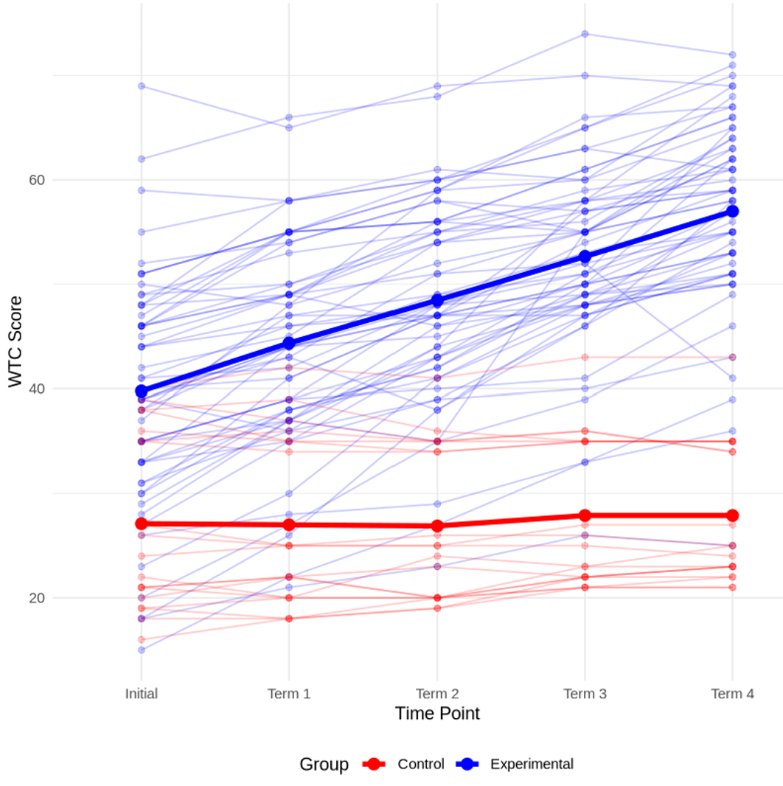

Similarly, for MWE scores (Figure 2), the experimental group exhibited a consistent upward trajectory, increasing from a mean baseline score of zero to M = 11.2 (SD = 2.1) by the final time point. The control group, however, showed negligible improvement, with MWE scores remaining relatively stable around M = 2.3 throughout the study (SD = 1.3). These findings indicate that the experimental intervention successfully enhanced learners' MWE knowledge, which appears to have contributed to increased WTC over time.
داورها از من خواستن شکل دوم رو تغییر بدم و مانند شکل اول باشه.
Figure 2
MWEs Change Trend in Experimental and Control Groups Over Time
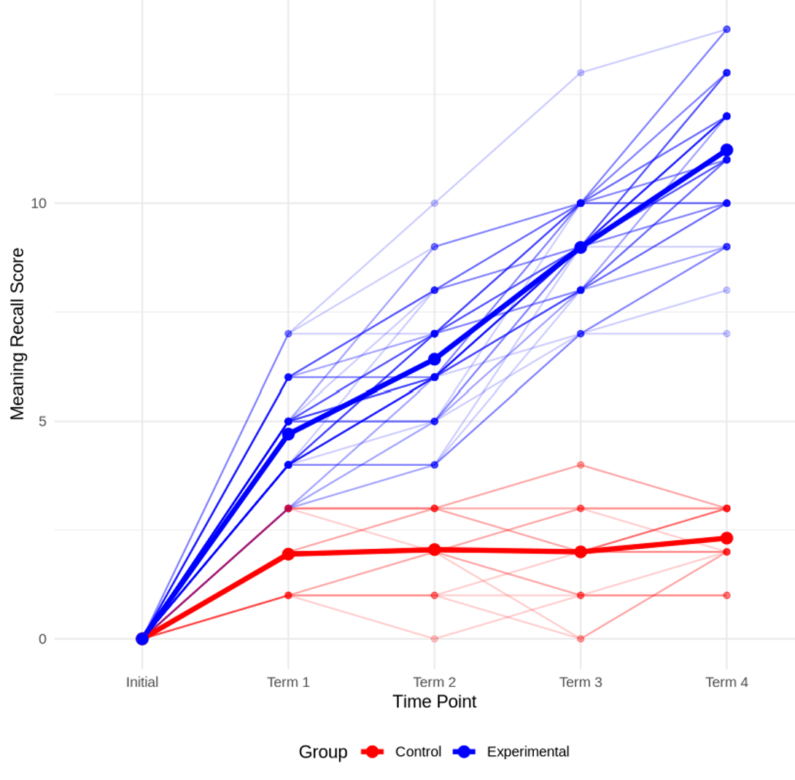
Both figures were generated based on mean WTC and MWE scores at each of the five measurement points. These visual representations illustrate the interaction effect between Group and TimePoint, as identified in the mixed ANOVA results (see Section 4.2). Specifically, the widening gap between the two groups over time reflects the significant Group × TimePoint interaction (p < .001), suggesting that the effects of MWE instruction on WTC and lexical gains accumulated progressively rather than occurring immediately.

