To
Hakim Tejarat Sahand
Iran

Subject: Quotation of Granulation Line 150 Kg
- Paste kettle PKK ‐ 50 GMP Model
- Vibro sifter PVS ‐ 30 GMP Model
- Prism High Shear Mixer Granulator PRMG ‐ 400 GMP Model
- Fluid Bed Dryer PFBD ‐ 150 GMP Model
- Prism Multi Mill PMTM ‐ 200 GMP Model
- Octagonal Blender POB ‐ 300 GMP Model
- Double Sided Rotary Tablet Press PTCMB4 ‐ 27 Station “D” Tooling GMP Model
- Prism Tablet Press Tooling ‐ Dies & Punches.
- Elevating (Uphill) De Duster PDD ‐ 250E GMP Model
- Dust Extractor PDE ‐ 300 GMP Model
- Automatic Capsule Filling Machine PCAP ‐ 750 GMP Model
- Automatic Blister Packing Machine ALU ‐ ALU (Cold Forming) Blister & PVC /PVDC – ALU (Thermo Forming) PEXCEL ‐ 44 GMP Model

Sr. No. | Item Description | Qty
1. | Prism Paste Kettle PPK ‐ 50 GMP Model  - Kettle bowl with 50 liter capacity.  - Bowl jacketed, Steam heated and insulated.  - Tilting bowl for unloading.  - Anchor stirrer with VFD  - Electric pane with push button and digital indicator. | 1 No.
1. | Recommended Spares | 1 Set
1. | Validation Documents (DQ,IQ,OQ) | 1 Set
2. | Prism Vibro Sifter PVS ‐ 30 GMP Model  - Contact Parts in S.S.316 & Non Contact Parts in S.S.304  - Machine fitted with 20 mesh sieve.  - ON‐OFF starter. | 1 No.
2. | Additional sieve of S.S.316 with silicon seal  Require Size: #10,#18,#40,#120,#170 Each No. | 5 Nos.
2. | Recommended Spares | 1 Set
2. | Validation Documents (DQ,IQ,OQ) | 1 Set
3. | High Shear Mixer Granulator PRMG ‐ 400 GMP Model  - Bowl capacity working volume 300 Liter/ 150 Kg. @ 0.5 B.D.  - Variable speed drive for main impeller & Chopper impeller.  - Pneumatic operated top lid  - Pneumatic operated discharge gate.  - Interlock top lid and discharge gate.  - Inline Wet sieve ‐ Cone Mill with VFD  - Cone Mill with Perforated Sieve Size 10mm & 12mm hole of 2 Nos. of each  - Air pursing for shaft seal.  - Main mixing blade lifting device for cleaning and QC.  - CIP Spraying provision.  - PLC Controls with 10” HMI touch screen | 1 No.
3. | Binder solution spraying system with 50 liter vessel, Weighing scale, Gear pump, Silicon tube and spray Nozzle  - 50 liter vessel with jacketed, steam heated insulated, with anchor  stirrer  - Provides Steam controls and steam trap valve.  - Anchor stirrer with VFD  - Peristaltic pump. | 1 No.

- Spray Nozzle for binder spray.
- Recommended Spares
- Validation Documents (DQ, IQ, OQ)
 | Recommended Spares | 1 Set
 | Validation Documents (DQ,IQ,OQ) | 1 Set
4. | Prism Fluid Bed Dryer PFBD ‐ 150 GMP Model  - Single piece construction with retarding and expansion chamber.  - Bowl capacity 410 liter/150kg.  - Inlet Air Handling Unit with made from inside and outside SS304, Pre Filter‐10 Micron, dehumidifier, Heat exchanger,  - Electric Heated, Final Filter‐5 Micron, HEPA filter‐0.3 Micron  - Dehumidifier ‐ Child water circulation coil.  - Exhaust Air unit with blower assembly and 5 micron filter.  - Variable Frequency Drive‐20 hp  - Automatic filter bag shaking system.  - Differential Pressure Gauge for HEPA, Product sieve and Filter Bag.  - Powder Escape Prevention System with Solid flow sensor at  exhaust air.  - Air flow CFM Sensor.  - Inlet air RH Sensor.  - CIP‐WIP Wash Provision/Arrangement.  - PLC Control with 10” HMI Touch Screen  - Piping for Ducting 4 meter length provide with machine. | 1 No.
4. | Additional product container with Trolley | 1 No.
4. | Air Ducting Of S.S.304 Per Meter | 1 Meter.
4. | Recommended Spares | 1 Set
4. | Validation Documents (DQ,IQ,OQ) | 1 Set
5. | Prism Multi Mill PMTM ‐ 200 GMP Model  - Milling with knife & Impact edge blade with cylindrical sieve.  - Rotor has Variable speed by VFD.  - Machine fitted with 2 mm hole size of perforated sieves  - Electric Controls panel with push button & Digital indicator.  - Recommended Spares  - Validation Documents (DQ,IQ,OQ) | 1 No.
5. | Additional Perforated sieve of S.S.316  Require Hole Size: 0.5, 1, 1.5, 2, 2.5, 3, 4 & 5mm Each No. | 8 Nos.
5. | Recommended Spares | 1 Set

 | Validation Documents (DQ,IQ,OQ) |  |  |  |  | 1 Set
6. | Prism Octagonal Blender POB ‐ 300 GMP Model  - Machine working Capacity 300 Liter/150Kg  - Variable speed of container with VFD.  - Inter locked Safety reeling for rotating area.  - Electric Controls panel with push button with digital indicator. |  |  |  |  | 1 No.
6. | Round Container 50 Kg & Pallet raising jacking trolley |  |  |  |  | 1 No.
6. | Recommended Spares |  |  |  |  | 1 Set
6. | Validation Documents (DQ,IQ,OQ) |  |  |  |  | 1 Set
7. | Double Sided Rotary Tablet Press PTCMB4 – 27 GMP Model  - Double Rotary Tablet Press with two side output.  - 27 station “D” Tooling.  - Turret with 3 Pc Turret Die pot of S.S.316.  - Turret drive with worm wheel and worm.  - Gear box with worm with Electromagnetic clutch and worm shaft have belt drives with motor.  - BI ‐ Layer / Two Layer tablet attachment  - Rotary Force Feeder with AC Drive  - Variable speed drive for turret drive.  - Upper cam plate assembly with tunnel type upper cam track.  - Front controls for tablet thickness and weight adjustment.  - Gravity feeding with feed frame and hopper.  - Front operating electric controls panel with push button and digital indicator. |  |  |  |  | 1 No.
7. | Recommended Spare |  |  |  |  | 1 Set
7. | Validation Documents (DQ,IQ,OQ) |  |  |  |  | 1 Set
8. | Dies & Punches for Tablet Press  Capsule / Oval Shape Dies & Punches each set = 30 Set |  |  |  |  | 3 Nos.
9. | Elevating (Uphill) De Duster PDD ‐ 250E GMP Model  - Recommend Spare  - Validation Documents (DQ,IQ,OQ) |  |  |  |  | 2 Nos.
10. | Dust Extractor PDE – 300 GMP Model  - Recommended Spares  - Validation Documents (DQ,IQ,OQ) |  |  |  |  | 1 No.
11. | Automatic Capsule Filling Machine PCAP ‐ 750 GMP Model  • Basic machine fitted with powder filling unit |  |  |  |  | 1 No.
11. |  | • | Machine | fitted with one set of change part for “0” number size |  | 1 No.

 | •  •  •  •  •  •  •  •  • | capsule. | PLC control panel is supplied with 10” Touch‐screen Control  All powder contact parts are in S.S. 316 qualities.  Machine maximum output is 45,000 capsules/hour for powder depending upon fill weight, powder characteristic and capsule size  The main body is fabricated out of SS 304 quality plate and frame. Inbuilt with Vacuum Pump  Provide Pellet Filling Attachment.  Dust Collector Unit ‐1 No.  Empty capsule loader ‐1 No.  Filled Capsule Polisher with Un‐filled Capsule Sorter‐1 No.
 | •  •  •  •  •  •  •  •  • | system.  ( etc.)
 | Additional set of change parts for any size of capsule |  |  | 2 Nos.
 | Recommended Spare |  |  | 1 Set
 | Validation Documents (DQ, IQ, OQ) |  |  | 1 Set
12. | Automatic Blister Packing Machine ALU ‐ ALU (cold forming) Blister & PVC /PVDC – ALU (Thermo forming) PEXCEL ‐ 44 GMP Model  - PLC with MMI and servo Indexing.  - Machine fitted with one set of change parts  - Cross perforation station  - Full length acrylic guard  - Vibratory product feeder device.  - Acrylic guard cover sealing station onward till the blister pack discharge point |  |  | 1 No.
12. | Thermo‐ Forming Attachment for ALU‐PVC |  |  | 1 No.
12. | Printing registration controls |  |  | 1 No.
12. | NO fills detection system |  |  | 1 No.
12. | Cross perforation arrangement |  |  | 1 No.
12. | Additional change parts  - Cold Forming station  - Upper Sealing platen  - Lower Sealing Platen  - Web Support Track  - Crescent Feeding System  - Pack Punching assembly. |  |  | 1 No.
12. | Water cooling system‐ Chiller with capacity of 120 liters per hour at 30 PSI pressure with a temperature drop of 15 to 18° C |  |  | 1 No.
 | Recommended Spares |  |  | 1 Set
 | Validation Documents |  |  | 1 Set

1. Paste Kettle PPK‐ 50 GMP Model

Application & Process:
PRISM Paste Kettle unit is ideal for making Paste/Starch solution for making granulation for Tableting.

The kettle is provided with electric heated or steam heated and jacked by 50 mm glass wool with SS 304 cladding. The entire unit completely made from SS 304 and all contact parts made from SS 316 quality. The kettle is mounted on SS structure with pillow block and having arrangement for tilting with gear box and hand wheel for unloading.
The control panel is fitted with inlet temperature indicator of heating media and timer.
MODEL |  | PPK ‐ 50
Application | • | Melting Starch and make starch paste by Mixing liquid with Heating for binder.
Machine Standard/ Construction guide line | •  • | The Current state of the art GMP Compliance.  European Medicine Agency (EMA) and USFDA Regulations compliance.
Machine design Standard for safety | • • • • | The European Machinery Directive 2006/42/EC  The European Low Voltage Directive 2014/35/EU  ISO/TR 12100:1992: Safety Of machinery (Basic Concepts, general Principle of design), part 1 & 2.  ISO 15534:2000: Ergonomic Design for the safety of machine, Part 1 &2,
 | • | ISO 13849‐1:1999: Safety Machinery – Safety related parts of controls systems‐parts 1: General Principle for design.
 | • | ISO 13850:1996: Safety of machinery‐Emergency StopPrinciples of design.
 | • | ISO 13852:1996: Safety of Machinery‐ Safety distance to prevent danger zones being reached by upper limbs.

Salient Features:
- Design is cGMP – Current Good Manufacturing Practices compliance.
- All contact parts AISI 316, all seal of silicon food grade & non contact parts AISI 304.
- Product Bowl with Jacketing and Insulation for heating.
- Product bowl is having tilting unit for unloading.
- Heating media – Electric Heater.
- Temperature controls with Contactor for Heater.
- Anchor type stirrer with reduction gear motor drive with Up to 30 RPM by VFD.

TECHNICAL SPECIFICATIONS:

- ISO 13853:1996: Safety of Machinery‐ Safety distance to prevent danger zones being reached by lower limbs.
- ISO 13854:1996: Safety of Machinery‐ Minimum gaps to avoid crushing of parts of the human body.
- ISO 14110:1998: Safety of Machinery –Interlocking devices associated with guards‐ principles for design & selection.
Room Condition | - Room temperature : NMT 18 to 27 °C  - Relative humidity : NMT 30 to 65%  - Zoning : Class D Grade  - Pressure : 10 Pa
Type of kettle | Deep spherical bowl with jacketed ‐ Steam heated, Insulated, tilting for unloading
Mixing Vessel Capacity | - Gross Volume: 70Liter  - Maximum Working Volume: 50 Liter • Minimum Working Volume :  - 30% less of working volume for heating and mixing.  - 70% less of working volume for mixing only.
Material and surface finish of parts in contact with the product | - AISI 316.  - Teflon, Silicon food grade USFDA  - Ra ≤0.5 Mirror finish.  - All contact parts rather that stainless steel should be food grade material.
Material and surface finish of parts not in contact with the product | - AISI304  - Ra ≤0.85 Matt Finish
Material and surface finish of outer surface | - All material used in the equipment will be durable type.  - The outer surface shall be easy to clean.  - Outer surface finish of stainless materials in classified rooms will be mirror polished to Ra  0.9 m, if not otherwise stated.
Non‐metallic materials | - Elastomers in direct contact with the product will be according to FDA Code 21 CFR 177  - All non‐metallic materials used in the equipment will be of durable type and must withstand cleaning with ethanol 70% and detergents.  - Gaskets, diaphragms and O‐rings in direct contact with the product will be PTFE and/or EPDM or Silicone.  - Oil in instruments in direct contact with the product will be according to FDA Code 21 CFR 172.
Mixing vessel design | • Design Parameter for shell

- Design Pressure inside vessel shell: Atmosphere
- Operating pressure inside vessel shell : Atmosphere
- Hydro test inside vessel shell: Not Applicable
- Design Temperature: 100°C
- Operating Temp[rapture: 90°C
- Design Parameter for Jacket
  - Design Pressure in Jacket : 4bar
  - Operating pressure in Jacket: 4bar
  - Hydro test in Jacket:6bar
  - Design Temperature: 120°C
  - Operating Temp[rapture: 100°C
- The welds in and in contact with the inside vessel and outside of the vessel will be orbital welded
- The vessel will be fully drainable.
Noise level | • 75Db from 1 meter distance.
Bowl type | - Deep spherical shell  - MOC S.S.316 with 3 mm thick  - Jacketed with S.S.304 of 3 mm thickness  - Temperature Working range Atmosphere to 90°C  - Insulation 50 mm thickness fiber glass wool  - Insulation cover S.S.304 of 2 mm thickness.  - Two side mounting on bearing for tilting with gearbox with handle to manual tilt.  - Top lid is provided in loose and 1/3 part hinged.
Heating Media | • Electric Heater 1.5 Kw X 2 Nos. = 3 Kw Or 3 Kw
Top Lid | • Provide top lid in 2 parts of S.S.316
Stirrer | - Provided anchor type with gear motor.  - Motor hp 1 hp/0.75kw /3phase  - Stirrer speed is Up to 30rpm by VFD  - Stirrer mounting on machine structure with tilting to  - unload materials.
Machine structure | “A” type structure of S.S.304 Pipe to mounting kettle bowl and stirrer.
Discharge system | Titling bowl to unload paste for kettle with gear drive and operate manually.
Jacket Connection | - N1: Dia.130mm Flange connection for Heater.  - N2: Dia.12.5 NPT for Pressure gauge.  - N3: Dia.12.5 NPT for Safety Valve.

 | • N3: Dia.12.5 NPT for Drain.
Sensor & Gauge | - TS1: RTDT PT100 Temperature sensor for Products at connection.  - PG1: Pressure Gauge for jacket pressure at connection N2.  - SV1: Safety Valve for jacket pressure at connection N3.
Electric controls panel | - Electric Panel with S.S.305 Encloser.  - Main Isolation switch  - ON‐OFF Selector switch.  - Temperature Controller.  - ON‐OFF push button for stirrer.  - RPM Controller for Stirrer  - Emergency Stop Switch.  - MCB, VFD, Contactor, Relay, Controls relay & SMPS.
Safety futures | - Overload relay controls.  - Emergency stop.
Operation in hazard situations | Utility failure  - When reconnected after an electric power failure, the system must not start automatically any control actions without operator input. Emergency stop  - Emergency stop the complete machine immediately in a safe way.  - Restart after emergency stop will be performed from the control panel by the operator in an easy and safe way.  - The equipment will be equipped with switches for emergency stop. The switch/switches will be located in easily accessible places.
Make of Brought Items | - Reduction Gear Motor : Rotomotive/Bonfigilioli. • VFD: Mitsubishi  - MCB, Contactor & Relay: Schneider  - Controls Relay: – BCH / Phoenix / Elmex  - SMPS: Omron / Multispan  - Main Isolator switch: Sulzer  - Emergency Switch: Teknic  - Limit Switch: Honeywell  - Temperature Sensor: Rays / Aris  - Silicon pipe & Gasket seal, O ring: Ami Polymer.
Require Utilities: | • Electric Power: 0.75kw/3phase/380v‐415v/50hz.

- Compressed Air: 1cfm @ 4bar pressure.
- Hot Water: For washing required
- Distilled Water : For washing required
- Purified Water: For Processing & washing required.
Documents & Certificate | Manuals and Maintenance Instructions  - Operator manual.  - Installation and assembly instructions for all devices.  - User’s manuals for all components.  - Trouble shooting guide.  - Maintenance manual.  - Safety instructions.  - Training documentation.  Electrical and control diagrams  - Single line drawings for electrical distribution  - Circuit diagrams.  - Cable list..  Qualification Protocols  - DQ protocols and reports.  - FAT protocol and report.  - IQ protocol and report.  - OQ protocol and report.  - DQ: Provide after received confirm order.  - FAT: Provide before machine gets ready for FAT & Trails.  - IQ, OQ, Machine Instruction & maintenance manual will be providing along with machine.  - DQ & FAT hard copy provide along with machine.  - PQ: PQ is not our scope of supply.  Test, Calibration, MOC Certification:  - All Test certificate for Brought Items will be provides during FAT with FAT Documents.  - MOC Certificate will be providing during FAT with FAT Documents.  - Calibration certificate provide for pressure gauge during FAT.  - Above all certificate hard copy will be with FAT reports  only.
Factory Acceptance Test (FAT) | - The supplier will perform FAT at the supplier’s facility with attendance of supplier/ buyer personnel. The FAT has to be successfully completed prior to delivery.  - The operational performance of the equipment will be
 |  | verified during the FAT in complete tests.
 | • | Buyer will bear Cost for FAT as per terms & condition.
Installation Qualification (IQ) & Operation Qualification (OQ) | • | The supplier will provide test protocols for IQ and OQ covering requirements in the URS. The test protocols will be reviewed and approved by Buyer before the IQ/OQ is performed.
 | • | The supplier will perform the IQ and OQ with attendance of buyer’s personnel and write corresponding reports.
 | • | Buyer will bear Cost for SAT as per terms & condition.
Performance Qualification (PQ) | • | The supplier CANNOT provide test protocols for PQ performed. It is not scope of supply.
 | • | The suppliers will attendance during PQ. But not write any corresponding reports.
Recommended Spare | • | 1 No. Temperature sensor.
 | • | 1 No. Controls relay.
 | • | 2 Nos. Pneumatic Connection.
 | • | 3 meter M8 Pneumatic Pipe.

Actual Images of Paste Kettle 100 Liter GMP Model:
*All Pictures shown are for illustration purpose only. Actual product may vary due to product enhancement

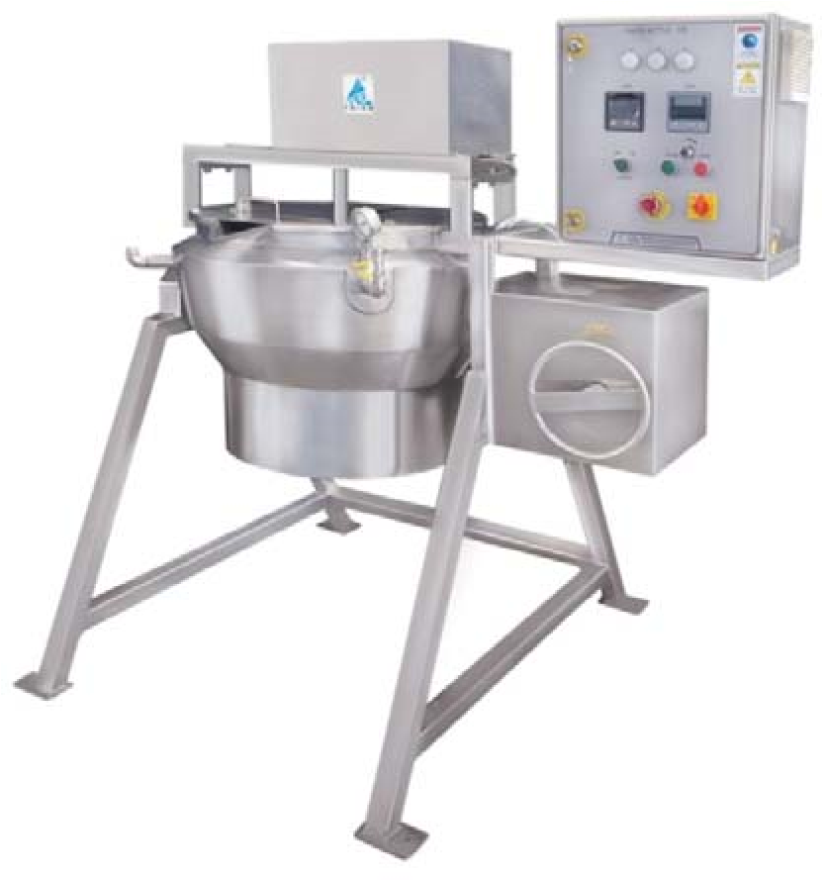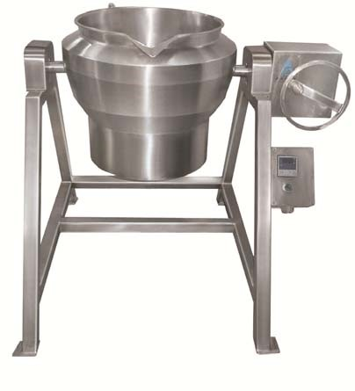

2. Prism Vibro Sifter PVS ‐ 30 GMP Model

Compact sieving & Grading Process
Vibro Sifter is a versatile sieving and grading machine for separation of solids from solids, liquid from solids and production of graded materials in proportion to their size.

Vibro Sifter is designed on the principle of ‘Gyratory Motion” with 1 nos. sieve with 2 nos. discharges. Material is fed on to the centre of the screen and then travels on a spiral path to the periphery whilst the fine particles fall through and discharge at bottom outlet. At top discharge received materials are oversize and not passed through top sieve. The material being screened is therefore drawn apart automatically and no additional force is exerted to separate coarser particles. The sieving is done gently and with little abrasion.

The external vibrator is a three phase asynchronous motor which has eccentric weights mounted at the end of the rotor Shafter. The rotating shaft causes centrifugal forces which can be adjusted by moving the weights. The motor is special designed with high stability M.S. Body special bearing with increased load capacity and vibration proof winding.

SALIENT FEATURES:
- Design is cGMP – Current Good Manufacturing Practices compliance.
- Product contact parts AISI 316 and non contact part AISI 304.
- Simple & Convenient Operation, Changeover, Cleanliness, Operator Protection & Ease to Maintenance.
- Powerful vibration by special vibro motor.
- Vibration spring with rubber supports.
- Vibrating sieve 1no. With 2 nos. discharge.
- Dia. 750mm sieve with silicon sealing.
- Machine fitted with 20 mesh sieve.
- Charging from top in centre.
- 2 nos. Side outlet for fines and over size.
- Easy movable & Easy to clean.
- Noiseless machine.
- Round structure with 3 nos. castor PU wheel with brake.
- Electric overload relay starter on the machine.
TECHNICAL SPECIFICATIONS:
Model | PVS‐30
Machine | Vibro sifter
Application | Grading of dry powder materials.
Working Principle | Create Vibration by ‘Gyratory Motion” and passed materials through wire mesh sieve.
Machine Standard/ Construction guide line | - The Current state of the art GMP Compliance.  - European Medicine Agency (EMA) and USFDA Regulations compliance.
Machine design Standard for safety | - The European Machinery Directive 2006/42/EC  - The European Low Voltage Directive 2014/35/EU  - ISO/TR 12100:1992: Safety Of machinery (Basic Concepts, general Principle of design), part 1 & 2.  - ISO 15534:2000: Ergonomic Design for the safety of machine, Part 1 &2,  - ISO 13849‐1:1999: Safety Machinery – Safety related parts of controls systems‐parts 1: General Principle for design.  - ISO 13850:1996: Safety of machinery‐Emergency Stop‐  Principles of design.  - ISO 13852:1996: Safety of Machinery‐ Safety distance to prevent danger zones being reached by upper limbs.  - ISO 13853:1996: Safety of Machinery‐ Safety distance to prevent danger zones being reached by lower limbs.  - ISO 13854:1996: Safety of Machinery‐ Minimum gaps to avoid crushing of parts of the human body.  - ISO 14110:1998: Safety of Machinery –Interlocking devices associated with guards‐ principles for design & selection.
Room Condition | - Room temperature : NMT 18 to 27 °C  - Relative humidity : NMT 30 to 65%  - Zoning : Class D Grade  - Pressure : 10 Pa
Machine Type | Single Deck with 1 nos. sieve.
Output kg / Hour | 75 to 300 Kg/hr
Material and surface finish of parts in contact with the product | - AISI 316.  - Teflon, Silicon food grade USFDA  - Ra ≤0.5 Mirror finish.  - All contact parts rather that stainless steel should be food grade material.
Material and surface finish of parts | • AISI304

not in contact with the product | • Ra ≤0.85 Matt Finish
Material and surface finish of outer surface | - All material used in the equipment will be durable type.  - The outer surface shall be easy to clean.  - Outer surface finish of stainless materials in classified rooms will be mirror polished to Ra  0.9 m, if not otherwise stated.
Non‐metallic materials | - Elastomers in direct contact with the product will be according to FDA Code 21 CFR 177  - All non‐metallic materials used in the equipment will be of durable type and must withstand cleaning with ethanol 70% and detergents.  - Gaskets, diaphragms and O‐rings in direct contact with the product will be PTFE and/or EPDM or Silicone.  - Oil in instruments in direct contact with the product will be according to FDA Code 21 CFR 172.
Sieve Diameter | 750 mm
Charging height | 1240 mm
Sieve fitted with machine | # 20 mesh
Type of sieve | Wire mesh with silicon seal molding.
Oversize‐ Top discharge height. | 878 mm
Fines‐ Bottom Discharging height | 730 mm
Clamping of hopper & sieve | By easy clamping device
Vibration spring | Stainless steel with rubber bush.
Vibro Motor | 0.5 HP /0.375 Kw/3 phase
Machine Structure | Round body of S.S.304
Machine mounting | 3 nos. PU wheel with break
PU Wheel size | Dia. 100 mm with stainless steel bracket.
Electric Starter | - Starter Mounting on the machine  - ON‐OFF starter with contactor& overload relay.
Safety futures | • Overload relay controls.
Make of Brought Items | - Motor: Motion.  - Starter : BCH
Require Utilities: | - Electric Power: 0.375kw/3phase/415v/50hz.  - Hot Water: For washing required.  - Portable Water: NIL.  - Distilled Water : For washing required  - Purified Water: For washing required.

Documents & Certificate | Manuals and Maintenance Instructions  - Operator manual.  - Installation and assembly instructions for all devices.  - User’s manuals for all components.  - Trouble shooting guide.  - Maintenance manual.  - Safety instructions.  - Training documentation.  Qualification Protocols  - DQ protocols and reports.  - FAT protocol and report.  - IQ protocol and report.  - OQ protocol and report.  - DQ: Provide after received confirm order.  - FAT: Provide before machine gets ready for FAT & Trails.  - IQ, OQ, Machine Instruction & maintenance manual will be providing along with machine.  - DQ & FAT hard copy provide along with machine.  - PQ: PQ is not our scope of supply.  Test, Calibration, MOC Certification:  - All Test certificate for Brought Items will be provides during FAT with FAT Documents.  - MOC Certificate will be providing during FAT with FAT Documents.  - Calibration certificate provide for pressure gauge during FAT.  - Above all certificate hard copy will be with FAT reports  only.
Factory Acceptance Test (FAT) | - The supplier will perform FAT at the supplier’s facility with attendance of supplier/ buyer personnel. The FAT has to be successfully completed prior to delivery.  - The operational performance of the equipment will be verified during the FAT in complete tests.  - Buyer will bear Cost for FAT as per terms & condition.
Installation Qualification (IQ) & Operation Qualification (OQ) | - The supplier will provide test protocols for IQ and OQ covering requirements in the URS. The test protocols will be reviewed and approved by Buyer before the IQ/OQ is performed.  - The supplier will perform the IQ and OQ with attendance of buyer’s personnel and write corresponding reports.
 | • | Buyer will bear Cost for SAT as per terms & condition.
Performance Qualification (PQ) | • | The supplier CANNOT provide test protocols for PQ performed. It is not scope of supply.
 | • | The suppliers will attendance during PQ. But not write any corresponding reports.
Recommended Spare | • | 1 sets Rubber bush for vibration spring.
 | • | 1 Set spring sets.
 | • | 1 no. silicon rubber gasket at charging hopper clamping.
IMAGE OF VIBRO SIFTER:
*All Pictures shown are for illustration purpose only. Actual product may vary due to product enhancement.
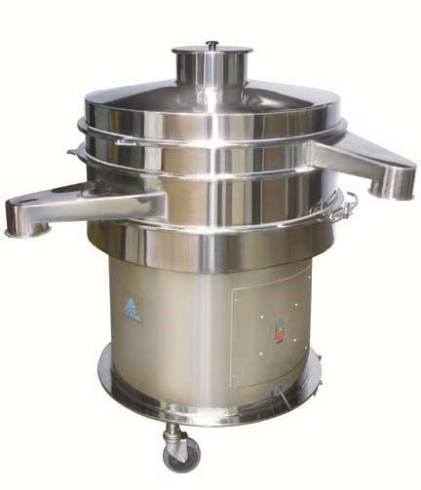

3. High Shear Mixer Granulator PRMG – 400 GMP Model

The High Shear Mixer Granulator used for process of fast dry & wet mixing, homogenizing, humidifying and granulating of the powder in Pharmaceutical, Chemical, Cosmetic, Food, Plastic, General Mixing Industries.

High Shear Mixer Granulator series is characterized by the compact construction, modern design and all the user and maintenance friendly attributes which form the ergonomics design aspects are essential for a wide range of application.

THE COMPLETE RELIABILITY OF THE PROCESS TECHNOLOGY FOR THE STEPS • Mixing
- Homogenizing
- Humidifying • Granulating

PRISM RAPID MIXER GRANULATION PROVIDES:
- High Mixing Precision.
- Short Batch Time.
- Problem free Cleaning.
- Residue Free Discharge.

As the guarantee for optimum system available in strict compliance with the stipulation of cGMP.

The Process:
The High Shear Mixer Granulator performs dry mixing & wet granulating by basic design of the special four arm of the mixing impeller and sequences of the mixing process in the cylindrical mixing drum with rounded connection to the base plate, achieve another special effect. The mixing process runs without varying pressure zone in the volume of mixing product. Separately driven multiple choppers can effectively intensify the mixing result in particular when liquid or paste components are added. During humidifying and granulating process of the products the chopper controls and regulates the granular spectrum and structure of the granules according to the product, chopper shape and time. The HSMG system requires only small quantities of granulating liquid or pastes to obtain the required granulate structure. This reduces the amount of drying energy require

Salient Features:
- Designed strictly compliance with the stipulation of cGMP.
- Product contact parts AISI 316 Quality & Food grade silicon.
- Integrated High Shear Mixer Granulator with Powder loading by VTS and powder unloading to Fluid Be Dryer.
- High Precision mixing and granulation with Short Batch Time, Problem free Cleaning and Residue Free Discharge.
- Simple & Convenient Operation, Changeover, Cleanliness, Operator Protection & Ease to Maintenance. All mechanical and electrical elements are installed so the machine is ready for operation.
- Self‐contained unit and Plug 'n' Play concept for easy installation

TECHNICAL SPECIFICATIONS:
MODEL | PRMG – 400
Machine Name | High Shear Mixer Granulator Machine
Machine Application | • Dry and wet mixing and granulating of powder and inline milling.
Machine Bowl capacity | - Product container Gross Volume: 400 Liter  - Product container Working Volume: 300 Liter  - Product container loading capacity: 150 Kg@ 0.5B.D. of material.
Machine Standard/  Construction guide line | - The Current state of the art GMP Compliance.  - European Medicine Agency (EMA) and USFDA Regulations compliance.
Machine design Standard for safety | - The European Machinery Directive 2006/42/EC  - The European Low Voltage Directive 2014/35/EU  - ISO/TR 12100:1992: Safety Of machinery (Basic Concepts, general Principle of design), part 1 & 2.  - ISO 15534:2000: Ergonomic Design for the safety of machine, Part 1 &2,  - ISO 13849‐1:1999: Safety Machinery – Safety related parts of controls systems‐parts 1: General Principle for design.  - ISO 13850:1996: Safety of machinery‐Emergency Stop‐Principles of design.  - ISO 13852:1996: Safety of Machinery‐ Safety distance to prevent danger zones being reached by upper limbs.  - ISO 13853:1996: Safety of Machinery‐ Safety distance to prevent danger zones being reached by lower limbs.  - ISO 13854:1996: Safety of Machinery‐ Minimum gaps to avoid crushing of parts of the human body.  - ISO 14110:1998: Safety of Machinery –Interlocking devices associated with guards‐ principles for design & selection.

Room Condition | - Room temperature : NMT 18 to 27 °C  - Relative humidity : NMT 30 to 65%  - Zoning : Class D Grade  - Pressure : 10 Pa
Material and surface finish of parts in contact with the product | - AISI 316.  - Taflon, Silicon food grade USFDA  - Ra ≤0.5 Mirror finish.  - All contact parts rather that stainless steel should be food grade material.
Material and surface finish of parts not in contact with the product | - AISI304  - Ra ≤0.85 Matt Finish
Material and surface finish of outer surface | - All material used in the equipment will be durable type.  - The outer surface shall be easy to clean.  - Outer surface finish of stainless materials in classified rooms will be mirror polished to Ra  0.85 m, if not otherwise stated.
Non‐metallic materials | - All non‐metallic materials used in the equipment will be of durable type and must withstand cleaning with ethanol 70% and detergents.  - Gaskets, diaphragms and O‐rings in direct contact with the product will be PTFE and/or EPDM or Silicone.
Powder charging | • Manually
Discharge of materials | - Direct gravity discharge to Product Container of FBD Through inline cone mill at discharge gate.  - Discharge 4 feet height.  - Discharge at right side of the machine  - Stair and discharge at 90°
Mixing Bowl | 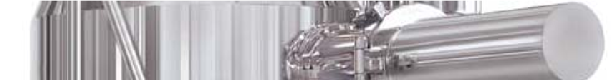  - Bowl Gross Volume: 400 liter  - Bowl working volume: 300 liter  - Bowl loading capacity 150 kg@ 0.5 depends on bulk density.  - MOC: S.S.316  - Bottom 8 mm thick of S.S.316 with radius corner machined.

- Shell in 5 mm thick
- Top flange 20 mm thick.
- Machine bowl designed with machined bottom plate with cylindrical body with top cone for fast mixing and radius corner for material fluidization.
- Bottom face has arrangement to connect drive with seal for main impeller.
- Side wall have arrange for shaft & seal housing for chopper to connect chopper drive.
- Side wall have discharge gate with hinged mounting and pneumatic operated.
- Top flange have hinge arrangement for top lid.
Mixing bowl top lid | 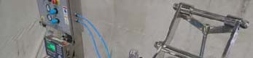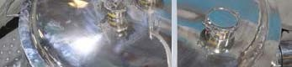  - MOC: S.S.316  - Made from 3 mm thick with decent shape.  - Top lid have Flange 20 mm thick.  - Top lid with radius corner, Flange with seal, Binder adding pot with lid, Eye glass and Air vent connection.  - Hinged top Lid with complete opening and closed/locking automatic by pneumatically.  - Top lid Pneumatic operated for close & open.  - Top lid with inter lock limit switch  - Top lid fix on bowl and locking with clamp. • Connection on top lid  - Dia.38 mm T.C. End connection for binder adding.  - Dia. 38 mm T.C. End connection for WIP/CIP system with spray ball nozzle and valve.  - Dia.25 mm with T.C. connection for Air vent with sanitary filter 5 micron.
Air filter at top lid. | - Filter is placed with aid of vent air filter for remove purging air and retained granules inside  - Cartridge type 5 micron in S.S.316 for air vent.
Mixing Blade & Drive Motor | 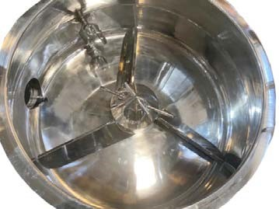  - Unique design with three arm mixing impeller with blade angle to pushing product radically outward.  - Main mixing impeller blade designed with 3 nos. paddle arms to create centrifugal force for mixing.  - Main impeller drive trough rigid gearbox with motor.  - 3 arm mixing blade with centrifuge force design.  - Mounting on direct shaft from bottom side.  - Drive Shaft fitted with Teflon seal with air pursing.  - The seals are cleaned by Air purging system so that the areas around the seals are germ free  - Mixing blade drive by reduction gear motor.  - Motor to gear box drive by belt.  - Gear box to drive shaft connect with chain coupling.  - Hollow Reduction gear Ratio: 1:10  - Motor: 40hp/30kw/3Phase/380v‐415v/50hz/1450rpm.  - Main Impeller Variable Speed 10 to 150 RPM by VFD.  - Mixing blade working operating link with top lid interlock.
Granulation Blade & Drive | 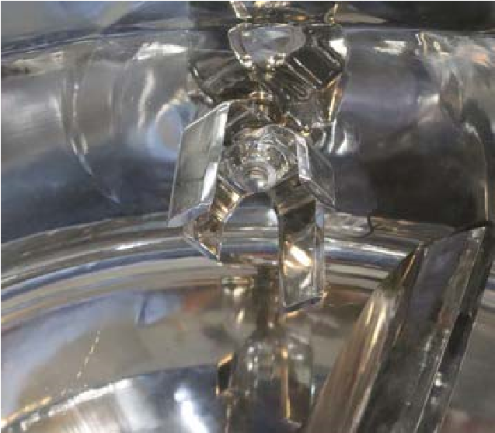  • These are specially designed small blades located at the side of the product mixing bowl. It rotates at high speed RPM to give easy and uniform granulation. Chopper cuts the wet lumps of the material int small sized parts those are mixed equally by the impellers and its speed is responsible for the size of the granules.
- “U” shape Intensify chopper blade with 2 nos. blade of each longer
& shorter with sharp edges for lumps cutting for granulation.
- Chopper blade drive coupled with directly motor shaft.
- Chopper blade designed to cuts lumps and make granules.
- Chopper blade Variable Speed 500 to 2800 RPM by VFD.
- Teflon seal provide for chopper blade shaft housing.
- Drives shaft seals are with Air purging system so that the areas around the seals are germ free.
- Fitted in horizontal axis.
- Chopper blade speed 500 to 2800 RPM By VFD
- Motor: 7.5hp/5.625kw/3phase/2800rpm
- Granulator motor operating is interlinked with mixing blade motor working.
Air pursing system for shaft seal | - Purging air is supplied in to taflon seal of impeller/ chopper blade shafts to prevent enter materials in seal and stick the materials to th impeller/ chopper and also helps prevents contamination.  - Provided air pursing with inter lock system.
Discharge Gate | 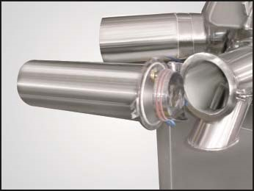  - A discharge port is located horizontally at side and bottom of the product mixing bowl.  - Materials discharge by gravity flow directly bowl of FBD. and there are option for wet milling by Cone Mill installed at discharge gate.  - The opening of the discharge port is operated by a pneumatic operated cylinder.  - Flush fitting discharge plug is electro pneumatically operated.  - Pneumatic operated discharge with interlocked limit switch.  - Discharge gate assembly is mounted with hinged assembly for complete open and interlocked with machine  - Pneumatic cylinder size 25 bore X 250 mm stroke Double acting type  - Interlock with limit switch.  - Discharge gate mount with inline cone mill.  - Discharge position provide as per plant requirements.
o e
- Discharge of cone mill have connection to connect suction pipe for transfer materials to FBD by Suction.
- Materials suction connection is having T.C. connection to connect at discharge of cone mill at discharge gate.
- Materials suction connection has one side dia.100mm T.C. connection for connect flexible pipe to FBD and another end have filter with ball valve.
Inline wet sieve cone mill –  Inbuilt with HSMG | 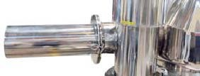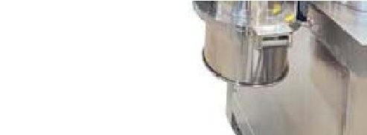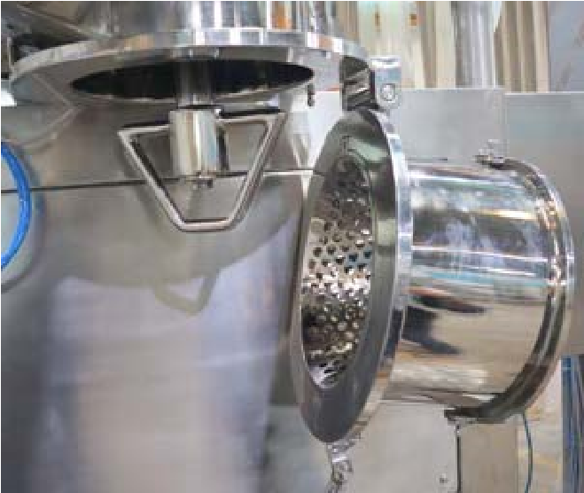  - Product can be discharged from the RMG directly into a receiving container, or via inline cone mill. This breaks down the granules to produce more even sizing for subsequent processing. Hinge‐mounte cone mill directly mounted on discharge gate.  - Inbuilt On discharge of the machine  - Provide to break lumps.  - Directly mounted on discharge gate of HSMG.  - Cone type blade with cone type sieve.  - Cone sieve have 12mm hole size.  - Cone blade speed is 100 to 1450 RPM Variable By VFD.  - Drive motor: 3hp/2.25kw/3phase/380v‐415v/50hz/1400rpm.
Machine Structure | 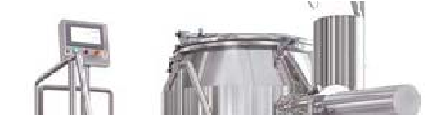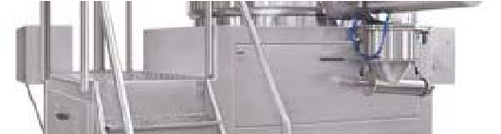  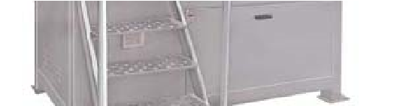  - Machine made with heavy duty M.S. Chanel structure with outside  S.S 304 with full cladded and covered.  - Base plate of the machine with embossed for anti slippage for safety  - Provided staircase with embossed step for anti slippage for safety
d
.

- Main Impeller Drive unit mounted on bottom compartment of structure.
- Bottom compartment front have with door.
- Top plate is having mounting for bowl and chopper motor, mixing blade drive unit and operating panel.
- Mixing blade drive unit mounting inside of the structure and bottom side of the top plate.
- Bowl and operating panel mounted on top of structure.
- Stair made from S.S.304 sheet with safety reeling.
- Embossed damped did on top plate and step of stair to avoid sleep.
- Stair at front side
- Stair and discharge at 90°
- Structure mounting on 4 nos. anti vibration pad.
Machine mounting | • 4 nos. Anti vibration pad.
 | - Provide binder spraying system with solution preparation vessel‐50 liter, weighing scale, peristaltic pump and spray nozzle.  - The solution spray system operates and controls by HSMG operating panel.
  Binder solution preparation
  vessel &
  Binder spraying system with
  Weighing scale.
❖ Solution Preparation Vessel
- Solution preparation vessel type: cylindrical, vertical, Jacketed,
Insulated, electric heated and slow speed stirrer.
- Shell MOC: 4mm thickness, SS.316
- Vessel working volume: 50 Liters
- Bottom disc: Torispherical shape full welded with shell MOC‐ 4mm of S.S.316.
- Top disc: Flat shape with 1/3 part hinged loose lid & 3mm thickness of S.S.316.
- Insulation with mineral glass wool.
- Insulation cover made from 1.2mm Thickness of S.S.340
- Vessel is mount 4 nos. legs.
- Vessel bottom have discharge flues bottom valve with Pneumatic operated.
- Jacket has connection for safety valve and pressure gauge.
- Top lid have connection for and CIP Wash with rotary spray nozzle.
- Stirrer type: Anchor stirrer with reduction gear motor.
- Stirrer mounts on top lid.
- Stirrer rotation speed up to 30 RPM by VFD.
- Reduction Gear motor drive.

- Gear Motor: 1hp/0.75KW/3phase/
- Heater Load : 2 kw
❖ Weighing Scale
- Provide weighing scale for vessel
- Make is Rudra Sensor
- Digital display provide to visualization weight.
- Synchronies with PLC Controls of the HSMG for binder spray flow controls by speed of Peristaltic pump.
❖ Peristaltic Pump
- Peristaltic Pump: 0.5hp/0.37kw.
- Pump capacity 50 ml to 12 liter per minute.
- Silicon Tube size: ID 18 mm
- Spraying nozzle type: Needle less atomizes.
- Orifice size 2mm.
❖ Spray Nozzle
- MOC: S.S.316
- Make: Spraytech
- Vertical mount On top lid with Triclove connection.
- Multi spray head.
- Internal mix setup.
- Fine droplet size.
- Anti drop spray nozzle.
- Auto shutoff.
- Flow rate 10liter to 50 liter per minute.
- Spray nozzle has thread to mount on top lid with nut.
Sound Level | 75Db from 1 meter distance.
WIP/CIP Arrangement‐  Provision | - The machine will be designed with an accent on cleanliness & easy accessibility to all parts to ensure easy maintenance and cleaning for changeover. The equipment must with stand cleaning with 70% ethanol, 70% IPA, Sodium Hydroxide, Sodium hypochlorite, detergents and hot water (up to 100°C).  - The connecting hoses, spray nozzle will be removable.  - Provide inbuilt provision for WIP/CIP washing of bowl and discharge gate with Rotary spray Nozzle with valve.  - The machine is inbuilt with provision for rotary spray nozzle for CIP/WIP washing. There is 1 no. spray ball nozzle is provides at top lid. The nozzle will be connected with Utilities/ Your CIP‐WIP system are available at your plant.  - Provides CIP/WIP washing rotary spray nozzle at top lid for washing

and cleaning.
- Dia. 32mm sprays nozzle/ ball with Dia.25 mm T.C. Clamping for easy to connect and remove.
- Dia.38mm T.C. Connection provide on top disc for Spray Nozzle.
- Provide manual ball valve at CIP/WIP Connection for Open/close CIP/WIP washing.
- Provide 3meter flexible wire breather hose pipe with Dia.25mm T.C. Connection both Side.
- The washing spray ball to be connect your centralize CIP/WIP system or utilities.
- This is not complete CIP/WIP system, it is provision only. We can provide CIP/WIP system if customer wish and we can offer on demands and as per site requirements.
Electric control panel | 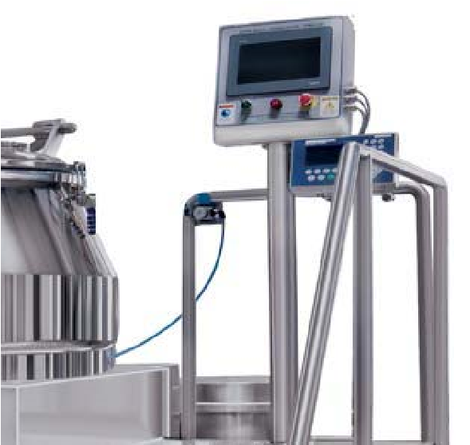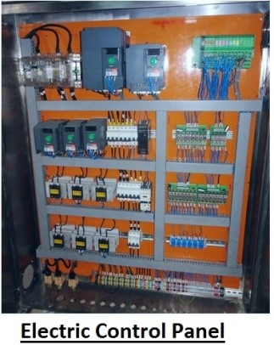  5  - Electric controls panel PLC controls with HMI touch screen operation controls.  - Electric Operating controls panels made from S.S.304 and it is installed in technical area.  - Main isolate switch –ON‐OFF  - Emergency switch –ON‐OFF.  - Electric panel with fitted main isolate switch, MCB, Contactor, Overload relay, Controls relay, PLC, VFD, SMPS etc.
PLC Controls system function | - PLC Controls with 10” HMI touch screen provide for operating and controls.  - Machine function Auto Mode & Manual Mode.  - ON‐OFF Main Impeller motor.  - Speed setting of Impeller blade.  - ON‐OFF Main Chopper motor.  - Speed setting of Chopper blade.  - Process on time base for dry mixing, binder adding, wet mixing and granulating with blade speed automatic.

 | • | Process controls on Ampere of Main Impeller motor & Chopper motor.
 | • | Air pursing ON‐OFF and it is inter lock with machine in auto mode.
 | • | Top lid –Open / Close and inter lock with machine in auto code.
 | • | Discharge gate – Open / Close and interlock with process.
 | • | Solution Preparation vessel heating controls for steam valve‐ONOFF.
 | • | Solution vessel stirrer ON‐OFF
 | • | Solution vessel stirrer speed controls‐ Increased‐ Decreased.
 | • | Solution vessel discharge valve ON‐OFF.
 | • | Solution weight display.
 | • | Binder Solution Peristaltic Pump ON‐OFF.
 | • | Binder solution Spray flow – Increased – Decreased with real measurement by weighing scale.
 | • | Solution nozzle sprays ON‐OFF.
 | • | Cone mill ON‐OFF with interlock with discharge gate.
 | • | Cone mill speed adjustment & set
 | • | WIP/CIP valve Open‐ Close.
 | • | Safety Futures: Process Interlock on time base & ampere base, Top lid, discharge gate, Air pursing inter lock and Air pressure.
 | • | Recipe Management for Products parameter
 | • | Main Isolate switch.
 | • | Emergency Stop Switch.
 | • | Electric panel fitted with main isolate switch, Power indicator, MCB, Contactor, Overload Relay, Controls relay, VFD, PLC & SMPS.
 | • | The electric panel will be installed in technical service area.
 | • | Electric panel Make: Rittal
Endpoint Determination | • | Different Techniques to determine Granulation end point are there. When particular set parameter is reached machine will stop automatically or change the cycle automatically.
 | • | Ampere load method:  The current which is used by Impeller and chopper motor to rotate when granules are formed ampere load on the impeller and chopper it will display on PLC with current amp display. When the set value of ampere is reached machine will automatically change the cycle or shut down.
 | • | Timer Mode:  When set time of the cycle has achieved value of ampere is reached machine will automatically change the cycle or shut down.
Sensors and Controls | • | Various sensors provided for operation and safety of personal &

equipment.
- RPM Proxy sensor for Speed of Impeller and Chopper Blade.
- Position Proxy sensor for identify discharge gate position.
- Limit switch for Top Lid. – Interlock with main impeller and chopper blade operation.
- Limit switch for Discharge Assembly. ‐ Interlock with main impeller and chopper blade operation
Pneumatics controls | - The process compressed air is required with filter of 2 micron and lubrication free for spraying ingredient at Pressure at 6 kg/cmP2P.  - The Pneumatic controls panel provided with necessary solenoid valve for automatic following function of the machine.  - ON‐OFF‐ Top lid Open – Close.  - ON‐OFF– Powder Discharge gate Open – Close  - ON‐OFF – Air purging
Safety features | - Total drive transmission system enclosed.  - Limit switch installed in the top lid ensure lid is closed.  - Air pressure switch installed to ensure pressure is in limit.  - Limit switch installed at discharge gate and assembly to ensure closed.  - Batch complete Process times & ampere inter lock.  - Controls wiring with 24 DC for safety.  - Emergency Stop button.
Operation in hazard situations | Utility failure  - The control system will work such that a utility failure does not break the process (Stirring operation) /system or cause hazardous situations).  - Programs must retain on electric power failure. System recovery after power failure must be possible.  - The stored data must retain on electric power failure.  - When reconnected after an electric power failure, the system must not start automatically any control actions without operator input.  Emergency stop  - Emergency stop the complete machine immediately in a safe way.  - Restart after emergency stop will be performed from the control panel by the operator in an easy and safe way.  - The Equipment will be equipped with switches for emergency stop. The switch/switches will be located in easily accessible places.  Alarms  - Error messages on control panel will be in plain text with fault code.

 | • All alarms shall be indicated by a light column & audible signal.
Make of Brought Items | - Reduction Gear Box: Elecon.  - Motor: Crompton Graves.  - PLC: Mitsubishi.  - HMI: Schneider.  - VFD: Schneider / Mitsubishi  - Contactor & Relay: Schindler  - Controls Relay: – BCH / Phoenix / Elmex  - SMPS: Phoenix / Multispan  - Isolator switch: Sulzer  - Pneumatic Cylinder: Festo/ SMC  - Explosion Electric Panel Box: Sai Industries.  - Electric Panel: Rittal  - Belt: Fanner  - Bearing: SKF/NTN/ZKF.  - Blower of Vacuum Transfer System: Garden Denver  - Weighing Scale: Rudra Sensor  - Peristaltic Pump: Flowtech / Ostech  - Spray Nozzle: Spraytech  - Silicon pipe & Gasket seal, O ring: Ami Polymer.  - Reduction Gearbox for Mixing Blade | Lifting:
 | Rotomotive/Bonfigilioli.  - Reduction Gearbox for Solution vessel  Rotomotive/Bonfigilioli.  - Safety Valve: Forbe Marshal  - Pressure Gauge: Bummer.  - CIP Spray Nozzle: Jet spray. | stirrer:
Require Utilities: | - Electric Power: 38.75kw/3phase/380v‐415v/50hz.  - Compressed Air: 7cfm @ 4bar pressure.  - Steam: Nil.  - Cooling Water: Nil.  - Hot Water: For washing required.  - Portable Water: NIL.  - Distilled Water : For washing required  - Purified Water: For washing required.  - Purified Steam: NIL
Documents & Certificate | Manuals and Maintenance Instructions  ▪ Operator manual.

- Installation and assembly instructions for all devices.
- User’s manuals for all components.
- Trouble shooting guide.
- Maintenance manual.
- Safety instructions.
- Training documentation.
Electrical and control diagrams
- Single line drawings for electrical distribution.
- Circuit diagrams.
- Cable list.
- Equipment location drawings for electrical equipment and instruments.
Qualification Protocols
- DQ protocols and reports.
- FAT protocol and report.
- IQ protocol and report.
- OQ protocol and report.
- DQ: Provide after received confirm order.
- FAT: Provide before machine gets ready for FAT & Trails.
- IQ, OQ, Machine Instruction & maintenance manual will be providing along with machine.
- DQ & FAT hard copy provide along with machine.
- PQ: PQ is not our scope of supply.
Test, Calibration, MOC Certification:
- All Test certificate for Brought Items will be provides during FAT with FAT Documents.
- MOC Certificate will be providing during FAT with FAT Documents.
- Calibration certificate provide for gauge during FAT.
- Above all certificate hard copy will be with FAT reports only.
Factory Acceptance Test (FAT) | - The supplier will perform FAT at the supplier’s facility with attendance of supplier/ buyer personnel. The FAT has to be successfully completed prior to delivery.  - The operational performance of the equipment will be verified during the FAT in complete tests.  - Buyer will bear Cost for FAT as per terms & condition.
Installation Qualification (IQ)  & Operation Qualification  (OQ) | - The supplier will provide test protocols for IQ and OQ covering requirements in the URS. The test protocols will be reviewed and approved by Buyer before the IQ/OQ is performed.  - The supplier will perform the IQ and OQ with attendance of
 |  | buyer’s personnel and write corresponding reports.
 | • | Buyer will bear Cost for SAT as per terms & condition.
Performance Qualification (PQ) | • | The supplier CANNOT provide test protocols for PQ performed. It is not scope of supply.
 | • | The suppliers will attendance during PQ. But not write any corresponding reports.
Recommended Spare | • | 1 No. Taflon Seal at shaft of Main Impeller.
 | • | 1 Set of spring at shaft seal of main impeller.
 | • | 1 No. Taflon Seal at shaft of Chopper Blade
 | • | 2 Nos. Silicon Gasket Seal at top lid.
 | • | 2 Nos. Gasket seal at Dia.150 T.C. Connection.
 | • | 2 Nos. Gasket seal at Eye glass window.
 | • | 1 No filter 5 micron at air vent.
 | • | 1 No, Toughen Glass for eye glass window.
 | • | 2 Nos. Gasket seal at Dia.38 T.C. Connection.
 | • | 2 Nos. Gasket seal at Dia.25 T.C. Connection
 | • | 1 seta of belt for main drive.
 | • | 1 No. Rubber of coupling of chopper drive.
 | • | 1 No. – Silicon tube for Binder spray.
 | • | 1 No. Controls relay card.
 | • | 1 No. Solenoid Valve.
 | • | 10 Nos. Pneumatic Connection.
 | • | 10 meter M8 Pneumatic Pipe.

IMAGE OF RAPID MIXER GRANULATOR:
*All Pictures shown are for illustration purpose only. Actual product may vary due to product enhancement.
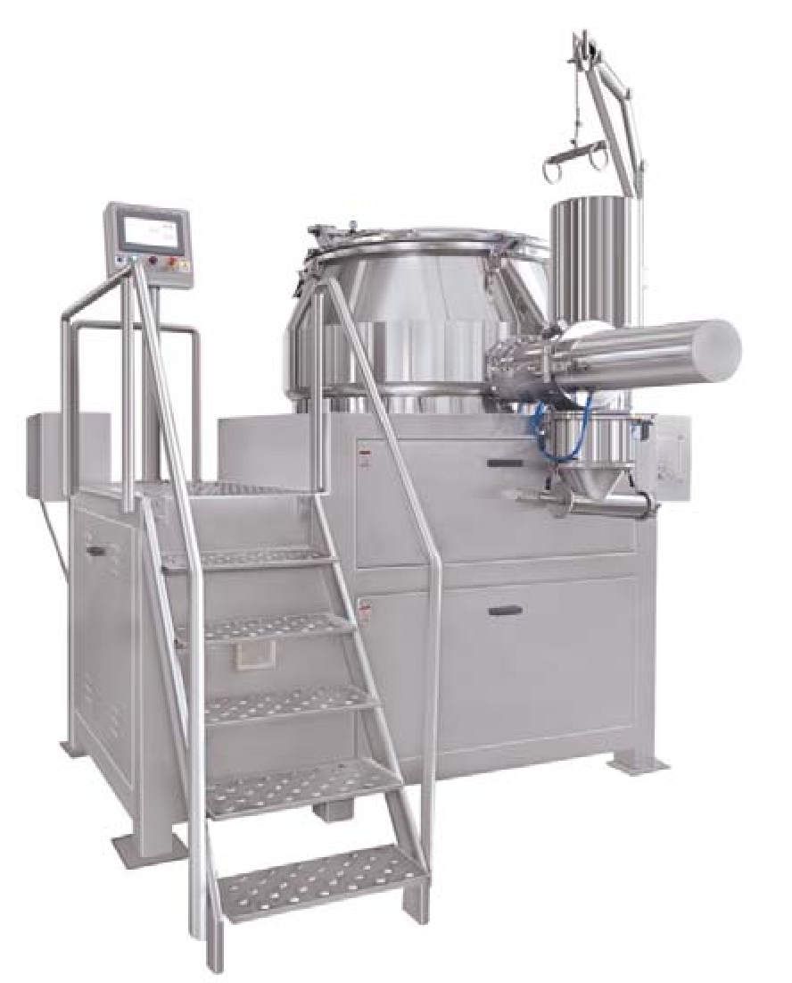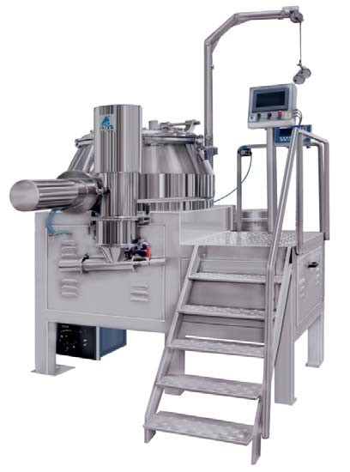

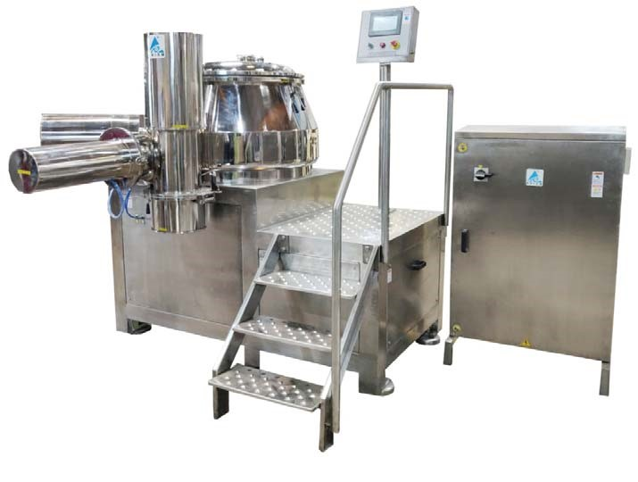

4. Prism Fluid Bed Dryer PFBD ‐ 150 GMP Model

Fluid Bed Technology offers an effective and efficient method for drying and agglomerating. The Fluid Bed Equipment has universal application for drying.

The PRISM Fluid Bed Dryer cGMP Model offers an effective and efficient method for drying, and agglomerating. It is invented keeping in mind the latest cGMP norms with all contact parts AISI 316 Quality. By using modular construction and simplified design we provide flexible installation. The Machine is vertical type, electric/steam Heated, Flame proof construction, PLC controls Auto Mode, and suitable for efficient accurate and uniform drying wet granulated pharmaceutical solid powder at desire temperature Atmosphere to 85°C.

PROCESS:
It works on the principle of air flow. The process is as follows.
Step 1 : Mixing
Dry mixing by fluidizing the material in the machine

Step 2 : Agglomeration / Granulation & Drying
Mixed wet powder is loaded in bowl of FBD from Mixer machine. The wet powder is fluidized by stream Atmosphere to 85°C m of filtered hot air so it’s get agglomeration & dries the powder at desire temperature.

Technical Description of the Machine: FLUID BED DRYER

- Retarding & Expansion chamber with Top Disc:
The Fluid Bed Dryer has one single piece chamber for expansion & retarding chamber. The chamber is connected with top retarding chamber with full welded and smooth finished. Retarding chamber is designed for filter bag mounting and which are connected with exhaust air duct with pneumatic operated valve having arrangement to hold filter bag. The expansion chamber is provides suitable distance from carrier bed to filter bags for fluidization of powder for drying. The expansion chamber is designed with to easily drop down granulation and drying dwell time for granules. The expansion chamber is having explosion gate with rapture disc. The expansion chamber is holding on 2 nos. pillar structure. An expansion chamber is made from S.S.316 Quality with arrangement to hold inflatable seal at to seal for product container

The retarding chamber is having following arrangement. The retarding chamber is manufactured out of S.S. 316 Quality & made out in single piece construction with decent type top disc.

      - 2 Nos. Flange provided for resting retarding chamber on pillar.
      - Filter bag housing and sealing arrangement.
      - Filter bag Hinging and shaking system.
      - Eye glass window with toughen glass for visualization.
      - Explosion vent at top disc for safety.
      - Exhaust air vent at top disc.
      - Provision for WIP washing at top disc with spraying nozzle.
      - Light window with toughen glass and FLP Light.
      - Arrangement to hold silicon inflatable seal at bottom to seal product container.

- Explosion Vent:
As per standard practice explosion vent is provided on top disc and it is connected with duct to outside production area for safety purpose. The explosion vent is fitted with rapture disk with aluminum material and tested at 2 bar pressure to tear. Also additional explosion vents are provided in the Inlet Air duct and Exhaust air duct for safety.

- Supporting Pillar:
The supporting pillar is made from hollow square pipe of S.S304 quality. It is provides complete base structure of the machine. The retarding chamber is resting on these 2 nos. supporting pillars. The pillars are grounded with anchor fastener bolt with ground and bottom chamber is also give support and hold two pillars in parallel position and holding complete assembly line in centre. Pneumatic cylinders for filter bag hinging and shaking are mounted inside the supporting pillars.

- Filter Bag Housing and Auto Shaking:

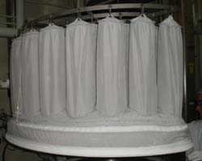
The filter bags are mounted inside of the retarding chamber with inflatable silicon seal. Filter bags are fitted on housing ring with steel strip and hinging with fingers of filter bag with hinging ring. The hinging rings are fitted and hinging with rope and the ropes are connected with pneumatic cylinder assembly for shaking and up down for changing.

The filter bags are shaking automatically by pneumatic cylinder that does auto shaking of filter bag periodically based on timer set value. The filter bags for top spray and bottom spray. The filter bag is made from Satin material with 5 micron.

- Product Container:
The Product Container made from S. S. 316 quality fitted with S. S. 316 Dutch Hollander wire mesh sieve 24 x100 mesh size with supported plate is special air diverter type designed for proper air distribution in circulation patterns. The Dutch Hollander sieve and perforated sieve assembly are fitted by quick released assembly for cleaning. A manual sampling pot provided with slotted bar for taking sample during working of process without disturbs and stop of the process. The product container is having toughened Eye glass window for process visulation and mirror finished. The same container can be used for only drying process for powder without spraying system. The following arrangements are having product container.
      - Quick Locking arrangement for air distribution plate and sieve.
      - Sampling pot.
      - Special designed embossed sieve for circular air distribution.
      - Dutch Hollander sieve with 24 x 100 mesh size with silicon seal.
      - Eye glass window with toughen glass.
      - Product bed temperature probe.
      - Arm 3 nos. for resting on trolley.
      - Interlink with safe earthling for static current.

- Container Trolley:
The container trolley is made out of S.S.304 pipe. The trolley is used for resting of product container and load and unload product container on the machine. The trolley is fitted with 4 nos. PU castor wheels for easy mobility.

- Bottom Chamber:
The bottom chamber is designed with decent to distribute air flow on bottom side of the product container. The bottom chamber is connected at side with inlet air handling unit with inlet air damper. Top flange of the bottom chamber is having seal for sealing with product container. The bottom chamber is having centre discharge for drain water during washing and cleaning. It is bolted with supporting pillars from both side and its keep centre of the machine. Bottom chamber is having bottom support legs and made from S.S.316 Quality.

- Sealing Mechanism:
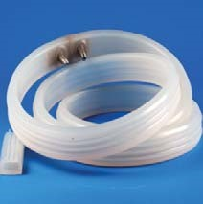
The Pneumatic inflatable silicon seals are provided to seal following items.
    - Between Bottom Chamber and Product container.
    - Between Product Container and expansion chamber. • For Filter Bags

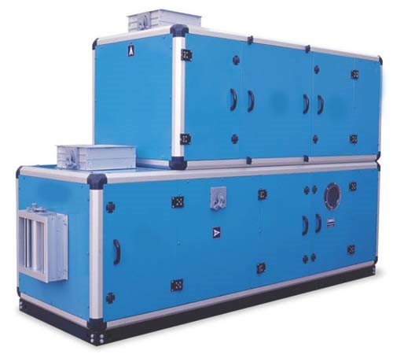
- The Inlet Air Handling Unit:
The Double skin Air Handling Unit is constructed with strong Extruded aluminum framework. Unit comprising Pre‐filter section 10 micron filter, Dehumidifier with child water circulation coil, Heating section with electric coil/steam heating coil, Micro Vee plenum with 5 micron Micro Vee filter and Super HEPA filter plenum with 0.3 micron Super HEPA filter. Panels are of double skinned type with 50 mm thick “RPUF” insulation material. Panels for AHU made from 24 SWG thick. S.S. 304 sheet duly powder coated on outside surface, inside skin of panels made from 24 SWG
S.S. 304 sheet.

The inlet air handling unit fitted with door and air filter with electric heating arrangements.
The entire unit is separately installed in the service zone to avoid interference of the maintenance people in the production zone.

- Inlet Pre Air Filter:
The inlet air system comprising of 10 micron pre‐filter and atmosphere air passed prior to dehumidifier. The filter is made from HDPE washable material.

- De‐Humidifier:
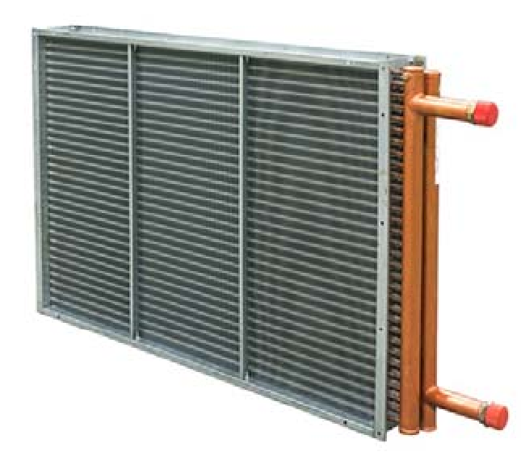
The dehumidifier unit comprises of chilling water circulation coil for maintaining the proper humidity of inlet air. The child water supply by end user as utilities is the end user have not facility than can be supply separate chiller as option at extra cost for child water supply to child water circulation coil.
The configuration of de‐humidifier shall be shell and Tube Type (Extended area), Multipass, fixed head type having chilled water inlet and outlet connections completed with bonnets, pass participation plates and entertainment separator, duly mounted on structural support. Tubes shall be of copper materials and Finns shall be made of Aluminum.
Child water inlet valve is provided with automatic ON‐OFF with synchronized RH value of inlet air and maintaining proper RH Value as desire and sets in PLC Controls. Dehumidifier shall be mounted prior to electric heater/ steam Heater.



Customer Name | Caspian Cleanroom | Country | Iran
Quote Ref No & DT |  | Page No | 38 of 114

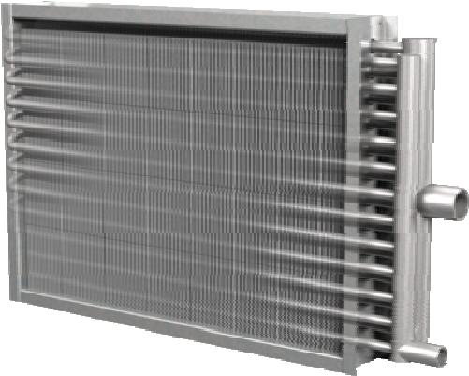
- Heat Exchanger: – Steam
The Steam Coil is providing to exchange heat as per capacity of the machine requirement as per end user requirements. The exchanger is made from S.S.304 with fins of s.s.304. The heat exchanger is shell type with fin s to extended surface area and multi pass heat exchanger providing adequate heat transfer area to ensure the temperature of air.

- Final Filter:
Final filter‐5 micron is placed after Heater Exchanger in the inlet Air Handling Unit. The filters are mounted on receptacle wall with suitable gasket to prevent any leakage.

- HEPA Filter:
HEPA 0.3 micron Filter is mounted at last and provided for final filtration. The filters are mounted on receptacle wall with suitable gasket to prevent any leakage.

- Service Door:
All doors are provided with suitable knobs. Doorframes are sealed with specially designed gasket to prevent leakages and easy service to any internal part of the Inlet Air Handling Unit.

- Inlet Air Damper:
Inlet air damper is provided at the suction of the machine at bottom chamber. These are Provides to isolate the machine from atmosphere when machine is switched off. Dampers are operated through the pneumatic actuators. Stainless steel 304 construction fulfills the cGMP Requirements.

- Exhaust Air Unit With Dust Collector
Exhaust Air Handler is through blower and filtration unit with filter bag‐5 microns and air blow bag System for shaking and dust collection container 20 Liter. This filtration unit removes any residual Discharge and meets the strictest emission Laws and dust is collected in container.
One of the important features is the control of air volumes, which in most cases is done via AC frequency drives, thereby giving total control over the process and saving energy too. The exhaust air filter unit is meant to collect the impurities from the exhaust air. It is provided at exhaust side of the machine before exhaust blower. It consists of filter unit structure, Filter, and dust collection container. The exhaust air filter unit is made from S.S. 304.

  - Exhaust Dust Filtration (Dry Scrubber):
Exhaust Air Handler is through blower and filtration unit with filter 5 microns. This filtration unit removes any residual discharge and meets the strictest emission Laws and

dust. One of the important features is the control of air volumes, which in most cases is done via AC frequency drives, thereby giving total control over the process and saving energy too. The exhaust air filter unit is meant to collect the impurities from the exhaust air. It is provided at exhaust side of the machine before exhaust blower. It consists of filter unit structure & Filter‐ 5 micron. The exhaust air filter unit is made from S.S 304.

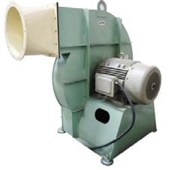
  - Exhaust Fan Blower
The exhaust Air Blower is centrifugal type with having back ward curves type fan and direct mounted on motor shaft. The blower and motor assembly is mounted on M.S. structure to easy installation. The fan is dynamic balanced for vibration free. Also provided anti vibration pad avoid vibration. The fan is made from Aluminum and casing is made from M.S. with epoxy painted. Blower is fitted with Compton make motor. The ac frequency drive is provided to vary speed of blower to adjust air flow for fluidization.

  - Exhaust Air Flow Controls:
One of the important features is the control of air volumes for fluidization, which is done via AC frequency drives means speed of blower, thereby giving total control over the fluidized process and saving energy too.

  - Exhaust Damper:
Exhaust dampers are provided at the discharge of the machine. They are provided to isolate the machine from atmosphere when machine is switched off. Dampers are operated through the pneumatic actuators. Also exhaust dampers are synchronized with filter bag shaking system for ON‐OFF during filter bag shaking. Stainless steel 304 constructions fulfill the cGMP requirements.
- Inlet Air and Exhaust Air Duct:
The air duct is used to transfer hot filtered air from inlet air from inlet air handling unit to the Fluid Bed Equipment and from Fluid Bed Equipment to Exhaust Air Handling unit and then to atmosphere through exhaust blower. Stainless steel 304 construction fulfills the cGMP requirements.
Ducting between Inlet Air Handling Unit and the Equipment are insulated to minimize heat loss and provide safety against accidental contact with hot surface. There is zero leakage in the air duct. All duct pipe having flange end so all joint of pipe and bend are connected easy with flange and blots with silicon seal.

- Safe Earthling system:
The safe earthling system is consists of specially manufactured spring loaded dual earthing device duly connected with a low voltage relay to absorb any static charge development. The spring loaded dual earthlings to be touch with product container and passed the static currants low voltage relay to absorb.

Customer Name | Caspian Cleanroom | Country | Iran
Quote Ref No & DT |  | Page No | 40 of 114

Temperature Controls:
Temperature sensor provided in inlet air, which is sense, the inlet temperature and controls the temperature as desired temperature. Also provides temperature sensor at outlet air duct to sense outlet air temperature and at product container to sense product bed temperature. The Temperature sensor PT‐100 RTDT provided for following
    - Inlet Air and controls as desired set value.
    - Product Bed and display in touch screen and desire set value the process is stop. • Exhaust Air display in touch screen.

- Automatic Filter Bag Shaking System:
The filter bag shaking system is completely automatically with consists of pneumatic cylinders and pneumatic solenoid valves and it’s synchronized with exhaust dampers and automatically work based on time setting by PLC controls systems.

- Powder escapes prevention system:
The powder escapes system is provided for sensing solid particles in exhaust air by solid flow monitor sensor at exhaust air duct. The filter bag is not proper sealed and if tearing then its failure to stop solid particles in the chamber then solid particles are passed in exhaust air that time this the solid flow sensor will sense the Fluidized solid particle going out of exhaust and immediately switch off the blower with alarm to prevent the loss of material.
The solid flow Sensor for torn filter bag or solid particle detection system if opted for ensures contained process. It stops the machine if there is any detection of solid particles in exhaust duct of the machine.

- Differential pressure gauge:
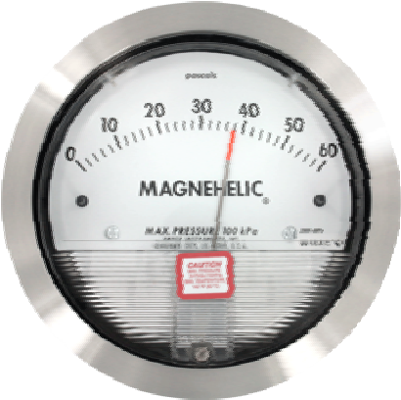
The Magnehelic differential pressure gauges are provided for measure pressure differential across following filter.
    - Across HEPA Filter of inlet air handling unit.
    - Across Product Bed sieve at product container.
    - Across Filter Bag at retarding chamber.
    - Across filter at exhaust air unit.

- Lighting Arrangement:
The Flame proof light 100 watt/ 220 V/1 phase/50 hz provided and fitted on expansion chamber with toughen glass window. The Flame proof light can be ON round the clock and on and off function to be with touch screen.

- Electric Control Panel: PLC BASED AUTOMATION PANEL with 10” HMI TOUCH SCREEN:
The Fluid Bed Dryer system is operated through a user friendly integrated control panel suitable for automatic operation. The panel includes PLC and HMI TOUCH SCREEN with necessary hardware and software to meet requirement of process. The material of construction of the panel shall be of AISI 304 Q. The Electric Power Panel made from S.S 304 and installed in utilities area.
The control parameters include system monitoring, control, feedback and data acquisition and processing. Provide total security and easily add or delete product recipe with proper password access. The Controls panel having the following features:

  - Automatically controlled process parameters with indication and display as:
    - Complete Process cycle controls on timing by PLC
    - Inlet Air Temperature PID Controls.
    - Exhaust Air and Product Bed Temperature Display
    - Exhaust Blower RPM
    - Product wise parameter / programming memory.

  - Automatic stoppage of machine in case of. • Inlet air temperature blower sets value.
    - Atomization of air pressure falls below set point.
    - Solid particles are detected in exhaust air.
    - Safe earthling is not connected/Product container is not in position.
    - Sets Process time completed.

  - Receipt Management
    - Operation history Reports with set data and actual data with print timing.
    - 20 product data save in receipt management.
    - Online cyclic printing of functional data during operation.

- Safety Features:
    - If process air is below set value then complete process is stop.
    - If solid particles are found in exhaust air then complete process is stop.
    - Safe earthling is not connected then process is not start.
    - If product temperature is overheated then stop complete process. • Automatic stops when process is completed.

- Compressed Air and Pneumatic Panel:
The process compressed air is required wish filter with 2 micron and lubrication free for spraying Ingredient at Pressure at 6 kg/cm². The Pneumatic controls panel provided with necessary solenoid valve for automatic following function of the machine.

    - ON‐OFF – Inlet air Damper with pneumatically.
    - ON‐OFF – Exhaust air Damper with pneumatically.
    - ON‐OFF – Steam Inlet Valve – ON‐OFF if steam heated.
    - ON‐OFF – Child water Inlet Valve – ON‐OFF for dehumidifier.
    - ON‐OFF – Sealing of Inflatable seal at bottom chamber.
    - ON‐OFF – Sealing of Inflatable seal at top of product container.
    - ON‐OFF – Sealing of Filter bag
    - ON‐OFF – Shaking of Filter bag
    - ON‐OFF – Hinging of Filter bag

TECHNICAL SPECIFICATIONS:
MODEL | PFBD ‐ 150
Type of Device | Automatic Fluid Bed Dryer
Machine Standard | Current Good Manufacturing Practices
Application & Function of machine | Drying of wet follow able materials and agglomeration of wet materials.
Machine Standard/ Construction guide line | - The Current state of the art GMP Compliance.  - European Medicine Agency (EMA) and USFDA Regulations compliance.
Machine design Standard for safety | - The European Machinery Directive 2006/42/EC  - The European Low Voltage Directive 2014/35/EU  - ISO/TR 12100:1992: Safety Of machinery (Basic Concepts, general Principle of design), part 1 & 2.  - ISO 15534:2000: Ergonomic Design for the safety of machine, Part 1 &2,  - ISO 13849‐1:1999: Safety Machinery – Safety related parts of controls systems‐parts 1: General Principle for design.  - ISO 13850:1996: Safety of machinery‐Emergency Stop‐  Principles of design.  - ISO 13852:1996: Safety of Machinery‐ Safety distance to prevent danger zones being reached by upper limbs.  - ISO 13853:1996: Safety of Machinery‐ Safety distance to prevent danger zones being reached by lower limbs.  - ISO 13854:1996: Safety of Machinery‐ Minimum gaps to avoid crushing of parts of the human body.  - ISO 14110:1998: Safety of Machinery –Interlocking devices associated with guards‐ principles for design & selection.
Room Condition | - Room temperature : NMT 18 to 27 °C  - Relative humidity : NMT 30 to 65%

- Zoning : Class D Grade
- Pressure : 10 Pa
Material and surface finish of parts in contact with the product | - AISI 316  - Taflon, Silicon food grade USFDA  - Ra ≤0.5 Mirror finish.  - All contact parts rather that stainless steel should be food grade material.
Material and surface finish of parts not in contact with the product | - AISI304  - Ra ≤0.85 Matt Finish
Material and surface finish of outer surface | - All material used in the equipment will be durable type.  - The outer surface shall be easy to clean.  - Outer surface finish of stainless materials in classified rooms will be mirror polished to Ra  0.9 m, if not otherwise stated.
Non‐metallic materials | - Elastomers in direct contact with the product will be according to FDA Code 21 CFR 177  - All non‐metallic materials used in the equipment will be of durable type and must withstand cleaning with ethanol 70% and detergents.  - Gaskets, diaphragms and O‐rings in direct contact with the product will be PTFE and/or EPDM or Silicone.  - Oil in instruments in direct contact with the product will be according to FDA Code 21 CFR 172.
Powder charging/ Loading | • Gravity from discharge of HSMG in bowl of FBD.
Discharge of materials/ Unloading | By gravity from discharge of High shear mixer granulator.  OR  By Manually
Product Container Capacity | - Gross Capacity: 450 Liter  - Working Capacity: 150 Kg.
Operating Modes | PLC Controls with 10” Color touch screen –Automatic & Manual Mode.
Operating Temperature | Control able between Atmosphere/ 20®C to 100° C
Explosion pressure | 2 bar rapture disc.
Temperature sensing & Controls | - Atmosphere Air temperature: Display.  - Dehumidify Child Air temperature: SET ‐ ACTUAL ‐ Controls set point controls.  - Inlet Hot Air: SET ‐ ACTUAL ‐ Controls set point controls  - Product Bed Temperature: Display & high set value shutoff

 | • | Exhaust Air Temperature: Display & high set value shutoff
Retarding & Expansion Chamber | - • • • •  - • •  • | MOC S.S.316 of 3 mm thick.  Single piece Retarding and Expansion chamber.  The Retarding & expansion chamber is mounted on 2 nos. pillar.  Top disc Torrispherical shape and full welded with retarding chamber.  Filter bag shaking arrangement by rope with pneumatic cylinder.  Explosion vent with 2 bar pressure at top disc.  Exhaust air pipe connection at top disc.  Filter bag shaking & sealing arrangement by inflatable silicon seal.  Product container sealing arrangement by inflatable silicon seal.
 | • | Connection for differential pressure for Filter bag & product sieve.
 | • | Eye glass window
 | • | Light glass widow with FLP light.
 | • | WIP – Spray Rotary nozzle at top disc.
 | • | Provide Dia.38 T.C Connection at top of the retarding chamber to mounting spraying ball.
 | • | The washing spray ball to be connect your centralize CIP/WIP system or utilities.
 | • | This is not complete CIP/WIP washing system.
Filter bag arrangement | • • •  • | Provides fingers type filter bag  Provide filter bag hanging assembly with rope.  Filter bag shaking by pneumatic cylinder on time basis.  Filter bag up and down by rope assembly with pneumatic cylinder.
 | • | Filter bag MOC: SATIN.
 | • | Filtration 5 micron
Product container | • • • | MOC: S.S.316 of 3 mm thick  Cone shape product container with top and bottom flange welded.  Top flange have “C” type for safety to attach with machine chamber.
 | • | Bottom flange having attachment to connect bottom supports plate with easy clamping.
 | • | Supported plate is a special designed with embossing for

 |  | circular air flow of powder in the chamber.
 | • | The supported plate is a fitted with bottom sieve 110x24 mesh Dutch holder sieve.
 | • | Supported plate is having easy clamped to connect with product container.
 | • | Provide spring loaded sampling pot with bottle on product container.
 | • | Provide Dia.100mm Eye glass window with toughen glass.
 | • | Provide discharge gate with pneumatic operated at bottom of container for unloading materials by suction by VTS.
 | • | Provide Dia.80mm T.C. Connection to connection suction pipe for materials loading.
 | • | Product container is a mount on trolley with 4 nos. wheel
 | • | The trolley have wheels with 2 nos. are fixed and 2 nos. are swing type.
 | • | Product container is a connected with Safe earthling for static current.
 | • | Proxy sensor for position is in place.
 | • | Temperature sensor probe for product bed.
Bottom Chamber | • •  • | MOC S.S.316 of 3 mm thick.  Mounted with 4 nos. legs and supported with pillar.  Arrangement for inflatable silicon Seal for product container.
 | • | Connection for Inlet air from rear side.
 | • | Drain connection with manual ball valve.
Inlet Air Handler | - •  - • • • | Type: Double scan handling unit with insulation.  Dedicated Gas tight Housing, Double Walled Insulated AHU for inlet air for controlling of inlet air temperature, humidity, and quality  MOC Inside: S.S.304 of 24 SWG.  MOC outside: Galvanize with powder coated with 24 swg.  Insulation : PUF  AHU Capacity: 1700cfm / 3000m³/hr.
 | • | Inlet AHU consists of Pre filter, Dehumidifier, Heat Exchangers, Final filter and HEPA Filter.
 | • | Inlet air AHU will be install in technical service area.
 | • | Freeze protection system with Freeze protection flap. This flap prevents ambient air from entering the inlet air handling unit while not in operation.
 | • | Inlet air Pre Filter H‐7( 5 micron)

 | • | Differential pressure gauge (0‐250 Pa) Magnehelic gauge mounted on AHU for pre filter.
 | • | Dehumidifier child water/Brain circulation coil.
 | • | Heat Exchanger : Saturated Steam coil of Seamless pipe S.S.304 with fins of S.S.304
 | • | Steam heated steam consumption: 140 kg/hr @ 4 bar
 | • | Modulating steam controls vale.
 | • | Steam trap valve.
 | • | Pneumatically operated Steam condensate valve is provided, operated from HMI.
 | • | Inlet air fine Filter H‐7 ( 5 micron)
 | • | Differential pressure gauge (0‐250 Pa) Magnehelic gauge mounted on AHU for fine filter.
 | • | HEPA Filter H‐13 ( 0.3 micron)
 | • | DOP door for HEPA Testing.
 | • | Differential pressure gauge (0‐1 KPa) Magnehelic gauge mounted on AHU for HEPA filter.
 | • | Pneumatic operated dapper
 | • | Inlet air flow sensor probe (CFM).
 | • | Inlet air RH sensor Probe.
 | • | Inlet Hot air temperature probe.
 | • | Non‐Flame proof lamps mounted on view ports on the outer surface of the air handling unit, All three filter chambers and face and bypass area are lit by these lamps.
 | • | Limit switches for all service doors of the AHU with interlock for machine tripping in case of open door.
 | • | Humidity of inlet air is measured (in a cooling bypass for improved measuring accuracy.) by Absolute humidity sensor with a measuring range of: 0 ‐ 50 g/kg.
 | • | Δp across all filtration elements (G4, F8 and H13 HEPA filter) for initiating filter change alarm.
 | • | Pre Filter Make: Freudenberg
 | • | Type of Pre Filter: Combination Filter
 | • | Pre filter: 10 micron
 | • | Pre Filter Grade: EU – 3
 | • | Pre Filter Media: ALU mesh + GF Cloth + GF Tissue + GF Clo
 | • | MOC OF Casing : Aluminum Extrusion + sheet
 | • | Pre filter efficiency: 90 to 95 % down to 10 micron.
 | • | Initial pressure drop : 10.5 – 12.5 mm of WC
 | • | Final pressure drop : 30 mm of WC

 | • | Maximum Sustainable Temperature: up to 120°C
 | • | Differential pressure transducer indication (0‐250 Pa) and alarm.
 | • | Dehumidifier type: Child water circulation coil
 | • | Dehumidifier coil MOC: Copper Tube with aluminum fins.
 | • | The dehumidification system is designed for an ambient air condition of 32°C and 40% RH. Dew point of 10 deg C is achieved subject to an inlet temperature of 6 deg C (Dew point achieved will be 4 deg plus inlet water temperature) and a max. process air humidity level of 8 gm/kg. Requires cold water supply temperature +6°C / return temperature +12°C.
 | • | Child water/Brain Circulation: 80 liter per minute‐ Recirculation.
 | • | Child water/ Brain temperature: 6° C
 | • | Child air temperature: 10°C depends on atmosphere air temperature.
 | • | Child water inlet connection: 40 NB with ON‐OFF Valve
 | • | Child water outlet connection: 40 NB
 | • | Child water/brain temperature sensor.
 | • | Heat Exchange type: Saturated Steam coil
 | • | Saturated Steam Coil MOC: S.S.304
 | • | Steam coil Type: Tube with fins.
 | • | Working temperature : 40°C to 130°C
 | • | Design pressure : 6 kg/cm²
 | • | Working pressure: 6 kg/cm²
 | • | Hydro test pressure: 9 kg/cm².
 | • | Saturated Steam Consumption: 140 Kg/hr.
 | • | Hot air temperature: Atmosphere to 90°C depends on steam temperature.
 | • | Steam inlet connection: 40 NB with 150glass flange and steam modulating control valve.
 | • | Steam trap condense connection: 40 NB with 150glass flange and steam trap valve
 | • | Valve:  - Steam controls Modulating valve.  - Steam by pass Ball vale.  - Steam trap valve.
 | • | Final Filter Make: Freudenberg
 | • | Type of Final Filter: Flange ‐ Plated

 | • | Final filter: 5 micron
 | • | Final Filter Grade: EU – 5
 | • | Final Filter Media: HDPE + Non Woven + AL Mesh
 | • | MOC OF Casing : Aluminum Extrusion
 | • | Pre filter efficiency: 90 to 95 % down to 5 micron.
 | • | Initial pressure drop : 6.5 – 7.5 mm of WC
 | • | Final pressure drop : 18‐19 mm of WC
 | • | Maximum Sustainable Temperature: up to 120°C
 | • | Differential pressure transducer indication & Alarm (0‐250 Pa).
 | • | HEPA Filter Make: Freudenberg
 | • | Type of HEPA Filter: Box ‐ Plated
 | • | HEPA filter: 0.3 micron
 | • | HEPA Filter Grade: EU – 13
 | • | HEPA Filter Media: Sub Micronics Glass Fiber
 | • | MOC OF Casing : Aluminum Extrusion
 | • | Pre filter efficiency: 90.997 % down to 0.3 micron.
 | • | Initial pressure drop : 25 mm of WC
 | • | Final pressure drop : 60 mm of WC
 | • | Differential pressure gauge for HEPA
 | • | Maximum Sustainable Temperature: up to 120°C.
 | • | Differential pressure transducer indication & Alarm (0‐1 KPa).
Exhaust air blower & Exhaust Air filter Unit. | • • • •  • | Separate Exhaust air filter Unit will install in technical area.  Exhaust Air filter unit provide with 5 micron filtration.  Exhaust air filter unit made from M.S. Epoxy Painted  Nos. of Filter 4 Nos.  Filtration: 5 micron.
Exhaust air blower & Exhaust Air filter Unit. | • •  • | Separate Unit will install in technical area.  Blower type: Centrifugal.  Casing is made from M.S. with epoxy painted.
 | • | Blower is made from S.S.304.
 | • | Dynamic balanced fan with direct mounted on shaft of motor.
 | • | Blower capacity 1600cfm / 2700m³/hr.
 | • | Blower Static Pressure 900mmHg.
 | • | Blower motor: 20hp/15kw/3phase/2800RPM/38v‐  415v/50hz.

 | • | Blower air flow controls by VFD.
 | • | Blower mounted on 4 nos. anti vibration pad.
 | • | Exhaust air Temperature sensor probe.
 | • | Silencer provide at outlet of blower.
Inlet Air Duct and Exhaust Air duct. | •  • | Provide 3meter long Dia.300mm inlet air duct with flange connection and made from S.S.304 to connect Inlet AHU Provide 3meter long Dia.300mm Exhaust air duct with flange connection and made from S.S.304 to connect exhaust filter unit and blower.
 | • | Provide Dia.300mm Butterfly valve with pneumatic actuator for inlet air and exhaust for machine isolation.
 | • | Provide solid flow sensor at exhaust air duct for sensing solid particles.
CIP/WIP Arrangement | • • • •  • | Clean in palace/Wash in place provision is inbuilt with machine.  Provide Rotary spray nozzle with operated valve at top of the chamber for washing.  Provide Rotary spray nozzle with pneumatic operated valve at bottom chamber for washing.  Provides drain connection with pneumatic operated valve at bottom chamber.  CIP/WIP pipe connection 25mm with triclove.
 | • | Provide 3meter flexible wire breather hose pipe with Dia.25mm T.C. Connection both Side.
 | • | The washing spray ball to be connect your centralize CIP/WIP system or utilities.
 | • | This is not complete CIP/WIP system, it is provision only. We can provide CIP/WIP system if customer wish and we can offer on demands and as per site requirements.
Sensor and controls | • • • •  • | Provide Ambient Air Temperature Sensor probe at AHU.  Provide Child air Temperature Sensor probe at AHU.  Inlet Air Flow Sensor (CFM) at Inlet air duct.  Inlet air RH Sensor at Inlet Duct.  Provide Inlet air Temperature Probe at Inlet Duct.
 | • | Provide Product bed Temperature at Bowl.
 | • | Provide Exhaust air temperature probe at Exhaust Duct.
 | • | Solid Flow Detection Sensor at Exhaust Duct.
Differential Pressure Gauge | • | Provide Magnehelic Differential pressure gauge for HEPA  Filter.
 | • | Provide Magnehelic Differential pressure gauge for Product

 |  | bed sieve.
 | • | Provide Magnehelic Differential pressure gauge for Filter Bag
Electric Controls Panel  with PLC Controls & HMI Touch Screen | •  • | PLC Controls Phoenix with 10” HMI touch screen.  Operating Panel fitted on the machine.
 | • | Automatic controls by PLC & Manual Mode controls for ONOFF and manual shaking.
 | • | Manual Mode screen
 | • | Auto mode screen
 | • | ON‐OFF Blower
 | • | Blower speed SET‐ACTUAL for air flow controls by VFD.
 | • | Inlet air Temperature PID Controls screen – SET‐ ACTUAL and set value controls.
 | • | Product bed temperature ACTUAL‐ SET overshoot valve for shutoff.
 | • | Exhaust air temperature ACTUAL‐ SET overshoot valve for shutoff.
 | • | Process Drying time SET‐ACUAL & SET Value controls.
 | • | Interlock sealing of filter bag and product container in auto mode with blower.
 | • | Manual / Auto sealing of filter bag & Product container.
 | • | Manual / Auto shaking of filter Bag.
 | • | Recipe management.
 | • | 3 levels pass word controls.
 | • | Interlock process screen.
 | • | Batch data parameter screen.
 | • | Alarm History screen
 | • | Auditor trail screen.
 | • | Input and output summery screen.
 | • | Safety Inter Lock process.
 | • | Batch Data Printing provision.
 | • | Electric panel fitted with Main Isolate switch, MCB,  Contactor, Overload Relay, Controls Relay, VFD, PLC, SMPS etc.
 | • | Electric panel is installed in technical service.
Pneumatics Controls | • • • | Provide solenoid valve for following function.  ON‐OFF – Material Loading Valve‐ Open – Close.  ON‐OFF – Inlet air Damper Open – Close.
 | • | ON‐OFF – Exhaust air Damper Open – Close.

- ON‐OFF – Child water Inlet Valve.
- ON‐OFF ‐ Steam Inlet Valve. – If Steam Heated
- ON‐OFF – Child water Inlet Valve for dehumidifier.
- ON‐OFF – Sealing of Inflatable seal at bottom chamber.
- ON‐OFF – Sealing of Inflatable seal at top of product container.
- ON‐OFF – Sealing of Filter bag
- ON‐OFF – Shaking of Filter bag
- ON‐OFF – Hinging of Filter bag
- ON‐OFF – Material Unloading Valve‐ Open – Close.
- ON‐OFF – Top disc WIP‐CIP spray Valve‐ Open – Close.
- ON‐OFF – Bottom chamber WIP‐CIP spray Valve‐ Open –
Close.
- ON‐OFF – Drain Valve at bottom chamber ‐ Open – Close.
Safety Interlock | - Product container is in Place.  - Auto temperature controller for inlet air.  - High limit temperature set point for product and exhaust air.  - Safe earthling for static current  - 24v DC Controls wiring.  - Auto stop when process time is completed.  - Inter lock of product container & filter bag sealing.  - Low compressed air pressure switch interlock.
Operation in hazard situations | Utility failure  - The control system will work such that a utility failure does not break the process (Stirring operation) /system or cause hazardous situations).  - Programs must retain on electric power failure. System recovery after power failure must be possible.  - The stored data must retain on electric power failure.  - When reconnected after an electric power failure, the system must not start automatically any control actions without operator input.  Emergency stop  - Emergency stop the complete machine immediately in a safe way.  - Restart after emergency stop will be performed from the control panel by the operator in an easy and safe way.  - The equipment will be equipped with switches for emergency stop. The switch/switches will be located in easily accessible places.

Alarms
- Error messages on control panel will be in plain text with fault code.
- All alarms shall be indicated by a light column & audible
signal.
Brought Out Item Make List | - Blower Motor Make: Crompton  - VFD Make: Mitsubishi  - PLC Make: Mitsubishi  - Electric Panel: Rittal  - Operating Panel: Sai Industries.  - Contactor & Relay: Schneider  - Controls relay: BCH / Phoenix / Elmex  - SMPS: Omron / Multispan  - Push Button : Teknic  - Main Isolate switch: Sulzer  - RTDT Sensor: Rays/Aries  - Solid Flow detection sensor: One N only One  - CFM sensor: Dwyer  - RH sensor: Rotonix  - Filter bag: Khosala  - Differential Pressure Gauge: Dwyer / Care  - Filter of AHU : Freudenberg  - Inflatable silicon seal: Ami Polymer  - Pneumatic cylinder: Festo/ SMC  - Solenoid vale: Festo/ SMC  - FRL Unit: Festo/ SMC  - Actuator for butterfly valve: Festo/ SMC  - Air Pressure switch : Den Force  - Steam controls Valve: Forbes Marshall/ Festo / UFlow  - Steam Traps Valve: Sphirex  - Child water Inlet Valve: Forbes Marshall/ Festo / UFlow  - CIP Spray Nozzle: Jet Spray
Required utilities | - Electric Power: 15kw/3phase/380v‐415v/50hz. – If Steam Heated  - Electric Power: 75kw/3phase/380v‐415v/50hz. – If electric Heated  - Compressed Air: 7cfm @ 4bar pressure.  - Steam consumption: 140 Kg/hr @ 4 bar – If Steam Heated  - Cooling Water: Nil.

- Hot Water: For washing required.
- Portable Water: NIL.
- Distilled Water : For washing required
- Purified Water: For washing required.
- Purified Steam: NIL
Documents & Certificate | Manuals and Maintenance Instructions  - Operator manual.  - Installation and assembly instructions for all devices.  - User’s manuals for all components.  - Trouble shooting guide.  - Maintenance manual.  - Safety instructions.  - Training documentation.  Electrical and control diagrams  - Single line drawings for electrical distribution.  - Circuit diagrams.  - Cable list.  - Equipment location drawings for electrical equipment and instruments.  Qualification Protocols  - DQ protocols and reports.  - FAT protocol and report.  - IQ protocol and report.  - OQ protocol and report.  - DQ: Provide after received confirm order.  - FAT: Provide before machine gets ready for FAT & Trails.  - IQ, OQ, Machine Instruction & maintenance manual will be providing along with machine.  - DQ & FAT hard copy provide along with machine.  - PQ: PQ is not our scope of supply.  Test, Calibration, MOC Certification:  - All Test certificate for Brought Items will be provides during FAT with FAT Documents.  - MOC Certificate will be providing during FAT with FAT Documents.  - Calibration certificate provide for gauge during FAT.  - Above all certificate hard copy will be with FAT reports  only.
Factory Acceptance Test (FAT) | • The supplier will perform FAT at the supplier’s facility with attendance of supplier/ buyer personnel. The FAT has to be
 |  | successfully completed prior to delivery.
 | • | The operational performance of the equipment will be verified during the FAT in complete tests.
 | • | Buyer will bear Cost for FAT as per terms & condition.
Installation Qualification (IQ) & Operation Qualification (OQ) | • | The supplier will provide test protocols for IQ and OQ covering requirements in the URS. The test protocols will be reviewed and approved by Buyer before the IQ/OQ is performed.
 | • | The supplier will perform the IQ and OQ with attendance of buyer’s personnel and write corresponding reports.
 | • | Buyer will bear Cost for SAT as per terms & condition.
Performance Qualification (PQ) | • | The supplier CANNOT provide test protocols for PQ  performed. It is not scope of supply.
 | • | The suppliers will attendance during PQ. But not write any corresponding reports.
Recommended Spare | • | 2 Nos. Filter Bag.
 | • | 1 No. Silicon Inflatable seal for filter bag sealing.
 | • | 1 No. Silicon Inflatable seal for top of container sealing.
 | • | 1 No. Silicon Inflatable seal for bottom of container sealing.
 | • | 2 Nos. Wire rope for filter bag hanging.
 | • | 10 Nos. Gasket seal for duct line
 | • | 1 set ‐ Pre filter – 10 & 5 micron for Inlet AHU.
 | • | 1 set ‐ Final filter –5 micron for Inlet AHU.
 | • | 1 set ‐ HEPA filter – 0.3 micron for Inlet AHU.
 | • | 1 set ‐ Filter – 5 micron for Exhaust filtration Unit.
 | • | 2 Nos. Silicon Gasket seal for butterfly valve.
 | • | 2 Nos. Gasket seal at Dia.25 T.C. Connection.
 | • | 6 Nos. Gasket seal at Eye glass window.
 | • | 2 Nos. Toughen Glass for eye glass window
 | • | 1 No. Taflon bush sampling valve.
 | • | 1 No. Controls relay card.
 | • | 1 No. Temperature sensor for Inlet.
 | • | 1 No, temperature sensor for product container.
 | • | 1 No. Solenoid Valve 3/2.
 | • | 1 No. Solenoid Valve 5/2.
 | • | 2 Set Pneumatic Connection of each type.
 | • | 1 No. 20 meter M8 Pneumatic Pipe.

Image of Fluid Bed Dryer:
All Pictures shown are for illustration purpose only. Actual product may vary due to product enhancement.
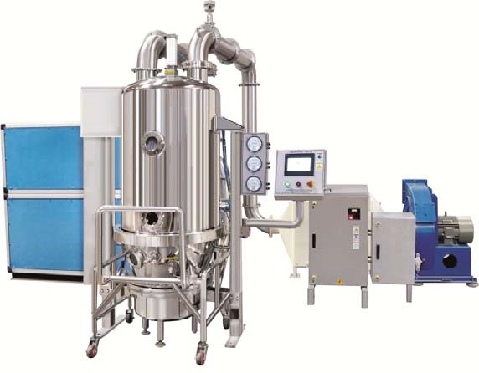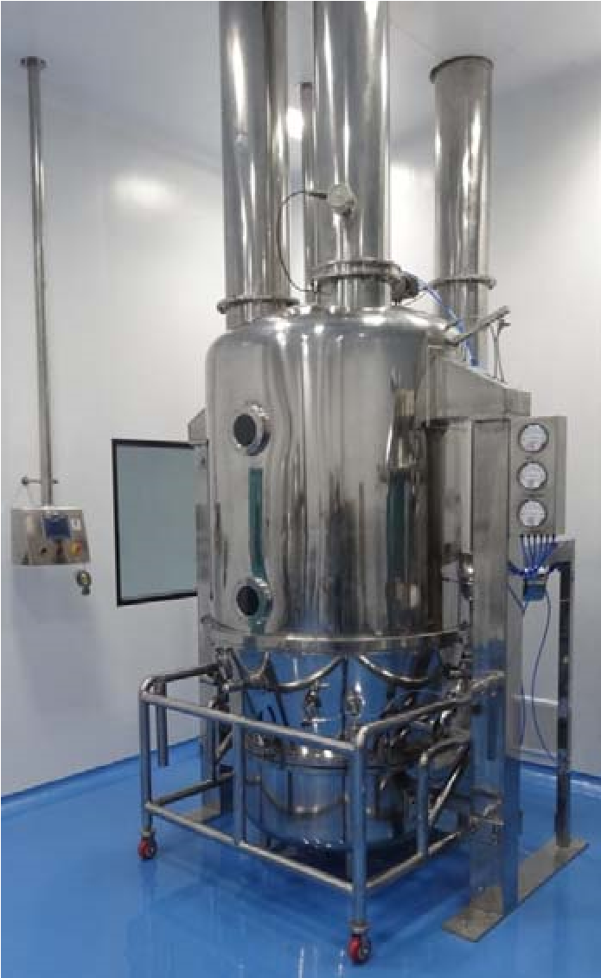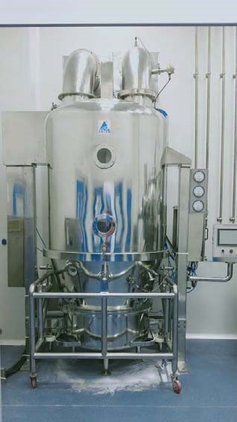

Customer Name | Caspian Cleanroom | Country | Iran
Quote Ref No & DT |  | Page No | 56 of 114

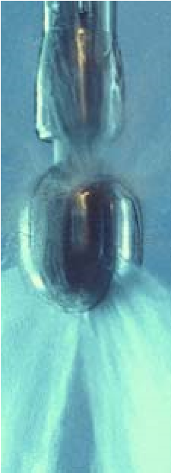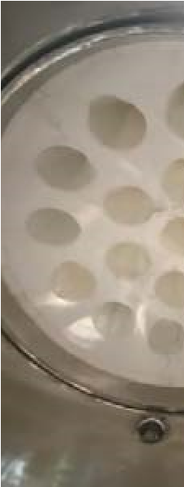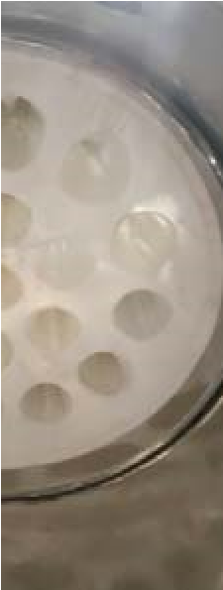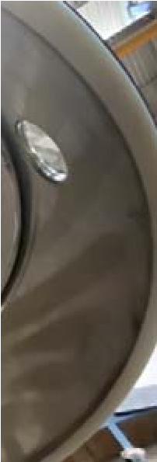

CIP Spray Ball Filter Bag Price:

5. Prism Multi Mill PMTM ‐ 200 GMP Model

Multi Mill is used for wet and dry granulation in pharmaceuticals, R&D institutions and food industry for milling and size reduction..

It is a self contained portable unit useful for granulating, pulverizing, milling and size reduction. The Multi mill operates on the principle of variable force swing beaters having both knife and impact edges rotating within a selected screen to get the required size reduction.

The material is fed in the hopper, shredded and milled through beaters consisting of knife and impact edges. The rotation speed and direction of beaters could be adjusted through control panel. The material then passes through the cylindrical screen in spiral motion which helps keeping the temperature low and avoids chocking of material during the process. The material is collected in the container placed under the hopper.

In multi mill particle size reduction is done through impact in air, on material by blades moving at high speeds, inside a cylindrical hopper.

New Design Features:
- Design is cGMP – Current Good Manufacturing Practices compliance.
- All contact parts to SS 316 and non contact parts in S.S.304.
- Vertical drive for milling blades with side with cylindrical sieve.
- Blades are fitted with rotor with pin for swing for force control.
- 12 nos. blade with knife & impact edge with 2 nos. scrapper blade.
- Belt less direct drive with bearing housing and coupled with motor.
- A C Frequency Drive to achieve desire speed up to 2800 RPM.
- Direction of beaters can be changed by forward & reversible switch for used for knife or impact edge of blade as per requirements.
- Impact edge use for fine milling and knife edge is use for cutting and granulating.
- High operating simplicity for easy cleaning of contact parts.
- Easy removable of contact parts for cleaning.
- Entire unit is movable and mounted on castor wheel.
- S.S.304 Encloser for motor.
- Electric panel with push button and digital indicator and fitted with MCB, Contactor, Overload relay, VFD, Controls relay,
- Available option for various size of perforated sieves.

TECHNICAL SPECIFICATIONS:
MODEL | PMTM‐200
Machine | Multimill
Application | - Milling & size reduction of powder & lumps powder with  desire size.  - Materials feeding by manual.  - Materials discharge by gravity.
Principle | • Rotates blades with knife or impact edge are an inside cylindrical perforated sieve and create shear and impact force on feeding materials for reduced particle size.
Machine Standard/ Construction guide line | - The Current state of the art GMP Compliance.  - European Medicine Agency (EMA) and USFDA Regulations compliance.
Machine design Standard for safety | - The European Machinery Directive 2006/42/EC  - The European Low Voltage Directive 2014/35/EU  - ISO/TR 12100:1992: Safety Of machinery (Basic Concepts, general Principle of design), part 1 & 2.  - ISO 15534:2000: Ergonomic Design for the safety of machine, Part 1 &2,  - ISO 13849‐1:1999: Safety Machinery – Safety related parts of controls systems‐parts 1: General Principle for design.  - ISO 13850:1996: Safety of machinery‐Emergency Stop‐  Principles of design.  - ISO 13852:1996: Safety of Machinery‐ Safety distance to prevent danger zones being reached by upper limbs.  - ISO 13853:1996: Safety of Machinery‐ Safety distance to prevent danger zones being reached by lower limbs.  - ISO 13854:1996: Safety of Machinery‐ Minimum gaps to avoid crushing of parts of the human body.  - ISO 14110:1998: Safety of Machinery –Interlocking devices associated with guards‐ principles for design & selection.
Room Condition | - Room temperature : NMT 18 to 27 °C  - Relative humidity : NMT 30 to 65%  - Zoning : Class D Grade  - Pressure : 10 Pa
Material and surface finish of parts in contact with the product | - AISI 316.  - Taflon, Silicon food grade USFDA  - Ra ≤0.5 Mirror finish.  - All contact parts rather that stainless steel should be food

 |  | grade material.
Material and surface finish of parts not in contact with the product | •  • | AISI304  Ra ≤0.85 Matt Finish
Material and surface finish of outer surface | •  • | All material used in the equipment will be durable type.  The outer surface shall be easy to clean.
 | • | Outer surface finish of stainless materials in classified rooms will be mirror polished to Ra  0.9 m, if not otherwise stated.
Non‐metallic materials | • | Elastomers in direct contact with the product will be according to FDA Code 21 CFR 177
 | • | All non‐metallic materials used in the equipment will be of durable type and must withstand cleaning with ethanol 70% and detergents.
 | • | Gaskets, diaphragms and O‐rings in direct contact with the product will be PTFE and/or EPDM or Silicone.
 | • | Oil in instruments in direct contact with the product will be according to FDA Code 21 CFR 172.
Material to be handled | • | Pharmaceutical Powder / Foods Powder
 | • | Bulk Density: 0.6 gm/cc (approx)
 | • | Particle Size: Average 100 mesh
Machine Working Principle/ Function | • | Knife OR Impact edges blades are rotating in cylindrical shape sieve so materials passed by shear or impact force to gets reeducation of particle size according to sieve hole size and speed of blade.
 | • | Blades have variable speed by VFD.
 | • | Interchangeable sieve for gets different particle size reduction.
 | • | Materials feeding by manual.
 | • | Materials discharge by gravity.
 | • | Machine mounts on 4 nos. castor wheel for easy movements.
Capacity | • | 50 to 200kg/hr.
 | • | Depends on Material Properties, Materials Particle Size, Sieve size and speed of blade.
Charging hopper | • | Charging hopper have from top side rectangular shape and having sliding gate at bottom for feeding controls.
 | • | By manual feeding.
 | • | Fitted with wing nuts for easily remove.
 | • | Lid provide for charging hopper.

 | • | Charging Height : 1470mm
Milling Chamber | • | Milling chamber have cylindrical shape and having arrangement for centrally drive rotor and mount charging hopper and cylindrical sieve with bottom plate.
 | • | Milling chamber fitted on top plat with drive unit.
 | • | Milling chamber have outer side flange to mount discharge hopper.
Blade | • | Rotor fitted with 12 nos. blade and 2 nos. scrapper blade.
 | • | Rotor is fitted on drive shaft with keyway.
 | • | 12 nos. blades have knife and Impact edge.
 | • | Knife edge is applicable for cutting, milling for granulation.
 | • | Impact edge applicable for pulverize for fine milling.
 | • | Knife to impact edge rotation change by rotation direction of motor by selection switch.
 | • | Blades are fitted with rotor with 4nos. pins for swing for force control.
 | • | Blade speed 100 to 2800RPM by VFD.
 | • | Blade rotation diameter is 258mm
 | • | Distance between blade and sieve is 1 to 1.5mm.
Sieve | • | Cylindrical Shape perforated sieve.
 | • | Cylindrical sieve diameter is 260mm and Height 140mm.
 | • | Machine fitted with 2 mm hole size sieve.
 | • | Sieve is fitted in chamber with supports of bottom plate with 2nos. tie rods.
 | • | Optional Available sieves hole size: 0.5, 0.8, 1, 1.25, 1.5,  1.75, 2, 2.5, 3, 4, 5, 8 in mm.
Drive | • | Direct drive with motor.
 | • | Flange mounted motor fit on structure.
 | • | Drive shaft fit with seal and bearing in housing on top plate.
 | • | Drive shaft is coupled with flange mounted motor.
 | • | Motor: 3hp/2.25kw/3phase/380v‐415v/50hz/1400RPM.
 | • | Motor is cover with S.S.304 encloser.
Discharge hopper | • | Discharge hopper is cylindrical shape with slope discharge hole.
 | • | Discharge hopper fitted on milling chamber with easy clamping and has bottom discharge.
 | • | Discharge Height: 737mm
Machine Structure | • | Rigid machine base structure is made with pipe pillar structures and 4nos castor wheel.

- Top plate mounts on pillar.
- Top plate fitted with complete drive and milling chamber.
- pillar mounts on blasé.
- Blasé plate fitted with 4 nos. castor wheel for easy movements.
- Electric panel is mounting on pillar.
- Provide 4 nos. PU castor wheels.
- 2 nos. wheel with break and 2 nos. without break revolving type
Electric controls panel | - Electric Controls panel with push button & Digital indicator.  - Electric panel is encloser in S.S.304.  - ON‐OFF push button for Motor,  - Speed regulator  - RPM display.  - Selector switch for Forward‐ Reveres.  - Main Isolate switch.  - Emergency Stop Switch.  - Electric panel with MCB, Contactor, Relay, VFD, Controls relay & SMPS.
Safety futures | - Safety interlocks limit switch for charging hopper & discharge hopper.  - Overload relay controls.  - Emergency stop.
Operation in hazard situations | Utility failure  - The control system will work such that a utility failure does not break the process /system or cause hazardous situations.  - Programs must retain on electric power failure. System recovery after power failure must be possible.  - The stored data must retain on electric power failure.  - When reconnected after an electric power failure, the system must not start automatically any control actions without operator input.  Emergency stop  - Emergency stop the complete machine immediately in a safe way.  - Restart after emergency stop will be performed from the control panel by the operator in an easy and safe way.  - The equipment will be equipped with switches for emergency stop. The switch/switches will be located in

 | easily accessible places.
Require Utilities: | - Electric Power: 2.25kw/3phase/380v‐415v/50hz.  - Compressed Air: Nil.  - Steam: Nil.  - Cooling Water: Nil.  - Portable Water: NIL.  - Hot Water: For washing required.  - Distilled Water : For washing required  - Purified Water: For washing required.  - Purified Steam: NIL
Documents & Certificate | Manuals and Maintenance Instructions  - Operator manual.  - Installation and assembly instructions for all devices.  - User’s manuals for all components.  - Trouble shooting guide.  - Maintenance manual.  - Safety instructions.  - Training documentation.  Electrical and control diagrams  - Single line drawings for electrical distribution.  - Circuit diagrams.  - Cable list.  - Equipment location drawings for electrical equipment and instruments.  Qualification Protocols  - DQ protocols and reports.  - FAT protocol and report.  - IQ protocol and report.  - OQ protocol and report.  - DQ: Provide after received confirm order.  - FAT: Provide before machine gets ready for FAT & Trails.  - IQ, OQ, Machine Instruction & maintenance manual will be providing along with machine.  - DQ & FAT hard copy provide along with machine.  - PQ: PQ is not our scope of supply.  Test, Calibration, MOC Certification:  - All Test certificate for Brought Items will be provides during FAT with FAT Documents.  - MOC Certificate will be providing during FAT with FAT Documents.
- Calibration certificate provide for gauge during FAT.
- Above all certificate hard copy will be with FAT reports
only.
Factory Acceptance Test (FAT) | - The supplier will perform FAT at the supplier’s facility with attendance of supplier/ buyer personnel. The FAT has to be successfully completed prior to delivery.  - The operational performance of the equipment will be  verified during the FAT in complete tests.  - Buyer will bear Cost for FAT as per terms & condition.
Installation Qualification (IQ) & Operation Qualification (OQ) | - The supplier will provide test protocols for IQ and OQ covering requirements in the URS. The test protocols will be reviewed and approved by Buyer before the IQ/OQ is performed.  - The supplier will perform the IQ and OQ with attendance of buyer’s personnel and write corresponding reports.  - Buyer will bear Cost for SAT as per terms & condition.
Performance Qualification (PQ) | - The supplier CANNOT provide test protocols for PQ  performed. It is not scope of supply.  - The suppliers will attendance during PQ. But not write any corresponding reports.
Machine Dimension‐ L x W x H | 1060 X 860 X 1715 H in mm.
Net Weight | 250 Kg
Recommended Spare | - 2 Nos. Silicon Gasket seal at charging Hopper.  - 2 Nos. Silicon Gasket seal at for milling chamber.  - 2 Nos. Silicon Gasket seal at discharge Hopper  - 2 Nos. Seal at shaft.  - 1 No. Controls relay.  - 1 No. Limit switch.

Image of Multi Mill:
*All Pictures shown are for illustration purpose only. Actual product may vary due to product enhancement.
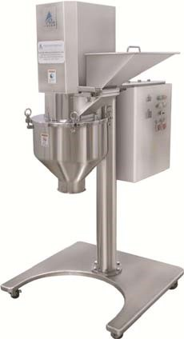

6. Prism Octagonal Blender POB ‐ 300 GMP Model
The effective & uniformed mixing, lubrication and blending process of dry powder & granules.

Prism Octagonal Blender is an efficient and versatile machine for mixing, lubricating and blending of dry powder and granules homogeneously for facilitating better flow ability of the dry powder form material...

The basic machine consists of product mixing drum. A drum fitted with both ends by hub shafts which is given support on pillow block bearing. The complete drum assembly mounted on “A” Type fabricated structure which is SS 304 quality cladded. The drive unit consisting of motor, reduction gear box, chain coupling & control panel.

The machine meets cGMP requirements with contact parts of SS 316 quality and non contact parts of SS 304. All welded joints are argon process ground and well polished to mirror/matt finished. The mixing drum is mirror finished from inside and outside up to 220 grit.

The mixing drum is fitted with baffles for uniform mixing and breaking of lumps. The baffles made from SS 316 quality pipes which is fitted with Stud and Nut and can be easily removed and refixed for cleaning.

The mixing drum has two sides opening. One is fitted with 250 mm diameter butterfly valve with silicon seal and having arrangement to hold IPC and loading arrangement. The other side is fitted with a man hole door bolted to the side with silicon gasket. The entire machine is provided with safety hand realign made of SS 304 quality pipes. The entry gate shall be provided with limit switch to ensure safety of operator. The separate control panel fitted on machine with digital timer, “A” meter & “ON‐OFF” Push Button. Also hand wheel provide for manual tilting of mixing drums.

SALIENT FEATURES:
- Design is cGMP ‐ Current Good Manufacturing Practices compliance.
- All contact parts AISI 316, Silicon food grade seal & non contact parts AISI 304.
- Octagonal Shape product container with working volume 300Liter/150kg @0.5product density.
- Fixed Baffles provided inside container form lumps breaking.
- Product Container with variable Speed 02 to 16 RPM VFD
- Rigid drive reduction gear box with motor with enclose.
- Process timer for auto shutoff for mixing time.
- Main advantage of this system is that it is totally dust free. • A suitable reeling around the container with entry point.
- Charging hole with lid is provided on top with quick opening.
- Bottom discharge with butterfly valve.
- Safety reeling with limit switch.
- Safety features: Limit switch on entry door to prevent the accidental operation of the container, Overload relay protection & Emergency stop button. • Electric Control Panel with push button and digital indicator. Safety Features:
- Safety reeling with limit switch.
- Overload protection and emergency stop.

Optional Features:
1. LOADING BY CONTAINER:
The loading container (100 Liter) is brought close to the mixing drum on jacking trolley having lifting arrangement. The Jacking trolley ensures that the container is lifted and is aligned with the transition piece fixed with the mixing drum’s outlet butterfly valve. This transition piece mouth is clamped with the outer periphery of the container by using clamp. Then the blender is rotated by 180º till the container is vertically inserted over the blender. Once the container reaches upward in inverted position than butterfly valve is made to open by special hand wheel so that entire content of the container gets unloaded into the blender. Once it becomes empty, the valve is closed and container is brought again downward by rotating the blender again by 180º and another container is fixed, raised and unloaded. In similar way, the product is loaded in the blender. By this method, material is loaded and unloaded in batches of 50 kg each.

TECHNICAL SPECIFICATIONS:
Model | POB ‐ 300
Application | Dry Mixing of powder
Container Shape | Octagonal shape
Machine Standard/ Construction guide line | - The Current state of the art GMP Compliance.  - European Medicine Agency (EMA) and USFDA Regulations compliance.
Machine design Standard for safety | - The European Machinery Directive 2006/42/EC  - The European Low Voltage Directive 2014/35/EU  - ISO/TR 12100:1992: Safety Of machinery (Basic Concepts, general Principle of design), part 1 & 2.  - ISO 15534:2000: Ergonomic Design for the safety of machine, Part 1 &2,  - ISO 13849‐1:1999: Safety Machinery – Safety related parts of controls systems‐parts 1: General Principle for design.  - ISO 13850:1996: Safety of machinery‐Emergency StopPrinciples of design.  - ISO 13852:1996: Safety of Machinery‐ Safety distance to prevent danger zones being reached by upper limbs.

- ISO 13853:1996: Safety of Machinery‐ Safety distance to prevent danger zones being reached by lower limbs.
- ISO 13854:1996: Safety of Machinery‐ Minimum gaps to avoid crushing of parts of the human body.
- ISO 14110:1998: Safety of Machinery –Interlocking devices associated with guards‐ principles for design & selection.
Room Condition | - Room temperature : NMT 18 to 27 °C  - Relative humidity : NMT 30 to 65%  - Zoning : Class D Grade  - Pressure : 10 Pa
Material and surface finish of parts in contact with the product | - AISI 316.  - Taflon, Silicon food grade USFDA  - Ra ≤0.5 Mirror finish.  - All contact parts rather that stainless steel should be food grade material.
Material and surface finish of parts not in contact with the product | - AISI304  - Ra ≤0.85 Matt Finish
Material and surface finish of outer surface | - All material used in the equipment will be durable type.  - The outer surface shall be easy to clean.  - Outer surface finish of stainless materials in classified rooms will be mirror polished to Ra  0.9 m, if not otherwise stated.
Non‐metallic materials | - Elastomers in direct contact with the product will be according to FDA Code 21 CFR 177  - All non‐metallic materials used in the equipment will be of durable type and must withstand cleaning with ethanol 70% and detergents.  - Gaskets, diaphragms and O‐rings in direct contact with the product will be PTFE and/or EPDM or Silicone.  - Oil in instruments in direct contact with the product will be according to FDA Code 21 CFR 172.
Material to be handled | - Pharmaceutical Powder  - Bulk Density: 0.6 gm/cc (approx)  - Particle Size: Average 100 mesh
Powder Loading | • By Manually
Powder Unloading | By Gravity.
Container | - Container Shape: Octagonal shape  - Octagonal shape container with charging port/ Man Hole and discharge port.

 | • | Container MOC: S.S.316 of 4 mm thickness sheet
 | • | Container Gross volume : 360 Liter
 | • | Container working volume : 300 Liter
 | • | Container loading capacity: 150 kg @ 0.05 B.D.
 | • | Fixed baffles provide inside of container for lumps braking.
 | • | Container mounting on 2 nos. hub with shaft and bearing pillow block.
 | • | Man hole / Charging Hole are rectangular shape with hinged lid.
 | • | Discharge gate with dia.150 mm butterfly valve.
 | • | Container rotation Stop with always in Discharge position.
 | • | Proxy sensor provide for discharge position.
Drive Unit | • | Reduction gear drive with motor.
 | • | Drive end connected with coupling to reduction gear drive.
 | • | Motor to reduction gear motor drive with Belt.
 | • | Container rotating on Variable Speed 02 to 16 RPM by variable Frequency Drive
 | • | Rigid drive with reduction gear with break motor.
 | • | Container rotation Stop with always in Discharge position.
 | • | Motor: 3 Hp/2.25kw/3phase/380v/50hz.
Safety Reeling | • | Safety reeling with interlock limit switch provides for sounding area of rotating container area.
Machine Structure | • | ‘A” type made from S.S.304 square pipe.
 | • | Container mounting on structure with bearing block.
 | • | Structure has mourning of gear motor drive.
 | • | Drive unit totally enclose with S.S.304 Cover.
 | • | Rear side provide fixed safety reeling.
 | • | Front side provides door type safety reeling with interlock limit switch.
 | • | Electric panel mounting machine structure.
WIP provision | • | Provide Provision for WIP washing with rotary spray ball on top lid with manual ball Valve.
 | • | Provide manual ball valve WIP.
 | • | Provide TC. Connection to connect your utilities for WIP.
Electric controls panel | • | Electric operating panel in S.S.304 encloser.
 | • | Electric Control Panel with push button and digital indicator.
 | • | ON‐OFF push button for Motor.
 | • | Inching button
 | • | Digital RPM indicator.

- Speed regulator.
- Digital Process cycle Timer (0‐999 Minute.)
- Main Isolate switch.
- Emergency Stop Switch.
- Panel with MCB, Contactor, Overload Relay, Controls relay, VFD & SMPS.
Safety futures | - Safety reeling with interlock limit switch  - Overload relay controls.  - Emergency stop.  - Auto stop when sets time achieved.
Operation in hazard situations | Utility failure  - The control system will work such that a utility failure does not break the process (Stirring operation) /system or cause hazardous situations).  - Programs must retain on electric power failure. System recovery after power failure must be possible.  - The stored data must retain on electric power failure.  - When reconnected after an electric power failure, the system must not start automatically any control actions without operator input.  Emergency stop  - Emergency stop the complete machine immediately in a safe way.  - Restart after emergency stop will be performed from the control panel by the operator in an easy and safe way.  - The equipment will be equipped with switches for emergency stop. The switch/switches will be located in easily accessible places.  Alarms  - Error messages on control panel will be in plain text with fault code.  - All alarms shall be indicated by a light column & audible signal.
Require Utilities: | - Electric Power: 2.25kw/3phase/380v‐415v/50hz.  - Compressed Air: Nil.  - Cooling Water: Nil.  - Portable Water: NIL.  - Hot Water: For washing required.  - Distilled Water : For washing required  - Purified Water: For washing required.

Brought Item Make | - Motor: Crompton  - Reduction Gear Box: Elecon  - Bearing Pillow Block: SKF/ZKL/NTN  - Belt: Fanner Eco Drive  - Coupling: Fanner  - VFD Make: Mitsubishi  - Contactor & Overload Relay: Schneider  - Controls relay: BCH / Phoenix /Elmex  - SMPS: Omron / Multispan  - Push Button : Teknic  - Main Isolate switch: Sulzer  - Limit switch: Honeywell  - Gasket Seal: Ami Polymer.  - Electric Panel: Prism
Documents & Certificate | Manuals and Maintenance Instructions  - Operator manual.  - Installation and assembly instructions for all devices.  - User’s manuals for all components.  - Trouble shooting guide.  - Maintenance manual.  - Safety instructions.  - Training documentation.  Electrical and control diagrams  - Single line drawings for electrical distribution.  - Circuit diagrams.  - Cable list.  - Equipment location drawings for electrical equipment and instruments.  Qualification Protocols  - DQ protocols and reports.  - FAT protocol and report.  - IQ protocol and report.  - OQ protocol and report.  - DQ: Provide after received confirm order.  - FAT: Provide before machine gets ready for FAT & Trails.  - IQ, OQ, Machine Instruction & maintenance manual will be providing along with machine.  - DQ & FAT hard copy provide along with machine.  - PQ: PQ is not our scope of supply.
Test, Calibration, MOC Certification:
- All Test certificate for Brought Items will be provides during FAT with FAT Documents.
- MOC Certificate will be providing during FAT with FAT Documents.
- Calibration certificate provide for gauge during FAT.
- Above all certificate hard copy will be with FAT reports only.
Factory Acceptance Test (FAT) | - The supplier will perform FAT at the supplier’s facility with attendance of supplier/ buyer personnel. The FAT has to be successfully completed prior to delivery.  - The operational performance of the equipment will be verified during the FAT in complete tests.  - Buyer will bear Cost for FAT as per terms & condition.
Installation Qualification (IQ) & Operation Qualification (OQ) | - The supplier will provide test protocols for IQ and OQ covering requirements in the URS. The test protocols will be reviewed and approved by Buyer before the IQ/OQ is performed.  - The supplier will perform the IQ and OQ with attendance of buyer’s personnel and write corresponding reports.  - Buyer will bear Cost for SAT as per terms & condition.
Performance Qualification (PQ) | - The supplier CANNOT provide test protocols for PQ performed. It is not scope of supply.  - The suppliers will attendance during PQ. But not write any corresponding reports.

Image of Octagonal Blender:
*All Pictures shown are for illustration purpose only. Actual product may vary due to product enhancement.
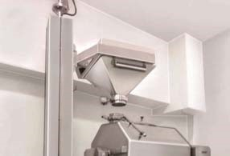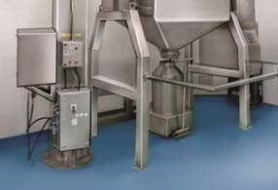

7. Double Sided Rotary Tablet Press Machine PTCMB4 ‐ 27 “D” Tooling GMP Model

PRISM PTCMB4 is a square GMP model. Double sided Rotary Tablet Press suitable for medium size batch production. The PTCMB4 Tablet Press is designed in an effort to exceed the highest cGMP requirement with use of advance technology and to ensure the most economical and efficient tablet production. The PTCMB4 Tablet Press features a unique ergonomic design. It is easy to operate, clean and maintain.

THE MACHINE CONCEPT
The basic construction of the machine consists of:
- Rigid Base frame fitted on rigid square body.
- Tablet Compression Zone. • Electric Control Panel.

THE ERGONOMICS DESIGN
The PTCMB4 has been completely new designed according to the most modern ergonomic aspects.
- CGMP Model.
- Easy Cleaning and Changeover.
- Stainless Steel and acrylic Glass Surrounding. • Easy to Operate and Maintenance.

THE DRIVE
The machine is equipped with frequency controlled drive. A large torque can be achieved even at low speed because of its high regulating speed. The turret driven by a precise phosphorus bronze worm fitted to a bearing mounted worm shaft gearbox which is driven by motor via Electromagnetic clutch. Small adjustments may be the engagement between the worm and worm wheel to allow for any wear which can be adjusted in turn extending its life.

THE GRAVITY FEED FRAME:
Non mechanical open gravity feed frame are standard equipment in this machine. The Gravity feed frame fitted with easy removed fixing knob on rigid base plate and can be easily set and maintained at the desired height. Resetting of the feed frame base is not required during change over and cleaning. The gravity feed frame fitted with re‐circulation band to keep avoid spilling of the powder.

THE FORCE FEEDER SYSTEMS:
The mechanical Rotary force feeders are also supplied as an extra option. The feeder equipped with AC frequency controlled drive to ensure high exception of tablet weight consistency through feeding performance of the powder in high speed of the machine.
THE POWDER LEVEL
Powder Level in the feed frame can be easily adjusted by hopper support bracket and knob. These adjustments are possible without having to shut down the machine and open the guard.

THE TURRET AND DIE TABLET
PRISM is proposing a S.G. Iron Steel Turret. Also can be supplied turret with stainless steel 316 die tablet.

THE CAMS DESIGN
For smooth operation, all Cams are calculated by computer with a harmonic profile to fluent operation and wear.

THE UPPER PUNCH PENETRATION
Adjustable upper punch penetration is provided as a standard feature of PTCMB4 Model. The system provides the following benefits:
- Change of level of compression of the tablet is possible in the die.
- Reduces ejection loads leading to extended punch head life.
- Facilitate tab letting of difficult product like floppy or sticky.
- Die life can be increased by changing the level of tablet compression and reversing the die.

THE LOWER PUNCH SCRAPPER SEAL
All PTCMB4 Model Tablet Press supplied with Lower Punch scraper seal to avoid problems of tight lower punches caused by possible ingress of powder in to the punch guide holes. Wear and tear is greatly reduced hence extending tool life and the machine is running for longer periods between clean down.

THE OVERLOAD AND PRESSURE RELEASE
The compression spring loaded overloaded and pressure release systems fitted to lower pressure roll for applying unique systems fitted to lower pressure roll for applying unique compression force. It combines the advantage of selecting constant force or constant thickness of the tablet. The overload release ensures any overloading transmitted to the punches without serious damage. The overload pressure release should always be set to relieve the pressure with minimum effort consistent with the diameter and hardness of the tablet being made.

THE DUST EXTRACTOR SYSTEM
In high speed Tabletting dust extraction is essential. The effective dust suction nozzles are fitted at compression point with quick release design for easy cleaning.

THE LUBRICATION SYSTEM
The PTCMB4 machine equipped with one shot Lubrication systems to serve Lubrication all pressure roll pin. Oil Cups are provided wherever continuous Lubrications is required.
THE OPERATOR SAFETY
All upper guards are fitted with interlock switches by ensuring that the machine is not operated when the guards are in open condition.

THE NOISE LEVEL
The compression area is completely encapsulated and the machine itself is surrounded by sound absorbing covering. Therefore, the noise level is low even under highest load. The machine is mounted on anti vibration mounts. operation at maximum speed must be below 75db at 1M distance.

THE TABLET PARAMETER CONTROLS
The Following functions are provide at front of the machine with fine tuning sikko dial.
- Both Tablet weight adjustments – Left & Right side.
- Both Tablet thickness adjustments – Left & Right side.

The balance compression load pressure set inside of bottom compartment of the machine for both side. The upper punch penetration setting from inside upper compartment of the machines for both side.

THE OPERATING & ELECTRIC CONTROL PANEL
The front control panel fitted on front side of the machine with hinged on bottom compartment of the machine. The Control Panel allows easy and safe adjustment of operating parameters, easy cleaning and gives excess space for setting, change over and cleaning of the machine. The control panel fitted with digital tablet counter, RMP meter and Push buttons. The electric components closed panel installed in the machine cabinet fitted with MCB, overload relay, contractor, AC frequency Drive, SSPM etc.

THE CLEANLINESS AND CLEANABILITY
The Tab letting zone has no painted surface and corners to avoid dust traps. The large cabinet combined with acrylic guards gives excellent access area for cleaning. Dust Extractor nozzle significantly reduce the dust levels in the Tabletting zone.

THE SERVICE
PRISM is committed for providing a competitive quality service create a long term partnership with you, the client. As a step in this direction we would welcome the opportunity of discussing your requirements and of advising on specific needs or service related to machine.

SALIENT FEATURES:
- Design is cGMP – Current Good Manufacturing Practices compliance.
- Product contact parts AISI 316 and non contact part AISI 304.
- Simple & Convenient Operation, Changeover, Cleanliness, Operator Protection & Ease to Maintenance.
- Double sided tablet press with two side filling, pressing and tablet take off.
- Turret having 27 station with “D” tooling.
- Turret having variable speed 14 to 42 RPM by VFD to get output Tablet per hour.
- 3 Pc. Turret made with S.S.316 Die pot.
- Turret drive trough worm and open worm wheel gear with electromagnetic clutch with belt drive moto .
- Variable speed for Turret with AC Frequency Drive for main motor.
- Turret is fitted on centre pillar with roller bearing & bush lining.
- Turret is having facility for upper punch hole with keyway for capsule shape tablet and lock arrangement for die and anti turning provision for lower punches.
- Upper Punch penetration system to adjust upper punch entry in die.
- The upper punch penetration setting from inside upper compartment of the machines for both side.
- Completely Paint free tablet compression area.
- Turret having Lower Punch scraper seal to scrape powder from lower punch.
- Rigid feeder stand with fine flow setting of powder.
- Powder hopper to be min. capacity of 15 liters and easily set hopper height for powder flow.
- Gravity feed frame with powder scrapper and tablet take off plate.
- Force feeder assembly with gear motor drive with variable frequency drive.
- Precise weight controls by wedge and weight adjustment dozer assembly.
- The Table parameter setting functions are provide at front of the machine with fine tuning Sikko dial.
  - Both Tablet weight adjustments – Left & Right side.
  - Both Tablet thickness adjustments – Left & Right side.
- The balance compression load pressure set inside of bottom compartment of the machine for both side.
- Over load pressure adjustment assembly with compression spring with easy pressure adjustment by handle assembly.
- Lower cam track for depth of powder filling is D‐20 mm.
- Ejection track with adjustment screw and wedge for setting of tablet ejection.
- Easy to cleaning and changeover
- Upper cam plate fitted with two sided upper lifting cam for smooth running and long life of cam.
- Discharge chute with slope to flow down tablet by gravity.
- Provided dust extraction for nozzle at compression point for dust suction.
- Upper guard with interlock for safety.
- Lower Drive zone covers with stainless steel enclose and doors.
- Central oil lubrication systems with manual hand pump for roller pin.
- Dropping type oil cups are provided for lubrication for turret bearing and worm.
- Machine is mounted on anti vibration pad so no need for foundation.
- Dust suction nozzle provided at compression point.
- The electric controls panel is mounted on top hood and fitted with electronics Table output & RPM Counter, Amp Display, ON‐OFF Push Button.

Safety Features:
- Interlocked upper guard and Overload relay protection. • Overload pressure release mechanism.

TECHNICAL SPECIFICATIONS:
MODEL | PTCMB4‐27
Machine type | Double rotary tablet press with two hopper and tow side outlet.
No. of Stations | 27 Nos. station
Type of Tooling | “D” tooling.
Machine Standard/ Construction guide line | - The Current state of the art GMP Compliance.  - European Medicine Agency (EMA) and USFDA Regulations compliance.
Machine design Standard for safety | - The European Machinery Directive 2006/42/EC  - The European Low Voltage Directive 2014/35/EU  - ISO/TR 12100:1992: Safety Of machinery (Basic Concepts,  general Principle of design), part 1 & 2.  - ISO 15534:2000: Ergonomic Design for the safety of machine, Part 1 &2,  - ISO 13849‐1:1999: Safety Machinery – Safety related parts of controls systems‐parts 1: General Principle for design.  - ISO 13850:1996: Safety of machinery‐Emergency Stop‐Principles of design.  - ISO 13852:1996: Safety of Machinery‐ Safety distance to prevent danger zones being reached by upper limbs.  - ISO 13853:1996: Safety of Machinery‐ Safety distance to prevent danger zones being reached by lower limbs.  - ISO 13854:1996: Safety of Machinery‐ Minimum gaps to avoid crushing of parts of the human body.  - ISO 14110:1998: Safety of Machinery –Interlocking devices associated with guards‐ principles for design & selection.
Room Condition | - Room temperature : NMT 18 to 27 °C  - Relative humidity : NMT 30 to 65%  - Zoning : Class D Grade

 | • Pressure : 10 Pa
Material and surface finish of parts in contact with the product | - AISI 316.  - Taflon, Silicon food grade USFDA  - Ra ≤0.5 Mirror finish.  - All contact parts rather that stainless steel should be food grade material.
Material and surface finish of parts not in contact with the product | - AISI304  - Ra ≤0.85 Matt Finish
Material and surface finish of outer surface | - All material used in the equipment will be durable type.  - The outer surface shall be easy to clean.  - Outer surface finish of stainless materials in classified rooms will be mirror polished to Ra  0.85 m, if not otherwise stated.
Non‐metallic materials | - Elastomers in direct contact with the product will be according to FDA Code 21 CFR 177  - All non‐metallic materials used in the equipment will be of durable type and must withstand cleaning with ethanol 70% and detergents.  - Gaskets, diaphragms and O‐rings in direct contact with the product will be PTFE and/or EPDM or Silicone.  - Oil in instruments in direct contact with the product will be according to FDA Code 21 CFR 172.
Output for Single layer | Maximum: 129,000 tablet per hour.  Minimum: 54,000 tablet per hour.
Output for Two layer | Maximum: 64,500 tablet per hour.  Minimum: 27,000 tablet per hour.
Turret speed | 10 to 42 RPM by VFD.
Operating Pressure | - Operating pressure 10 to 100 KN / 10 Ton adjustable.  - Impact load / Balance load with compression type spring system.  - Compressor pressure set manual from inside of the machine.
Tablet Diameter | - Maximum Round tablet size: Dia. 24 mm ‐ “D’ tooling  - Maximum Oblong tablet size.: 21 mm ‐ “D’ tooling  - Minimum Round Table: Diameter 5 mm Round.
Max depth of fill | - Maximum 20 mm depth of fill by lower cam track.  - Dosing assembly provide to set weight of tablet / Powder  volume in die cavity.  - Weight adjustment to be do from front side of the machine.  - Weight adjustment assembly provide fine tuning Sikko dial.

Tablet Thickness | • | 2 mm to 10 mm – Adjustable
 | • | Tablet Thickness adjustment to be do from front controls of the machine.
 | • | Tablet Thickness assembly provide fine tuning Sikko dial.
Turret | • | It is made in 3 parts for upper punch. Die pot and lower punch part.
 | • | Die pot is made from S.S.316 Quality.
 | • | Upper punch parts and lower punch drive parts made from S.G. Iron alloy steel materials with ELNP Coating.
 | • | Upper punch hole have Key way for oblong shape punch guide.
 | • | Die pot have die lock arrangement.
 | • | Lower punch hole have arrangement for anti rotating brake plug assembly.
 | • | Lower punch scrapper seal provide to scrap powder from lower punches.
 | • | Turret drive worm wheel gear teeth fitted on lower parts.
 | • | Turret has internal 2 nos. bush assembly to rotate on centre pillar with mounting on middle bearing.
 | • | There oil lubrication grooves inside the bush.
Turret Drive | • | It is have open type adjustable worm and worm wheel turret drive.
 | • | Worm wheel teeth ring fitted on turret.
 | • | Worm is fitted in gearbox assembly.
 | • | Worm gear box have arrangement to adjust gap between worm and worm wheel.
 | • | Electromagnetic clutch provide on gearbox to connect drive with torque and when heavy torque it will release.
 | • | Motor to gear box drive with V belt with pulley assembly.
 | • | Motor is mounting on reeling assembly to adjust V belt tension.
 | • | Motor drive with VFD to set turret speed 10 to 42 RPM.
 | • | Turret drive Motor: 5hp/3.75kw/3phase.
 | • | Gear box have dropping type oil cup for lubrication on worm.
Type of powder feeding in die cavity | • | Gravity feeding with hopper and feed frame.
 | • | Cylindrical with bottom cone type hopper.
 | • | Hopper capacity 15 liter.
 | • | MOC: s.s.316 of Hopper
 | • | Feed frame made from Gun Metal.
 | • | Feed frame have tablet take off and powder scrapper.
Powder level sensor | • | Provide powder level sensor in hopper to sense minimum level

 |  | to stop machine as well as alarm to operator.
Force feeding system | • | Can be providing Force feeder system with paddle type feeder with gear motor.
 | • | 2 nos feeder assembly.
 | • | 2 nos. paddle in each feeder housing assembly.
 | • | Close gear train with feeder drive gearbox.
 | • | Drive with gear motor: 0.5hp/0.37kw/3phase.
 | • | Paddle shaft speed 10 to 60 RPM by VFD.
 | • | Feeder drive from top side and mounting on top plate.
 | • | Feeder have tablet take off and powder scrapper.
Upper Punch Path | • | Upper punch path guide with cam track.
 | • | Lifting and lowering cam track provide with double side resting tunnel type cam track for long life and straight lifting of punches.
 | • | Upper lifting and lowering cam tack and take of piece fitted on upper cam plate.
 | • | Upper can plate fitted on centre pillar.
Pressure Roll, Head and upper punch penetration. | •  • | Upper rolls are fitted in Head.  Upper rolls are fitted in eccentric pin to adjust penetration of upper punch in die.
 | • | Upper punch penetration adjustable 3 to 6 mm.
 | • | Upper roll pin have provision for lubrication.
 | • | Upper punch penetration to be sets from inside of the machine.
Lower Punch Path | • | Lower punch path fitted with Lower cam track, wedge, dozer assembly, Lower pressure roll and ejection cam track.
 | • | Lower cam track made from alloy steel with 20 mm depth of fill and optional available different feeling of cam.
 | • | Lower cam track are designed and manufacturer with ejection function and lowering to punch for depth of fill.
 | • | Ejection point has specific wedge assembly to set ejection point.
Lower roll assembly | • | Lower roll assembly provides with lower roll carrier, Pressure lever, and fork and compression spring system.
 | • | Lower carrier fitted with Lower pressure roll.
 | • | Lower roll pin have provision of lubrication.
 | • | Pressure lever and compression spring assembly provide to balance load of compression.
Weight adjustment / Depth of fill. | • | There are wedge with spring and dozer assembly to set desire Wight/ filling powder in die cavity.
 | • | Dozer move up‐ down 20 mm.

 | • | Depth of fill 20 mm by lower cam track and can change by replace of lower cam track and available with different fill.
 | • | Through dozer by manual from outside of the machine.
 | • | Weight adjustment to be do from front side of the machine.
 | • | Weight adjustment assembly provide fine tuning Sikko dial.
Tablet thickness adjustment | • | From outside of the machine manually.
 | • | Tablet Thickness adjustment to be do from front controls of the machine.
 | • | Tablet Thickness assembly provide fine tuning Sikko dial.
Tablet Parameter setting‐ Tablet thickness, weight adjustment, Pressure & Upper punch penetration | •  •  • | The Table parameter setting functions are provide at front of the machine with fine tuning Sikko dial.  Provide front controls with SIKO dial with fine adjustment.  Provide 2 nos. front side controls for Wight adjustments.
 | • | Provide 2 nos. front side controls for Tablet thickness adjustments.
 | • | The balance compression load pressure set inside of bottom compartment of the machine for both side.
 | • | The upper punch penetration setting from inside upper compartment of the machines for both side.
Powder flow in feed frame | • | Hoppe UP‐DOWN from top of the machine manually in Gravity feeding.
 | • | If force feeder than no need to adjust hopper and can be set by speed of feeder.
Discharge chute | • | Single path discharge chute of MOC: S.S.316
 | • | Mounted with slope to smoothly flow down by gravity.
Balance Compressed force pressure | • | Compression Spring type system.
 | • | Adjustable load up to 10 ton pressure.
 | • | Pressure adjusts with spring housing with handle.
 | • | The balance compression load pressure set inside of bottom compartment of the machine for both side.
Top Hood & Upper guard | • | Top hood provide to mount hopper and acrylic upper guard.
 | • | Upper acrylic guard provide with Manual hinged
 | • | Safety Interlock limit switch provide for upper guard.
 | • | 2 Nos. hoppers are mounting on top hood.
Lower Guard | • | Enclosure of drive unit and Made from S.S.304
 | • | 2 sides fix encloser and 2 sides with door provide.
Dust Suction | • | Provide dust suction nozzle 2 nos. at compression area to dust suction area.

Lubrication system | - Provide pump with manifold to do lubrication all fulcrum pin.  - Manual handle pump./ Auto Lubrication pump provide.  - Upper rolls and lower roll pin connected with pipe to do  lubrication.
Electric panel | - Electric panel with Push button and digital indicator.  - ON‐OFF Controls for turret drive.  - Electro Magnetic clutch ‐ Engage ‐ Disengage.  - Inching function for turret.  - Turret speed ‐ Set & Display.  - Tablet Output per minute display.  - Total tablet output display.  - Force feeder ON‐OFF  - Inching function for force feeder  - Force feeder speed Set/ Display.  - Main isolation switch  - Emergency stop.  - Electric panel fitted with MCB, Contactor, Overload relay, Controls relay, VFD, SMPS etc.
Machine Mounting | 4 Nos. Anti Vibration pad provide on base plat.
Powder Charging height | 1750 mm
Brought item | - Turret Motor: Crompton.  - Gear Box force feeder: Bonfigilioli / Rotomotive  - Force feeder Motor: Bonfigilioli/ Rotomotive‐ Optional  - VFD: Mitsubishi  - Main isolate switch: Sulzer  - Contactor & overload relay: Schneider  - Controls relay: BCH / Phoenix /Elmex  - SMPS: Omron/ Multispan.  - Push Button: Technique.  - Limit switch: Honeywell.  - Electromagnetic clutch: GLOBAL Engineering.  - Powder level sensor: IFB.  - Lubrication pump: Maruti Industries.  - Belt: Fanner
Safety futures | - Safety interlock limit switch at guard.  - Inter link function of force feeder with turret drive  - Overload relay controls.  - Emergency stop.

Require Utilities: | - Electric Power: 3.75kw/3phase/380v‐415v/50hz.  - Compressed Air: Nil  - Portable Water: NIL.  - Hot Water: For washing required.  - Distilled Water : For washing required  - Purified Water: For washing required.
Documents & Certificate | Manuals and Maintenance Instructions  - Operator manual.  - Installation and assembly instructions for all devices.  - User’s manuals for all components.  - Trouble shooting guide.  - Maintenance manual.  - Safety instructions.  - Training documentation.  Electrical and control diagrams  - Single line drawings for electrical distribution.  - Circuit diagrams.  - Cable list.  - Equipment location drawings for electrical equipment and instruments.  Qualification Protocols  - DQ protocols and reports.  - FAT protocol and report.  - IQ protocol and report.  - OQ protocol and report.  - DQ: Provide after received confirm order.  - FAT: Provide before machine gets ready for FAT & Trails.  - IQ, OQ, Machine Instruction & maintenance manual will be providing along with machine.  - DQ & FAT hard copy provide along with machine.  - PQ: PQ is not our scope of supply.  Test, Calibration, MOC Certification:  - All Test certificate for Brought Items will be provides during FAT with FAT Documents.  - MOC Certificate will be providing during FAT with FAT Documents.  - Calibration certificate provide for gauge during FAT.  - Above all certificate hard copy will be with FAT reports only.
Factory Acceptance Test (FAT) | • The supplier will perform FAT at the supplier’s facility with attendance of supplier/ buyer personnel. The FAT has to be
successfully completed prior to delivery.
- The operational performance of the equipment will be verified during the FAT in complete tests.
- Buyer will bear Cost for FAT as per terms & condition.
Installation Qualification (IQ) & Operation Qualification (OQ) | - The supplier will provide test protocols for IQ and OQ covering requirements in the URS. The test protocols will be reviewed and approved by Buyer before the IQ/OQ is performed.  - The supplier will perform the IQ and OQ with attendance of buyer’s personnel and write corresponding reports.  - Buyer will bear Cost for SAT as per terms & condition.
Performance Qualification (PQ) | - The supplier CANNOT provide test protocols for PQ performed. It is not scope of supply.  - The suppliers will attendance during PQ. But not write any corresponding reports.
Machine Mounting | 4 Nos. Anti Vibration pad provide on base plat.
Powder Charging height | 1750 mm
Machine Overall size. | 1175 L X 1180 W X 1750 H – in mm
Working dimension | 2030 L X 2210 W X 2070 H‐ in mm
Net Weight | 1200 Kg Approx.

IMAGE OF PTCMB4 MACHINE:
*All Pictures shown are for illustration purpose only. Actual product may vary due to product enhancement.
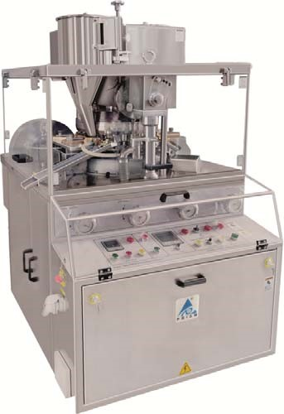
8. Prism Tablet Press Tooling ‐ Dies & Punches.

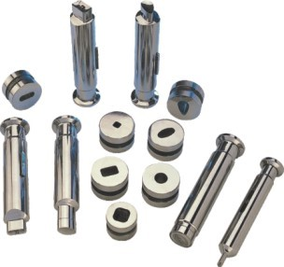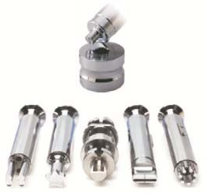

MOC Die = HCHC
MOC punches = OHNS (T)
1 set = 1 No Upper punch, 1 No. Lower punch, 1 no. Die

9. Elevating (Uphill) De Duster PDD ‐ 250E GMP Model

Application & Process:
In Elevating De‐duster there is a vibrated uphill type sieve. The tablets enter bottom inlet of perforated sieve from directly Tablet Press then they are gently vibrated and the tablet to move forward, upward , turning and rotating along the spiral uphill path of perforated plate to outer at top of the sieve.

These remove the layer of surface dust and edges of tablet. The dust is collected by a dust extraction system through a hose pipe spigot connection and the tablet fall into the container.

Salient Features:
- Design is cGMP – Current Good Manufacturing Practices compliance.
- All contact parts AISI 316 & non contact parts AISI 304.
- Geometrically designed tablet route to ensure remove dust and burrs.
- Easy to install with all types of Tablet Press with inline metal detector.
- Option for Spiral OR Elevating‐Up hill type Deduster.
- Adjustable height.
- Easy to mobility.
- Easy and simple dismantle for cleaning of all contact parts.

Technical Specifications:
MODEL | PDD ‐ 250E
Machine | Elevating Deduster & Debarring machine
Application | - Inline working with tablet Press and metal detector..  - Removers dust and burs from tablets.  - Dust suction by dist extractor system.
Machine Standard/ Construction guide line | - The Current state of the art GMP Compliance.  - European Medicine Agency (EMA) and USFDA Regulations compliance.
Machine design Standard for safety | - The European Machinery Directive 2006/42/EC  - The European Low Voltage Directive 2014/35/EU  - ISO/TR 12100:1992: Safety Of machinery (Basic Concepts, general Principle of design), part 1 & 2.  - ISO 15534:2000: Ergonomic Design for the safety of machine, Part 1 &2,  - ISO 13849‐1:1999: Safety Machinery – Safety related parts of controls systems‐parts 1: General Principle for design.  - ISO 13850:1996: Safety of machinery‐Emergency Stop‐

 |  | Principles of design.
 | • | ISO 13852:1996: Safety of Machinery‐ Safety distance to prevent danger zones being reached by upper limbs.
 | • | ISO 13853:1996: Safety of Machinery‐ Safety distance to prevent danger zones being reached by lower limbs.
 | • | ISO 13854:1996: Safety of Machinery‐ Minimum gaps to avoid crushing of parts of the human body.
 | • | ISO 14110:1998: Safety of Machinery –Interlocking devices associated with guards‐ principles for design & selection.
Room Condition | • | Room temperature : NMT 18 to 27 °C
 | • | Relative humidity : NMT 30 to 65%
 | • | Zoning : Class D Grade
 | • | Pressure : 10 Pa
Material and surface finish of parts in contact with the product | • •  • | AISI 316.  Taflon, Silicon food grade USFDA  Ra ≤0.5 Mirror finish.
 | • | All contact parts rather that stainless steel should be food grade material.
Material and surface finish of parts not in contact with the product | •  • | AISI304  Ra ≤0.85 Matt Finish
Material and surface finish of outer surface | •  • | All material used in the equipment will be durable type.  The outer surface shall be easy to clean.
 | • | Outer surface finish of stainless materials in classified rooms will be mirror polished to Ra  0.9 m, if not otherwise stated.
Non‐metallic materials | • | Elastomers in direct contact with the product will be according to FDA Code 21 CFR 177
 | • | All non‐metallic materials used in the equipment will be of durable type and must withstand cleaning with ethanol 70% and detergents.
 | • | Gaskets, diaphragms and O‐rings in direct contact with the product will be PTFE and/or EPDM or Silicone.
 | • | Oil in instruments in direct contact with the product will be according to FDA Code 21 CFR 172.
Material to be handled | • | Pharmaceutical Powder
 | • | Bulk Density: 0.6 gm/cc (approx)
 | • | Particle Size: Average 100 mesh
Machine Working Principle/ Function | • | There are perforated sieve with spiral with continues joint

 |  | to elevating tablet upward from bottom inlet.
 | • | Create vibration to move tablet from bottom to top by 2 nos. Vibro motor.
 | • | Vibration is adjustable by VFD.
 | • | Working with inline with Tablet press and Metal detector.
 | • | Height adjustable to suite with tablet discharge chute.
 | • | Tablet Charging at Bottom at perforated sieve.
 | • | Discharge at top of sieve.
Capacity & Tablet size | • | 1,74,000 Tab/Hour
 | • | Maximum Tablet Diameter: 20 mm
 | • | Minimum Tablet Diameter: 5 mm
 | • | Conveying Height Differential: 235 mm
Tablet Charging | • | Continuous by gravity with inline from Tablet press.
Tablet Discharge | • | Continuous by gravity with inline to metal detector or Bin.
Dedusting & Deburring Unit. | • | It is consist of basic structure, Vibrating head with motor, bottom plate , tie rod, bottom sieve, elevating sieve, acrylic cylindrical shell, top lid and fixing knob.
 | • | The vibrating head is mounted 2 nos. motor and having provision for fixing of bottom sieve, tie rod and dust  suction connection at bottom.
 | • | Bottom sieve fit with set pin point on vibrating pad and tie rod fit in centre of vibrating head.
 | • | Elevating sieve fit on bottom sieve with overlapping edge bellow of bottom sieve end and fix with top space with tie rod.
 | • | Cylindrical acrylic shell is place on bottom vibrating head fix with top cover with knob.
 | • | Complete assembly vibrate by vibrating head with motor to move tablet from bottom to upward on the sieve to remove dust and burrs.
Vibrating motor. | • | Type of Motor: Vibro motor.
 | • | Quantity: 2 No. motor
 | • | Mounting: Inclined with foot mounting.
 | • | Electric motor: 0.25HP/0.18kW/3phase/400v/50hz.
 | • | Motor drive: BY Variable frequency Drive to set vibration.
 | • | Drive unit mount with base plate and vibrating head with encloser.
Machine Structure | • | Machine structure made with pipe with 4 nos. castor wheel.

- Vibrating drive unit is mount on central cylinder‐piston type pillar of structure for UP‐Down movement for set charging height.
- Cylinder‐piston type pillar is fitted with pipe stcrure with castor wheel 4 nos.
- 4 nos. legs with 2 nos. wheel with break and 2 nos. without break revolving type.
Electric controls panel | - Electric Controls panel with VFD.  - Electric panel is encloser in S.S.304.  - ON‐OFF push button for Motor.  - Speed regulator
Safety futures | • Overload controls by VFD.
Operation in hazard situations | - Utility failure  - The control system will work such that a utility failure does not break the process /system or cause hazardous situations.  - Programs must retain on electric power failure. System recovery after power failure must be possible.  - The stored data must retain on electric power failure.  - When reconnected after an electric power failure, the system must not start automatically any control actions without operator input.  - Emergency stop  - Emergency stop the complete machine immediately in a safe way.  - Restart after emergency stop will be performed from the control panel by the operator in an easy and safe way.  - The equipment will be equipped with switches for emergency stop. The switch/switches will be located in easily accessible places.
Require Utilities: | - Electric Power: 0.36kW/3phase/400v/50hz.  - Compressed Air: Nil.  - Steam: Nil.  - Cooling Water: Nil.  - Portable Water: NIL.  - Hot Water: For washing required.  - Distilled Water : For washing required  - Purified Water: For washing required.  - Purified Steam: NIL
Documents & Certificate | Manuals and Maintenance Instructions

- Operator manual.
- Installation and assembly instructions for all devices.
- User’s manuals for all components.
- Trouble shooting guide.
- Maintenance manual.
- Safety instructions.
- Training documentation.
Electrical and control diagrams
- Single line drawings for electrical distribution.
- Circuit diagrams.
- Cable list.
- Equipment location drawings for electrical equipment and instruments.
Qualification Protocols
- DQ protocols and reports.
- FAT protocol and report.
- IQ protocol and report.
- OQ protocol and report.
- DQ: Provide after received confirm order.
- FAT: Provide before machine gets ready for FAT &
Trails.
- IQ, OQ, Machine Instruction & maintenance manual will be providing along with machine.
- DQ & FAT hard copy provide along with machine.
- PQ: PQ is not our scope of supply.
Test, Calibration, MOC Certification:
- All Test certificate for Brought Items will be provides during FAT with FAT Documents.
- MOC Certificate will be providing during FAT with FAT Documents.
- Calibration certificate provide for gauge during FAT.
- Above all certificate hard copy will be with FAT reports
only.
Factory Acceptance Test (FAT) | - The supplier will perform FAT at the supplier’s facility with attendance of supplier/ buyer personnel. The FAT has to be successfully completed prior to delivery.  - The operational performance of the equipment will be verified during the FAT in complete tests.  - Buyer will bear Cost for FAT as per terms & condition.
Installation Qualification (IQ) & | • The supplier will provide test protocols for IQ and OQ covering requirements in the URS. The test protocols will
Operation Qualification (OQ) |  | be reviewed and approved by Buyer before the IQ/OQ is performed.
 | • | The supplier will perform the IQ and OQ with attendance of buyer’s personnel and write corresponding reports.
 | • | Buyer will bear Cost for SAT as per terms & condition.
Performance Qualification (PQ) | • | The supplier CANNOT provide test protocols for PQ performed. It is not scope of supply.
 | • | The suppliers will attendance during PQ. But not write any corresponding reports.
Recommended Spare | • | 4 Nos. Silicon Gasket seal at top cover.
 | • | 4 Nos. Silicon Gasket seal at bottom.
 | • | 1 No. Locking Know.

Image of Deduster:
*All Pictures shown are for illustration purpose only. Actual product may vary due to product enhancement.
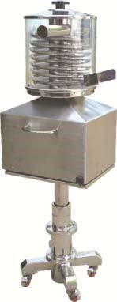

10. Dust Extractor PDE ‐ 300 GMP Model

The Dust Extractor unit is an ideal for controlling dust in process of Tableting and packing. The unit strongly recommends the use of dust control equipment with all Tablet press and De‐duster

The Dust Extractor deals with the light process dust problems and is adaptable for special applications. Dust laden air enters the collector through an expansion chamber, where heavy dust particles are deposited by gravity. The fine dust passes upwards through single large orifice and is finally collected by filter. There is an effective snap action shaking mechanism for shaking filter and dust is deposited into drawer type tray. There is a large door for changing filter bag and cleaning of the machine. The entire unit is on castor wheel to give complete manoeurrability.

SALIENT FEATURES:
- Design confirming to cGMP standards.
- Contact parts SS 316 and non contact parts SS 304.
- Simple and Convenient Operation, Changeover, Cleanliness, Operator Protection and Easy to Maintenance.
- Easy to connect all Tablet press and De‐Duster.
- Dynamically balanced blower. • Easy mobility.

OPTIONAL FEATURES:
- Flame proof electrical.
- Food Grade 5 micron filters.

TECHNICAL SPECIFICATIONS:
MODEL | PDE‐300
Machine | Dust Extractor Unit
Application | • Suction lying duct from tablet Press and Deduster unit.
Machine Standard/ Construction guide line | - The Current state of the art GMP Compliance.  - European Medicine Agency (EMA) and USFDA Regulations compliance.
Machine design Standard for safet | - The European Machinery Directive 2006/42/EC  - The European Low Voltage Directive 2014/35/EU  - ISO/TR 12100:1992: Safety Of machinery (Basic Concepts, y general Principle of design), part 1 & 2.  - ISO 15534:2000: Ergonomic Design for the safety of machine, Part 1 &2,  - ISO 13849‐1:1999: Safety Machinery – Safety related parts of

 |  | controls systems‐parts 1: General Principle for design.
 | • | ISO 13850:1996: Safety of machinery‐Emergency Stop‐  Principles of design.
 | • | ISO 13852:1996: Safety of Machinery‐ Safety distance to prevent danger zones being reached by upper limbs.
 | • | ISO 13853:1996: Safety of Machinery‐ Safety distance to prevent danger zones being reached by lower limbs.
 | • | ISO 13854:1996: Safety of Machinery‐ Minimum gaps to avoid crushing of parts of the human body.
 | • | ISO 14110:1998: Safety of Machinery –Interlocking devices associated with guards‐ principles for design & selection.
Room Condition | • | Room temperature : NMT 18 to 27 °C
 | • | Relative humidity : NMT 30 to 65%
 | • | Zoning : Class D Grade
 | • | Pressure : 10 Pa
Material and surface finish of parts in contact with the product | •  •  • | AISI 316.  Taflon, Silicon food grade USFDA  Ra ≤0.5 Mirror finish.
 | • | All contact parts rather that stainless steel should be food grade material.
Material and surface finish of parts not in contact with the product | •  • | AISI304  Ra ≤0.85 Matt Finish
Material and surface finish of outer surface | •  • | All material used in the equipment will be durable type.  The outer surface shall be easy to clean.
 | • | Outer surface finish of stainless materials in classified rooms will be mirror polished to Ra  0.9 m, if not otherwise stated.
Non‐metallic materials | • | Elastomers in direct contact with the product will be according to FDA Code 21 CFR 177
 | • | All non‐metallic materials used in the equipment will be of durable type and must withstand cleaning with ethanol 70% and detergents.
 | • | Gaskets, diaphragms and O‐rings in direct contact with the product will be PTFE and/or EPDM or Silicone.
 | • | Oil in instruments in direct contact with the product will be according to FDA Code 21 CFR 172.
Material to be handled | • | Pharmaceutical Powder
 | • | Bulk Density: 0.6 gm/cc (approx)
 | • | Particle Size: Average 100 mesh

Machine Working  Function | Principle/ | • | Closed chamber unit with suction air by blower from manifold and passed air through filter and collected flying dust in tray.
Capacity |  | • | 300cfm impeller design
Machine design |  | • | It is closed fabricated unit with having provision for mounting of blower motor, manifold, filter and dust collection tray.
 |  | • | Blower motor is mounting outside of the machine.
 |  | • | Blower impeller fitted in side in stricture.
 |  | • | Closed chamber is having provision to mount finger bag with manual spring loaded shaking unit and suction air from bottom.
 |  | • | Filtration area have rear side door to replace and clean the filter.
 |  | • | Bottom part of chamber having provision for mount dust collection tray.
 |  | • | Dust tray easily removes from rear side.
 |  | • | Manifold is fitted at front side to connect tablet press and Deduster.
 |  | • | Manifold bottom part is open in the tray to collect flying dust.
 |  | • | Complete unit mount on 4 nos. castor wheel for easy movements.
Filtration Area & Filter |  | • | Filtration area: 15 sq.feet.
 |  | • | Filter: 5 micron
 |  | • | Nos. Filter: 6 nos.
 |  | • | Filter MOC: Satin.
Dust Collection tray |  | • | Rectangular tray type
 |  | • | Mount at bottom of filtration area and manifold to collect dust.
 |  | • | Dust storage volume: Brim Volume 45 liter
Manifold |  | • | Made with cone type design
 |  | • | Nod. of manifold: 2 nos.
 |  | • | each manifold have connection for Dia.62mm ‐1 no and Dia.38mm ‐2 nos.
 |  | • | Bottom end with square design with flange type to mount on the machine.
Blower & motor. |  | • | Blower type: Centrifugal type
 |  | • | Blower capacity : Impeller design 300cfm
 |  | • | Impeller MOC: Aluminum.
 |  | • | Type of Motor: Foot mounted.
 |  | • | Mounting: on stand with foot mounting.
 |  | • | Blower speed: 2800RPM.
 |  | • | Electric motor: 1.5HP/1.18kW/3phase/380v‐415v/50hz.

- Motor drive: BY Variable frequency Drive to set vibration.
- Drive unit mount with base is encloser.
Machine Structure | - Complete structure made from S.S. sheet with single unit.  - machine is mount on 4 nos. castor wheel .
Electric controls panel | - Electric panel is encloser in S.S.304.  - ON‐OFF starter with overload relay controls..
Safety futures | • Overload relay controls.
Operation in hazard situations | - Utility failure  - The control system will work such that a utility failure does not break the process /system or cause hazardous situations.  - Programs must retain on electric power failure. System recovery after power failure must be possible.  - The stored data must retain on electric power failure.  - When reconnected after an electric power failure, the system must not start automatically any control actions without operator input.  •  - Emergency stop  - Emergency stop the complete machine immediately in a safe way.  - Restart after emergency stop will be performed from the control panel by the operator in an easy and safe way.  - The equipment will be equipped with switches for emergency stop. The switch/switches will be located in easily accessible places.
Require Utilities: | - Electric Power: 1.18kW/3phase/380v‐415v/50hz.  - Compressed Air: Nil.  - Steam: Nil.  - Cooling Water: Nil.  - Portable Water: NIL.  - Hot Water: For washing required.  - Distilled Water : For washing required  - Purified Water: For washing required.  - Purified Steam: NIL
Documents & Certificate | Manuals and Maintenance Instructions  - Operator manual.  - Installation and assembly instructions for all devices.  - User’s manuals for all components.  - Trouble shooting guide.

- Maintenance manual.
- Safety instructions.
- Training documentation.
Electrical and control diagrams
- Single line drawings for electrical distribution.
- Circuit diagrams.
- Cable list.
- Equipment location drawings for electrical equipment and instruments.
Qualification Protocols
- DQ protocols and reports.
- FAT protocol and report.
- IQ protocol and report.
- OQ protocol and report.
- DQ: Provide after received confirm order.
- FAT: Provide before machine gets ready for FAT & Trails.
- IQ, OQ, Machine Instruction & maintenance manual will be providing along with machine.
- DQ & FAT hard copy provide along with machine.
- PQ: PQ is not our scope of supply.
Test, Calibration, MOC Certification:
- All Test certificate for Brought Items will be provides during FAT with FAT Documents.
- MOC Certificate will be providing during FAT with FAT Documents.
- Calibration certificate provide for gauge during FAT.
- Above all certificate hard copy will be with FAT reports only.
Factory Acceptance Test (FAT) | - The supplier will perform FAT at the supplier’s facility with attendance of supplier/ buyer personnel. The FAT has to be successfully completed prior to delivery.  - The operational performance of the equipment will be verified during the FAT in complete tests.  - Buyer will bear Cost for FAT as per terms & condition.
Installation Qualification (IQ) & Operation Qualification (OQ) | - The supplier will provide test protocols for IQ and OQ covering requirements in the URS. The test protocols will be reviewed and approved by Buyer before the IQ/OQ is performed.  - The supplier will perform the IQ and OQ with attendance of buyer’s personnel and write corresponding reports.  - Buyer will bear Cost for SAT as per terms & condition.
Performance Qualification (PQ) | • The supplier CANNOT provide test protocols for PQ performed.
 |  | It is not scope of supply.
 | • | The suppliers will attendance during PQ. But not write any corresponding reports.
Recommended Spare | • | 1 set Filter bag
 | • | 1 Set Silicon Gasket seal at door of filter area and tray.
 | • | 2Nos. Spring.
 | • | 1 set. Locking Know.

IMAGE OF DUST EXTRACTOR
*All Pictures shown are for illustration purpose only. Actual product may vary due to product enhancement.
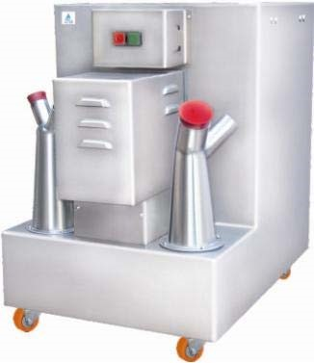

11. Automatic Capsule Filling Machine PCAP ‐ 750 GMP Model

The machine is designed and further improved on the basis of original full automatic capsule filling machine from aboard. With high technology and exclusive performance, it has reached international performance standards. It is an ideal equipment for filling empty hard gelatin capsules with medicine in pharmaceutical industry with full compliance to GMP requirements.

Standard equipment incorporates PLC programmable controller, stepless frequency inverter, touch panel operation. PLC system includes detection of low level of capsules and powder in hopper that automatically activates alarm and shut down, and resets automatic alarm after troubleshooting.

USAGE
- It is suitable for filling of powder, tablet and pellets in capsules.

SALIENT FEATURES:
- Good‐looking appearances, exquisite workmanship, ease of operation, simplicity of use.
- Powder ‘Tamping’ station and dozing disk are designed as one unit that ensures accurate alignment of dozing disk and tamping pins without any deviation. This avoids friction between tamping pins and dozing disk, improves filling precision, furthermore, greatly enhances the machine life.
- Improper and unopened capsules can be automatically ejected, the medicine in the capsule can be recycled and be reused, and thus it can improve greatly the economic efficiency.
- Simple, convenient and easy dismantling, cleaning, re‐assembling and adjusting of various parts facilitates quick change‐over from one product to another and from one capsule size to another.
- Capsule loading accuracy ≥99%, with precise dosage. • Stable in running, safe and reliable.

TECHNICAL SPECIFICATIONS:
MODEL | PCAP ‐ 750
Name | Capsule filling & sealing Machine
Application & Process | - Fills Power OR Pellets in hard gelatin capsule.  - Loads empathy hard gelatin capsule in hopper  - Loads powder or pellets in hopper.  - Rotates hard gelatin capsule in vertical position with big diameter in upward position.  - Open hard gelatin capsule by vacuum  - Move capsule with indexing gear drive.  - Fills powder or pellets in hard gelatin capsule.  - Powder fills by rotary disc type powder filler.  - Seal filled capsule by pressure  - Take off filled and sealed capsule from the machine.
Machine capacity | - Rated Output Powder filling: 45,000capsule/hour  - Rated Output for Pellets filling: 35,000capsule/hour
Machine Standard/ Construction guide line | - The Current state of the art GMP Compliance.  - European Medicine Agency (EMA) and USFDA Regulations compliance.
Machine design Standard for safety | - The European Machinery Directive 2006/42/EC  - The European Low Voltage Directive 2014/35/EU  - ISO/TR 12100:1992: Safety Of machinery (Basic Concepts, general Principle of design), part 1 & 2.  - ISO 15534:2000: Ergonomic Design for the safety of machine, Part 1 &2,  - ISO 13849‐1:1999: Safety Machinery – Safety related parts of controls systems‐parts 1: General Principle for design.  - ISO 13850:1996: Safety of machinery‐Emergency Stop‐Principles of design.  - ISO 13852:1996: Safety of Machinery‐ Safety distance to prevent danger zones being reached by upper limbs.  - ISO 13853:1996: Safety of Machinery‐ Safety distance to prevent danger zones being reached by lower limbs.  - ISO 13854:1996: Safety of Machinery‐ Minimum gaps to avoid crushing of parts of the human body.  - ISO 14110:1998: Safety of Machinery –Interlocking devices associated with guards‐ principles for design & selection.
Room Condition | • Room temperature : NMT 18 to 27 °C

- Relative humidity : NMT 30 to 65%
- Zoning : Class D Grade
- Pressure : 10 Pa
Material and surface finish of parts in contact with the product | - AISI 316.  - Taflon, Silicon food grade USFDA  - Ra ≤0.5 Mirror finish.  - All contact parts rather that stainless steel should be food grade material.
Material and surface finish of parts not in contact with the product | - AISI304  - Ra ≤0.85 Matt Finish
Material and surface finish of outer surface | - All material used in the equipment will be durable type.  - The outer surface shall be easy to clean.  - Outer surface finish of stainless materials in classified rooms will be mirror polished to Ra  0.85 m, if not otherwise stated.
Non‐metallic materials | - Elastomers in direct contact with the product will be according to FDA Code 21 CFR 177  - All non‐metallic materials used in the equipment will be of durable type and must withstand cleaning with ethanol 70% and detergents.  - Gaskets, diaphragms and O‐rings in direct contact with the product will be PTFE and/or EPDM or Silicone.  - Oil in instruments in direct contact with the product will be according to FDA Code 21 CFR 172.
Empty Cupules loading | • Provide empty capsule loader to load in hopper.
Powder charging | • By Manually
Pellets Charging | • By Manually
Discharge of materials | • Gravity from machine to Capsule polishing machine.
Machine fitted with change parts | ‘’0”capsule size.
Additional Change Parts ‐ Option | - Option can be provides additional change parts for capsule size Powder filling and pellets filling  - ‘000’ size for powder & pellets filling.  - ‘00’ size for powder & pellets filling.  - ‘0’ size for powder & pellets filling.  - ‘1’ size for powder & pellets filling.  - ‘2’ size for powder & pellets filling.  - ‘3’ size for powder & pellets filling.  - ‘4’ size for powder & pellets filling.

 | • | ‘5’ size for powder & pellets filling..
Capsule Loading station | • | Empty capsule hopper with sensor.
 | • | Made from perforated sheet of S.S.316
 | • | Gravity chute with capsule guide assembly.
 | • | Capsule automatic rotating in perfect position.
 | • | Capsules push in cavity and Vacuumized for Open both parts.
 | • | The empty capsule filling and pushing assembly working with cam and follower with rod.
Pellet Filling station | • | Provide pellet dosing station with hopper and pellet weight  Adjustment assembly.
 | • | The Pellets filling assembly working with cam and follower with rod.
Powder dosing station | • | Powder dosing station have rotary weighing disc with pressure rod assembly.
 | • | Powder hopper with level sensor.
 | • | Scrapper provide rotary disc.
 | • | Powder pressure in dosing plate after that it will fill in capsule by rod.
 | • | Powder weight adjustable by working sets of pressure rod.
Empty capsule rejection | • | Station provides of empty capsule rejection
 | • | Bottom push rod working with cam and followers & rods.
Capsule sealing station | • | Capsule seal at capsule sealing station by rod pressure.
 | • | Rod height and sealing pressure is adjustable.
 | • | Bottom push rod working with cam and followers & rods.
Capsule Ejection station | • | Filled capsule eject at ejection station on discharge chute.
 | • | Bottom push rod working with cam and followers & rods.
Cavity cleaning station | • | After ejection there are 1 no. station to remove capsule if stick inside the cavity and suction by dust extraction  System.
 | • | Bottom push rod working with cam and followers & rods.
Capsule Loading in hopper of the machine | • | Provide empty capsule loader system.
Capsule polishing and shorting | • | Provide capsule polishing and empty capsule shorter unit  Tighter with polishing machine.
PLC Controls system function | • | Advance PLC control with 10” HMI Touch screen.
 | • | Machine function Auto Mode & Manual Mode.
 | • | ON‐OFF Main Pocket holder motor.

- Speed setting SET‐ACTUAL.
- ON‐OFF Vacuum Pump.
- ON‐OFF feeder screw motor.
- Speed SET ‐ACTUAL of feed screw.
- Powder level sensor in feeding powder hopper.
- Powder level sensor in pellet feeding hopper.
- Total output actual count.
- Process door Interlock,
- Process interlock with Air pressure
- Auto controls screen.
- Manual controls screen.
- Alarms History /Interlock screen
- Batch data screen.
- 3 level password protection.
- Recipe Management for Products parameter.
- Batch data printing.
- INPUT ‐ OUTPUT List screen.
- Electric panel fitted with Main Isolate switch, MCB, Contactor,
Overload Relay, Controls Relay, VFD, PLC, SMPS etc.
Safety features & interlock | - Top acrylic Door in position is interlock.  - Powder level in hopper.  - Batch complete Process time is interlock.  - Compressed Air pressure is interlock.  - Over load relay.  - Controls wiring with 24 DC for safety.  - Emergency Stop button.
Operation in hazard situations | Utility failure  - The control system will work such that a utility failure does not break the process (Stirring operation) /system or cause hazardous situations).  - Programs must retain on electric power failure. System recovery after power failure must be possible.  - The stored data must retain on electric power failure.  - When reconnected after an electric power failure, the system must not start automatically any control actions without operator input.  Emergency stop  - Emergency stop the complete machine immediately in a safe

way.
- Restart after emergency stop will be performed from the control panel by the operator in an easy and safe way.
- The equipment will be equipped with switches for emergency stop. The switch/switches will be located in easily accessible places.
Alarms
- Error messages on control panel will be in plain text with fault code.
- All alarms shall be indicated by a light column & audible signal.
Make of Brought Items | - PLC‐ Mitsubishi / Phoenix make.  - HMI.: Mitsubishi /Schneider  - VFD: Schneider.  - Motor: Crompton/Siemens.  - Indexing Gear Box: Condex.  - Vacuum Pump: PCI  - Reduction gear motor: Bonfigilioli/Rotomotive/Lenze  - Contactor & Relay‐ Schindler.  - Controls reply – Pla / Phoenix  - SMPS‐ Phoenix / Minwell.  - Isolator switch – Sulzer  - Make‐ Festo  - Solenoid Valve  - FRL UNIT  - Flow controls Valve  - Pressure switch‐ Denforce.
Required Utilities | - Electric Power: 6.5kw/3phase/400V/50hz.  - Compressed Air : 20cfm @ 4 bar pressure  - Steam: Nil  - Portable water: Nil  - Hot water : Nil  - Purified water : Nil
Documents & Certificate | Manuals and Maintenance Instructions  - Operator manual.  - Installation and assembly instructions for all devices.  - User’s manuals for all components.  - Trouble shooting guide.  - Maintenance manual.  - Safety instructions.

- Training documentation.
Electrical and control diagrams
- Single line drawings for electrical distribution.
- Circuit diagrams.
- Cable list.
- Equipment location drawings for electrical equipment and instruments.
Qualification Protocols
- DQ protocols and reports.
- FAT protocol and report.
- IQ protocol and report.
- OQ protocol and report.
- DQ: Provide after received confirm order.
- FAT: Provide before machine gets ready for FAT & Trails.
- IQ, OQ, Machine Instruction & maintenance manual will be providing along with machine.
- DQ & FAT hard copy provide along with machine.
- PQ: PQ is not our scope of supply.
Test, Calibration, MOC Certification:
- All Test certificate for Brought Items will be provides during FAT with FAT Documents.
- MOC Certificate will be providing during FAT with FAT Documents.
- Calibration certificate provide for gauge during FAT.
- Above all certificate hard copy will be with FAT reports only.
Factory Acceptance Test (FAT) | - The supplier will perform FAT at the supplier’s facility with attendance of supplier/ buyer personnel. The FAT has to be successfully completed prior to delivery.  - The operational performance of the equipment will be verified during the FAT in complete tests.  - Buyer will bear Cost for FAT as per terms & condition.
Installation Qualification (IQ) & Operation Qualification (OQ) | - The supplier will provide test protocols for IQ and OQ covering requirements in the URS. The test protocols will be reviewed and approved by Buyer before the IQ/OQ is performed.  - The supplier will perform the IQ and OQ with attendance of buyer’s personnel and write corresponding reports.  - Buyer will bear Cost for SAT as per terms & condition.
Performance Qualification (PQ) | - The supplier CANNOT provide test protocols for PQ performed. It is not scope of supply.  - The suppliers will attendance during PQ. But not write any
 | corresponding reports.
Overall Dimensions | 850 x 1000 x 2200 (H)
Net Weight | 1000 kg
Recommended Spare | - 1 Set of complete spring.  - 2 Nos. Limit switch at door.  - 1 No. Controls relay card.  - 1 No. Solenoid Valve.  - 10 Nos. Pneumatic Connection.  - 10 meter M8 Pneumatic Pipe.

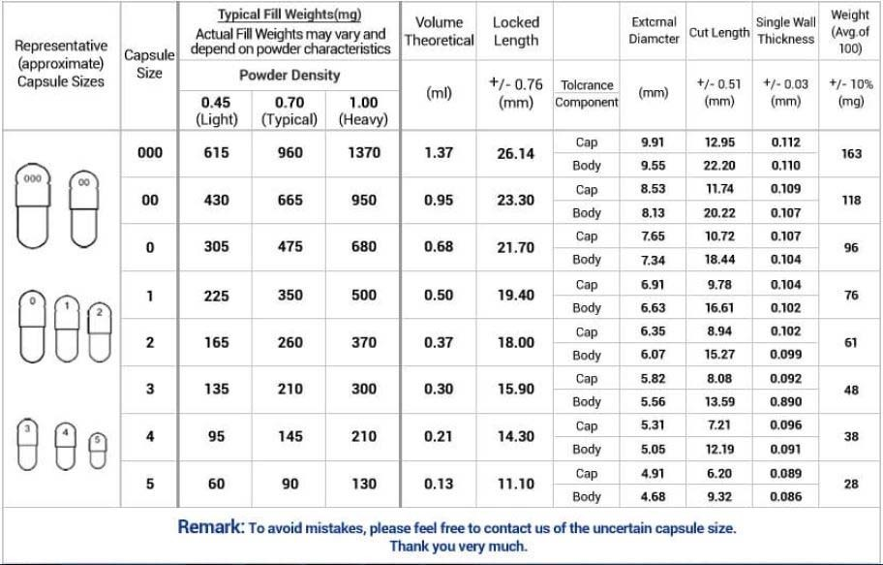

IMAGE OF AUTOMATIC CAPSULE FILLING MACHINE:
*All Pictures shown are for illustration purpose only. Actual product may vary due to product enhancement.

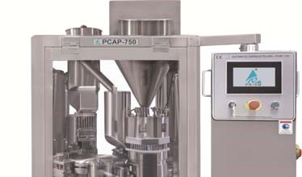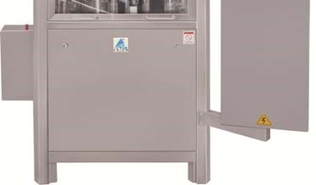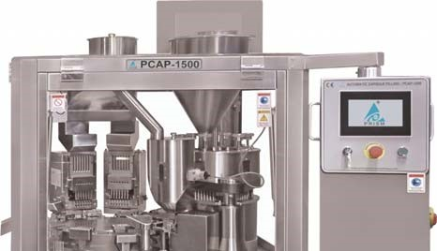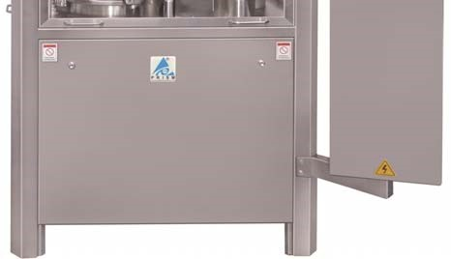

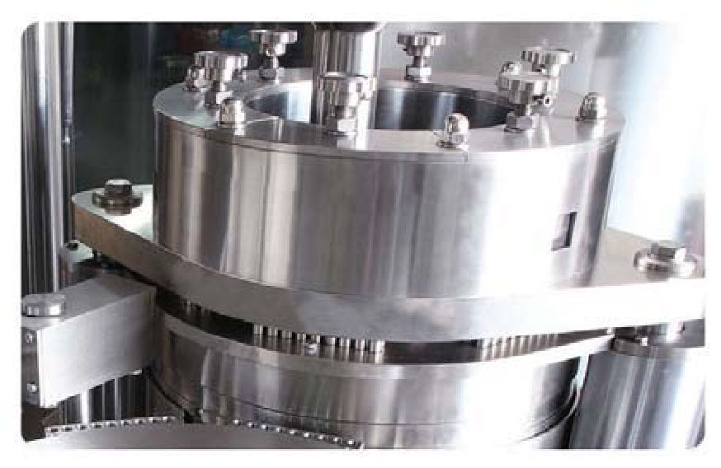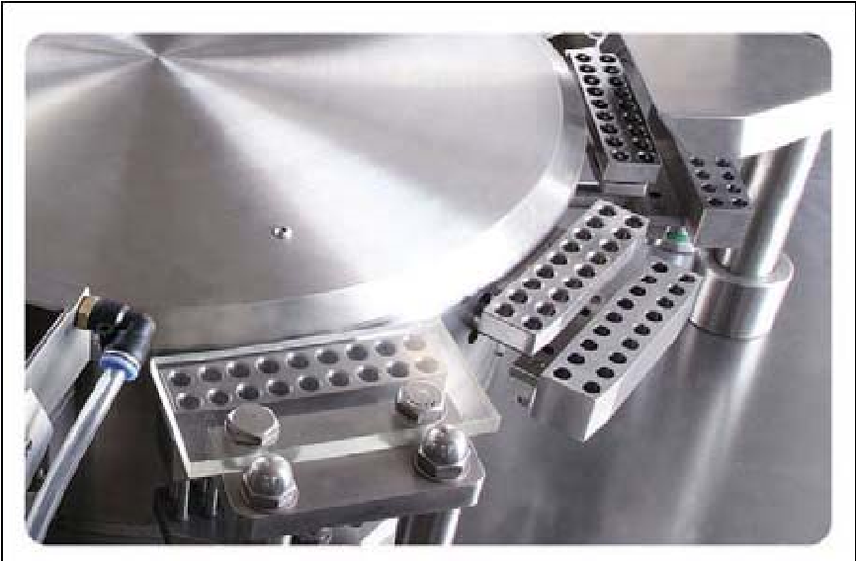

Dust Extractor: Model
The Dust Extractor unit is an ideal for controlling dust in process of capsule filling machine. The unit strongly recommends the use of dust control equipment with capsule filling machine and capsule polishing machine.

The Dust Extractor deals with the light process dust problems and is adaptable for special applications. Dust laden air enters the collector through an expansion chamber, where heavy dust particles are deposited by gravity. The fine dust passes upwards through single large orifice and is finally collected by filter. There is an effective snap action shaking mechanism for shaking filter and dust is deposited container. There is a door at top side for changing filter bag and cleaning of the machine. The entire unit is on castor wheel to give complete manoeurrability.

Connected Load:
• Blower Motor: 2hp/1.5km/400v/50hz/3 phase • Blower capacity: 160m³/hr

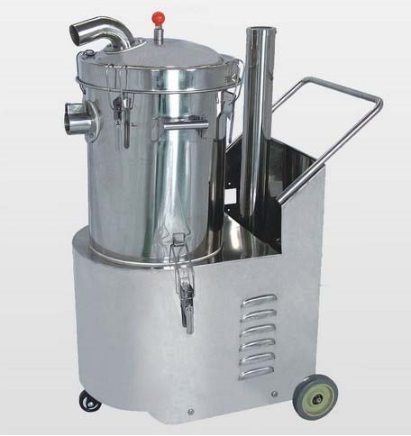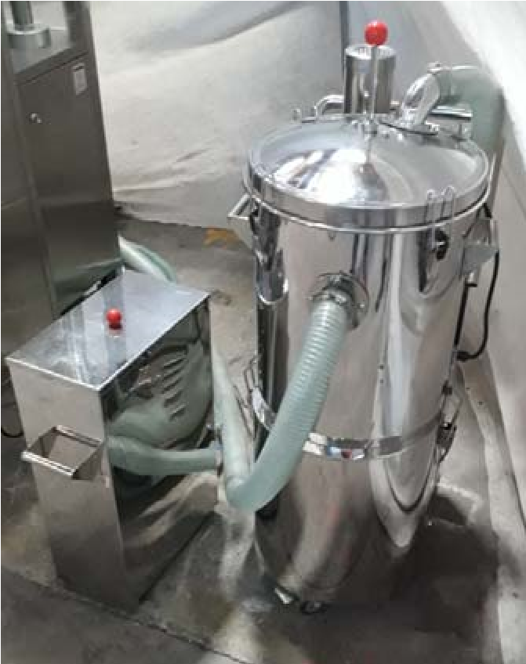

Empty Capsule Loader: Model ECE
- The Empty Capsule Elevator is used to load empty capsules from the lower level to the higher level hopper of the capsule filling machine. The Empty Capsule Elevator is a part of the transfer line for the transfer of empty capsules into the capsule hopper of the Automatic Capsule Filling Machine, which is at higher level.
- The machine works on the principle of air and lifting the capsules by airflow. A continuous stream of air at a high velocity lifts the capsules up as soon as they are fed into the blower inlet chute. The capsules are fed at a lower level and machine conveys them to a higher level.

Connected Load:
- Blower Motor: 0.5hp/400v/50hz/3 phase

IMAGE OF AUTOMATIC CAPSULE LOADER
*All Pictures shown are for illustration purpose only. Actual product may vary due to product enhancement.
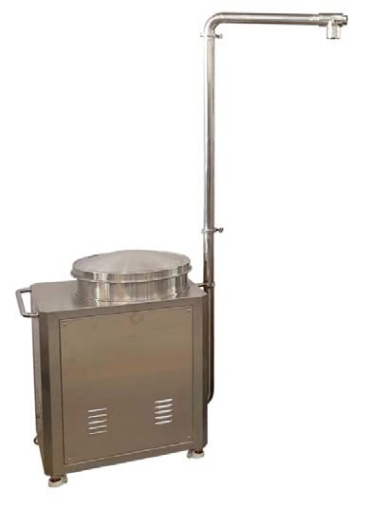

Capsule Polishing Machine and empty capsule shorter: Model DPM
- Capsule Polishing machine connect with dust extraction.
- Concept of rotating brush with spiral groove is used to convey and clean the capsules on a continuous basis.
- Capsules are fed into the cylindrical chamber (polishing Chamber). In this chamber, rotating spiral brush removes the powder particles deposited on the capsule surface. At the same time, the capsules are carried in forward direction. The outer Teflon net prevents capsules from getting damage due to metal contact and provides area for vacuum suction of powder, removed from capsule surface. Compressed air and Vacuum keeps the polishing chamber and nylon brush clean and free of powder.
- After the capsules are fed in the polishing chamber from the inlet chute, the spiral brush pushes them against gravitational force & towards the delivery chute. During this process, the capsules are rubbed against the nylon bristles. With this surface powder gets removed & is sucked by vacuum pump. The capsules get completely polished by continuous rubbing against rotating brush.
- Polished capsule feed in shorter at discharges of polishing machine. The shorter machine working principle is on air. The compressed air is spate empty capsule in rejection bowl and good capsule discharge through chute.

Connected Load:
- Brush Drive Motor: 0.5HP/400V/3 Ph/50 H
Utility Requirement:
- Compressed Air:2‐3 CFM at 4‐5 kg/sq.cm,

IMAGE OF AUTOMATIC CAPSULE SORTER
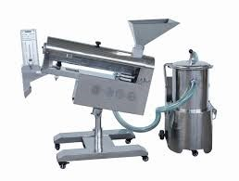

12. Automatic Blister Packing Machine ALU ‐ ALU (Cold Forming) Blister & PVC /PVDC – ALU (Thermo Forming) PEXCEL ‐ 44 GMP Model

PRISM has wide range of high precision automatic Blister Packing Machines. AII machines are manufactured under stringent quality control process to ensure years of trouble free production. Special design of machine ensures total synchronization of timings between sealing of ALU ‐ALU & ALU‐ PVC base web.

SALIENT FEATURES:

Packing Speed: 40 Cycle/min for Thermo Forming
35 Cycle/min for Cold Forming

Feeding System: Auto feeding system by PLC Logic with pneumatic Combination.
(For critical products)
Servo Drive Indexing: Servo web indexing by rigid PLC Logic.

Operator Interface: User friendly MMI touch screen (Man machine interface)

Pneumatic Operations: Festo make for fast response, oil free, minimum wear and tear, easy maintenance and universal Availability of bought outs.

Packaging Materials:
Base Material: PVC/PVC‐PVDC/ACCLAR/TRIPLEX/PP/ALU‐ALU (OPA)
Lading Material: Aluminium with Heat Sealable Lacquer Coating.

MACHINE TECHNICAL SPECIFICATIONS
DESCRIPTION | THERMO FORMING  (WHEN FITTED) |  | COLD FORMING ALU‐ALU
Base Film Width | PVC Film 227 mm. |  | Alu. Foil 227 mm
Blister Foil Thick | PVC 0.25 – 0.40 mm. |  | Alu. 0.13‐0.15 mm
Base Foil Reel Dia. | 440 mm. |  | 440 mm
Sealing Foil Thick | 0.02 – 0.03 mm |  | 0.02 – 0.03 mm
Sealing Foil Reel Dia. | 250 mm. |  | 250 mm.
Sealing Foil Width | 227 mm |  | 227 mm
Pack Length | 219 mm |  | 219 mm
Pack Width | 140 mm |  | 140 mm
Forming Depth | 12 mm |  | 12 mm
Cycle Speed/Output | 40 Cycles/Min |  | 35 Cycles/Min
Floor Space Approx. | (L) 4100 mm. × (W) 1200 mm.× (H) 1800 mm. |  | (L) 4100 mm. × (W) 1200 mm.× (H) 1800 mm.
Net Weight Approx. |  | 2100 Kg.

Utilities Requirement:
Compressed Air : Dry Air at Constant pressure 6.0 Bar
Water Cooler : 150 Liters / Hours, Inlet pressure = 2.5 bar (Max)
Water outlet Temp. = 15 ± 2° C
Connected Load : 6.5 KW (When Machine is only Alu/Alu)
10.0 KW (When Machine with Alu/Alu & Pvc/Alu) Electrical Power : 415 V ± 10%, 3 Phase, AC, 50 Hz ± 2 (4 Wire).
Earth Cable : Copper, 2.5 mm² (Minimum)
❖ Chart for Approximate Rate of Production.

SR. No. | Tablets/ Capsules | Nos. of  Pack Per Stroke | Machine Output 10  Tab/Cap Pack Packs/Min  (Approximate) | Production per shift 8.0 Hours
1 | Up to Ø 9.7mm. | 4 | 120 | 500,000
2 | Ø 12.7mm | 3 | 90 | 400,000
3 | Size '2' Cap/Small DS Tablet | 3 | 90 | 400,000
4 | Size '0' Cap/Big DS Tablet | 2 | 50 | 300,000
5 | Size '1' Cap/Medium DS Tablet | 2 | 50 | 300,000

IMAGE OF AUTOMATIC BLISTER PACKING MACHINE‐ EXCEL‐44
*All Pictures shown are for illustration purpose only. Actual product may vary due to product enhancement.

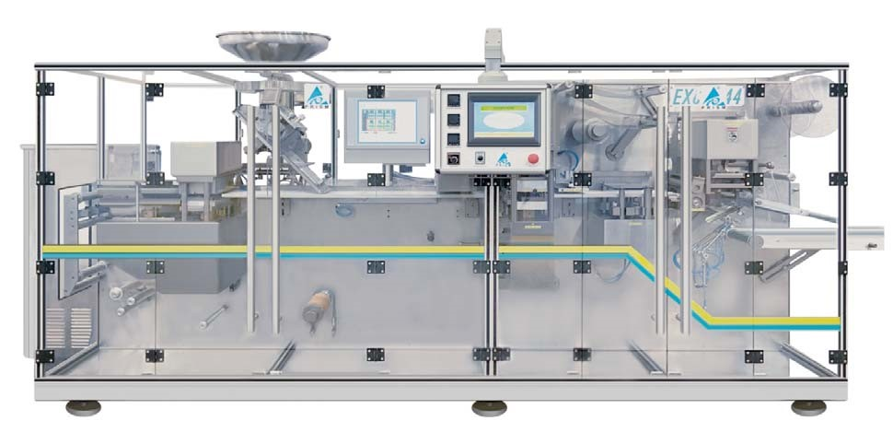
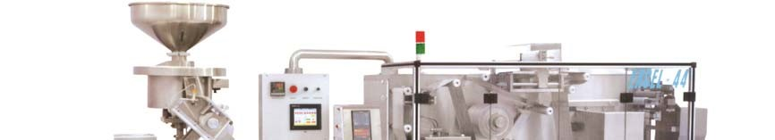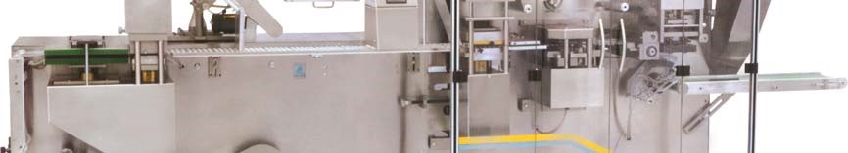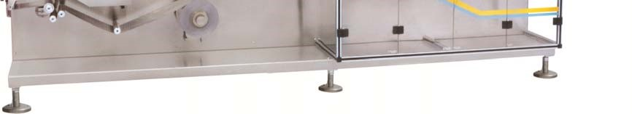

For Blister Pack Machine:
NOTE: Above Two item are an option and out of two one has to be selected / Purchased.

- No fills detection gadget works only for product filled in a cavity and to be purchased with each and every change parts. OR
- Blister inspection system (camera) is useful for No fills, broken/crushed tablets, color variation, black spots on a tablet. Camera is common for every each and every change parts.

TERMS & CONDITIONS:
Prices | FOB Any Seaport, India – By Sea.
Packing | Export Sea worthy packing.
Payment | 40% advance payment via Telegraphic Transfer along with Purchase Order.  60% After Successful FAT
Delivery | Within 16 weeks after receipt of advance along with purchase order OR Letter of  Credit. Shipping Time is extra as applicable.
FAT @ Prism site before dispatch | FAT for 2 persons from Customer’s site @ Prism site before dispatch. Lodging Boarding, To & Fro Fare air ticket charges from your country to Last Destination will be arranged and borne by customer. Lodging & boarding, food, Local conveyance charges will be arranged and borne by Prism.
Installation & Commissioning &  SAT | - Will be charged extra @ EURO 100 per man per day of 8 hrs.  - To & Fro Fare air ticket charges from Ahmedabad to Last Destination, lodging & Boarding, Local Conveyance charges as actual will be arranged and borne by you.  As soon as the machines are received at your end kindly make sure that the site is ready with all required utilities.
Documentation | The Machine Instructions Manual, operating and maintenance manuals along with test certificates and drawings will be provided free of cost. Validation Documents (DQ, IQ, and OQ) will be provided at the extra cost as mentioned above.
Warranty | - Warranty is valid for 12 months from the date of dispatch unless otherwise specified and agreed before the purchase order.  - Warranty does not cover the parts which are subject to normal wear & tear such as gaskets, bearings, variable belts, electric / electronic items, and oil / grease seals.  - Any defect caused by incorrect use of machine and other parts which are
normally the bought out items like electric / electronic and pneumatic parts which are not made by us. The warranty claim will be directly to the supplier or it covers the warranty which we get from supplier from time to time.
- Warranty does not cover manpower cost which is required to be arranged for necessary repairs or rectification of the equipment during the warranty period.
- On receipt of machine the customer should verify that the packing crate is in sound condition. The supply corresponds to the purchase order specifications.
- Any claim should be intimated to PRISM in writing.
- Any legal dispute / issue will be settled in India / Ahmedabad as per the Indian Regulations.
Validity | The offer is valid till 6 months from date of quotation.

