**Deep Neural Networks Based Method to Islanding Detection for Multi-Sources Microgrid**

**Abstract-**One of the significant issues in the field of microgrids is their islanding, where in many cases, the lack of awareness of microgrid islanding can lead to interference in the protective and control functions of the microgrid. Therefore, the accurate detection of microgrid islanding is of utmost importance. In this article, a method based on deep neural networks is presented. The proposed approach utilizes terminal parameters of microgrid resources, such as sequence current components, voltage, and other parameters, to detect islanding. Various operational states of the microgrid are simulated offline as standard test cases, and the parameters of each of them are recorded for later use. These data are then used to extract statistical features using discrete wavelet transform. Subsequently, the extracted features are fed into deep neural networks for training, and the training and evaluation results demonstrate an accuracy of over 99% for the proposed method in terms of precision and reliability. Furthermore, the accuracy of the proposed method is compared with some similar approaches for islanding detection.

**Keywords** - Microgrid, Islanding Detection, Deep Neural Networks, Deep Learning, Discrete Wavelet Transform.

1. **Introduction**

Microgrids, as decentralized and self-sustaining energy systems, have garnered increasing attention due to their potential to improve energy efficiency, [1] . In these autonomous systems, multi-source microgrids, composed of distributed energy resources (DERs) such as solar panels, wind turbines, and energy storage devices, play a crucial role in meeting the ever-growing energy demands while reducing carbon emissions. However, one of the significant challenges in the effective operation of multi-source microgrids is the occurrence of islanding events [2].

Islanding refers to the situation when a section of the microgrid becomes electrically disconnected from the main grid while still operating autonomously [3]. This phenomenon can pose serious safety risks and disrupt the normal operation of protective and control functions within the microgrid [4]. If islanding events go undetected, they can lead to equipment damage, voltage fluctuations, and potential blackouts. Hence, accurate and efficient detection of islanding events is of paramount importance to ensure the overall stability and reliability of multi-source microgrids [5].

The presence of distributed generation (DG) resources in distribution and transformation networks has many benefits for the power system. In addition to reducing the use of fossil fuels, DGs improve the reliability, security, and performance of the system [6]. While the existence of DGs provides many advantages for microgrids, they also have some disadvantages. The presence of DGs changes the characteristics of the network. Therefore, microgrids face serious protection challenges. DGs have different protection challenges due to their limited output power compared to synchronous generators [7]. They must operate in island mode to feed critical loads [8]. Additionally, in the event of major disturbances in the main network, the microgrid must be able to operate in island mode [9]. A microgrid consists of several distributed generation sources, short transmission lines, loads, and control and protection equipment that interact with each other at a specific electrical boundary. Microgrids usually operate in two modes: connected to the network and independent (islanded). In the connected mode, the microgrid can exchange power with the main network, but in the islanded mode, only the resources available in the microgrid can supply its loads. Detecting islanding in a microgrid is a major challenge for microgrid operators. Islanding events can be intentional or unintentional [10]. In intentional cases, the microgrid operates as an independent network and provides demand for its loads. Intentional islanding is used to supply critical loads during a planned process. However, unintentional islanding may occur during unplanned events due to the microgrid being disconnected from the main network under various fault conditions [11]. Intentional islanding is a controllable operation mode required for the maintenance of the main grid, while unintentional islanding is an uncontrollable operation caused by regular faults such as line outages, equipment failures, or other uncertainties in the power system [12]. Islanding operation in microgrids poses a significant threat to power quality, equipment integrity, and overall system stability [13]. Detecting and promptly addressing such isolated and outage conditions in microgrids have become crucial requirements to ensure the safe and reliable operation of these decentralized energy systems [14]. Conventional protection devices, which rely on sufficient fault currents to operate effectively, may prove inadequate in certain scenarios, especially when distributed generation (DG) units are unable to provide the required fault current [15]. As a result, novel and sophisticated approaches are required to address the challenges of islanding detection and protection.

Various methods have been proposed for islanding detection in different network types, including microgrids. One such method, introduced by Authors in [16], employs Long Short-Term Memory (LSTM) networks with short-term and long-term memory to passively detect islanding in microgrids. This approach utilizes voltage and current harmonics at the Point of Common Coupling (PCC) within the microgrid. Similarly, in [17], the authors presented a method that combines one-dimensional convolutional neural networks with memory-based networks for islanding detection. This technique also relies on voltage and current harmonics at the PCC to identify islanding events in the microgrid.

On the other hand, Authors in [18] proposed an active method for islanding detection, involving signal injection using a photovoltaic inverter as an intermediary in the grid. The modified Görtzel algorithm and harmonic components at the PCC are utilized to implement an islanding detection threshold function, enabling effective operation under diverse conditions. A comprehensive review of various islanding detection methods in microgrids is provided by the authors in [19]. Additionally, the Authors in [20] offers an extensive research study exploring conventional and modern islanding detection techniques.

These existing approaches showcase the ongoing efforts to address the critical challenge of islanding detection in microgrids. Each method leverages unique features and techniques, highlighting the diverse and evolving nature of research in this field. In this paper, we propose a new method based on deep neural networks, which aims to contribute to the existing body of knowledge and offer an innovative solution to enhance the reliability and performance of islanding detection in multi-source microgrids.

Sudden islanding of the microgrid is one of the problems of microgrids. When the microgrid is suddenly disconnected from the network, many control and protection issues must also adapt to the new conditions. If the operator becomes aware of this issue with a longer delay, it can cause numerous problems such as protection relay settings, control equipment, injected power by distributed generation sources, and so on [21]. Therefore, it is necessary to design a reliable mechanism for detecting islanding in the microgrid so that it can quickly detect the microgrid's independence and send the necessary signals to the operator and other equipment to adapt to the current conditions.

In recent years, the emergence of deep learning techniques, particularly deep neural networks (DNNs), has revolutionized various fields, including image recognition, natural language processing, and pattern recognition. Leveraging the powerful capabilities of DNNs, researchers have explored their potential application in addressing the islanding detection problem [22]. These sophisticated neural networks can learn complex patterns and representations from vast amounts of data, making them a promising solution for reliable and precise islanding detection in multi-source microgrids.

Islanding Detection Methods, IDM-based on various techniques discussed in the aforementioned papers have significant technical issues that need to be addressed to enhance their performance and make them more reliable and efficient. Threshold-based IDM methods have an inherent non-detect zone (NDZ) that is challenging to eliminate, while injection-based methods may compromise power quality [23], [24]. On the other hand, signal processing-based techniques offer higher accuracy, robustness, and reliability compared to existing IDM approaches, but they come with a high computational burden. In some methods, Fourier Transform [25] and Fast Fourier Transform (FFT) [26] have been employed for islanding detection. Fourier Transform is a frequency-domain analysis, and as a result, it does not process non-stationary features in voltage, current, and power signals effectively.

In this paper, we present a method for islanding detection in multi-source microgrids based on deep neural networks. Our approach utilizes terminal parameters of microgrid resources, such as sequence current components, voltage, and other relevant parameters, to capture distinctive patterns associated with islanding events. By simulating various operational states of the microgrid and recording corresponding parameters, we create a comprehensive dataset for training and evaluation purposes. The recorded data is then subjected to discrete wavelet transform to extract statistical features, which are subsequently fed into the deep neural network for learning and classification. The voltage and current components of distributed generation sources are utilized for islanding detection. Considering that distributed generation sources take on the responsibility of supplying the system loads during microgrid islanding, monitoring their performance and response to system events can contribute to the development of a comprehensive method for islanding detection. The required variables for training deep neural networks are extracted through simulations. As the measured variables contain implicit features related to the system operating state, wavelet transformation is employed to extract these features. The feature vectors are used as inputs to the deep neural network. The output of this network consists of a single neuron, which is set to one in islanding condition and zero when the microgrid is connected to the main grid.

The primary objective of this research is to demonstrate the effectiveness and accuracy of our proposed method compared to existing islanding detection techniques. It is assured that harnessing the potential of deep neural networks can significantly enhance the detection performance, contributing to the overall stability and resilience of multi-source microgrids. The successful implementation of this method can pave the way for more efficient, reliable, and sustainable operation of microgrid systems, bringing us closer to a cleaner and greener energy future.

The contributions of the paper is as follow:

* Introducing a method for islanding detection in multi-source microgrids based on deep neural networks and terminal parameters of microgrid resources, such as sequence current components, voltage, etc.
* Simulation of islanding detection cases for feature extraction steps.
* Using Dense and gated recurrent unit layers for creating deep neural networks structures.
* Using discrete wavelet transform for signal processing and feature extraction due to its advantages over FFT.

This paper is organized as follows. In section II, introduces the peoposed islanding detection scheme. In section III, simulation and numerical have been presented. The paper conclusion presented in section IV.

1. **Proposed islanding detection scheme**

The reliable and timely detection of islanding events in microgrids is of paramount importance to ensure their safe and efficient operation. Islanding, characterized by the unintentional disconnection of a section of the microgrid from the main grid, can lead to potential damage to equipment, compromised power quality, and safety hazards. To address this critical challenge, various islanding detection schemes have been proposed, leveraging advanced techniques and algorithms. In some methods, islanding is detected by analyzing the deviations in voltage and frequency. In the active method, non-constant components are deliberately injected into the system by the operator, and islanding is detected based on the system's responses. Additionally, artificial intelligence and signal processing methods have been employed for islanding detection. In certain approaches, Fourier transform and fast Fourier transform have been used to identify islanding events. However, Fourier transform, being a frequency domain analysis, may not adequately process non-constant features in voltage, current, and power. In this scheme, the voltage and current components of distributed generation sources in the system are utilized for islanding detection. Since the distributed generation sources become responsible for supplying the system loads during islanding, monitoring their performance and response to system events can assist us in developing a comprehensive method for islanding detection.

Simulation of the studied microgrid

Entering features into the process of training deep neural networks

Simulation of a large number of different working states of the microgrid, including disconnection and connection of equipment, loads and different sources

Registering and saving the parameters resulting from the simulation of states

Extracting features from stored data using the violet transform

Islanding detection and obtaining performance accuracy and reliability of the proposed scheme

Designing, building and training data to neural networks of different types شبکه

Figure 1- General diagram of the proposed design

In contrast to conventional methods that rely on threshold-based techniques or specific algorithms, the DWT-based islanding detection scheme offers a more robust and adaptive approach. It is capable of adapting to different microgrid configurations and operating conditions, ensuring reliable detection under varying scenarios. In the following sections, we present the theoretical foundations of the proposed DWT-based islanding detection scheme, along with its implementation methodology. We demonstrate the effectiveness and performance of the scheme through extensive simulations and evaluation using real-world microgrid data. Furthermore, a comparative analysis with existing islanding detection techniques is presented to highlight the advantages and contributions of the proposed approach.

1. Symmetrical components

In electrical engineering, three-phase systems are decomposed into their symmetrical components for analysis. This decomposition method was introduced by Charles Legeyt Fortescue in 1918 [27]. According to Fortescue's theory, the unbalanced phases of a three-phase system can be transformed into three symmetrical systems of phases called positive sequence components, negative sequence components, and zero sequence components, where the positive and negative components each form a symmetrical three-phase system, and the zero sequence components consist of three equal single-phase components. To perform this transformation, a matrix of symmetrical component transformation is used, where I+, I-, and I0 are the positive, negative, and zero sequence current components, respectively, and matrix A is the transformation matrix from three-phase components to symmetrical components, where alpha is a value equal to one with a 120-degree angle. In the event of an error in the main network, some microgrids automatically disconnect from the main network to prevent disturbances in the microgrid. In islanding mode, the distributed generation sources are responsible for supplying the loads of the microgrid. Given this fact, the terminal parameters of distributed generation sources can be used to identify the occurrence of islanding. Islanding events in a microgrid can create an unbalanced operational state. Factors such as the presence of distributed generation sources with low inertia, harmonics in the output of distributed generation sources with inverters in the microgrid, large three-phase loads, and other factors can cause voltage and frequency imbalances in the microgrid. Some islanding detection methods are based on unbalanced voltage and THD, which are good indicators of the unbalanced performance of the microgrid. In this paper, current and voltage sequence components at the terminal of distributed generation sources are measured to detect islanding events. Sequence components contain information about imbalanced events in the microgrid. Current sequence components are the main indicators of islanding detection in this scheme. However, they cannot be used alone for microgrid islanding detection, and preprocessing steps must be taken, such as applying wavelet transforms to the parameters.

1. Discrete wavelet transform and feature extraction

One thing that can be mentioned about the Fourier transform is that it has a high resolution in the frequency domain, while it has zero resolution in the time domain. In other words, the Fourier transform can tell us exactly what frequencies are present in a signal, but it cannot determine when the desired frequency occurs in the signal.

A better method for analyzing a signal with a dynamic frequency spectrum is to use the wavelet transform. The wavelet transform has high resolution in both the time and frequency domains. This transform not only determines the frequency values present in the signal, but also determines when those frequencies occur in the signal. The wavelet transform achieves this capability by working at different scales. In the wavelet transform, the signal is first considered with a large scale or window, and its large features are analyzed. In the next step, the signal is examined with small windows, and its small features are obtained. Figure 2 shows the resolution of the time and frequency domains in various transform methods.

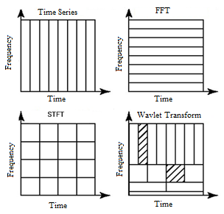

Figure 2- Resolution of time and frequency domains in different transforms.

The wavelet transform decomposes the input signal into two orthogonal signals. At each level of the wavelet transform, the input signal passes through a high-pass filter and a low-pass filter. The output of the low-pass filter is an approximation coefficient, and the output of the high-pass filter is a detail coefficient. Testing all possible combinations of wavelets to find the best wavelet group for feature extraction may not be feasible. In this paper, four types of wavelet transforms from the Sym and Db mother wavelet families were selected for processing the input signal, namely, the voltage components and current sequence. Since the sampling frequency of relays is 3.2 kHz and the frequency of the power grid is 50 Hz, each cycle of measured signals consists of 3200/50=64 samples. For each time period equivalent to 20 milliseconds in the power grid, 1296 features can be calculated, which is obtained by multiplying 12 (measured parameters) by 18 (coefficients) by 6 (features). These features are used as inputs to deep neural networks. Table 1 presents the type, family, filter size, and decomposition level of the used wavelet transforms.

Table 1. Type, filter size, and decomposition level of the used wavelet transforms.

|  |  |  |
| --- | --- | --- |
| Type of wavelet transform | Filter size | Decomposition level |
| Db2 | 4 | 4 |
| Sym2 | 4 | 4 |
| Db4 | 8 | 3 |
| Sym4 | 8 | 3 |

A neural network consists of neurons, weights, and an activation function:

• Neuron: An artificial neuron is a mathematical function. Neurons take one or more inputs, which are multiplied by weights and added together. This value is then passed through a non-linear function known as an activation function to transform it into the neuron's output.

• Weight: A weight is a parameter in a neural network that changes the input data in the hidden layers of the network. A neural network is a collection of nodes or neurons. Each node has a set of inputs, weights, and a bias value. Often, a neural network has hidden layers in the network. Weights and biases (usually denoted as w and b) are the learnable parameters of the machine learning model. When inputs are passed between neurons, weights along with biases are applied to the inputs.

C. Activation function

Given n inputs as values from $X_{1}$ to $X_{n}$ and their corresponding weights from $W_{k1}$ to $W_{kn}$, weights are first multiplied by their inputs and then added to the bias value. The result is called $u$.

|  |  |
| --- | --- |
| $$u=\sum{w×x+b}$$ | (1) |

Then, the activation function is applied to u, denoted as $f(u)$, and finally, we obtain the final output value from the neuron. The best definition of a neural network is given by a person named Laping Yang. He defines a neural network as follows: "A neural network consists of a number of artificial neurons that exchange information with each other, each with weights that are based on the experience of the network. Neurons have activation points, and if the sum of weights and data sent to them passes that point, they become active. The neurons that are activated lead to learning."

Deep neural networks can have layers with different models. Some types of layers include Dense layer, GRU layer, Convolutional layer (CNN), LSTM layer, and other layers. In this paper, Dense or Fully Connected layers will be used. Figure 3 shows an example of a Dense neural network structure. In Dense layers, all neurons are connected to the neurons in the previous layer with a specific ratio. As mentioned before, the weight vectors between neurons are called weights. Weights are the trainable parameters of the Dense layer. The specifications of the deep neural networks used in this paper are presented in Table 2.

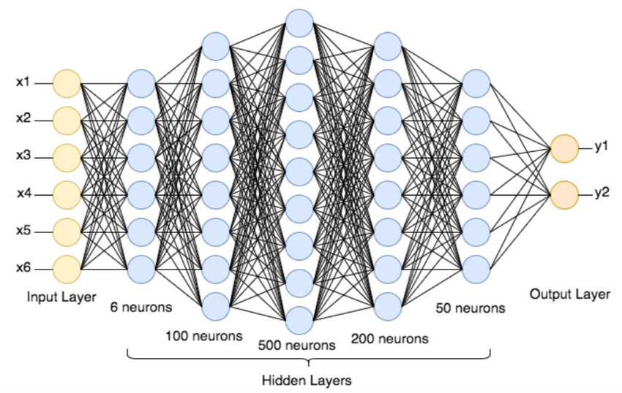

Figure 3- Example structure of deep neural networks

Table 2. Specifications of the deep neural networks used

|  |  |  |
| --- | --- | --- |
| Structure 2 | Structure 1 | Number of layers |
| 4 | 4 | **Type of layers** |
| Dense, GRU | Dense | **Type of activation function** |
| Sigmoid | Relu, Sigmoid | **Number of training Epochs** |
| 100 | 300 | **Type of optimizer function** |
| Adam | Adam | **Type of output error minimization function** |
| Binary Cross Entropy | Binary Cross Entropy | **Number of layers** |

Figures 4 and 5 also show the structures of the deep neural networks used to detect islanding in this paper. The deep neural networks used consist of 4 dense layers. The input of the deep neural network is a 1x1296 vector containing the features extracted from the measured parameters. The output of the deep neural network is a binary vector of 0 or 1, indicating whether islanding has occurred or not. In the case of islanding, the output vector is 1 and 0 when connected to the network. There are over 2.5 million trainable parameters in this structure. The deep neural network used in the Python environment and in the Tensorflow platform. Since the output is a binary number, the Binary Cross Entropy function is used as the optimization objective function in this paper. The Adam optimizer is also used to find optimal values for trainable parameters.

**Output of grid-connected mode: 0**

**Output of islanding mode: 1**

**Flatten, Dense**

**Output: 1 × 1500**

**Dense**

**Output: 1 × 1000**

**Dense**

**Output: 1 × 250**

**Dense**

**Output: 1 × 1**

**Features extracted from the parameters**

**Input: 1 × 1296**

**DNN**

**Activation: Relu**

**Activation: Relu**

**Activation: Relu**

**Activation: sigmoid**

Figure 4. Deep neural network structure 1 for detecting microgrid islanding.

**Output of grid-connected mode: 0**

**Output of islanding mode: 1**

**Flatten, GRU**

**Output: 1 × 1250**

**GRU**

**Output: 1 × 500**

**GRU**

**Output: 1 × 250**

**Dense**

**Output: 1 × 1**

**Features extracted from the parameters**

**Input: 1 × 1296**

**DNN**

**Activation: sigmoid**

Figure 5. Deep neural network structure 2 for detecting microgrid islanding.

To evaluate the performance of the protection scheme in islanding detection, suitable metrics are required. Two metrics are defined for this purpose. The accuracy metric is considered the primary indicator for assessing the islanding detection performance of the microgrid. It is calculated by dividing the number of correctly predicted states by the total number of states. This metric provides a comprehensive perspective on the performance of the protection scheme to the operator.

|  |  |
| --- | --- |
| $$Accuracy index\left(\%\right)=\frac{Correctly classified instances}{Total number of instances}×100$$ | (2) |

The reliability metric is another indicator that has been used to assess the performance of the protection scheme. Reliability is calculated by dividing the number of detected islanding states by the total number of islanding states.

|  |  |
| --- | --- |
| $$Dependability index\left(\%\right)=\frac{Number of detected islanding events}{Number f total islanding events}×10$$ | (3) |

For a better understanding of how these metrics are computed, in some cases, their calculation is based on a confusion matrix obtained from the output of the neural network. The diagonal elements of this matrix represent the states that have been correctly detected by the neural network.

1. **Simulation Results**

To evaluate the performance of the proposed protective design, the CERTS microgrid has been selected. This microgrid has been used to investigate various protective designs; therefore, the proposed design's performance can be compared with these designs. Figure 1 shows the single-line diagram of the CERTS microgrid. The diversity of equipment, resources, and loads is among the prominent features of the microgrid under study. This microgrid operates at a voltage of 480 volts and a frequency of 60 Hz and has the ability to supply loads in islanded mode. The microgrid can be connected and disconnected from the main grid via a switch located at the point of common coupling. Additionally, the microgrid's structure can be altered by switches embedded in some of its points. There are three distributed generation sources in the studied microgrid: a battery storage system located at bus 1, a photovoltaic source with its converter installed at bus 6, and a synchronous generator located at bus 3. The battery storage system and the photovoltaic source operate using current control in connected mode to the grid. In islanded mode, the synchronous generator is responsible for controlling the network frequency. Figure 6 shows the single-line diagram of the studied microgrid.

Figure 6 - Single-line diagram of the studied microgrid

Table 3 also shows the specifications and parameters of the equipment in it.

**Table 3- Characteristics and details of the studied microgrid**

|  |  |  |
| --- | --- | --- |
| Equipment | Name and parameters | Values |
| Dispersed production resources | Battery storage resources | 100 kW photovoltaic system, unit power factor and 15 kW capacitor |
| Small scale synchronous generator | 100 kV and power factors of 0.8 |
| Lines | Lines 12, 34 and 56 | 70 meters of type AWG2 |
| Line 23 | 50 meters of type AWG00 |
| Charges | Charges 2 and 4 | 90 kW and 45 kV |
| Charge 5 | 90 kW and -45 kV |
| Charge 8 | 90 kW and -20 kV |
| Transformers | Transformers 1, 3, 6 and 16 | 0.48/0.48 kV and 1 percent |
| Transformer 7 | 13.8/0.48 kV and 5 percent impedance |

Figure 7 shows the places where the meters are installed to record the terminal parameters of distributed generation sources. As can be seen in the figure, these meters are placed in the terminals of distributed generation sources. The parameters that are measured are listed in Table 4. In the next step, the data and parameters recorded in the Excel files will be pre-processed in MATLAB software by discrete violet transformation.

**Table 4- The parameters used in the terminals of distributed generation sources**

|  |  |
| --- | --- |
| Parameters description | Parameter |
| The terminal voltage of the photovoltaic source | V_PV |
| Battery storage source terminal voltage | V_Battery |
| Synchronous generator terminal voltage | V_SG |
| Terminal zero sequence current of distributed generation sources | I(0) |
| Negative sequence current of the terminal of distributed generation sources | I(-) |
| Positive sequence current of the terminal of distributed generation sources | I(+) |
| The three-phase flow of the terminal of distributed generation sources | I(3Phase) |

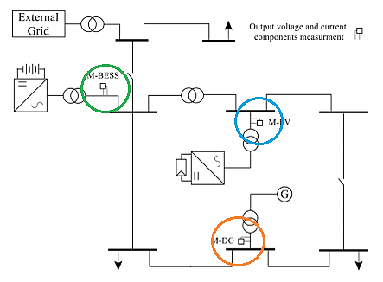

**Figure 7- Location of the meters in the studied microgrid**

Three software programs were used in the microgrid islanding detection scheme. DIgSILENT, Matlab, and Python are among these software programs.

1. Simulation and implementation of different states in DIgSILENT software

In this microgrid, a large number of operational states are considered. These states include connecting and disconnecting various loads to the microgrid, the open and closed states of various switches in the microgrid, and the connection of various distributed generation resources to the microgrid. If two on/off states are considered for loads 2, 4, 5, and 8, a total of 32 states are counted for the desired loads. In addition, four states are considered for the switches available at the common connection point between the microgrid and the main grid, as well as for the switch connecting two points in the microgrid. For resources, two states are considered for each except for the synchronous generator, which is always on to control the microgrid frequency, resulting in a total of 512 states for the specified conditions. Considering that there are 10 changeable elements in the microgrid, this number of states is multiplied by the number of elements, resulting in 5120 rows of data for entering the pre-processing stage and then entering the deep neural network training stage. These states are simulated in the DIgSILENT software, and the voltage and current parameters of negative, positive, and zero sequence for these states are saved in an Excel file. Additionally, 1500 states are also simulated for evaluation as validation data, which are randomly selected and simulated. The outputs of these simulations are also saved in a separate Excel file.

Also, Figures 8 to 11 show the positive sequence voltage, negative sequence voltage, positive sequence current, and negative sequence current at the terminal of distributed generation sources, respectively. Considering that in this case the network was in a balanced state, zero sequence voltage and current had a negligible value. In this case, islanding has happened at 0.3 seconds.

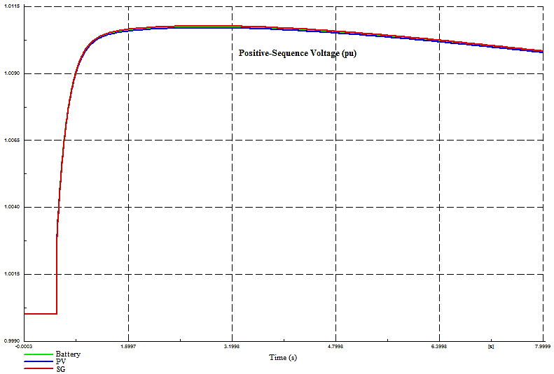

**Figure 8. Positive sequence voltage in distributed generation resources terminal (pu)**

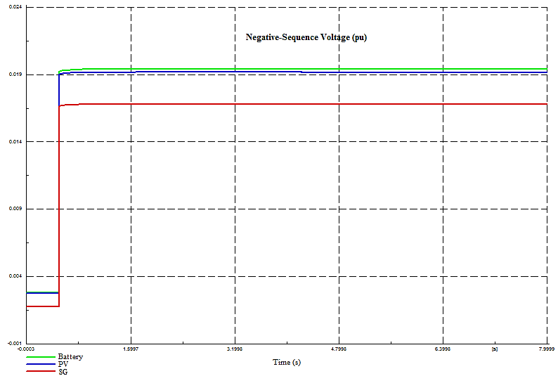

**Figure 9. Negative sequence voltage in distributed generation resources terminal (pu)**

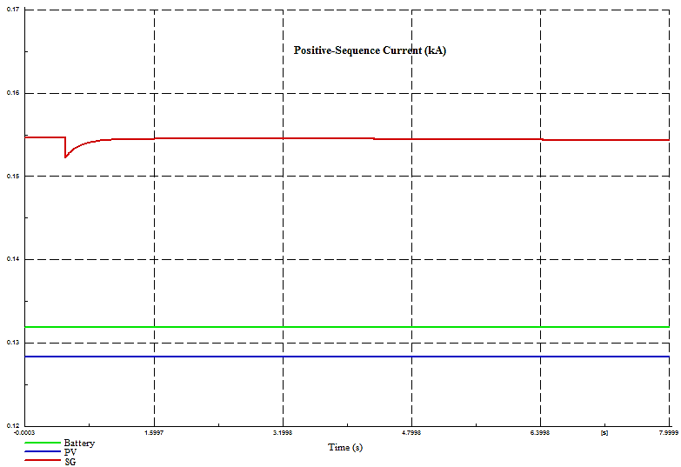

**Figure 10. Positive sequence current in distributed generation resources terminal (kA)**

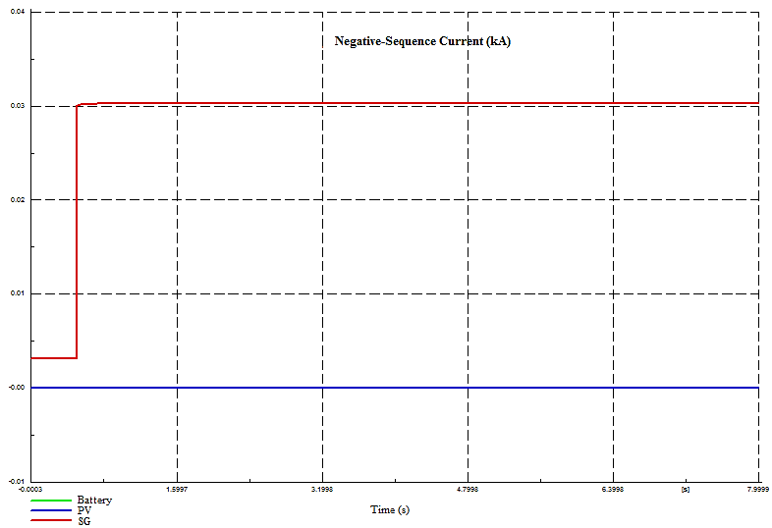

**Figure 10. Negative sequence current in distributed generation resources terminal (kA)**

1. Data processing in MATLAB and applying discrete wavelet transform.

Various signals, including voltage and current, are processed by some tools to extract their frequency and time content along with their hidden features. In this paper, discrete wavelet transform is used for this purpose. In this section, the parameters stored in the Excel files mentioned in the previous section are transferred to MATLAB software environment for processing. In this paper, Sym and Db wavelet families are used for wavelet transform. The reason for choosing this type of wavelet is their suitable performance in decomposing current and voltage signals. 64 samples are recorded and saved for each voltage and current signal in each window. These 64 samples go through the wavelet transform stage for processing. Using Sym2 in 4 levels of decomposition results in 8 series of coefficients, which ultimately results in 5 series of coefficients using 4 partial coefficients and one approximation coefficient. In each sampling, 7 signals from the terminal of distributed generation resources are extracted (voltage, three sequence components of current, and three phase currents), which results in 21 signals extracted for each state considering the existence of 3 distributed generation resources. Based on statistical features, 108 coefficient features are extracted from each signal after applying the wavelet transform, resulting in a total of 2268 features for each state.

1. Deep neural network training

DNN is a type of artificial neural network with multiple hidden layers of neurons between the input and output layers [28]. Deep neural network training is performed in Python software using the Tensorflow framework. The extracted features from the previous stage are used to train the data in the neural network structure. In this paper, two types of deep neural network structures are used. One structure consists only of dense layers, and the second structure is a combination of dense and GRU layers. The training data consists of a set of microgrid operational states under different conditions, where various equipment may or may not be present in the circuit at any given time, and different loads may be connected or disconnected from the microgrid. Initially, each equipment, including sources, loads, switches, etc., has an initial state that may change in subsequent moments.

1. Results of deep neural network training and evaluation

Structure 1 with 300 epochs and Structure 2 with 100 epochs have been trained. It is evident that the presence of the GRU layer requires fewer epochs to achieve the desired accuracy.

The results of training and evaluation of the proposed method are presented for two different neural network architectures based on the defined metrics in Table 5. As observed, the accuracy of the proposed method is higher in the second deep neural network architecture compared to the first one. This improvement in accuracy is attributed to the use of GRU layers. However, this increase in accuracy comes at a cost, including longer training times and increased optimization expenses. The high accuracy and reliability of over 99% indicate the effective performance of the islanding detection approach using deep neural networks.

The results also include the islanding detection time for both examined architectures. The reliability metric is used to assess the operator's confidence in the islanding detection. Table 6 provides a comparison of the proposed method's performance with other artificial intelligence-based approaches, demonstrating that the proposed method outperforms the mentioned methods in terms of accuracy and reliability. Additionally, in another comparison (Tables 7 and 8), the proposed approach is compared with other islanding detection methods from various aspects, providing a comprehensive view to the reader.

**Table 5- The performance of the proposed plan in two indicators of accuracy and reliability**

|  |  |  |  |  |
| --- | --- | --- | --- | --- |
| Plan | Accuracy (%) | | Dependability (%) | |
| Train | Test | Train | Test |
| Performance of islanding detection scheme using deep neural networks in structure number 1 | 99.89 | 99.87 | 99.55 | 99.45 |
| The performance of the islanding detection scheme using deep neural networks in structure number 2 | 99.95 | 99.9 | 99.7 | 99.6 |
| Average | 99.92 | 99.885 | 99.625 | 92.525 |

**Table 6- Comparison of the proposed plan with other plans based on machine learning**

|  |  |  |
| --- | --- | --- |
| Plan | Accuracy (%) | Dependability (%) |
| Test | Test |
| LSTM | 99.5 | 97.45 |
| ANN | 98.85 | 96.5 |
| DT | 97.45 | 96.85 |
| SVM | 98.4 | 95 |
| Deep Neural Network | 99.885 | 99.525 |

**Table 7- Comparison of the proposed plan in different indicators with other microgrid islanding detection plans.**

|  |  |  |  |  |  |
| --- | --- | --- | --- | --- | --- |
| Method | Type | The effect of power imbalance on the method | Time of diagnosis | The effect of the method on power quality | Misdiagnosis rate |
| Harmonic based | Inactive | High | 45 ms | No | Top |
| Based on voltage and frequency fluctuations | Inactive | High | 2 - 4ms | No | Down |
| Based on phase jump | Inactive | High | 10-20 ms | No | Down |
| Based on voltage imbalance | Inactive | High | 53 ms | No | Down |
| Based on active and reactive power changes | Active | Low | 0.3- 0.75 ms | Reduced power quality | Top |
| Based on negative sequence current component injection | Active | - | 60 ms | Reduced power quality | Down |
| Based on impedance measurement | Active | Low | 0.77- 0.95 ms | Reduced power quality | Down |
| Based on high frequency signal injection | Active | Very low | A few ms | Very little reduction in power quality | Down |
| Combination of power change method and voltage change rate method | Hybrid | Low | Instant | Reduced power quality | Down |
| Combination of impedance measurement method and frequency change rate method | Hybrid | Low | 0.216 ms | No | Down |
| PLC method | Remote | - | 200 ms | No | - |
| SCADA based method | Remote | - | Too slow for complex networks | No | - |

**Table 8- Comparison of the proposed plan in different indicators with other microgrid islanding detection plans.**

|  |  |  |  |  |  |  |
| --- | --- | --- | --- | --- | --- | --- |
| Method | Type | The effect of power imbalance on the method | Details of the duration of the process and the diagnosis of islanding | | The effect of the method on power quality | Misdiagnosis rate |
| Proposal  Method  Method | artificial intelligence (deep learning)  type  type | Very little (considering different loading conditions) | Violet transform and feature extraction (any transform) | 0.54 ms | - | Very low |
| Deep neural network training | 963 ms |
| Deep neural network training 2 | 1452 ms |
| Classification and evaluation of each network | 1.26 ms |
| Detection time (from the time of microgrid islanding to its detection in a sequential process)* | 8.82 ms |

1. **Conclusion**

One of the crucial issues in the field of microgrids is islanding, which in many cases can cause interference with the microgrid's protective and control functions due to a lack of awareness of the islanding occurrence. Therefore, accurate islanding detection is a highly important topic. As mentioned in chapter two of this paper, various methods have been proposed in the literature for islanding detection. In this paper, a deep neural network-based method is proposed, using three software tools, including DIgSILENT, MATLAB, and Python. A large number of simulation scenarios were created, and voltage and current parameters with zero, negative, and positive sequence components were recorded at the locations of the distributed generation sources. These data were then used to extract statistical features using discrete wavelet transform. In the next step of the research process, the extracted features were trained on deep neural networks, and the training and evaluation results were presented in chapter four, indicating a high accuracy of over 99% for the proposed design in terms of accuracy and reliability indices. Additionally, the proposed design's accuracy in comparison with some similar methods for islanding detection was significantly higher.

Some of the results obtained from this paper by the student researcher are presented below:

• Islanding detection can occur intentionally by the operator or suddenly due to disturbances in the network. In the event of sudden islanding of the microgrid, a mechanism for detecting it is required to prevent control and protection disturbances in the microgrid after islanding.

• There are many methods for islanding detection, many of which have low accuracy, while some have high accuracy but have failed in cases such as large load entry and exit and have misdiagnosed islanding.

• A deep neural network-based method for islanding detection was proposed in this paper, which had high accuracy.

• The time required for islanding detection in the proposed design was also acceptable.

• The use of microgrid parameters is a crucial issue in islanding detection methods, and in this paper, a local and simple information-based method using voltage and current parameters (sequence components) was used, which achieved high accuracy without using communication channels.

• The type of deep neural network structure used, including layer types and learning parameters, will affect the accuracy of training deep neural networks.

In the future, these proposals can be used to improve the proposed design in this research in subsequent designs. A more precise analysis of the impact of different microgrid terminal parameters and their use can be performed in islanding detection. The impact of different deep neural network structures on the accuracy of neural network predictions can be investigated. Economic feasibility studies of smart designs, including the proposed design, can be conducted. The proposed design can be analyzed and evaluated in different network structures if it is used in those networks.

**Referesnces**

[1] B. Chen, J. Wang, X. Lu, C. Chen, and S. Zhao, “Networked Microgrids for Grid Resilience, Robustness, and Efficiency: A Review,” *IEEE Trans Smart Grid*, pp. 1–1, Aug. 2020, doi: 10.1109/tsg.2020.3010570.

[2] A. Serrano-Fontova and M. Azab, “Development and performance analysis of a multi-functional algorithm for AC microgrids: Simultaneous power sharing, voltage support and islanding detection,” *International Journal of Electrical Power & Energy Systems*, vol. 135, p. 107341, Feb. 2022, doi: 10.1016/J.IJEPES.2021.107341.

[3] M. Ganjian-Aboukheili, M. Shahabi, Q. Shafiee, and J. M. Guerrero, “Seamless Transition of Microgrids Operation from Grid-Connected to Islanded Mode,” *IEEE Trans Smart Grid*, vol. 11, no. 3, pp. 2106–2114, May 2020, doi: 10.1109/TSG.2019.2947651.

[4] J. Gouveia, C. Gouveia, J. Rodrigues, L. Carvalho, C. L. Moreira, and J. A. P. Lopes, “Planning of distribution networks islanded operation: from simulation to live demonstration,” *Electric Power Systems Research*, vol. 189, p. 106561, Dec. 2020, doi: 10.1016/j.epsr.2020.106561.

[5] W. Sun, S. Ma, I. Alvarez-Fernandez, R. R. Nejad, and A. Golshani, “Optimal self-healing strategy for microgrid islanding,” *IET Smart Grid*, vol. 1, no. 4, pp. 143–150, Dec. 2018, doi: 10.1049/IET-STG.2018.0057/CITE/REFWORKS.

[6] M. Vahid-Ghavidel *et al.*, “Hybrid IGDT-stochastic self-scheduling of a distributed energy resources aggregator in a multi-energy system,” *Energy*, vol. 265, p. 126289, Feb. 2023, doi: 10.1016/J.ENERGY.2022.126289.

[7] S.-E. Razavi *et al.*, “Impact of distributed generation on protection and voltage regulation of distribution systems: A review,” *Renewable and Sustainable Energy Reviews*, 2019, doi: 10.1016/j.rser.2019.01.050.

[8] M. S. Javadi, C. S. Gouveia, L. M. Carvalho, and R. Silva, “Optimal Power Flow Solution for Distribution Networks using Quadratically Constrained Programming and McCormick Relaxation Technique,” *2021 IEEE International Conference on Environment and Electrical Engineering and 2021 IEEE Industrial and Commercial Power Systems Europe (EEEIC / I&CPS Europe)*, pp. 1–6, Sep. 2021, doi: 10.1109/EEEIC/ICPSEUROPE51590.2021.9584627.

[9] J. A. P. Lopes *et al.*, “The future of power systems: Challenges, trends, and upcoming paradigms,” *WIREs Energy and Environment*, Dec. 2019, doi: 10.1002/wene.368.

[10] J. A. P. Lopes, A. G. Madureira, and C. C. L. M. Moreira, “A view of microgrids,” *Wiley Interdiscip Rev Energy Environ*, vol. 2, no. 1, pp. 86–103, Jan. 2013, doi: 10.1002/wene.34.

[11] M. H. Oboudi, M. Mohammadi, and M. Rastegar, “Resilience-oriented intentional islanding of reconfigurable distribution power systems,” *Journal of Modern Power Systems and Clean Energy 2019 7:4*, vol. 7, no. 4, pp. 741–752, Jul. 2019, doi: 10.1007/S40565-019-0567-9.

[12] W. J. Chiang, H. L. Jou, and J. C. Wu, “Active islanding detection method for inverter-based distribution generation power system,” *International Journal of Electrical Power & Energy Systems*, vol. 42, no. 1, pp. 158–166, Nov. 2012, doi: 10.1016/J.IJEPES.2012.03.038.

[13] X. Xie, C. Huang, and D. Li, “A new passive islanding detection approach considering the dynamic behavior of load in microgrid,” *International Journal of Electrical Power & Energy Systems*, vol. 117, p. 105619, May 2020, doi: 10.1016/J.IJEPES.2019.105619.

[14] A. M. Alishavandi and S. M. Moghaddas-Tafreshi, “Interactive decentralized operation with effective presence of renewable energies using multi-agent systems,” *International Journal of Electrical Power and Energy Systems*, vol. 112, pp. 36–48, Nov. 2019, doi: 10.1016/j.ijepes.2019.04.023.

[15] R. Aazami, S. Esmaeilbeigi, M. Valizadeh, and M. S. Javadi, “Novel intelligent multi-agents system for hybrid adaptive protection of micro-grid,” *Sustainable Energy, Grids and Networks*, vol. 30, p. 100682, Jun. 2022, doi: 10.1016/J.SEGAN.2022.100682.

[16] A. K. Özcanlı and M. Baysal, “A novel Multi-LSTM based deep learning method for islanding detection in the microgrid,” *Electric Power Systems Research*, vol. 202, p. 107574, Jan. 2022, doi: 10.1016/J.EPSR.2021.107574.

[17] A. K. Ozcanli and M. Baysal, “Islanding detection in microgrid using deep learning based on 1D CNN and CNN-LSTM networks,” *Sustainable Energy, Grids and Networks*, vol. 32, p. 100839, Dec. 2022, doi: 10.1016/J.SEGAN.2022.100839.

[18] M. Hasanisadi, M. Khoei, and F. Tahami, “An improved active islanding detection method for grid-connected solar inverters with a wide range of load conditions and reactive power,” *Electric Power Systems Research*, vol. 224, p. 109714, Nov. 2023, doi: 10.1016/J.EPSR.2023.109714.

[19] M. Y. Worku, M. A. Hassan, L. S. Maraaba, and M. A. Abido, “Islanding Detection Methods for Microgrids: A Comprehensive Review,” *Mathematics 2021, Vol. 9, Page 3174*, vol. 9, no. 24, p. 3174, Dec. 2021, doi: 10.3390/MATH9243174.

[20] N. A. Larik, M. F. Tahir, Z. M. S. Elbarbary, M. Z. Yousaf, and M. A. Khan, “A comprehensive literature review of conventional and modern islanding detection methods,” *Energy Strategy Reviews*, vol. 44, p. 101007, Nov. 2022, doi: 10.1016/J.ESR.2022.101007.

[21] S. Chopra, G. M. Vanaprasad, G. D. A. Tinajero, N. Bazmohammadi, J. C. Vasquez, and J. M. Guerrero, “Power-flow-based energy management of hierarchically controlled islanded AC microgrids,” *International Journal of Electrical Power & Energy Systems*, vol. 141, p. 108140, Oct. 2022, doi: 10.1016/J.IJEPES.2022.108140.

[22] N. Chaudhuri and I. Bose, “Exploring the role of deep neural networks for post-disaster decision support,” *Decis Support Syst*, vol. 130, p. 113234, Mar. 2020, doi: 10.1016/J.DSS.2019.113234.

[23] X. Xie, W. Xu, C. Huang, and X. Fan, “New islanding detection method with adaptively threshold for microgrid,” *Electric Power Systems Research*, vol. 195, p. 107167, Jun. 2021, doi: 10.1016/J.EPSR.2021.107167.

[24] M. Mishra, S. Chandak, and P. K. Rout, “Taxonomy of Islanding detection techniques for distributed generation in microgrid,” *Renewable Energy Focus*, vol. 31, pp. 9–30, Dec. 2019, doi: 10.1016/J.REF.2019.09.001.

[25] S. Raza, H. Mokhlis, H. Arof, J. A. Laghari, and L. Wang, “Application of signal processing techniques for islanding detection of distributed generation in distribution network: A review,” *Energy Convers Manag*, vol. 96, pp. 613–624, May 2015, doi: 10.1016/J.ENCONMAN.2015.03.029.

[26] J. A. Cebollero, D. Cañete, S. Martín-Arroyo, M. García-Gracia, and H. Leite, “A Survey of Islanding Detection Methods for Microgrids and Assessment of Non-Detection Zones in Comparison with Grid Codes,” 2022, doi: 10.3390/en15020460.

[27] L. J. MYATT, “Symmetrical Components,” *Symmetrical Components*, pp. 24–47, Jan. 1968, doi: 10.1016/B978-0-08-012978-5.50006-8.

[28] Y. Lecun, Y. Bengio, and G. Hinton, “Deep learning,” *Nature 2015 521:7553*, vol. 521, no. 7553, pp. 436–444, May 2015, doi: 10.1038/nature14539.