Bi-Objective Supply Chain Network Design Model

1. Problem Description
This model addresses a bi-objective supply chain network design problem aiming to simultaneously:
- Minimize total logistics cost
- Minimize total delivery time
The supply chain consists of suppliers, distribution centers (warehouses), and customers.
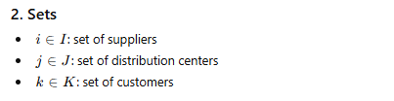
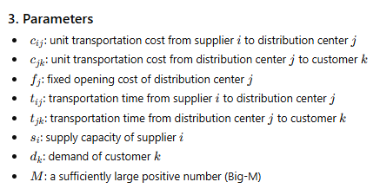
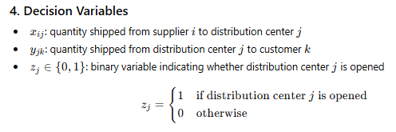
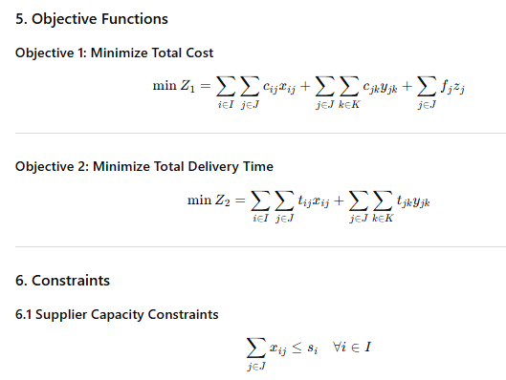
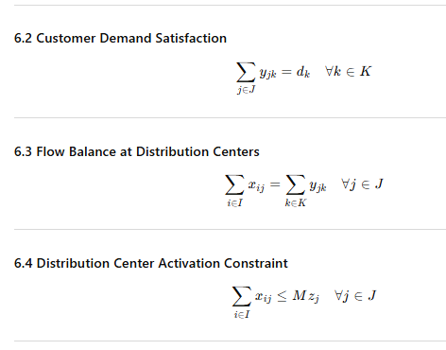
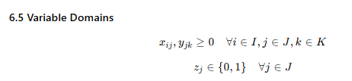

I = {1, 2, ..., 10} Suppliers

J = {1, 2, ..., 6} Warehouses

K = {1, 2, ..., 20} Customers

  Supplier (i) | Capacity (s_{i})
  1 | 400
  2 | 450
  3 | 500
  4 | 450
  5 | 480
  6 | 520
  7 | 610
  8 | 470
  9 | 530
  10 | 460
  Customer (k) | Demand (d_{k})
  1 | 120
  2 | 90
  3 | 110
  4 | 80
  5 | 100
  6 | 130
  7 | 95
  8 | 105
  9 | 115
  10 | 85
  11 | 125
  12 | 90
  13 | 110
  14 | 100
  15 | 95
  16 | 120
  17 | 85
  18 | 105
  19 | 115
  20 | 90
  Warehouse (j) | Fixed Cost (f_{j})
  1 | 18,000
  2 | 20,000
  3 | 17,500
  4 | 19,000
  5 | 16,500
  6 | 21,000

c_{ij} | c_{jk}
  (i \ j) | 1 | 2 | 3 | 4 | 5 | 6
  1 | 6 | 8 | 7 | 9 | 6 | 10
  2 | 7 | 6 | 8 | 7 | 9 | 8
  3 | 5 | 7 | 6 | 8 | 7 | 9
  4 | 8 | 9 | 7 | 6 | 8 | 7
  5 | 6 | 8 | 9 | 7 | 6 | 8
  6 | 7 | 6 | 8 | 9 | 7 | 6
  7 | 5 | 7 | 6 | 8 | 9 | 7
  8 | 9 | 8 | 7 | 6 | 8 | 7
  9 | 6 | 7 | 8 | 9 | 6 | 8
  10 | 7 | 6 | 9 | 8 | 7 | 6
  (j \ k) | 1 | 2 | 3 | 4 | 5 | 6 | 7 | 8 | 9 | 10 | 11 | 12 | 13 | 14 | 15 | 16 | 17 | 18 | 19 | 20
  1 | 6 | 8 | 7 | 5 | 9 | 10 | 6 | 8 | 7 | 6 | 9 | 8 | 7 | 6 | 8 | 9 | 5 | 7 | 8 | 6
  2 | 7 | 6 | 9 | 8 | 6 | 7 | 8 | 6 | 9 | 7 | 6 | 8 | 9 | 7 | 6 | 8 | 7 | 9 | 6 | 8
  3 | 5 | 7 | 6 | 9 | 7 | 8 | 6 | 7 | 8 | 6 | 7 | 6 | 8 | 9 | 7 | 6 | 8 | 7 | 6 | 9
  4 | 8 | 9 | 7 | 6 | 8 | 9 | 7 | 6 | 8 | 7 | 9 | 7 | 6 | 8 | 9 | 7 | 6 | 8 | 7 | 6
  5 | 6 | 8 | 9 | 7 | 5 | 6 | 8 | 9 | 7 | 6 | 8 | 9 | 7 | 6 | 8 | 7 | 9 | 6 | 8 | 7
  6 | 7 | 6 | 8 | 9 | 6 | 7 | 9 | 8 | 6 | 7 | 6 | 8 | 9 | 7 | 6 | 8 | 7 | 6 | 9 | 8

t_{ij} | t_{jk}
  (i \ j) | 1 | 2 | 3 | 4 | 5 | 6
  1 | 5 | 7 | 6 | 8 | 5 | 9
  2 | 6 | 5 | 7 | 6 | 8 | 7
  3 | 4 | 6 | 5 | 7 | 6 | 8
  4 | 7 | 8 | 6 | 5 | 7 | 6
  5 | 5 | 7 | 8 | 6 | 5 | 7
  6 | 6 | 5 | 7 | 8 | 6 | 5
  7 | 4 | 6 | 5 | 7 | 8 | 6
  8 | 8 | 7 | 6 | 5 | 7 | 6
  9 | 5 | 6 | 7 | 8 | 5 | 7
  10 | 6 | 5 | 8 | 7 | 6 | 5
  (j \ k) | 1 | 2 | 3 | 4 | 5 | 6 | 7 | 8 | 9 | 10 | 11 | 12 | 13 | 14 | 15 | 16 | 17 | 18 | 19 | 20
  1 | 2 | 3 | 2 | 1 | 3 | 4 | 2 | 3 | 2 | 2 | 3 | 3 | 2 | 2 | 3 | 4 | 1 | 2 | 3 | 2
  2 | 3 | 2 | 4 | 3 | 2 | 3 | 3 | 2 | 4 | 3 | 2 | 3 | 4 | 3 | 2 | 3 | 3 | 4 | 2 | 3
  3 | 1 | 2 | 2 | 3 | 2 | 3 | 2 | 2 | 3 | 2 | 2 | 2 | 3 | 3 | 2 | 2 | 3 | 2 | 2 | 3
  4 | 3 | 4 | 3 | 2 | 3 | 4 | 3 | 2 | 3 | 3 | 4 | 3 | 2 | 3 | 4 | 3 | 2 | 3 | 3 | 2
  5 | 2 | 3 | 4 | 3 | 1 | 2 | 3 | 4 | 3 | 2 | 3 | 4 | 3 | 2 | 3 | 3 | 4 | 2 | 3 | 3
  6 | 3 | 2 | 3 | 4 | 2 | 3 | 4 | 3 | 2 | 3 | 2 | 3 | 4 | 3 | 2 | 3 | 3 | 2 | 4 | 3

1. کد گمز مدل فوق با روش محدودیت اپسیلون.
مرز پارتوی بدست آمده بصورت نموداری. .2
خلاصه جواب ها شامل مقدار توابع هدف و انبارهای فعال شده برای جواب های پارتو..3

