GPS Cycle Slip with Bolovit Algoritm
Faeze seifollahzade of Technology,Tehran
e-mail:faeze.3d@gmail.com
2021/11/4
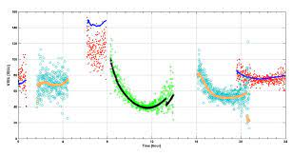
Abctract: A cycle slip is a discontinuity in a receiver's phase lock on a satellite's signal. A power loss, a very low signal-to-noise ratio, a failure of the receiver software, a malfunctioning satellite oscillator can cause a cycle slip.

Introduction
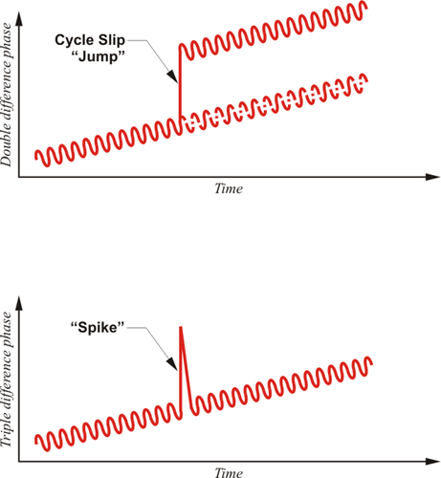
Phase jump or cycle slip is mostly caused by obstacles between the receivers and the satellite, and in general, when the connection between the receiver and the satellite is lost, no measurement is performed, so in measuring the phase of the carrier wave, the phase ambiguity number will be lost. Went. After a period of time when the satellite signal is received again by the receiver, the phase will be measured and in this case the amount of phase ambiguity as the start of the measurement is unknown and must be determined.

Causes of disconnection and cycle slip:
. There is a barrier between the receiver and the satellite
. Sudden acceleration of the receiver
. Software crash
In addition to disconnection, sometimes ionospheric disturbances, multidirectional phenomena, interference of satellite signals with other signals, and satellite and receiver errors cause phase mutations and erroneous measurements. It should be noted that what is considered as a cycle slip error is a phase jump caused by the receiver disconnecting from the satellite.

Phase mutation detection using Belevit algorithm
In this method, the mw combination is used. In the mw phase combination, the larger phase ambiguity number and phase detection will be estimated more accurately, and viewing the Nl code will have less noise. There is also no ionospheric term in this algorithm and we will have an accurate estimate in the case of turbulent ionosphere. To calculate using this method, we use formulas (1) and (2) and the output of the Belovit algorithm is seen in fig (1). Also the Epoch values on 15 March 2015 in Table (Table.1) and the Epoch values on 1 January 2021 in Table (Table.2) can be seen.

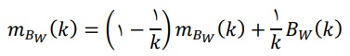
(1)
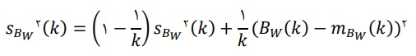
(2)

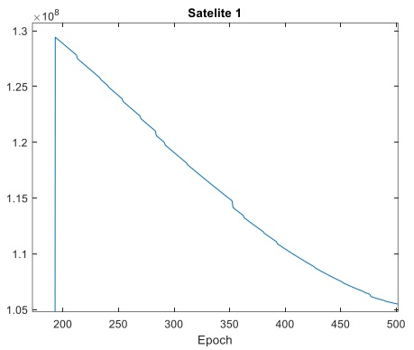

Fig.1. output of the Belovit algorithm

epoch | 1 | 1 | 2 | 2 | 2 | 3 | 3 | 3 | 3 | 3 | 4 | 4 | 4 | 4 | 5 | 5 | 5 | 5 | 6 | 6
index | 2215 | 130 | 2665 | 2150 | 468 | 720 | 1137 | 1369 | 690 | 652 | 1479 | 2483 | 299 | 1131 | 627 | 356 | 1691 | 481 | 1585 | 1962
Tabel 1.epoch value in 15 march2015

epoch | 1 | 1 | 1 | 2 | 2 | 2 | 2 | 3 | 3 | 3 | 4 | 4 | 5 | 5 | 5 | 5 | 6 | 6 | 6 | 6
index | 1115 | 130 | 1165 | 1350 | 518 | 520 | 1137 | 1569 | 190 | 852 | 1789 | 1483 | 278 | 1131 | 797 | 156 | 1641 | 181 | 1235 | 1262
Tabel 2.epoch value in 1 january 2021

Conclusion
So the algorithm we used was to get a continuous arc of observations for each satellite. If a phase jump occurred, record the time of its occurrence, then categorize the observations into a set of observations. If the phase jump did not occur in an observational category. The phase ambiguity will be constant at this distance. From then on, we will look for algorithms that reduce the phase jump, and the algorithm we choose should have the lowest cost, the highest accuracy, and the fastest time. The lowest cost means that our receiver is as single-frequency as possible.
References
http://www.ncc.org.ir

https://elmnet.ir

http://gistech.ir

http://mehrankooh.blogfa.com

https://wp.kntu.ac.ir

https://jfe.ut.ac.ir

https://civilica.com

https://civilica.com

http://irisweb.ir › rds_journals › article-986-200209

