Decision-Inspired Ensemble Learning for Urban Land Surface Temperature Prediction (A Case Study of Tehran-Iran)
Abstract
Climate change and increasing land surface temperature (LST) have become major environmental concerns in large metropolitan areas, particularly in arid and semi-arid regions. Reliable prediction of LST is essential for urban climate assessment, mitigation of the urban heat island effect, and informed urban planning. This study develops an interpretable machine learning–based framework for predicting LST across Tehran, Iran, using multiple base models and novel ensemble strategies. Five widely used machine learning algorithms—Artificial Neural Networks (ANN), Random Forest (RF), Support Vector Machine (SVM), Classification and Regression Tree (CART), and Generalized Linear Model (GLM)—were first trained using identical datasets to capture the spatial variability of LST and its driving factors. Model performances were evaluated separately across different urban zones of Tehran using statistical accuracy metrics. These performance scores were then used as inputs to four newly designed ensemble models inspired by collective human decision-making systems, including presidential voting, parliamentary voting, hierarchical governance, and ancient senate-based consensus mechanisms. The proposed ensemble frameworks consistently improved prediction accuracy compared to individual models, while also increasing robustness across heterogeneous urban landscapes. The results demonstrate that decision-inspired ensemble learning can enhance both accuracy and confidence in LST predictions. The proposed approach offers a transparent and transferable tool for urban climate analysis and can support evidence-based decision-making for heat mitigation strategies in large cities.
Keywords: Land Surface Temperature, Ensemble learning, Machine learning, Urban climate, Tehran
Abstract

- Introduction
Land surface temperature (LST) is a key indicator of urban thermal conditions and plays a central role in assessing the impacts of climate change and urbanization on metropolitan environments. In rapidly expanding cities, increased impervious surfaces, reduced vegetation cover, and intensified anthropogenic activities significantly alter surface energy balances, leading to elevated LST and the urban heat island (UHI) effect (Oke, 1982). Recent studies have shown that global urban expansion has accelerated considerably, intensifying thermal stress in large cities and increasing exposure to heat-related risks for urban populations.
Elevated LST has been associated with a range of negative environmental and socio-economic consequences, including increased energy demand for building cooling, degradation of air quality, heightened risks of heat-related illnesses, and reduced thermal comfort and quality of life. These impacts are particularly pronounced in megacities located in arid and semi-arid regions, where background climatic conditions already impose thermal stress.
Accurate prediction of LST in urban areas remains challenging due to the spatial heterogeneity of land use, complex interactions between natural and anthropogenic factors, and non-linear relationships among influencing variables. Conventional physics-based and energy balance models often require extensive input data and high computational costs, which may limit their applicability at fine spatial scales or for large urban regions. Consequently, data-driven approaches, particularly machine learning (ML) methods, have increasingly been adopted to model LST dynamics.
Machine learning algorithms such as Random Forest, Support Vector Machine, and Artificial Neural Networks have demonstrated strong capability in capturing complex non-linear relationships between LST and its controlling factors. However, the predictive performance of these algorithms can vary substantially depending on data characteristics, spatial context, and parameter tuning. Moreover, reliance on a single algorithm may introduce uncertainty and reduce robustness, particularly in heterogeneous urban environments.
Tehran, the capital of Iran, is a densely populated megacity characterized by diverse land use patterns, complex topography, and a semi-arid climate. Numerous studies have reported an increasing temperature trend in Tehran over recent decades, accompanied by intensified UHI effects. Despite growing interest in applying ML techniques for LST prediction in Tehran, several challenges remain, including data heterogeneity, algorithm selection, parameter optimization, and model interpretability.
To address these challenges, this study proposes a comparative and ensemble-based ML framework for LST prediction in Tehran. Multiple base learners are first evaluated independently to identify their strengths and weaknesses across different urban zones. Building on these results, four novel ensemble models inspired by collective human decision-making systems are introduced to integrate model outputs in a structured and transparent manner. Unlike conventional ensemble methods that rely solely on statistical averaging, the proposed approach incorporates decision-weighting concepts derived from governance and voting systems.
The objectives of this study are to:
(1) evaluate the performance of commonly used ML algorithms for LST prediction in Tehran;
(2) investigate the contribution of key explanatory variables to LST variability; and
(3) assess whether decision-inspired ensemble models can outperform individual ML models and enhance prediction reliability.
The proposed framework aims to provide a robust and interpretable tool for urban climate assessment and offers practical insights for urban planners and policymakers seeking to mitigate heat-related risks in large cities.

- Review of Literature
In recent years, machine learning (ML) techniques have been increasingly employed for land surface temperature (LST) prediction due to their ability to capture complex and non-linear relationships between thermal patterns and environmental variables. Advances in artificial intelligence have expanded the applicability of ML models across a wide range of spatial and temporal scales, enabling more flexible and accurate modelling compared to conventional approaches (Fleming et al., 2021; Gevaert, 2022; Gunning et al., 2019; McGovern et al., 2019). As global temperature rise has become a widely acknowledged environmental challenge, research efforts have increasingly focused on improving the accuracy and reliability of LST estimation methods.
Early comparative studies highlighted the advantages of ML-based approaches. For example, Weng et al. (2004) evaluated several ML models in Chinese cities and demonstrated that data-driven methods outperform traditional statistical approaches in urban LST analysis. Subsequent research has not only improved prediction accuracy but also examined the broader implications of rising surface temperatures and potential mitigation strategies. Santamouris (2001), for instance, investigated the climatic and energy impacts of urban environments, emphasizing the role of urban form and design in mitigating urban heat island (UHI) effects. Similarly, Kovats and Hajat (2008) established a clear link between increasing temperatures and the incidence of heat-related illnesses, highlighting the public health implications of urban warming.
More recent studies have integrated remote sensing data with ML techniques to explore the drivers of LST variability. Zhang et al. (2017) analyzed land use changes and their influence on LST in Beijing, demonstrating that urban expansion and surface modification significantly affect thermal patterns. Zubair Irshad et al. (2024) examined land use and land cover (LU/LC) changes in several regions of Pakistan and reported substantial LST increases between 2000 and 2020, with the highest values observed in densely built urban areas and the lowest in vegetated or water-covered regions.
In Iran, a growing body of literature has addressed temperature variability and urban warming. Aliakbari Bidokhti et al. (2016) analyzed long-term temperature and precipitation trends in Tehran, confirming an overall warming trend and emphasizing the need for reliable modelling tools. Roshan et al. (2024) investigated UHI intensity during heatwave events in Tehran and showed that thermal patterns vary across different climatic conditions and are strongly influenced by anthropogenic structures and industrial activities. Likewise, Kiavarz et al. (2022) employed satellite imagery to analyze and predict temperature changes in Tehran, concluding that the observed warming trend is likely to continue in the future.
Alongside advances in individual ML models, ensemble learning approaches have gained attention as an effective means of improving predictive performance. Ensemble models combine multiple learners to reduce uncertainty, compensate for individual model weaknesses, and enhance result robustness. Numerous studies have demonstrated the effectiveness of ensemble techniques in environmental applications, reporting improvements in prediction accuracy and interpretability (Ashrafzadeh et al., 2023). In Iran, while ensemble models have been applied to several environmental and ecological problems, their use in LST prediction—particularly at the city scale in Tehran—remains limited.
A notable example of ensemble modelling in Iran is the work by Ashrafzadeh et al. (2023), who investigated the spatial distribution of brown bears in the Zagros Mountains using multiple ensemble approaches. Their results showed that combining several models yields more reliable predictions than relying on a single algorithm. Similar conclusions have been reported in other environmental studies, where ensemble learning reduced bias and uncertainty and increased confidence in model outputs by requiring agreement among multiple predictors (Di Napoli et al., 2020).
Previous efforts have also contributed methodological advancements to this field. Thuiller et al. (2009) developed an ensemble-based modelling framework for ecological applications through the Biomod2 platform in R, demonstrating its effectiveness in handling environmental complexity. Despite these advancements, critical urban challenges such as surface warming in densely populated Iranian cities have received comparatively less attention within an ensemble-learning framework. Applying advanced ensemble methods to LST prediction can therefore improve understanding of urban thermal dynamics and provide a stronger scientific basis for mitigation and planning strategies.

- Methodology
  - Study Area
Tehran, the capital of Iran, is the country’s largest and most populous city, facing numerous environmental and climate change challenges. Geographically located on the southern slopes of the Alborz Mountain range within a closed basin, Tehran experiences temperature inversions and increased air pollution during colder seasons. These factors, combined with rapid urbanization, extensive construction, and diminishing green spaces, have contributed to rising land surface temperatures (LST) and the formation of urban heat islands (UHI). Tehran comprises 22 districts and 374 neighborhoods, as illustrated in Figure 1.
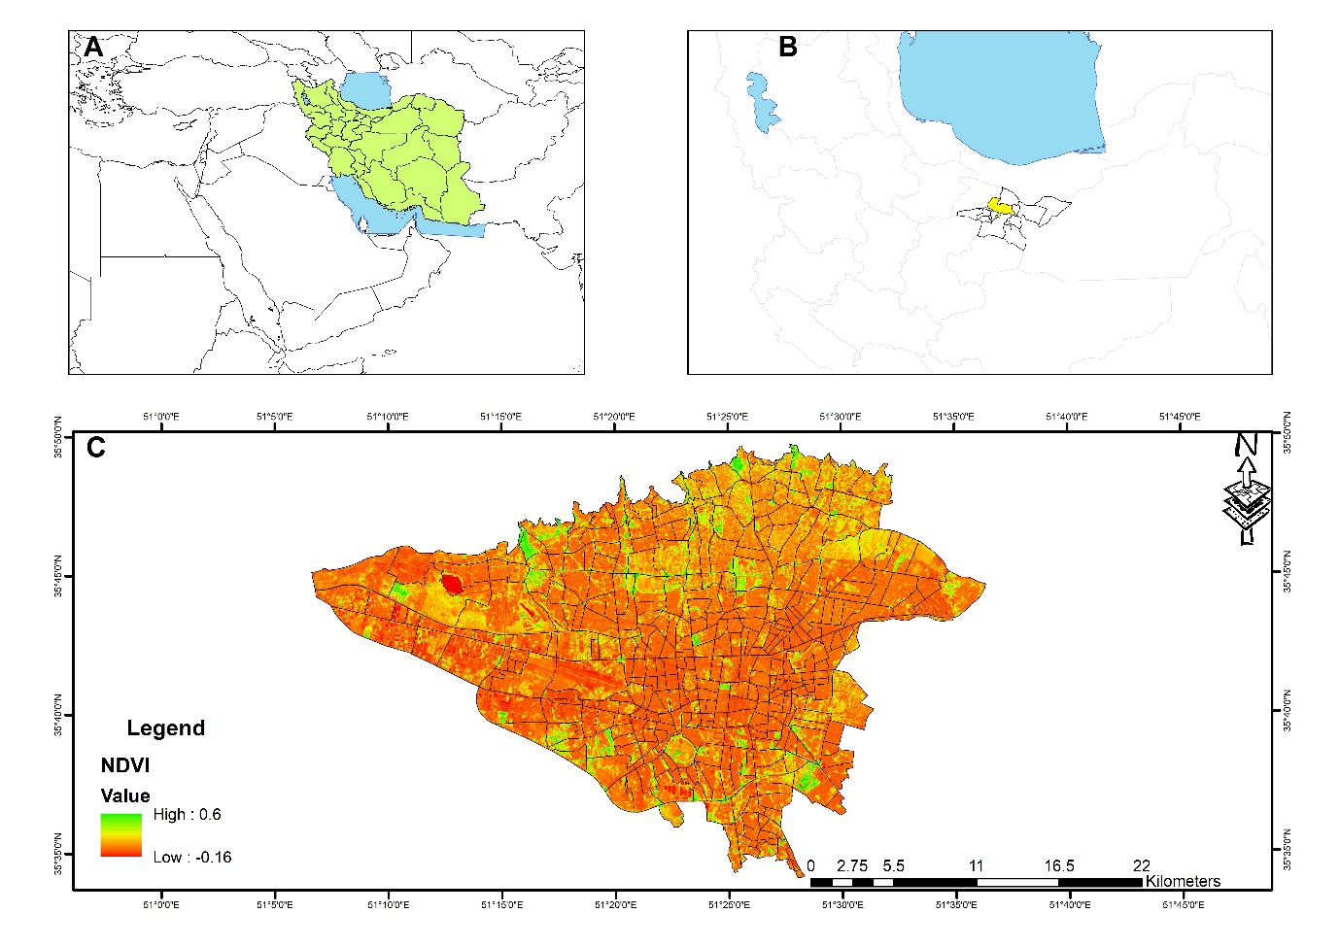
Figure 1. Location of the study area
  - Materials and Methods
This study introduces four novel ensemble models inspired by human collective systems, including the U.S. presidential election, the U.S. Congress, monarchical governance, and the ancient Senate system, to predict LST in the Tehran metropolitan area. LST and its influencing factors were initially analysed using machine learning algorithms, specifically ANN, RF, SVM, Classification and Regression Tree (CART), and Generalized Linear Model (GLM). The analysis for each model involved five stages: preparation of initial data, selection of parameters affecting LST, preparation of training and testing datasets, execution of machine learning models, and presentation of LST results in a map format.
Subsequently, the outputs of these models were statistically evaluated and processed to determine the accuracy of each model across different regions. These results were then used as input parameters for the ensemble algorithms. The ensemble models, including those inspired by the U.S. presidential election, U.S. Congress, monarchical governance, ancient Senate system, mean, median, and weighted mean approaches, were applied, followed by validation. Finally, the significance of various parameters was estimated and presented using five different algorithms and seven ensemble models.
    - Preparation of Geospatial Database
This study utilized 20 Landsat 8 satellite images from 2020 to determine LST and the Normalized Difference Vegetation Index (NDVI), as detailed in Table 1.

Table 1. Landsat 8 images specifications
 | Satellite | Sensor | Date | Spatial resolution
1 | Landsat 8 | OLI | 14-Jan-20 | Multispectral: 30 m  Thermal band: 100m
2 | Landsat 8 | OLI | 30-Jan-20 | Multispectral: 30 m  Thermal band: 100m
3 | Landsat 8 | OLI | 15-Feb-20 | Multispectral: 30 m  Thermal band: 100m
4 | Landsat 8 | OLI | 2-Mar-20 | Multispectral: 30 m  Thermal band: 100m
5 | Landsat 8 | OLI | 18-Mar-20 | Multispectral: 30 m  Thermal band: 100m
6 | Landsat 8 | OLI | 3-Apr-20 | Multispectral: 30 m  Thermal band: 100m
7 | Landsat 8 | OLI | 19-Apr-20 | Multispectral: 30 m  Thermal band: 100m
8 | Landsat 8 | OLI | 5-May-20 | Multispectral: 30 m  Thermal band: 100m
9 | Landsat 8 | OLI | 21-May-20 | Multispectral: 30 m  Thermal band: 100m
10 | Landsat 8 | OLI | 6-Jun-20 | Multispectral: 30 m  Thermal band: 100m
11 | Landsat 8 | OLI | 22-Jun-20 | Multispectral: 30 m  Thermal band: 100m
12 | Landsat 8 | OLI | 8-Jul-20 | Multispectral: 30 m  Thermal band: 100m
13 | Landsat 8 | OLI | 24-Jul-20 | Multispectral: 30 m  Thermal band: 100m
14 | Landsat 8 | OLI | 9-Aug-20 | Multispectral: 30 m  Thermal band: 100m
15 | Landsat 8 | OLI | 25-Aug-20 | Multispectral: 30 m  Thermal band: 100m
16 | Landsat 8 | OLI | 10-Sep-20 | Multispectral: 30 m  Thermal band: 100m
17 | Landsat 8 | OLI | 26-Sep-20 | Multispectral: 30 m  Thermal band: 100m
18 | Landsat 8 | OLI | 12-Oct-20 | Multispectral: 30 m  Thermal band: 100m
19 | Landsat 8 | OLI | 28-Oct-20 | Multispectral: 30 m  Thermal band: 100m
20 | Landsat 8 | OLI | 15-Dec-20 | Multispectral: 30 m  Thermal band: 100m

Image processing was conducted using Google Earth Engine. The resolution of bands 1 to 9 is 30 meters, providing sufficient accuracy, while the thermal bands have a resolution of 100 meters, suitable for analysing temperature variations across Tehran. Band 10 was used to extract surface temperature data with a wavelength range of 10.6 to 11.9 micrometres and a 100-meter resolution. Atmospheric corrections were performed using the FLASSH method prior to processing in Google Earth Engine. Geometric corrections were applied, and the Maximum Likelihood Classification (MLC) method, a widely used approach, was employed.
Urban morphology data, including building height (BH), building density (BD), and sky view factor (SVF), were derived from building block height information. Urban road length and area (Integ_Rn), two independent parameters, were obtained from Tehran’s 2014 development plan and used to calculate Integration Rn. Additionally, urban green spaces and their patterns, represented by NDVI, Mean Patch Index (MPI), and Mean Patch Fractal Dimension (MPFD), were included as influential parameters, as outlined in Table 2.

Table 2. the urban form indicators selected in this study
Category | Index | Description | Unit | range | Equation
Urban morphology | Building height(BH) | Expresses height of building | m | $$0<BH$$ | -
Urban morphology | Building density(BD) | Shows by the proportion of building square footage in a block, neighborhood or district. BD defines crowded or built-up a neighborhood, land intensity and worth of land or building | None | $$0≤BD$$ | $$\frac{Build up area}{land area}$$
Urban morphology | Sky view factor(SVF) | Addresses to the ratio of the radiation received (or emitted) by a planar surface to the radiation emitted (or received) by the entire hemispheric environment. SVF is more appropriate tools for describing urban geometry | Degree | $$0<SVF≤1$$ | $$2π-\sum_{d}^{ND}{S_{Hd}}$$  Where ND is the number of sky hemisphere sectors, d is a given azimuthal ray direction and SHd is the surface of sky hemisphere hidden by obstacles  in the azimuthal direction d.
Urban road | Road length (RL) | measures the sum of urban road length in the neighborhood. | m | $$0<RL$$ | $$\sum_{i=1}^{n}{L_{i}}$$  L_{i} is length of the road in urban neighborhood
Urban road | Road area (RA) | Presents total area of the urban roads in the neighborhood scale. Increasing RA has positive effect on LST | m² | $$0<RA$$ | $$\sum_{i=1}^{n}{L_{i}W_{i}}$$  Where Li is length of the road and Wi is width of the road.
Spatial configuration | Integration-Rn(Integ_Rn) | Describes the average depth of a space to all other space. A value which is used to measure of spatial configuration. Rn be used to represent integration patterns in the large scale; define small, close areas with geometric center | None | $$0<Int-Rn$$ | $$\frac{1}{{RRA}_{Rn}}$$  RRA is a normalized measure since it is calculated as RA normalized though the D-Value. Integration-Rn is inverse of RRA(Hillier and Hanson 1984).
Urban vegetation and spatial  patterns | NDVI | Is an useful index to quantify vegetation greenness, it’s density, changes and health. | None | $$-1≤NDVI≤+1$$ | NDVI is evaluated as a ratio between the red (R) and near infrared (NIR) values in traditional fashion:  $${R_{NIR}-R_{RED}}/{R_{NIR}+R_{RED}}$$
Urban vegetation and spatial  patterns | MPI | Measures the degree of isolation and fragmentation of urban vegetation. | None | $$0<MPI$$ | $$\sum_{i=1}^{n}{\frac{a_{i}}{h_{ij}^{2}}}$$  In this equation, n, is total number of patches, ai, is patch area, and hij, is distance from the patch i to the patch j.
Urban vegetation and spatial  patterns | MPFD | This metric quantifies the complexity of the shape, with values ranging from 1 to 2. A value of 1 corresponds to patches with simple perimeters, such as squares, while a value approaching 2 indicates increasingly complex shapes. | None | 1≤MPFD≤2 | $$\frac{\sum_{j=1}^{m}{(\frac{2lnp_{ij}}{{lna}_{ij}})}}{n_{i}}$$  where Pij is the patch perimeter of type ij, in units of m; aij is the patch area of type ij; and N is the number of patches of a certain type.

    - Distribution of Independent Parameters
The independent parameters exhibit varying spatial distributions, as shown in Figure 2. BH, BD, and Integ_Rn vary significantly across Tehran, with notable changes from the city centre to its outskirts. Conversely, road area, NDVI, and MPI exhibit higher values in the city centre.

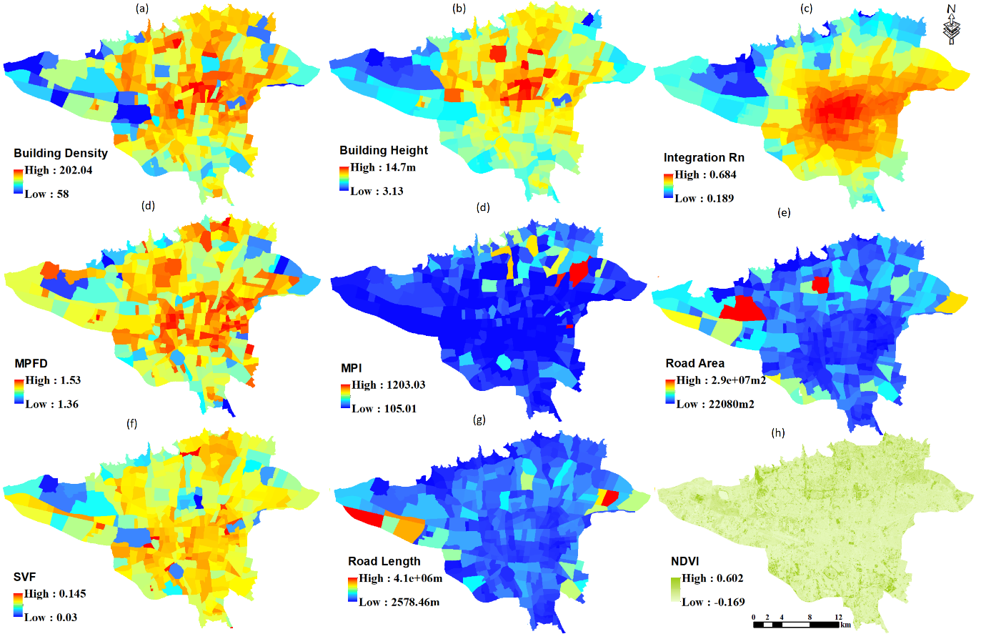
Figure 2- Spatial distribution of the selected variables

    - Structure of Ensemble Models
The following ensemble models were developed and applied:
      - Mean Method
In this method, the numerical mean of the outputs from all models was calculated and presented as a map. The value of each cell represents the average of the five models. The accuracy of this method generally depends on the average accuracy of all models.

      - Weighted Mean Method (WMean)
This ensemble method calculates a weighted mean based on the accuracy of each model (R-squared). The outputs of the five models were mapped, with higher-accuracy models exerting greater influence on the final ensemble result. This approach enhances the impact of more accurate models on the ensemble outcome.
      - Median Method
This method selected the model output with the least deviation from the weighted mean as the ensemble result. The weighted mean was first calculated, followed by the deviation of each model from this mean. The model’s output with the smallest deviation was presented as the ensemble result.
      - Genius King Method
Inspired by the concept of a wise monarch, this method leverages the strengths of each model in regions where it performs most accurately. By considering the performance of each model across different areas of the city, the method selects the output of the model with the lowest error (RMSE) for each region. In cases where identifying a superior model is not feasible, the method defaults to the mean of all model outputs, as depicted in Figure 3.

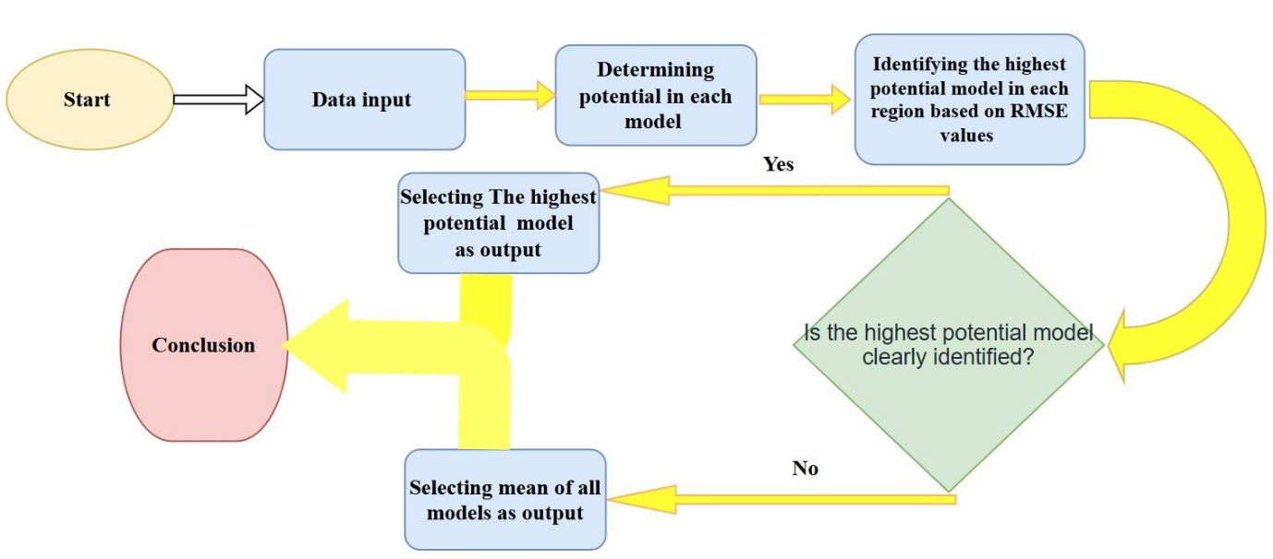
Figure 3. Flowchart for the Genius King Ensemble Method

      - Ancient Senate Method
In this method, inspired by the ancient Senate system, a polling process is conducted on a specific issue (hazard). Like human collectives, the group of models with the majority vote is declared the winner, and a decision is made on the issue. This study defined a temperature exceeding 20°C as a hazard. A vote was then taken, and the majority (at least three votes in favour or against) was identified as the winner. Finally, the mean of the winning models was calculated. Given that five models were used in this study, the criterion for winning was at least three aligned votes. Thus, the result for each cell could be the mean of three, four, or five models with aligned votes (either in favour or against), as shown in Figure 4.

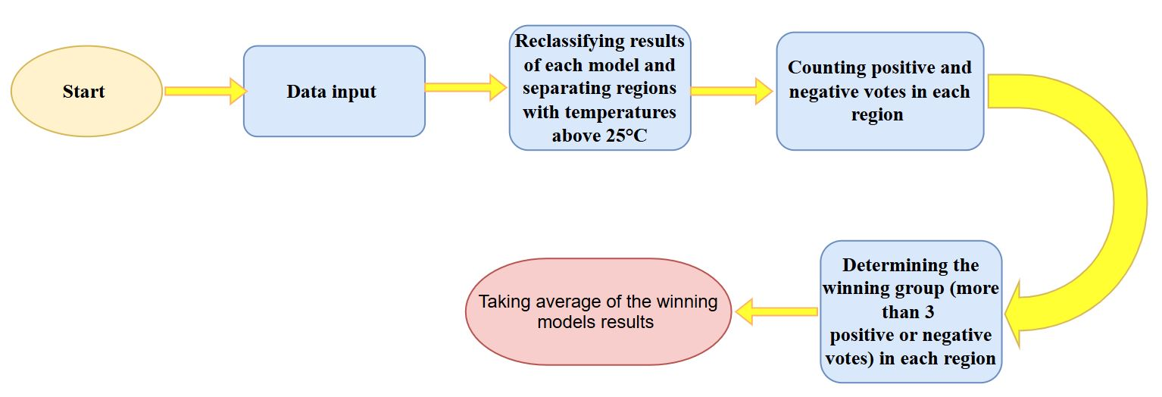Figure 4. Flowchart of the Ancient Senate Method

      - The U.S. Congress Method
This method is modelled after the decision-making process in the U.S. Congress. In the U.S. Congress, significant decisions are delegated to specialized committees. If a specialized committee is not formed or does not exist for a given issue, a general vote is conducted, with each model’s vote carrying equal weight. In this study, a specialized committee was first formed for each domain, decisions were made within the committee, and the mean of the committee members’ outputs was presented as the ensemble result. In regions where identifying superior models and forming an ensemble was not feasible, the mean of all models was used as the result, as shown in Figure 5.

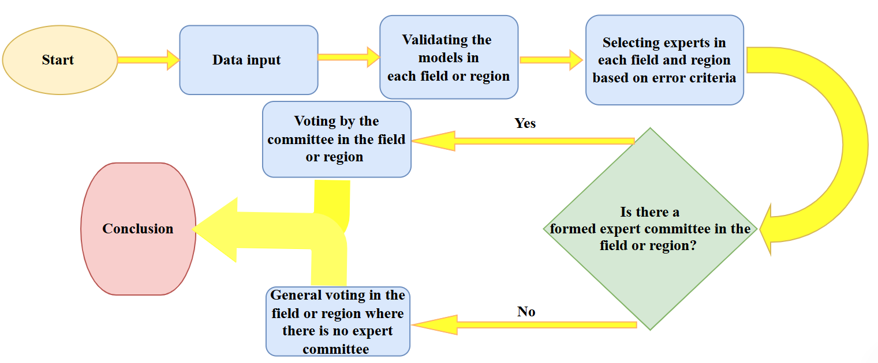
Figure 5: Flowchart of the U.S. Congress Method

      - The U.S. Presidential Election Method
This method is inspired by the U.S. presidential election system, where electoral votes are assigned to each model based on accuracy. The number of electoral votes for each model is determined as a function of its ability to detect a hazard or non-hazard, using the True Positive Rate (TPR) and True Negative Rate (TNR) as weighting factors. The total number of electoral votes was set to 538. A vote was then conducted: if the positive votes (indicating a hazard) exceeded 269, the weighted mean of the models with positive votes was calculated using TPR as the weighting factor. Conversely, if the negative votes (indicating no hazard) prevailed (positive votes < 270), the weighted mean of the models with negative votes was calculated using TNR as the weighting factor, as shown in Figure 6. This method enhances talent identification by considering two model capabilities: the ability to detect and negate a hazard. TPR is the weighting factor in hazard regions, while TNR is used in the non-hazard regions.
- Equation 1: TPR = TP / (TP + FN)
- Equation 2: TNR = TN / (TN + FP)
Where TP represents true positives, FN represents false negatives, FP represents false positives, and TN represents true negatives.
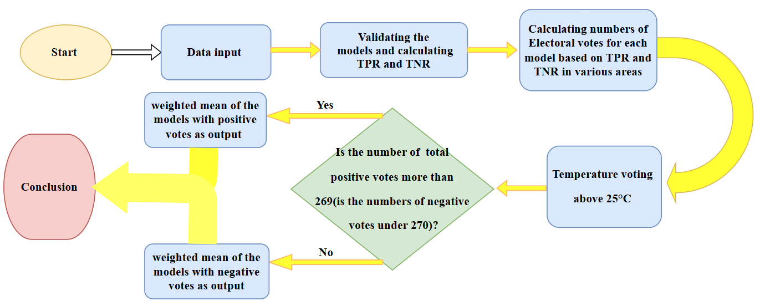
Figure 6: Flowchart of the U.S. Presidential Election Method

  - Evaluation and Comparison of Models
This study’s dataset was first divided into two subsets: training and testing. After training the models using the training data (70% of the dataset), the accuracy of each model was evaluated by predicting and comparing the test data (30% of the dataset) to assess their performance in predicting Land Surface Temperature (LST). The performance of five machine learning models and seven ensemble models was compared using statistical metrics, including Mean Absolute Error (MAE), Mean Squared Error (MSE), Root Mean Square Error (RMSE), and R-squared (R²). Additionally, to evaluate each model’s ability to predict temperatures above 20°C as a hazard accurately, the True Positive Rate (TPR) was calculated for the five models. Similarly, the True Negative Rate (TNR) was used to assess the models’ ability to predict regions with temperatures below 20°C.

  - Analysis of Parameter Importance in Prediction (VIP)
The study also analysed the factors influencing LST in Tehran. To this end, the importance of each parameter (VIP) was determined by calculating the change in the model’s error (RMSE) when that parameter was excluded. Specifically, the increase in the model’s error upon removing a parameter reflects its importance, as the model’s accuracy is affected proportionally to the significance of the excluded parameter.

- Results
  - Analysis of LST Using the RF Model
In this study, the RF model was employed to analyse LST. The results were presented as three temperature classes in map format (Figure 7 and Table 3). According to the findings, 64% of the study area has temperatures below 20°C, 35% fall between 20°C and 25°C, and 1% exceed 25°C.
  - Analysis of LST Using the ANN Model
The ANN model was also successfully applied in this study. The results were similarly presented as three temperature classes in map format (Figure 7 and Table 3). According to this model, 65% of the area has temperatures below 20°C, 30% ranges between 20°C and 25°C, and 5% exceeds 25°C. Compared to the RF model, the ANN model adopts a more conservative approach, identifying larger areas at risk of increased LST.
  - Analysis of LST Using the SVM Model
The SVM model was another method utilized in this study. The results were presented as three temperature classes in map format (Figure 7 and Table 3). According to the findings, 68% of the area has temperatures below 20°C, 31% ranges between 20°C and 25°C, and 1% exceeds 25°C. Compared to the RF model, the SVM model identifies smaller areas at risk of increased LST.
  - Analysis of LST Using CART
The results of LST prediction using the CART model were also presented in three temperature classes (Figure 7 and Table 3). According to the results, 65% of the area has temperatures below 20°C, and approximately 35% falls between 20°C and 25°C. Notably, this model did not predict any areas with temperatures exceeding 25°C, indicating its lack of accuracy in identifying regions with temperatures above 25°C.
  - Analysis of LST Using the GLM
The GLM was also used to analyse LST in this study. The results were presented as three temperature classes in map format (Figure 7 and Table 3). According to the findings, 65% of the area has temperatures below 20°C, 34% ranges between 20°C and 25°C, and 1% exceeds 25°C. Compared to the other models, the GLM model demonstrates a higher correlation in identifying areas with temperatures above 25°C.

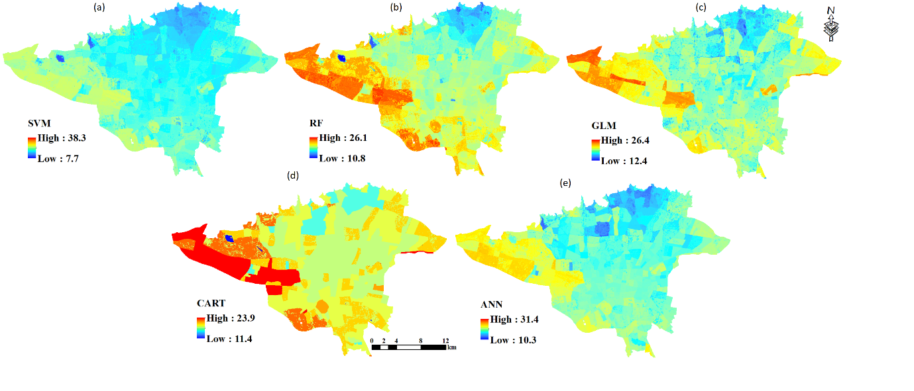
Predicted LST using different Algorithms. Fig. 7-

Model | ANN | CART | SVM | GLM | RF
<20 C | 65 | 65 | 68 | 65 | 64
20-25 C | 30 | 35 | 31 | 34 | 35
>25C C | 5 | 0 | 1 | 1 | 1
Table 3: Distribution of Predicted LST Using Different Models
  - Validation Assessment
Various statistical methods were employed to validate the accuracy of the models in this study. Five machine learning models, ANN, RF, CART, SVM, and GLM, were validated using MAE, MSE, RMSE, and R-squared (R²) metrics. These metrics reflect the models’ ability to predict LST. The MAE values for RF, SVM, ANN, CART, and GLM were 1.11, 1.28, 1.62, 1.68, and 1.77, respectively. The MSE values for these models were 2.33, 3.13, 4.54, 4.76, and 5.4, respectively. The RMSE values were also 1.06, 1.13, 1.27, 1.30, and 1.33 for RF, SVM, ANN, CART, and GLM, respectively. These results indicate that all five models are sufficiently accurate, with the RF model outperforming the others in predicting LST for this case study. The R² values for RF, SVM, ANN, CART, and GLM were 0.76, 0.68, 0.55, 0.50, and 0.44, respectively, further confirming the sufficient accuracy of all models and the superiority of the RF model in LST prediction (Table 4).
The sensitivity (TPR) of the ANN, RF, CART, SVM, and GLM models was 0.744, 0.825, 0.729, 0.819, and 0.719, respectively, while the specificity (FPR) was 0.161, 0.100, 0.176, 0.150, and 0.178, respectively. The TNR values for these models were 0.839, 0.900, 0.824, 0.850, and 0.822, respectively. These metrics demonstrate the models’ sufficient accuracy in predicting temperatures above 20°C, with the RF model showing the highest accuracy in detecting temperatures above and below 20°C based on TPR and TNR comparisons (Table 4).
Based on the statistical metrics, it can be concluded that all models exhibit good accuracy, but the RF and SVM models outperform the other three models overall.
Table4- Comparison different machine learning model’s accuracy
Model | TPR | TNR | TSS | MAE | MSE | RMSE | R-squared
ANN | 0.74 | 0.84 | 0.58 | 1.62 | 4.54 | 1.27 | 0.55
CART | 0.73 | 0.82 | 0.55 | 1.68 | 4.76 | 1.30 | 0.50
SVM | 0.82 | 0.85 | 0.67 | 1.28 | 3.13 | 1.13 | 0.68
GLM | 0.72 | 0.82 | 0.54 | 1.77 | 5.40 | 1.33 | 0.44
RF | 0.82 | 0.90 | 0.73 | 1.11 | 2.33 | 1.06 | 0.76

  - Analysis of VIP
A VIP analysis was conducted to evaluate and compare the influence of various parameters on LST. The results indicate that the importance of each parameter varies across different models. On average, the weighted importance of the parameters NDVI, BH, SVF, MPI, and BD was higher than other parameters in the ANN model. In contrast, the top five crucial parameters for the CART and RF models were NDVI, BH, SVF, MPI, and RL. The SVM model identified NDVI, BH, SVF, RA, and Integ_Rn as the most essential parameters, while in the GLM model, NDVI, BH, SVF, RA, and BD were deemed the most significant. Overall, urban morphology parameters (BH, BD, and SVF), vegetation cover parameters (NDVI and MPI) were identified as the most influential factors affecting LST in Tehran (Table 5).
Table 5 - Analysis the importance of various explanatory factors or predictors in the used machine learning models
Parameter | ANN | CART | SVM | GLM | RF
NDVI | 1.308 | 1.306 | 1.189 | 1.353 | 1.168
BH | 1.282 | 1.304 | 1.156 | 1.350 | 1.081
BD | 1.255 | 1.288 | 1.131 | 1.338 | 1.057
SVF | 1.272 | 1.300 | 1.152 | 1.336 | 1.074
RL | 1.252 | 1.297 | 1.143 | 1.341 | 1.064
RA | 1.248 | 1.286 | 1.150 | 1.340 | 1.064
Integ_Rn | 1.251 | 1.287 | 1.144 | 1.333 | 1.064
MPI | 1.266 | 1.292 | 1.140 | 1.338 | 1.065
MPFD | 1.247 | 1.292 | 1.143 | 1.328 | 1.064

  - Analysis of LST Using Ensemble Models
The results of LST analysis using ensemble models were presented as maps (Figure 8). The findings show that the Genius King and U.S. Congress methods were more successful in detecting temperatures above 25°C. These two methods estimated that approximately 1% of the study area had temperatures exceeding 25°C, closer to the observed value of 6% obtained through remote sensing compared to the other ensemble models.
Statistical analysis revealed that the influence of each model’s vote varies across different ensemble models. Generally, the most effective method maximizes the use of more accurate models. Talent identification enables the selection of the most accurate method, allowing greater reliance on the votes of stronger models. Statistical comparisons showed that the Mean, Weighted Mean, and U.S. Presidential Election methods utilized all models equally. However, the Weighted Mean and U.S. Presidential Election methods incorporated talent identification, whereas the Mean method did not account for the ability or talent of each model. In the Median method, the SVM model had the most significant influence on the final result (24%), followed by the ANN model (22%), while the GLM model contributed to only 13% of the decisions. In the Genius King method, the RF model contributed to 95% of the decisions, followed by the SVM model (37%), while the ANN model, with a 32% frequency, participated only in general votes. In the Ancient Senate method, all models had nearly equal influence (approximately 20% each) on the final result, as this method does not rely on talent identification but rather on the majority vote. In the U.S. Congress method, only 32% of decisions were made through general voting. Talent identification was precisely implemented, with 68% of decisions made by specialized committees comprising at least three models. Among these, RF and SVM had the highest influence on committee decisions, with frequencies of 22% and 21%, respectively, while GLM participated in only 4% of committee decisions. Additionally, ANN and CART contributed to 13% and 7% of the specialized committee decisions, respectively (Table 6).
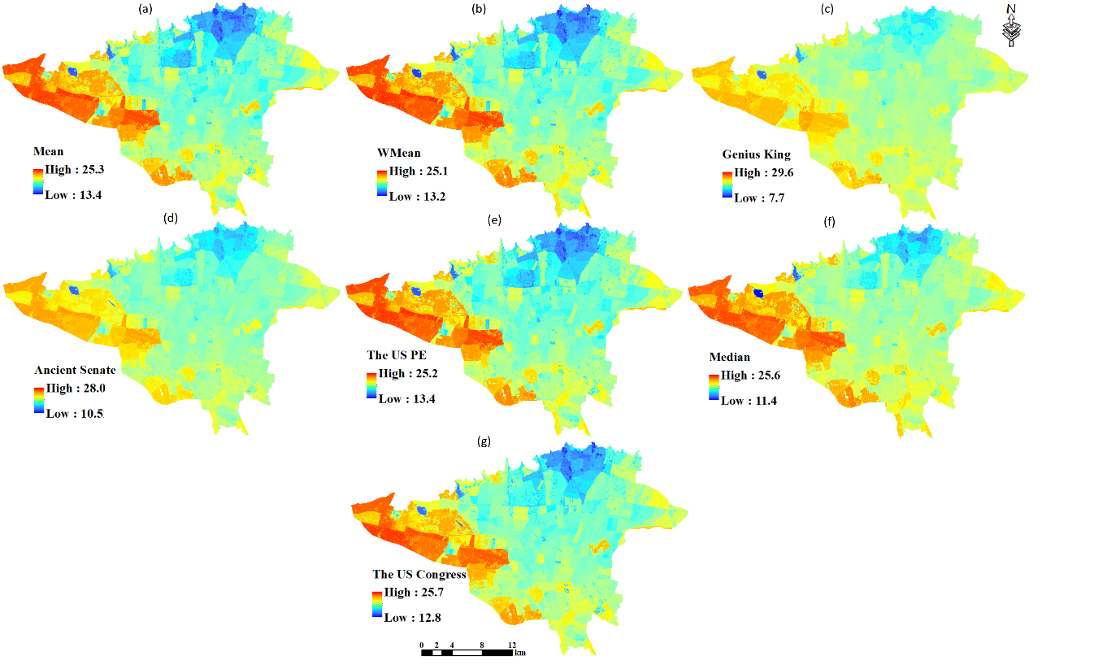
Fig. 8- Predicted LST using Ensemble Modeling
Table 6: Influence of Each Model in Different Ensemble Models (%)
Ensemble Modeling | ANN | CART | SVM | GLM | RF | General Election
Mean | 100 | 100 | 100 | 100 | 100 | 100
WMean | 100 | 100 | 100 | 100 | 100 | 100
Median | 22 | 21 | 24 | 13 | 21 | 0
Genoius_King | 32 | 33 | 37 | 33 | 95 | 32
Ancient Senate | 20.3 | 19.9 | 20.4 | 19.7 | 19.7 | 0
The US P.E | 100 | 100 | 100 | 100 | 100 | 100
The U.S. Congress | 45 | 39 | 54 | 37 | 55 | 32

  - Validation Assessment of Ensemble Models
Validation was conducted using the statistical metrics MAE, MSE, RMSE, and R-squared (R²) to evaluate the accuracy of the ensemble models and compare them with each other. The MAE values for the Genius King, Weighted Mean (WMean), Median, U.S. Congress, U.S. Presidential Election, Ancient Senate, and Mean methods were 1.31, 1.38, 1.38, 1.39, 1.41, 1.41, and 1.41, respectively. The MSE values for these methods were 3.03, 3.27, 3.33, 3.33, 3.39, 3.42, and 3.43, respectively. The RMSE values were also 1.14, 1.17, 1.18, 1.18, 1.19, 1.19, and 1.19 for the Genius King, WMean, Median, U.S. Congress, U.S. Presidential Election, Ancient Senate, and Mean methods, respectively. Overall, the Genius King method demonstrated higher accuracy compared to the other ensemble models in analysing LST in the Tehran metropolitan area (Table 7).
A comparison of the TPR and TNR parameters of the ensemble models (Table 7) with those of the individual models (Table 4) indicates that the ensemble models performed better in detecting areas with temperatures above 20°C. Specifically, the TPR for ensemble models ranged from 0.88 to 0.98, while the TPR for individual models ranged from 0.72 to 0.82. Similarly, the TNR for ensemble models ranged from 0.97 to 1.00, compared to a range of 0.82 to 0.92 for the individual models. Furthermore, the MAE, MSE, RMSE, and R² metrics demonstrate that ensemble models enhance confidence in the results and improve prediction accuracy.
Table7- Comparison different Ensemble Modeling’s accuracy
Ensembling | TPR | TNR | TSS | MAE | MSE | RMSE | R-squared
Mean | 0.89 | 0.98 | 0.87 | 1.41 | 3.42 | 1.19 | 0.65
Wmean | 0.90 | 0.98 | 0.88 | 1.38 | 3.27 | 1.17 | 0.67
Median | 0.90 | 0.97 | 0.87 | 1.38 | 3.33 | 1.18 | 0.66
Genius King | 0.98 | 1.00 | 0.98 | 1.31 | 3.03 | 1.14 | 0.69
Ancient Senate | 0.91 | 0.98 | 0.88 | 1.41 | 3.43 | 1.19 | 0.65
The US P.E | 0.88 | 0.98 | 0.86 | 1.41 | 3.39 | 1.19 | 0.65
The US Congress | 0.91 | 0.98 | 0.88 | 1.39 | 3.33 | 1.18 | 0.66

  - Analysis of VIP Using Ensemble Models
To evaluate and compare the influence of various parameters on LST using ensemble models, a Variable Importance in Prediction (VIP) analysis was conducted. The results revealed that the importance of each parameter varies across different ensemble models. Despite these differences, the parameters NDVI, BH, MPI, RL, and Integ_Rn consistently exhibited greater importance in the ensemble models than other parameters (Table 8).

Table8- Analysis the importance of various explanatory factors or predictors in the Ensemble Modeling
Model | Mean | WMean | Median | Genoius_King | Ancient Senate | The_US_P.E | The_U.S._Congress
NDVI | 1.234 | 1.222 | 1.226 | 1.205 | 1.229 | 1.232 | 1.229
BH | 1.201 | 1.184 | 1.188 | 1.152 | 1.198 | 1.197 | 1.189
BD | 1.188 | 1.170 | 1.180 | 1.119 | 1.186 | 1.184 | 1.175
SVF | 1.190 | 1.173 | 1.176 | 1.131 | 1.189 | 1.187 | 1.178
RL | 1.194 | 1.179 | 1.176 | 1.147 | 1.192 | 1.191 | 1.184
RA | 1.185 | 1.167 | 1.167 | 1.108 | 1.184 | 1.181 | 1.171
Integ_Rn | 1.194 | 1.179 | 1.181 | 1.147 | 1.191 | 1.191 | 1.184
MPI | 1.198 | 1.182 | 1.187 | 1.149 | 1.197 | 1.195 | 1.186
MPFD | 1.186 | 1.170 | 1.175 | 1.125 | 1.185 | 1.183 | 1.175

- Discussion
The application of machine learning in addressing complex issues, such as land surface temperature (LST) variations, can significantly enhance the precision and reliability of planning efforts. Ensemble models reduce errors and increase confidence in the results by simultaneously leveraging multiple algorithms. A key aspect of studying LST is identifying and prioritizing factors exacerbating temperature increases. Given the distinct approaches of different algorithms in analyzing this issue, employing multiple algorithms, assessing their accuracy, and comparing their performance can improve our ability to select the most accurate model, thereby enabling more precise analysis of environmental challenges. For instance, Tanuri et al. demonstrated the remarkable capability of Deep Neural Networks (DNNs) and Extreme Gradient Boosting (XGB) in analyzing LST in Shiraz, while Gourav Suthar et al. (2024) identified ANNs as the most accurate model for predicting LST using air pollution and urban parameter data. Today, various machine learning models are widely used to address environmental issues.
In this study, machine learning was employed to investigate LST variations as an environmental hazard in Tehran, the capital of Iran. Five machine learning models, ANN, RF, SVM, CART, and GLM, were applied to analyse LST. The results indicate varying levels of accuracy among the models in predicting environmental phenomena and hazards. Although all five models demonstrated sufficient accuracy, the RF and SVM models outperformed the other three, while the GLM model exhibited the lowest accuracy. The RF model’s superiority aligns with Fei Feng’s findings (2024). Conversely, Chaitanya Baliram Pande et al. (2024) highlighted the superior performance of the Bagging ensemble model over XG-Boost and AdaBoost.
Due to the differing computational approaches of the models, the extent of areas with temperatures exceeding 25°C varied across models. The ANN, RF, SVM, and GLM models identified larger areas with temperatures above 25°C, whereas the CART model failed to detect such regions. The results also revealed that all parameters used in this study influenced LST, but their importance varied across models due to differences in how each model estimates relationships between parameters. Despite these variations, urban morphology and green space parameters generally exhibited greater importance than other factors. The influence of urban morphology on LST was also noted in Tanuri et al. (2024). Consequently, future strategies to mitigate rising urban temperatures could focus on reducing BH and density while increasing urban green spaces. Addressing environmental challenges like rising LST requires long-term planning and reversing unsustainable urban development and industrial practices.
The introduction of novel ensemble models and the evaluation of their accuracy in addressing the environmental issue of rising LST demonstrated their effectiveness in enhancing precision and reliability. As these methods are inspired by human collectives, such as the U.S. Congress, presidential elections, monarchical governance, and ancient Senate systems, the results obtained from ensemble models are more reliable than those from a single model. This study’s findings confirm that ensemble models can reduce errors and increase confidence by incorporating the strengths of each model. The more adept these methods are at identifying model talents, the lower the error in the resulting predictions. The analysis revealed that the accuracy of ensemble models varied, with the Genius King and Weighted Mean methods demonstrating higher accuracy than others, while the Ancient Senate method exhibited the lowest accuracy and highest error. The Genius King method excelled in talent identification, whereas the Ancient Senate method relied solely on majority voting without considering model capabilities. These findings align with previous studies, such as Ashrafzadeh et al. (2023), which showed that ensemble models generally outperform most individual algorithms in accuracy and precision. Similarly, Achu et al. (2023) demonstrated that ensemble models (Mean, Weighted Mean, Median, and Committee Averaging) increase optimism, yield more accurate results, and reduce uncertainty compared to individual models.
Ensemble models can also be leveraged to analyze parameter importance. The VIP analysis using ensemble models confirmed that NDVI, BH, MPI, RL, and Integ_Rn were the most influential parameters, validating the results of individual algorithms. However, ensemble models provided greater confidence in these findings by considering the outputs of all models. These methods reaffirmed the significant role of urban morphology and green spaces in influencing LST, reinforcing the conclusion that proper urban design is a key strategy for controlling LST in urban areas.

- Conclusion
Given the fundamental differences in how each algorithm approaches and solves problems, ensemble models offer a valuable solution for consolidating results from multiple models. Moreover, introducing novel ensemble models enhances confidence in the outcomes derived from various algorithms. The ensemble models proposed in this study are inspired by human decision-making processes, where consultation and collaboration lead to successful outcomes. Validation of an issue by multiple models naturally instills greater audience confidence than validation by a single model. Ensemble models are the optimal approach for synthesizing the results of multiple models and delivering an outcome. The findings of this study confirm the positive impact of novel ensemble models in improving prediction accuracy and increasing confidence in the results. This issue is particularly significant as the proposed methods are derived from human collectives, and the decisions made closely resemble human group decision-making processes. However, the results are directly influenced by the extent and method of talent identification. In cases where talent identification was more effective and the influence of more accurate models was emphasized, the ensemble results exhibited lower error and higher accuracy. Conversely, in cases where decisions were based solely on majority voting without considering model capabilities, the results deviated more from reality, leading to increased error.

References
- Aliakbari Bidokhti, A., Hamidianpour, M., & Keshavarz, M. (2016). Trend analysis of temperature and precipitation in Tehran during the period of 1961–2010. Atmospheric Research, 176-177, 13-22.
- Kovats, R. S., & Hajat, S. (2008). Heat stress and public health: a review. Annual Review of Public Health, 29, 41-55.
- Li, X., Zhou, Y., Zhao, M., & Zhao, W. (2017). A meta-analysis of remote sensing-based studies on the relationship between land surface temperature and land use/land cover. Remote Sensing, 9(12), 1320.
- Oke, T. R. (1982). The energetic basis of the urban heat island. Quarterly Journal of the Royal Meteorological Society, 108(455), 1-24.
- Santamouris, M. (2001). Energy and climate in the urban built environment. James & James Science Publishers.
- Weng, Q., Liu, H., & Lu, D. (2004). Assessing the impact of land use and land cover change on urban surface temperature. Remote Sensing of Environment, 89(4), 467-483.
- Zhang, X., Friedl, M. A., Anderson, M. C., Johnson, D. M., Redmond, K., & Morisette, J. T. (2017). MODIS-based land surface temperature dynamics and relations to vegetation indices across the conterminous United States. Remote Sensing of Environment, 189, 133-148.
- Aliakbari Bidokhti, A., Hamidianpour, M., & Keshavarz, M. (2016). Trend analysis of temperature and precipitation in Tehran during the period of 1961–2010. Atmospheric Research, 176-177, 13-22.
- Aliakbari Bidokhti, A., Hamidianpour, M., & Keshavarz, M. (2016). Trend analysis of temperature and precipitation in Tehran during the period of 1961–2010. Atmospheric Research, 176-177, 13-22.
- Gartland, L. (2008). Heat islands: Understanding and mitigating heat in urban areas. Earths can.
- Kovats, R. S., & Hajat, S. (2008). Heat stress and public health: a review. Annual Review of Public Health, 29, 41-55.
- Li, X., Zhou, Y., Zhao, M., & Zhao, W. (2017). A meta-analysis of remote sensing-based studies on the relationship between land surface temperature and land use/land cover. Remote Sensing, 9(12), 1320.
- Oke, T. R. (1982). The energetic basis of the urban heat island. Quarterly Journal of the Royal Meteorological Society, 108(455), 1-24.
- Santamouris, M. (2001). Energy and climate in the urban built environment. James & James Science Publishers.
- Taha, H. (1996). Modeling urban albedo impacts on daytime temperature in the urban environment. Atmospheric Environment, 31(17), 2803-2818.
- Voogt, J. A., & Oke, T. R. (2003). Thermal remote sensing of urban climates. Remote Sensing of Environment, 86(3), 370-384.
- Weng, Q., Liu, H., & Lu, D. (2004). Assessing the impact of land use and land cover change on urban surface temperature. Remote Sensing of Environment, 89(4), 467-483.
- Zhang, X., Friedl, M. A., Anderson, M. C., Johnson, D. M., Redmond, K., & Morisette, J. T. (2017). MODIS-based land surface temperature dynamics and relations to vegetation indices across the conterminous United States. Remote Sensing of Environment, 189, 133-148.
- Statistical Center of Iran(2021), Results of the General Population and Housing Census 2016.
- Ashrafzadeh, M. R., Shahbazinasab, K., Mohammadi, A., & Penteriani, V. (2023). Determining the distribution factors of an endangered large carnivore: A case study of the brown bear Ursus arctos population in the Central Zagros Mountains, Southwest Iran. Global Ecology and Conservation, 46, e02590.
- L., Achu & C D, Aju & Di Napoli, Mariano & Prakash, Pranav & Gopinath, Girish & E., Shaji & Chandra S S, Vinod. (2023). Machine-learning based landslide susceptibility modelling with emphasis on uncertainty analysis. Geoscience Frontiers. 101657. 10.1016/j.gsf.2023.101657.
- Fleming, S.W., Watson, J.R., Ellenson, A., Cannon, A.J., Vesselinov, V.C., 2021. Machine learning in earth and environmental science requires education and research policy reforms. Nat. Geosci. 14, 878–880. https://doi.org/10.1038/s41561-021-00865-3.
- G evaert, C.M., 2022. Explainable AI for earth observation: a review including societal and regulatory perspectives. Int. J. Appl. Earth Obs. Geoinf. 112, 102869 https://doi.org/10.1016/j.jag.2022.102869.
- G unning, D., Stefik, M., Choi, J., Miller, T., Stumpf, S., Yang, G.-Z., 2019. XAI-Explainable artificial intelligence. Sci. Robot. 4 https://doi.org/10.1126/scirobotics. aay7120 eaay7120.
- McGovern, A., Lagerquist, R., John Gagne, D., Jergensen, G.E., Elmore, K.L., Homeyer, C.R., Smith, T., 2019. Making the black box more transparent: understanding the physical implications of machine learning. Bull. Am. Meteorol. Soc. 2175–2199. https://doi.org/10.1175/BAMS-D-18-0195.1.
- Gholamreza Roshan, Saleh Arekhi, Zainab Bayganeh, Shady Attia, Evaluation of the intensity of urban heat islands during heat waves using local climate zones in the semi-arid, continental climate of Tehran, Urban Climate, Volume 56, 2024, 102079, ISSN 2212-0955, https://doi.org/10.1016/j.uclim.2024.102079.(https://www.sciencedirect.com/science/article/pii/S221209552400275X)
- Majid Kiavarz, Sara Bourbour Hosseinbeigi, Naeim Mijani, Mohammad Sina Shahsavary, Mohammad Karimi Firozjaei, Predicting spatial and temporal changes in surface urban heat islands using multi-temporal satellite imagery: A case study of Tehran metropolis,Urban Climate,Volume 45,2022,101258,ISSN22120955,https://doi.org/10.1016/j.uclim.2022.101258.(https://www.sciencedirect.com/science/article/ii/S2212095522001766)‏
- Ghazaleh Tanoori, Ali Soltani, Atoosa Modiri, Machine Learning for Urban Heat Island (UHI) Analysis: Predicting Land Surface Temperature (LST)in Urban Environments,Urban Climate,Volume 55,2024,101962,ISSN22120955,https://doi.org/10.1016/j.uclim.2024.101962.(https://www.sciencedirect.com/science/article/pii/S2212095524001585)
- Fei Feng, Yaxue Ren, Chengyang Xu, Baoquan Jia, Shengbiao Wu, Raffaele Lafortezza,Exploring the non-linear impacts of urban features on land surface temperature using explainable artificial intelligence,Urban Climate,Volume 56,2024,102045,ISSN 22120955,https://doi.org/10.1016/j.uclim.2024.102045.(https://www.sciencedirect.com/science/article/pii/2212095524002414)
- Gourav Suthar, Nivedita Kaul, Sumit Khandelwal, Saurabh Singh,Predicting land surface temperature and examining its relationship with air pollution and urban parameters in Bengaluru: A machine learning approach,Urban Climate,Volume 53,2024,101830,ISSN 2212-0955,https://doi.org/10.1016/j.uclim.2024.101830.(https://www.sciencedirect.com/science/article/pii/S2212095524000269)
- Irshad, Z., Hassan, M., Akbar, S., Farooq, M., & Chishtie, F. A. (2024). Spatiotemporal changes in LULC and associated impact on urban Heat Islands over Pakistan using geospatial techniques. Urban Climate, 57, 102112.‏
- Chaitanya Baliram Pande, Johnbosco C. Egbueri, Romulus Costache, Lariyah Mohd Sidek, Qingzheng Wang, Fahad Alshehri, Norashidah Md Din, Vinay Kumar Gautam, Subodh Chandra Pal,Predictive modeling of land surface temperature (LST) based on Landsat-8 satellite data and machine learning models for sustainable development,Journal of Cleaner Production,Volume 444,2024,141035,ISSN 0959-6526,https://doi.org/10.1016/j.jclepro.2024.141035.
- Liu, X., Huang, Y., Xu, X., et al., 2020. High-spatiotemporal-resolution mapping of global urban change from 1985 to 2015. Nat Sustain 3, 564–570. https://doi.org/ 10.1038/s41893-020-0521-x.
- Li, C., Song, Y., Kaza, N., Burghardt, R., 2023. Explaining spatial variations in residential energy usage intensity in Chicago: the role of urban form and Geomorphometry. J. Plan. Educ. Res. 43 (2), 317–331. https://doi.org/10.1177/0739456X19873382.
- Halder, B., Bandyopadhyay, J., Banik, P., 2021. Monitoring the effect of urban development on urban heat island based on remote sensing and geo-spatial approach in Kolkata and adjacent areas, India. Sustain. Cities Soc. 74, 103186. ISSN 2210-6707. https://doi.org/10.1016/j.scs.2021.103186.
- Jiang, Y., Lin, W.P., Xu, D., Xu, D., 2023. Spatio-temporal variation of the relationship between air pollutants and land surface temperature in the Yangtze River Delta urban agglomeration China. Sustain Cities Soc. 91, 104429. https://doi.org/10.1016/j.scs.2023.104429.
- Z hang, N., Zhang, J., Chen, W., Su, J., 2022. Block-based variations in the impact of characteristics of urban functional zones on the urban heat island effect: a case study of Beijing. Sustain. Cities Soc. 76, 2210–6727. https://doi.org/10.1016/j.scs.2021.103529.
- Buyantuyev, A., Wu, J., 2009. Urban heat islands and landscape heterogeneity: linking spatiotemporal variations in surface temperatures to land-cover andsocioeconomic patterns. Landsc. Ecol. 25 (1), 17–33. https://doi.org/10.1007/s10980-009-9402-4.
- Connors, J.P., Galletti, C.S., Chow, W.T.L., 2013. Landscape configuration and urban heat island effects: assessing the relationship between landscape characteristics and land surface temperature in Phoenix Arizona. Landsc. Ecol. 28 (2), 271–283. https://doi.org/10.1007/s10980-012-9833-1.
- Ren, Z., Wang, C., Guo, Y., et al., 2024. The cooling capacity of urban vegetation and its driving force under extreme hot weather: a comparative study between dry- hot and humid-hot cities[J]. Build. Environ. 263, 111901. https://doi.org/10.1016/j.buildenv.2024.111901.
- Takebayashi, H., Moriyama, M., 2007. Surface heat budget on green roof and high reflection roof for mitigation of urban heat island. Build. Environ. 42 (8), 2971–2979. https://doi.org/10.1016/j.buildenv.2006.06.017.
- Takebayashi, H., Moriyama, M., 2012. Study on surface heat budget of various pavements for urban heat island mitigation. Adv. Mater. Sci. Eng. 523051, 11 Pages. https://doi.org/10.1155/2012/523051.
- Oke, T.R., Mills, G., Christen, A., Voogt, J.A., 2017. Urban climates. Cambridge university press.Oliveira, A.M., Kjerfve, B., 1993. Environmental responses of a tropical coastal lagoon system tohydrological variability: Mundau-manguaba, Brazil. Estuar. Coast.Shelf Sci. 37, 575–591.
- Magli, S., Lodi, C., Lombroso, L., Muscio, A., Teggi, S., 2015. Analysis of the urban heat island effects on building energy consumption. Int. J. Energy Environ. Eng. 6, 91–99.
- U. Nations, World urbanization prospects, https://population.un.org/wup/Publications/Files/WUP2018 Report.pdf, 2018.Uddin, A.S., Khan, N., Islam, A.R.M.T., Kamruzzaman, M., Shahid, S., 2022. Changes in urbanization and urban heat island effect in Dhaka City. Theor. Appl. Climatol.147, 891–907.
- Vinayak, B., Lee, H.S., Gedam, S., Latha, R., 2022. Impacts of future urbanization on urban microclimate and thermal comfort over the Mumbai metropolitan region,India. Sustain. Cities Soc. 79, 103703.
- de Souza, D.O., dos Santos Alval´a, R.C., do Nascimento, M.G., 2016. Urbanization effects on the microclimate of Manaus: a modeling study. Atmos. Res. 167, 237–248.dos Santos, E.C., Sampaio, C.L.S., 2013. A pesca artesanal na comunidade de fern˜ao velho, macei´o (alagoas, brasil): de tradicional a marginal. Revista de Gest˜ao Costeira Integrada-Journal of Integrated Coastal Zone Management 13, 513–524.
- Morris, K.I., Chan, A., Morris, K.J.K., Ooi, M.C., Oozeer, M.Y., Abakr, Y.A., Nadzir, M.S.M., Mohammed, I.Y., Al-Qrimli, H.F., 2017. Impact of urbanization level on theinteractions of urban area, the urban climate, and human thermal comfort. Appl. Geogr. 79, 50–72.
- Dadashpoor, H., Azizi, P., Moghadasi, M., 2019. Land use change, urbanization, and change in landscape pattern in a metropolitan area. Sci. Total Environ. 655,707–719.
- Lin, P., Lau, S.S.Y., Qin, H., Gou, Z., 2017. Effects of urban planning indicators on urban heat island: a case study of pocket parks in high-rise high-density environment. Landsc. Urban Plan. 168, 48–60.
- Zhou, M., Wang, R., Guo, Y., 2024. How urban spatial characteristics impact surface urban heat island in subtropical high-density cities based on LCZs: a case study of Macau. Sustain. Cities Soc. 112, 105587.

