Gamification: an innovative approach to reduce electricity consumption in the home

Proposed technical session (one choice only, must be the same as in the submission system)
Keep the chosen session only and withdraw the 5 other ones.
- Customers, Regulation, DSO Business & Risk Management

Authors' information – (Main author in the first row)
Name | Company | Country | e-mail
Hamid haghjoo | Power Distribution Company of Bushehr Province | iran | Hamid.haghjoo68@gmail.com
Marzeh zareh zadeh | Power Distribution Company of Bushehr Province | iran | h.haghjoo68@gmail.com
Mehdi ashkpour motlagh | Power Distribution Company of Bushehr Province | iran | midioapp@gmail.com

Abstract
Statement of the problem: Energy consumption in the country follows an increasing trend. Drought and temperature increase are among the reasons that have upset the balance of electricity production and consumption, the output of which may result in power outages for the electricity industry. One of the solutions for the upcoming challenge is to guide the consumer style in the home sector towards the optimal consumption pattern. In the last decade, gamification has been introduced in the global forums as one of the behavioral science solutions, especially for changing people's behavior and improving the consumption style.
Purpose: The purpose of conducting this research is to increase the participation of subscribers in consumption management and reducing the peak, as well as creating a culture of electricity consumption management, especially for families and children and teenagers.
Research method: In this research, 3 thousand electricity subscribers of Bushehr province were selected separately, voluntarily and randomly every year, as well as a number of high consumption subscribers. The case group was placed using the web system and an application called Gamify, in this system, which is supported by data mining and by engaging consumers with games and creating a sense of competition and fear of judgment, and creating a dedicated dashboard for each subscriber of the amount of consumption. It reduces their energy. The time frame of the implementation of the project is 1399-1401 and its geographical area is Bushehr province. The scope of the project implementation in this research was in the first phase of the families of electricity industry personnel of Bushehr province and in the second and third phases of all electricity subscribers of this province.
Findings: The findings indicate that by building the gamification system and by creating a sense of competition and fear of judgment, especially in local communities such as villages and cities such as neighborhoods and complexes and offices where people know each other, it leads to their cooperation. In this area, the significant reduction in energy consumption is up to 6.31%, while global research has shown that the global rate of reduction in electricity consumption in the world with gamification is 3%.
Conclusion: In this process, it was discovered that by creating a competition between people, they can be led to change their behavior in the direction of optimal energy consumption, and competition (and a little feeling of being judged) can inspire positive changes in the field of optimal energy consumption.

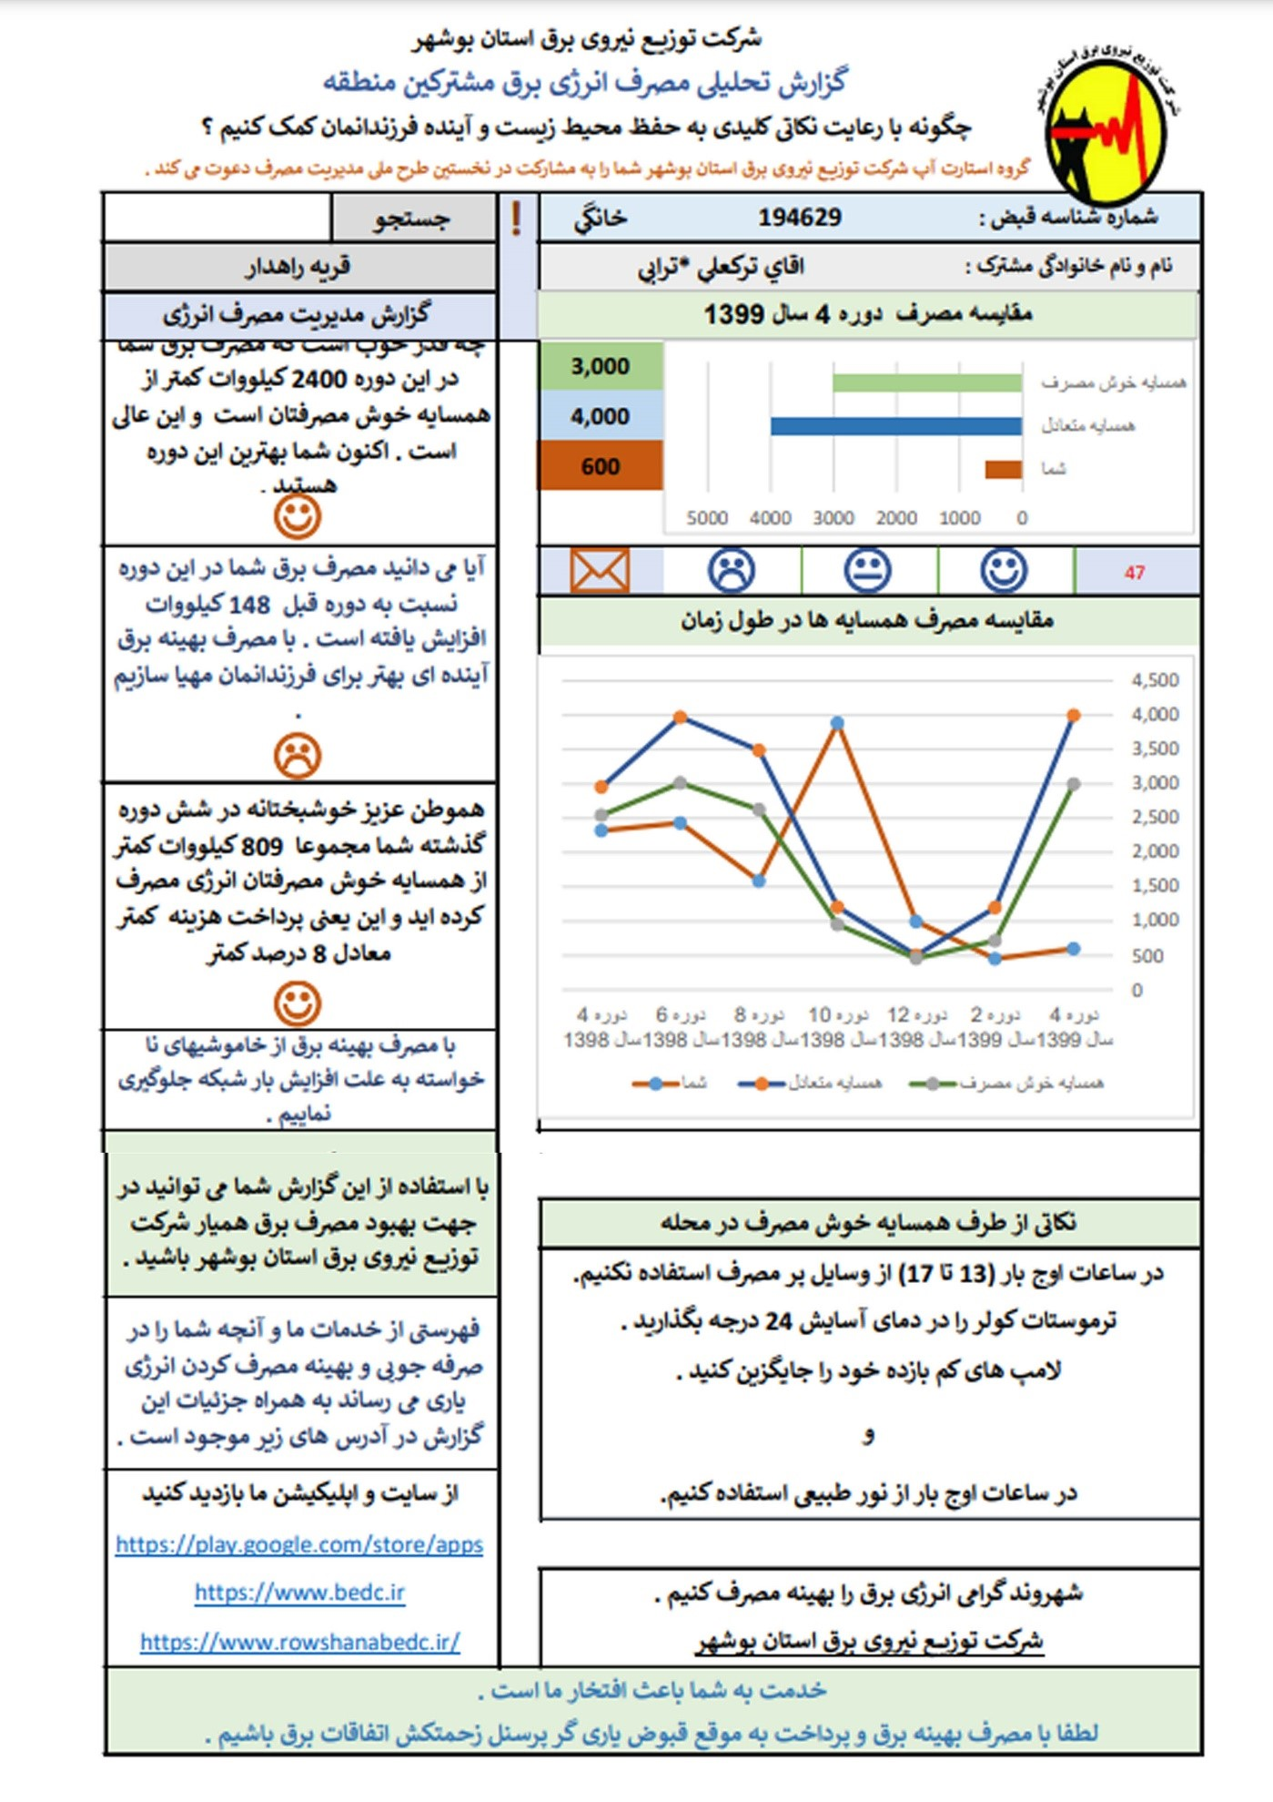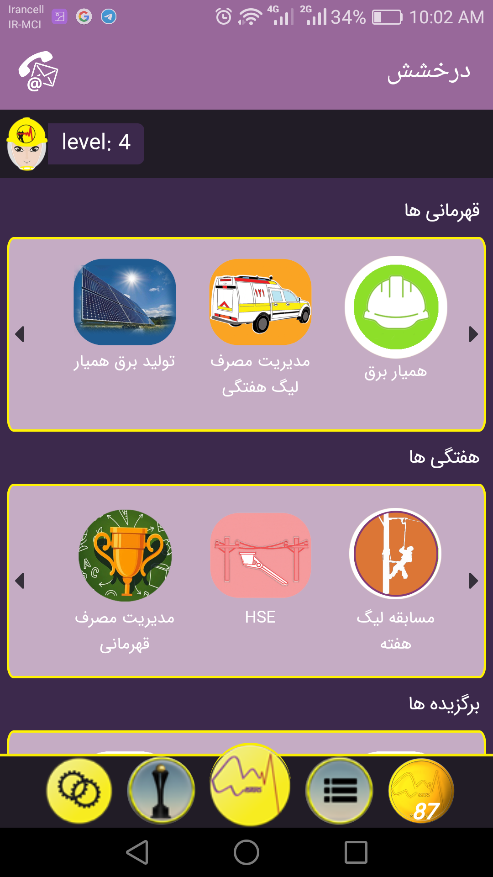

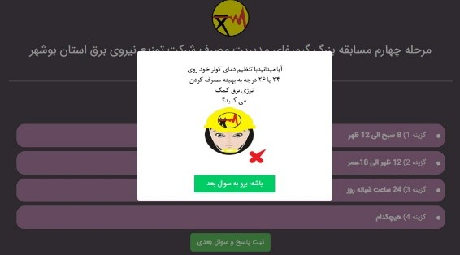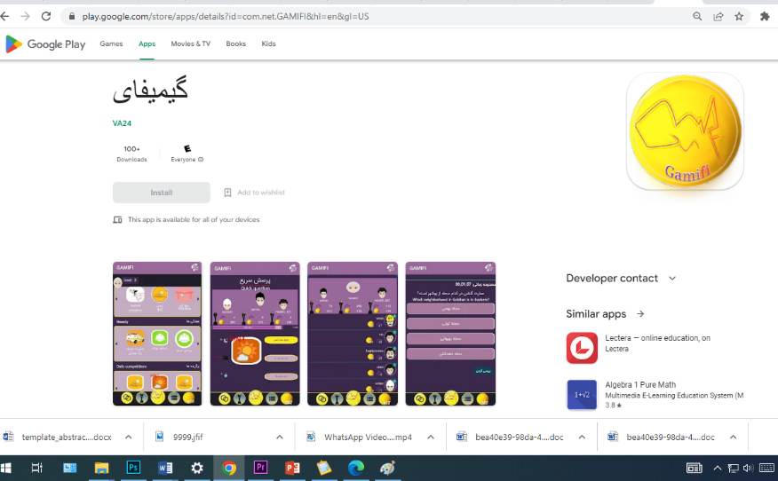

Link application Gamifi: https://play.google.com/store/apps/details?id=com.net.GAMIFI&hl=en&gl=US
Link samppale Gamification: https://www.gamifi.ir/form/000323084918

