Abstract
Based on previous studies indicating antiplatelet activity of chemical structures bearing an Indazole, Indole and Benzimidazole ring, In this study, twelve N-aryl-2-benzoyl benzimidazole compounds including 6 compounds from 2-benzoyl benzimidazole derivatives and 6 compound from N-aryl-2-benzoyl benzimidazole derivatives were prepared and their structure was confirmed by spectroscopic methods like NMR, GC-MS and FT-IR. The antiplatelet activity was evaluated and molecular modeling was performed.

Introduction
Cardiovascular diseases are the leading cause of death in the world. (1)
The role of platelets in hemostasis has been linked to the pathogenesis of atherothrombotic disease. Activation of platelets at the site of an atherosclerotic plaque rupture, results in thrombus formation and then vessel occlusion, that causes Ischemic diseases such as myocardial infarction, stroke, or peripheral artery disease. (2) so antiplatelet therapy has a key role in the treatment and prevention of thrombotic disorders. Various antiplatelet agents with different mechanisms of action are currently available. some commonly used antiplatelet drugs include aspirin, clopidogrel and abciximab. (3) P2Y12 receptor antagonists are widely used for treatment of acute coronary syndromes (ACS) (4) and for patients undergoing percutaneous coronary intervention (PCI) with stenting. (5) P2Y12 receptors are members of the purinergic P2Y family of G-protein-coupled receptors (GPCRs) and are located on the surface of platelets. (6) There is two types of P2Y12 inhibitors: the irreversible thienopyridines like clopidogrel and the more recently approved reversible ATP analogs like ticagrelor. (7) Some researches show that purine analogues, due to structural similarity with ADP which is endogenous ligand of P2Y12 receptor, can potentially inhibit P2Y12 and presents antiplatelet aggregation effects. There is some reports from antiplatelet effects of benzyl indazole and benzyl indole derivatives. In an study by Akhlaghi et al the antiplatelet activity of N-arylmethyl Substituted Indole Derivatives revealed. (8) And also Wu et al. reported antiplatelet activity of ethyl 4-(1-benzyl-1H-indazol-3-yl)benzoate derivatives (9).
Benzimidazole is a purine base analog. Benzimidazole ring is a trendy pharmacophore for development of therapeutic agents and a privilege structure in medicinal chemistry due to its unique chemical properties and a range of biological activities that benzimidazole and its derivatives show. Today benzimidazole which is presented in the structure of vitamin B12 and some drugs in the market, emerged as a pharmacophore of choice to design anti-inflammatory and analgesic agents. (10-12).
Vezzana et al worked on some quinolizidinyl-bezimidazoles with different substitutions of benzimidazole and evaluated their antiplatelet activity using turbidimetric method of human platelets activated by some inducers including ADP. All more active than indole. (13)
In this study, a group of novel benzoyl benzimidazole derivatives with various substitutions owing different lipophilicity and electrophilicity properties was prepared and their antiplatelet activity was evaluated. Comparing the antiplatelet activity of these derivatives provided some insights about the role of substituents on benzimidazole ring in exerting antiplatelet aggregation effects.

Experimental
All the chemicals and solvents were purchased from Merck (Darmstadt, Germany). Melting points were measured by an Electrothermal 9100 apparatus. The Infrared spectra (IR) were obtained on FT-IR Perkin-Elmer UATR Two spectrometer. Agilent GC 7890B and MSD 5977B. Proton nuclear magnetic resonance (1H NMR) spectra were recorded in DMSO solution on a Bruker Avance DRX 500 MHz spectrometer and Varian – INOVA 500 MHz spectrometer. Peak positions are reported in parts per million (δ) downfield from tetramethylsilane as internal standard, and J values are given in hertz. Results was evaluated by MestReNova software.

General procedure for 2-aryloylbenzimidazoles (1a-f) Benzimidazole (100 mmol) was completely dissolved in pyridine
(30 mL) then added triethylamine (28.4 mL). A suitable benzoylchloride
(200 mmol) was gently and slowly dropped to the
reaction media during the solution was stirred in ice bath under
atmosphere with nitrogen gas. Then the mixture was stirred in
room temperature without nitrogen atmosphere during a day.
NaOH solution (7.5 N, 6 g NaOH and 20 mL water) was added to the
mixture and refluxed for an hour. The reaction media was poured
into ice-water and kept in a refrigerator for two days. The residue
was filtered and washed with water. The raw product was recrystallized
from ethanol.

a:(C₂H₅)₃N, pyridine, stirring at room tempreture
b: NaOH, H₂O, reflux
R= H, NO₂ ,Cl ,CH₃ ,OCH₃ ,F

General procedure for 1-(2-aryl-2-oxoethyl)-2-
aryloylbenzimidazoles (2a-f)
A mixture of the suitable 2-aryloylbenzimidazole (5 mmol),
2-bromoacetophenone (5 mmol) and potassium carbonate
(5 mmol) in acetone (50 mL) was stirred at room temperature.
Stirring was continued at room temperature until the disappearance
of the starting material (4e6 h, TLC analyses). The solvent was
evaporated at low temperature. The residue was washed with
water and then ethanol. The raw product was recrystallized from
ethanol.Structural data.

a: K₂CO₃, CH₃COCH₃, stirring at room tempreture
R= H, NO₂ ,Cl ,CH₃ ,OCH₃ ,F

Structural data
1a
1H-Benzimidazol-2-yl(phenyl)methanone
Chemical formula: C₁₄H₁₀N₂O
Molecular weight: 222.24 g/mol
Melting point: 262-263 °C
FT-IR(ATR) (cm⁻¹ ): 3157 (N-H), 1666 (C=O), 1578 (C=N(
MASS: m/z=222 ,105
1H NMR(400 MHz)(DMSO-d₆) δ (ppm) : 10.57 (1H, s,NH), 7.96-8 (4H, m, Ar-H 4,7,2',6'), 7.52-7.66 (5H, m, Ar-H 5,6,3',4',5')
1b
1H-Benzimidazol-2-yl(4-nitrophenyl)methanone
Chemical formula: C₁₄H₉N₃O₃
Molecular weight: 267.24 g/mol
Melting point: 208-210 °C
FT-IR(ATR) (cm⁻¹ ): 3313(N-H), 1650 (C=O), 1595, 1347 (NO₂)
MS: m/z= 267
1H NMR(400 MHz)(DMSO-d₆) δ (ppm) : 10.15 (1H, s,NH), 8.29-8.39 (4H, m, Ar-H 2',3',5',6'), 8.04-8.19 (4H, m, Ar-H 4,5,6,7)
1c
1H-Benzimidazol-2-yl(4-chlorophenyl)methanone
Chemical formula: C₁₄H₉N₂OCl
Molecular weight: 256.69 g/mol
Melting point: 170-172 °C
FT-IR(ATR) (cm⁻¹ ): 3308(N-H), 1660 (C=O), 1593 (C=N)
MS: m/z= 139
1H NMR(400 MHz)(DMSO-d₆) δ (ppm) : 9.89 (1H, s, NH), 7.74-7.96 (4H, m, Ar-H 4,7,2',6'), 7.51-7.61 (4H, m, Ar-H 5,6,3',5')
1d
1H-Benzimidazol-2-yl(4-methylphenyl)methanone
Chemical formula: C₁₅H₉N₂O
Molecular weight: 236.27 g/mol
Melting point: 239-242 °C
FT-IR(ATR) (cm⁻¹ ): 3161(N-H), 1665 (C=O), 1610 (C=N)
MS: m/z= 221, 119
1H NMR(400 MHz)(DMSO-d₆) δ (ppm) : 10.45 (1H, s, NH), 7.87-7.92 (3H, m, Ar-H 4,2',6'), 7.69(1H, m, Ar-H 7), 7.30-7.36 (4H, m, Ar-H 5,6,3',5'), 2.39 (3H, s, C'H₃)
1e
1H-Benzimidazol-2-yl(4-methoxylphenyl)methanone
Chemical formula: C₁₅H₁₂N₂O₂
Molecular weight: 252.27 g/mol
Melting point: 226-228 °C
FT-IR(ATR) (cm⁻¹ ): 3207 (N-H), 1659 (C=O), 1595 (C=N)
MS: m/z= 135, 252
1H NMR(400 MHz)(DMSO-d₆) δ (ppm) : 10.33 (1H, s, NH), 7.92-7.97 (4H, m, Ar-H 4,7,2',6'), 7.05-7.10 (4H, m, Ar-H 5,6,3',5'), 3.85 (3H, s, OCH₃)
1f
1H-Benzimidazol-2-yl(4-fluorohenyl)methanone
Chemical formula: C₁₄H₉N₂OF
Molecular weight: 240.23 g/mol
Melting point: 240-242 °C
FT-IR(ATR) (cm⁻¹ ): 3410 (N-H), 1661 (C=O), 1607 (C=N)
MS: m/z= 123
1H NMR(400 MHz)(DMSO-d₆) δ (ppm) : 10.60 (1H, s, NH), 8.00-8.05 (4H, m, Ar-H 4,7,2',6'), 7.35-7.43 (4H, m, Ar-H 5,6,3',5')
2a
2-(2-Benzoyl-1H-benzimidazol-1-yl)-1-phenylethanone
Chemical formula: C₂₂H₁₆N₂O₂
Molecular weight: 340.37 g/mol
Meliting point: 161-162 °C

FT- IR(ATR) (cm⁻¹ ):, 1697 (C=O position 2), 1674 (C=O position 1), 1646 (C=N)
MS: m/z= 221, 340
1H NMR(400 MHz)(DMSO-d₆) δ (ppm) : 7.93-8.11 (2H, m, Ar-H 2",6"), 7.47-7.91 (7H, m, Ar-H 4, 7,2' ,3' ,4' ,5' ,6'), 7.37-7.45 (5H, m, Ar-H 5, 6, 3", 4", 5"), 3.36 (2H, s, CH₂)
2b
2-[2-(4-nitroBenzoyl)-1H-benzimidazol-1-yl]-1-phenylethanone
Chemical formula: C₂₂H₁₅N₃O₅
olecular weight: 385.37 g/mol
Melting point: 193-195 °C
FT- IR(ATR) (cm⁻¹ ): 1697 (C=O position 2),1632 (C=O position 1), 1584(C=N), 1351, 1573(NO₂)
MS: m/z=119, 266
1H NMR(500 MHz)(DMSO-d₆) δ (ppm) : 8.12-8.28 (2H, m, Ar-H 3' ,5'), 7.65-7.83 (4H, m, Ar-H 4, 7, 2', 6'), 7.50-7.63 (2H, m, Ar-H 2", 6"),7.48-7.63 (3H, m, 3", 4", 5"), 7.19-7.26 (2H, m, 5,6), 3.30 (2H, s, CH₂)
2c
2-[2-(4-chloroBenzoyl)-1H-benzimidazol-1-yl]-1-phenylethanone
Chemical formula: C₂₂H₁₅N₂O₂Cl
Molecular weight: 374.82 g/mol
Melting point: 208-210 °C

FT- IR(ATR) (cm⁻¹ ): 1679 (C=O position 2),1621 (C=O position 1), 1592(C=N)
MS: m/z=111, 139
1H NMR(500 MHz)(DMSO-d₆) δ (ppm) : 7.92-8.05 (4H, m, Ar-H 2", 6", 2', 6' ), 7.54-7.69 (4H, m, Ar-H 4, 7, 3', 5'), 7.45-7.50 (5H, m, Ar-H 3", 4", 5", 5, 6), 3.32 (2H, s, CH₂)
2d
2-[2-(4-methylBenzoyl)-1H-benzimidazol-1-yl]-1-phenylethanone
Chemical formula: C₂₃H₁₈N₂O₂
Molecular weight: 354.40 g/mol
Melting point: 222-224 °C
FT- IR(ATR) (cm⁻¹ ): 1665 (C=O position 2),1615 (C=O position 1), 1610 (C=N)
MS: m/z=119, 249
1H NMR(500 MHz)(DMSO-d₆) δ (ppm) : 7.74-7.86 (2H, m, Ar-H 2", 6"), 7.51-7.73 (4H, m, Ar-H 4, 7, 2', 6'), 7.13-7.31 (7H, m, Ar-H 3", 4", 5", 5, 6, 3', 5'), 3.32 (2H, s, CH₂), 2.35 (3H, s, CH₃)
2e
2-[2-(4-methoxyBenzoyl)-1H-benzimidazol-1-yl]-1-phenylethanone
Chemical formula: C₂₂H₁₈N₂O₃
Molecular weight: 370.40 g/mol
Melting point: 172-173 °C
FT- IR(ATR) (cm⁻¹ ): 1696 (C=O position 2), 1638 (C=O position 1), 1604 (C=N)
MS: m/z=135, 251, 265, 370
1H NMR(500 MHz)(DMSO-d₆) δ (ppm): 8.04,8.05 (2H, d, Ar-H 2", 6"), 7.53-7.80 (7H, m, Ar-H 4, 7, 2', 6', 3", 4", 5"), 6.89-6.95 (4H, m, Ar-H 5, 6, 3', 5'), 3.69-3.80 (5H, m, OCH₃ ,CH₂)
2f
2-[2-(4-nitroBenzoyl)-1H-benzimidazol-1-yl]-1-phenylethanone
Chemical formula: C₂₂H₁₅N₂O₂F
Molecular weight: 358.36 g/mol
Melting point: 191-192 °C
FT- IR(ATR) (cm⁻¹ ): 1693 (C=O position 2), 1672 (C=O position 1), 1602 (C=N)
MS: m/z=123, 253, 358
1H NMR(500 MHz)(DMSO-d₆) δ (ppm): 7.97-8.14 (2H, d, Ar-H 2", 6"), 7.53-7.75 (7H, m, Ar-H 4, 7, 2', 6', 3", 4", 5"), 7.21-7.37 (4H, m, Ar-H 5, 6, 3', 5'), 3.27-3.43 (2H, m, CH₂)
Compound code | Melting point | Appearance | Compound code | Melting point | Appearance
1a | 262-263 | Cotton like matte white crystalline | 2a | 161-163 | Light yellow crystalline
1b | 208-210 | powdery matte yellow crystalline | 2b | 193-195 | white matte crystalline
1c | 170-172 | Needle like white crystalline | 2c | 208-210 | matte light yellow crystalline
1d | 239-242 | Cotton like matte white crystalline | 2d | 222-224 | white matte crystalline
1e | 226-228 | Sparkling white crystalline | 2e | 172-173 | white crystalline
1f | 240-242 | white crystalline | 2f | 191-193 | light yellow crystalline

Molecular Modeling studies
In order to perform Molecular Modeling studies, the structure of P2Y12 protein (4NTJ)in pdb format obtained from (Protein Data Bank) http://www.rcsb.org. the structure of synthetized compounds drown by Hyper Chem and the energy was optimized. The Interaction of P2Y12 receptor and our 12 compounds was evaluated, stable interactions were studied and also their relative potency for inhibition of P2Y12 receptor ws obtained by AutoDock Vina.

Binding affinity (Kcal/mol) | ساختار | Compound code
-8.4 | 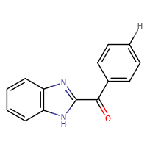 | 1a
-8.6 | 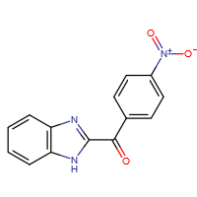 | 1b
-8.5 | 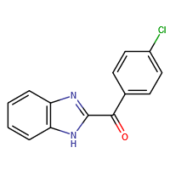 | 1c
-8.8 | 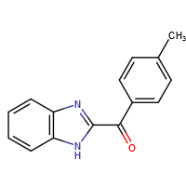 | 1d
-8.4 | 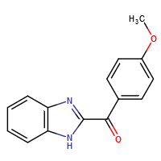 | 1e
-8.8 | 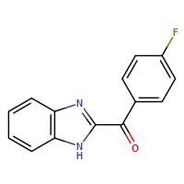 | 1f
-9.6 | 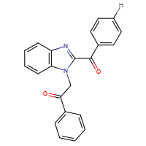 | 2a
-10 | 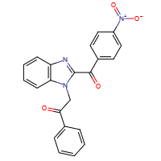 | 2b
-10 | 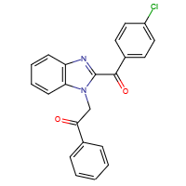 | 2c
-10.2 | 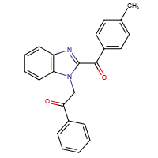 | 2d
-9.6 | 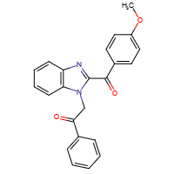 | 2e
-9.9 | 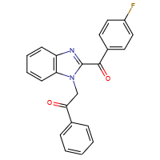 | 2f

Biological activity: In-vitro evaluation of antiplatelet aggregation activity

Discussion
The result of ducking studies indicated that all designed compounds have an appropriate affinity to the receptor. (-8.4,-10.2) and between two synthetized group, N-arylbenzimidazoles own higher affinity to P2Y12 receptor.
Carbonyl of position 2 and Carbonyl of position N of benzimidazole ring make a hydrogen bond with tyrosine 105 and arginine 256 respectively. Benzimidazole ring and its substitutions are surrounded by a hydrophobic pocket and proline 58, phenyl alanine 106, valine 190 and phenyl alanine 252 are involved in bonding of the ligand to this part of receptor.
This interactions indicate that this compounds bond to an appropriate part of the receptor. So hydrogen and hydrophob bondings play pivotal role in bonding of the compounds to the receptor.
1a
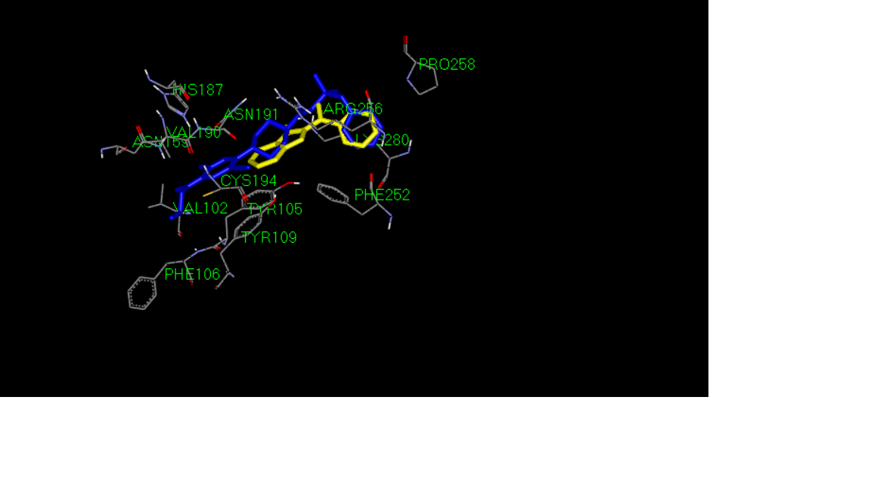
1b

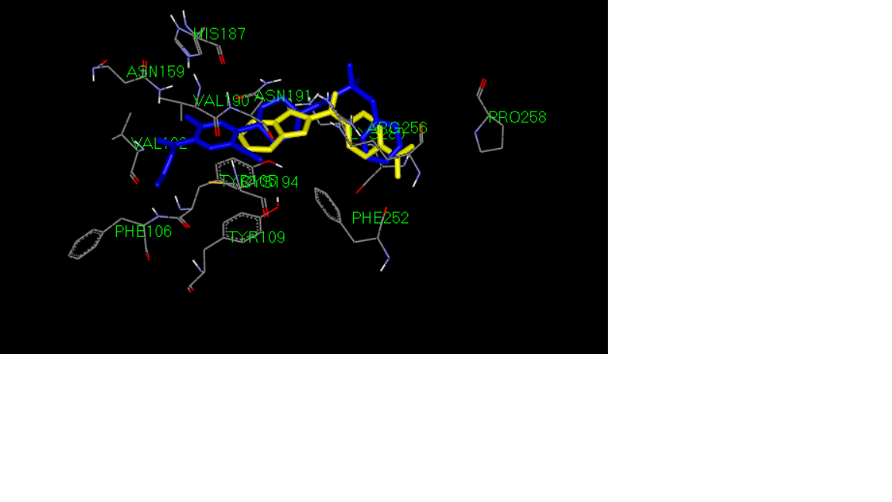
1c
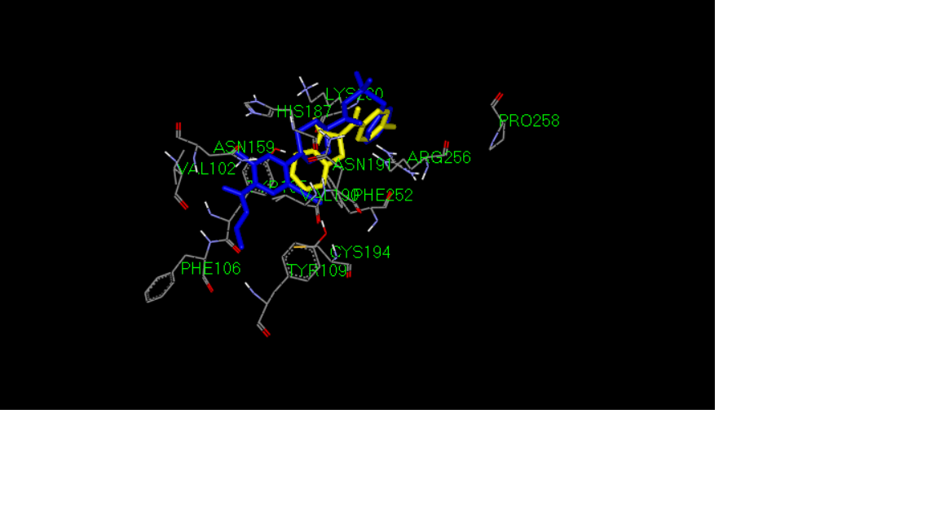
1d
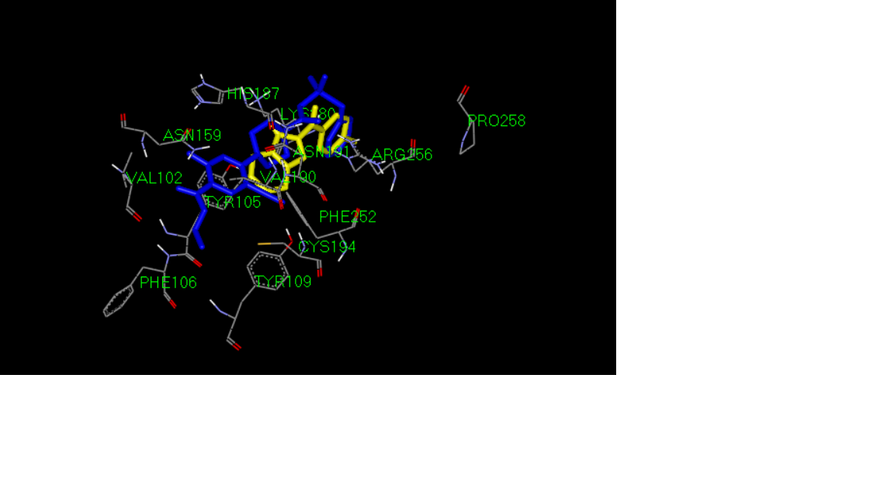
1e
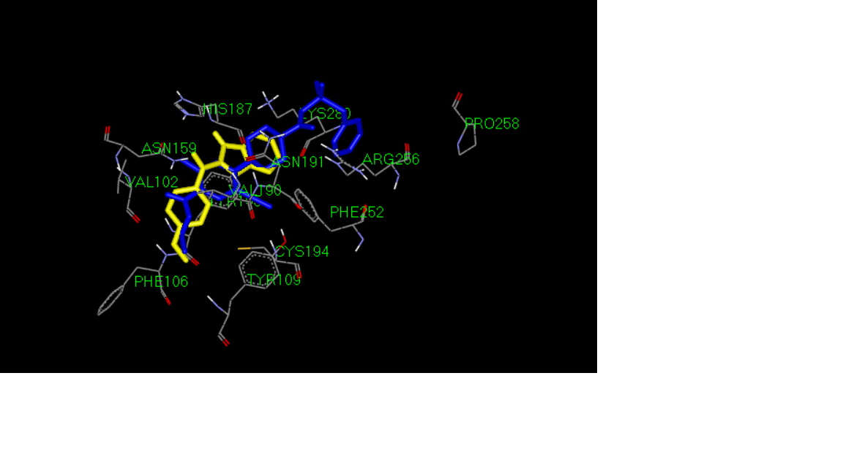
1f
2a
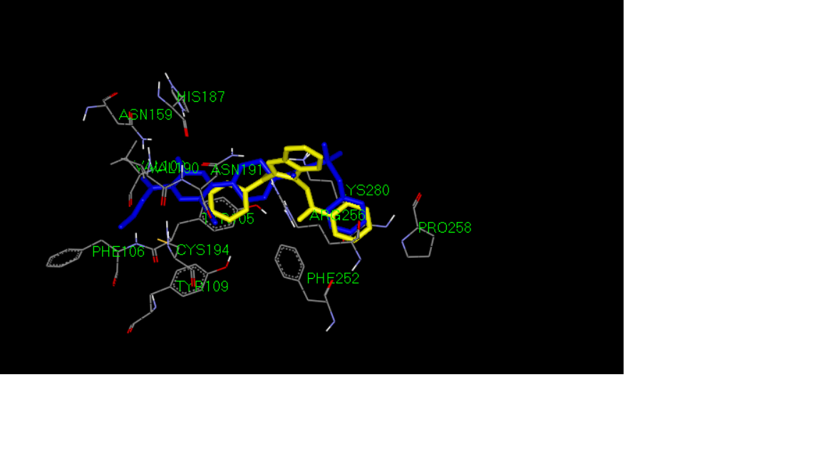
2b
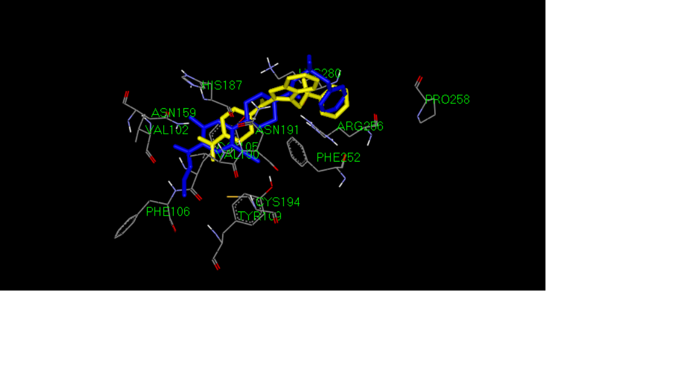
2c

2c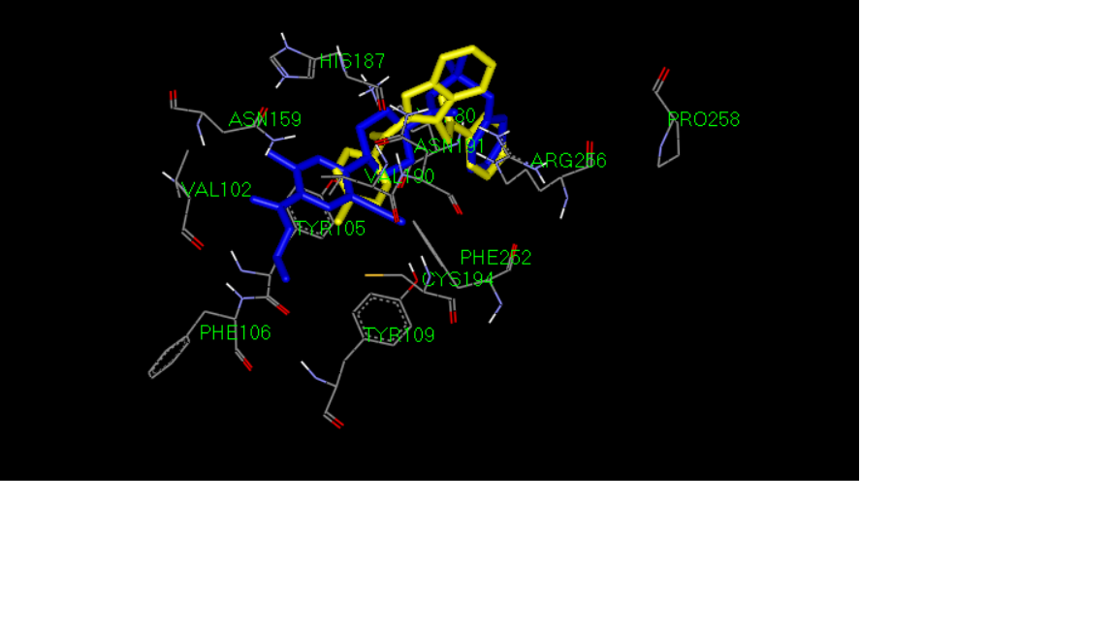
2d
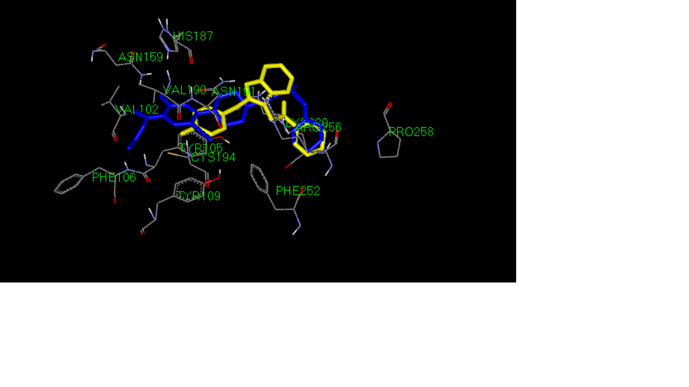
2e
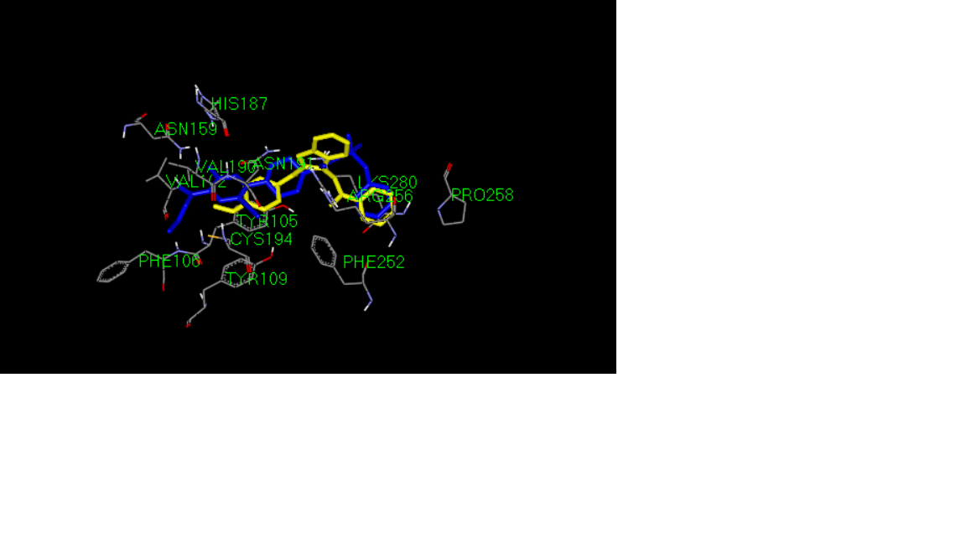
2f

The in-vitro antiplatelet activity of all the synthesized compounds was assayed on human platelet rich plasma (PRP) by using the Born’s reported turbidimetric method (23). ADP and Arachidonic acid (AA) were employed as inducers of platelet aggregation, and indomethacin and aspirin were used as the positive controls. IC50 values were calculated for compound that inhibited platelet aggregation more than 90%. IC50 was defined as the concentration of the test compound that inhibits platelet aggregation by 50%.
The antiplatelet aggregation activity of the derivatives is listed in Table 1. Data show that the majority of the derivatives inhibited AA-induced platelet aggregation more effectively than the aggregation induced by ADP and some compounds showed inhibitory effects comparable to Indomethacin. Among the tested compounds, derivatives 4a, 4c, 4d, 4f-i and 4k showed high IC50 values and 1-(2-nitro benzyl)-3-(phenyl imino)indole-2-one was the most potent compound with IC50 value of 3.4 μM against aggregation induced by AA. Based on the activity data, it could be suggested that the most active compounds were among the most lipophilic structures. The presence of substitution on para position of benzyl ring decreased the antiplatelet activity (compounds 4b, 4e and 4j).This may be due to the hindrance caused by para substituent in ligand-receptor interaction. However the high activity of compound 4 g (IC50 = 14.5 mM) which has a 4-methylbenzyl substituent on position 1, is not consistent with this hypothesis and suggest that other parameters such as lipophilic and electronic properties of the aromatic ring may possibly contribute to the activity of the compounds.

Conclusion
In the present study a series of N-benzyl substituted indole derivatives have been synthesized and their antiplatelet activities were assessed against ADP and AA-induced platelet aggregation in human plasma. The tested derivatives selectively inhibited platelet aggregation induced by AA with very good IC50 values. Among them, compound 4f with IC50 of 3.4 μM proved to be the most potent derivative of the series.

1. Vaduganathan M, Mensah GA, Turco JV, Fuster V, Roth GA. The Global Burden of Cardiovascular Diseases and Risk: A Compass for Future Health. American College of Cardiology Foundation Washington DC; 2022. p. 2361-71.
2. Asada Y, Yamashita A, Sato Y, Hatakeyama K. Pathophysiology of atherothrombosis: Mechanisms of thrombus formation on disrupted atherosclerotic plaques. Pathology International. 2020;70(6):309-22.
3. Mackman N, Bergmeier W, Stouffer GA, Weitz JI. Therapeutic strategies for thrombosis: new targets and approaches. Nature reviews Drug discovery. 2020;19(5):333-52.
4. Franchi F, Angiolillo DJ. Novel antiplatelet agents in acute coronary syndrome. Nature Reviews Cardiology. 2015;12(1):30-47.
5. Members WC, Lawton JS, Tamis-Holland JE, Bangalore S, Bates ER, Beckie TM, et al. 2021 ACC/AHA/SCAI guideline for coronary artery revascularization: a report of the American College of Cardiology/American Heart Association Joint Committee on Clinical Practice Guidelines. Journal of the American College of Cardiology. 2022;79(2):e21-e129.
6. Zhang K, Zhang J, Gao Z-G, Zhang D, Zhu L, Han GW, et al. Structure of the human P2Y12 receptor in complex with an antithrombotic drug. Nature. 2014;509(7498):115-8.
7. Cattaneo M. P2Y12 receptor antagonists: a rapidly expanding group of antiplatelet agents. Oxford University Press; 2006. p. 1010-2.
8. Akhlaghi MF, Amidi S, Esfahanizadeh M, Daeihamed M, Kobarfard F. Synthesis of N-arylmethyl substituted indole derivatives as new antiplatelet aggregation agents. Iranian Journal of Pharmaceutical Research: IJPR. 2014;13(Suppl):35.
9. Chen H-S, Kuo S-C, Teng C-M, Lee F-Y, Wang J-P, Lee Y-C, et al. Synthesis and antiplatelet activity of ethyl 4-(1-benzyl-1H-indazol-3-yl) benzoate (YD-3) derivatives. Bioorganic & medicinal chemistry. 2008;16(3):1262-78.
10. Sivakumar R, Pradeepchandran R, Jayaveera K, Kumarnallasivan P, Vijaianand P, Venkatnarayanan R. Benzimidazole: an attractive pharmacophore in medicinal chemistry. International Journal of Pharmaceutical Research. 2011;3(3):19-31.
11. Anand K, Wakode S. Development of drugs based on Benzimidazole Heterocycle: Recent advancement and insights. IJCS. 2017;5(2):350-62.
12. Gaba M, Singh S, Mohan C. Benzimidazole: an emerging scaffold for analgesic and anti-inflammatory agents. European journal of medicinal chemistry. 2014;76:494-505.
13. Vazzana I, Terranova E, Tasso B, Tonelli M, Piana A, Gastaldi S, et al. Quinolizidinyl‐benzimidazoles as Platelet‐Antiaggregating Agents. Chemistry & biodiversity. 2008;5(5):714-28.

