Identification of New Multitarget Anti-virulence Compounds Against Pseudomonas Aeruginosa

Abstract
Pseudomonas aeruginosa is a multidrug-resistant pathogen whose virulence is controlled by quorum-sensing (QS) regulators, including LasR, QscR, and PqsR. Targeting these receptors with anti-virulence agents offers a sustainable strategy to attenuate pathogenicity without exerting bactericidal pressure. In this study, a pharmacophore-guided virtual screening and docking pipeline was implemented to identify novel QS modulators. More than 550,000 synthetic and natural compounds were screened, yielding three promising candidates, STK649448, STK935680, and STL546559, for detailed docking evaluation. STK649448 exhibited balanced hydrogen bonding and π–π stacking with LasR and QscR, STL546559 showed extensive multi-contact binding with QscR and PqsR, and STK935680 demonstrated complementary polar and aromatic interactions with LasR and QscR. These compounds consistently engaged key residues essential for receptor activation, underscoring their potential as multitarget QS modulators and establishing a foundation for future therapeutic development.
Keywords: Pseudomonas aeruginosa, Quorum-sensing regulators, Pharmacophore-guided virtual screening, Anti-virulence agents
1.Introduction
Pseudomonas aeruginosa is a Gram-negative opportunistic pathogen that poses a major threat to immunocompromised individuals and patients with chronic conditions such as cystic fibrosis, burn wounds, and ventilator-associated pneumonia (1). Its clinical relevance stems from a remarkable ability to develop resistance to multiple classes of antibiotics, making it one of the leading causes of nosocomial infections worldwide. Traditional antimicrobial therapies often fail against P. aeruginosa due to intrinsic resistance mechanisms, biofilm formation, and the acquisition of resistance genes, prompting the urgent need for alternative therapeutic strategies (2).
One promising approach is the development of anti-virulence agents, which aim not to kill bacteria directly but to attenuate their pathogenicity by targeting virulence factors such as quorum-sensing systems, biofilm formation, secretion systems, and toxins (3). Unlike conventional antibiotics, anti-virulence strategies exert less selective pressure for resistance, potentially prolonging therapeutic efficacy (4). Moreover, targeting multiple virulence pathways simultaneously, a multitarget approach, may enhance effectiveness by disrupting redundant or compensatory mechanisms that bacteria use to maintain pathogenicity (5).
Recent studies have highlighted several classes of molecules, including repurposed drugs, natural products, and synthetic compounds, that interfere with P. aeruginosa virulence networks (6-9). For example, fluoxetine has been repositioned as an anti-virulence agent capable of inhibiting quorum sensing and biofilm formation at sub-inhibitory concentrations. Similarly, novel small molecules and peptides are being investigated for their ability to block type III secretion systems or impair biofilm matrix integrity (7, 10). These findings support the concept that multitarget anti-virulence agents could provide a robust therapeutic strategy against multidrug-resistant P. aeruginosa.
Therefore, the discovery and characterization of novel compounds that simultaneously modulate multiple virulence determinants represent a critical frontier in infectious disease research. Such agents may not only reduce bacterial pathogenicity but also synergize with existing antibiotics, offering a dual benefit in managing resistant infections.
In this study, using pharmacophore modeling and virtual screening, three key proteins (LasR, PqsR, and QscR) in the Quorum Sensing (QS) pathway are simultaneously targeted (Figure 1). It is anticipated that multitarget anti-virulence compounds will be identified that can effectively inactivate bacteria and render them non-pathogenic by inhibiting the QS system. At the same time, it does not affect bacterial growth, thereby substantially reducing or eliminating the likelihood of resistance development against them.
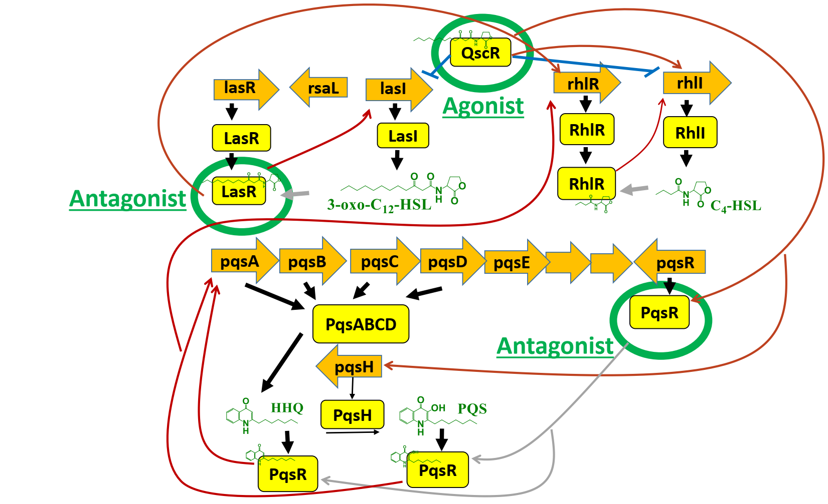
Figure 1. Quorum Sensing (QS) pathway in P. aeruginosa showing key targets QscR, PqsR, and LasR
2. Methods
2.1 Structure-Based Pharmacophore Modeling and Complex Visualization
To characterize receptor–ligand interactions and derive pharmacophore models, three representative complexes were selected: QscR–OHN (agonist), PqsR–M64 (antagonist), and LasR–OOHL (antagonist). Ligand structures were retrieved and optimized using energy minimization protocols before docking into their respective receptor binding sites. Protein–ligand complexes were generated through molecular docking using validated receptor structures, followed by visual inspection of binding poses to ensure consistency with known interaction profiles.
Pharmacophore models were constructed using structure-based algorithms that identify key interaction features, hydrogen bond acceptors (A), donors (D), and hydrophobic regions (H) based on spatial proximity and chemical functionality. Geometric constraints were applied to define inter-feature distances and spatial orientation, enabling accurate mapping of pharmacophore features within the binding pocket. Each complex was visualized in three panels: (i) 2D chemical structure of the ligand, (ii) 3D receptor–ligand binding representation using ribbon and surface diagrams, and (iii) pharmacophore model with geometric constraints, including labeled inter-feature distances. These visualizations facilitated comparative analysis of binding modes and pharmacophore architecture across the three targets.
2.2 Methodology for Assessing Pharmacophore Classification Performance
Pharmacophore models for QscR, PqsR, and LasR were retrospectively validated using curated datasets of known active and inactive compounds. Each dataset was compiled from published literature and experimental reports to ensure representative coverage of ligand diversity for each receptor. Using Discovery Studio, compounds were mapped against the defined pharmacophore features, and classification outcomes were recorded as true positives, false negatives, true negatives, and false positives.
Performance metrics were calculated to assess predictive reliability. Sensitivity was defined as the proportion of correctly identified actives, while specificity measured the proportion of correctly rejected inactives. The selectivity index was derived from the ratio of true positives to false positives, providing an estimate of discriminative strength. Receiver Operating Characteristic (ROC) values were generated within Discovery Studio to evaluate overall model accuracy and the separation between active and inactive classes.
2.3 Pharmacophore Modeling and Validation
Pharmacophore models were generated for QscR, PqsR, and LasR based on crystallographic receptor ligand complexes. Each model captured hydrogen bond donors, acceptors, hydrophobic regions, and aromatic features, with geometric constraints derived from experimentally observed binding interactions. Retrospective validation was performed against known active and inactive compounds to assess sensitivity, specificity, and ROC values, ensuring the models were suitable for guiding virtual screening.
2.4 Virtual Screening Workflow
A compound library of 555,802 synthetic and natural molecules was curated from Ibscreen databases. Ligands were energy minimized and aligned to pharmacophore features before screening. Flexible and rigid docking workflows were applied in parallel: flexible docking used stringent fit thresholds to prioritize selectivity, while rigid docking employed broader thresholds to explore chemical diversity. Candidate hits were progressively filtered across QscR, PqsR, and LasR pharmacophores, and top-ranking compounds were selected for docking refinement.
2.5 Molecular Docking and Interaction Profiling
Protein structures of quorum-sensing receptors were obtained from the UCSB Protein Data Bank, specifically LasR Apo (PDB ID: 3IX3), QscR- N-3-oxo-dodecanoyl-L-homoserine lactone (OHN) complex (PDB ID: 3SZT), and PqsR-2-[(5-nitro-1H-benzimidazol-2-yl)sulfanyl]-N-(4-phenoxyphenyl)acetamide (M64) complex (PDB ID: 6b8a). Due to the absence of a crystal structure of the LasR protein bound to an antagonist, the potent antagonist N-(3-oxo)-octanoyl L-homoserine lactone (OOHL) was selected and docked into the LasR receptor, and the LasR-OOHL complex was built. This was followed by a 250 ns MD simulation with NAMD2 and the CHARMM27 force field (11, 12), and the final frame after 250 ns was used for pharmacophore building (Figure S2).
Molecular docking was performed using the LibDock module in BIOVIA Discovery Studio 4.5 with default parameters. Both rigid receptor docking (using the standard LibDock protocol) and flexible docking (incorporating receptor side-chain flexibility via the Flexible Docking protocol) were performed to account for conformational variations in the binding site. The protein receptor was prepared by removing non-essential water molecules, adding hydrogens, and optimizing protonation states at physiological pH. The binding site was defined based on the co-crystallized ligand or cavity detection. Ligands were prepared by generating multiple conformations, followed by energy minimization with the Smart Minimizer algorithm under the CHARMm force field. Docked poses were ranked by LibDock scores (Libscores), and the top-ranked poses from both rigid and flexible modes were analyzed for binding interactions. Docking validation was performed by redocking x-ray ligands in QscR-OHN and PqsR-M64, and the RMSD values were 1.02 and 0.685 Å, respectively (Figure S1). Libscores were shown in Table S1
3. Results
3.1 Structure-Based Pharmacophore Profiles of Quorum-Sensing Receptors
To establish the structural framework for pharmacophore modeling, we compared three quorum-sensing receptor–ligand complexes: QscR–OHN (agonist), PqsR–M64 (antagonist), and LasR–OOHL (antagonist). Each model captured the essential spatial and chemical features required for receptor engagement, with geometric constraints derived from experimentally observed binding interactions.
The QscR–OHN model comprised six pharmacophore features (AADDHHH), reflecting a diverse interaction profile that includes hydrogen bond donors, acceptors, and hydrophobic regions. Notably, the extended conformation of OHN within the binding site was supported by long-range interfeature distances such as 12.809 Å and 8.916 Å, indicating a broad interaction footprint. In contrast, the PqsR–M64 model presented a more compact pharmacophore (ADHH), shaped by the ligand’s rigid aromatic scaffold and polar substituents. Distances such as 4.166 Å and 8.569 Å defined a tightly clustered arrangement of donor, acceptor, and hydrophobic features, consistent with its antagonist role. The LasR–OOHL model also exhibited a four-feature pharmacophore (ADHH), but with a distinct spatial layout influenced by its lactone ring and aliphatic tail. Interfeature distances like 6.602 Å and 9.044 Å captured the ligand’s curved binding pose within the LasR pocket (Figure 2).
Together, these models provide receptor-specific pharmacophore templates that highlight the importance of tailored architectures for achieving target selectivity. The geometric diversity across QscR, PqsR, and LasR sets the foundation for subsequent validation and screening.
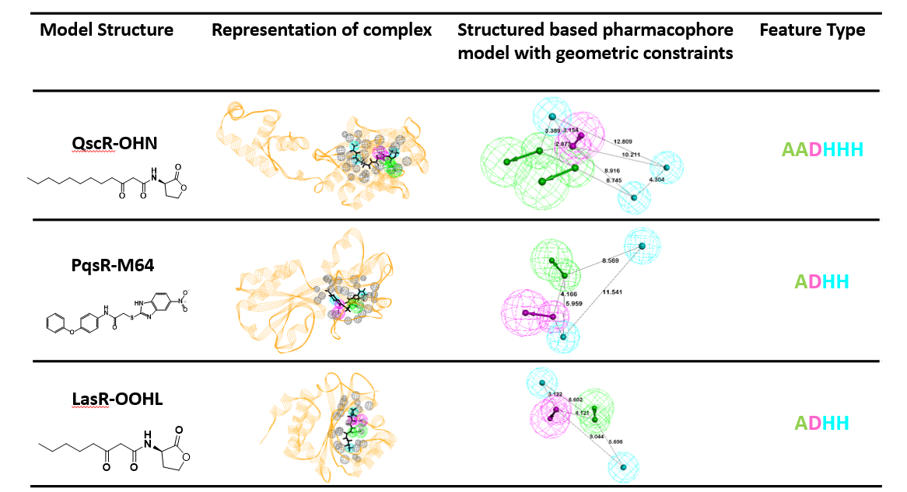
Figure 2. Structural comparison of three receptor–ligand complexes: QscR–OHN (agonist), PqsR–M64 (antagonist), and LasR–OOHL (antagonist). Each panel includes the 2D chemical structure of the ligand, its 3D binding representation within the receptor, and the corresponding structure-based pharmacophore model with geometric constraints. Pharmacophore features are annotated as A (acceptor), D (donor), and H (hydrophobic), with feature strings AADDHHH (QscR), ADHH (PqsR), and ADHH (LasR), highlighting differences in interaction profiles and spatial arrangements.
3.2 Performance Evaluation of Pharmacophore Models
Building on the structural profiles, the pharmacophore models were retrospectively validated against known active and inactive compounds, revealing distinct performance outcomes across the three targets. Validation metrics included sensitivity, specificity, selectivity, and ROC curve analysis, as summarized in Table 1.
The QscR agonist model exhibited flawless classification, correctly identifying all 9 actives and rejecting all 46 inactives. This resulted in perfect sensitivity and specificity (both 1.000), a selectivity index of 10.553, and an ROC value of 1.00, reflecting an ideal separation between active and inactive compounds. These results confirm that pharmacophore richness and spatial diversity, as seen in QscR, correlate with superior predictive accuracy. In contrast, the PqsR antagonist model showed high sensitivity (0.928), correctly identifying 13 of 14 actives, but suffered from reduced specificity (0.623) due to 26 false positives among 69 inactives. Despite this limitation, the model maintained a selectivity index of 7.555 and an ROC value of 0.74, suggesting moderate discriminative power with a tendency to overpredict activity. The LasR antagonist model demonstrated robust, balanced performance, achieving a sensitivity of 0.941 and a specificity of 0.880. It correctly classified 16 of 17 actives and 44 of 50 inactives, yielding a selectivity index of 7.280 and an ROC value of 0.92. These metrics reflect strong predictive reliability and balanced discriminative capacity. The structures for active ligands for LasR, QscR, and PqsR are shown in Table S2.
Figure 3 illustrates the ROC curves for the three models: QscR achieved perfect classification (ROC = 1.00), LasR demonstrated strong reliability (ROC = 0.92, Figure S3), and PqsR showed moderate performance (ROC = 0.74). Collectively, these results highlight the QscR model as the most accurate and selective, while the LasR model offers a strong balance between sensitivity and specificity. The PqsR model, although effective at identifying actives, may benefit from further refinement to reduce false-positive rates and improve overall specificity.
Table 1: Validation results of pharmacophore models for QscR, PqsR, and LasR. Metrics include classification outcomes (true/false positives and negatives) and performance indicators (sensitivity, specificity, and selectivity), highlighting the superior accuracy of QscR, the balanced reliability of LasR, and the reduced specificity of PqsR.
Pharmacophore Model | Total Actives | True Positives | False Negatives | Total Inactives | True Negatives | False Positives | Sensitivity | Specificity | Selectivity
QscR agonist | 9 | 9 | 0 | 46 | 46 | 0 | 1.000 | 1.000 | 10.553
PqsR antagonist | 14 | 13 | 1 | 69 | 43 | 26 | 0.928 | 0.623 | 7.555
LasR antagonist | 17 | 16 | 1 | 50 | 44 | 6 | 0.941 | 0.880 | 7.280

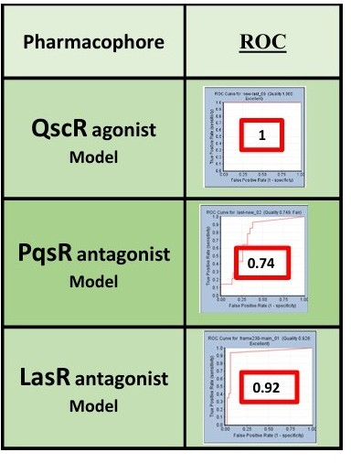
Figure 3. Receiver Operating Characteristic (ROC) curves illustrating the discriminative performance of the three pharmacophore models. The QscR agonist model achieved perfect classification (ROC = 1.00), reflecting ideal separation of actives and inactives. The LasR antagonist model demonstrated strong predictive reliability (ROC = 0.92), while the PqsR antagonist model showed moderate performance (ROC = 0.74) with reduced specificity.
3.3 Pharmacophore Validation Through Molecular Interaction Analysis
To further validate the pharmacophore models, molecular docking and interaction profiling were performed for representative compounds targeting QscR, PqsR, and LasR receptors. Each model revealed distinct binding patterns and key residue interactions consistent with their predicted activity profiles (Figure 4).
The QscR agonist model showed extensive engagement with the receptor’s ligand-binding domain. The compound formed interactions with multiple residues, including TYR58, SER38, TRP62, MET127, and TRP90, suggesting a stable and well-oriented binding pose. Additional contacts with ILE71, VAL78, ASP75, and LEU82 reinforced the compound’s agonistic potential, while hydrophobic interactions with ILE125, TYR62, and PHE54 contributed to binding affinity and specificity.
In the PqsR antagonist model, the compound occupied the receptor's hydrophobic pocket, forming key interactions with LEU203, GLN194, ILE207, and ILE149. Contacts with ILE236, VAL170, and ALA168 supported antagonist binding, while proximity to PRO238, LEU189, and ILE183 indicated steric hindrance that may disrupt native ligand activation. The presence of TYR258 at the periphery of the binding site suggests that π-stacking or polar interactions may contribute to receptor blockade.
The LasR antagonist model showed a well-defined binding pose, with the compound interacting with residues such as Leu40, Ala50, Tyr47, and Val76. Hydrogen bonding and polar contacts were observed with THR75, ASP73, and TYR64, alongside hydrophobic interactions with TRP88, LEU110, and ALA105. The compound also engaged PHE101, ALA127, and GLY126, indicating a broad interface that may effectively inhibit receptor activation.
Collectively, these structural insights support the pharmacophore models’ predictive validity, with each compound exhibiting binding features consistent with its functional role. The observed residue interactions align with the models’ classification performance, reinforcing their utility in virtual screening and rational design of quorum-sensing modulators.
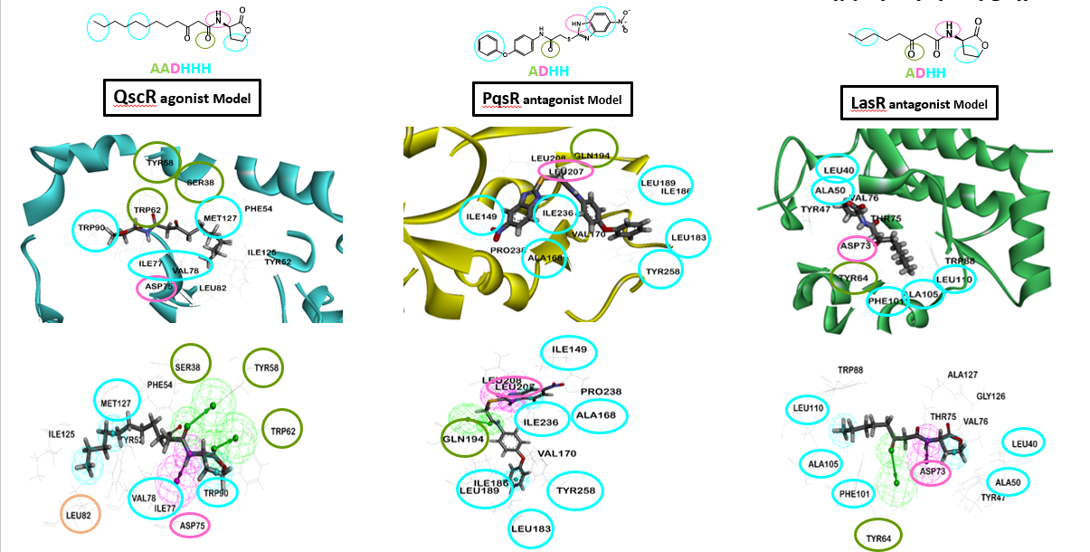
Figure 4. Binding interactions of representative compounds with quorum-sensing receptors. The QscR agonist, PqsR antagonist, and LasR antagonist models show key residue contacts consistent with their predicted activity.

3.4 Computational Filtering and Docking for Lead Compound Prioritization
Following validation of the pharmacophore models and their interaction profiles, a structure-based virtual screening (VS) and docking pipeline was implemented to identify potential quorum-sensing modulators targeting the QscR, PqsR, and LasR receptors. The initial compound library comprised 555,802 synthetic and natural molecules, which were filtered and evaluated through two parallel workflows: flexible and rigid docking, based on pharmacophore fit values and receptor-specific mapping. In the flexible docking pathway, 518,323 compounds were initially screened against the QscR pharmacophore, resulting in 62,534 hits. Applying a stringent fit-value threshold (>80%) narrowed the pool to 77 candidates, which were subsequently mapped to the PqsR and LasR pharmacophores, yielding 24 and 12 hits, respectively. Final docking refinement led to the selection of three top-ranking compounds: STOCK1N-74561, STOCK1N-44693, and STOCK6S-78803 (Codes for these compounds can be found in the IBScreen database (https://mastersearch.chemexper.com/misc/hosted/ibscreen/)). In the rigid docking pathway, the same initial library was screened against QscR, producing 62,534 hits. A broader fit-value threshold (>60%) identified 1,777 candidates, which were then filtered using PqsR and LasR pharmacophores, yielding 85 and 9 hits, respectively. Rigid docking refinement produced three final hits: STOCK7S-08617, STOCK15-30955, and STOCK7S-02668 (Figure 5, Table S3). Flexible docking produced three ligands: STOCK6S-78803 (STK649448, CID: 39335391), STOCK1N-74561 (STK935680, CID: 51043572), and STOCK1N-44693 (Table S4). The compounds originated from both flexible and rigid docking workflows, as illustrated in the figure, and were prioritized based on their performance across QscR, PqsR, and LasR targets. Their ability to interact with multiple QS receptors supports a multitarget inhibition strategy, which is more effective in attenuating virulence and biofilm formation than single-receptor approaches. This focused selection enabled a deeper mechanistic investigation of ligand–receptor interactions and provided a rational basis for advancing these compounds toward experimental validation.
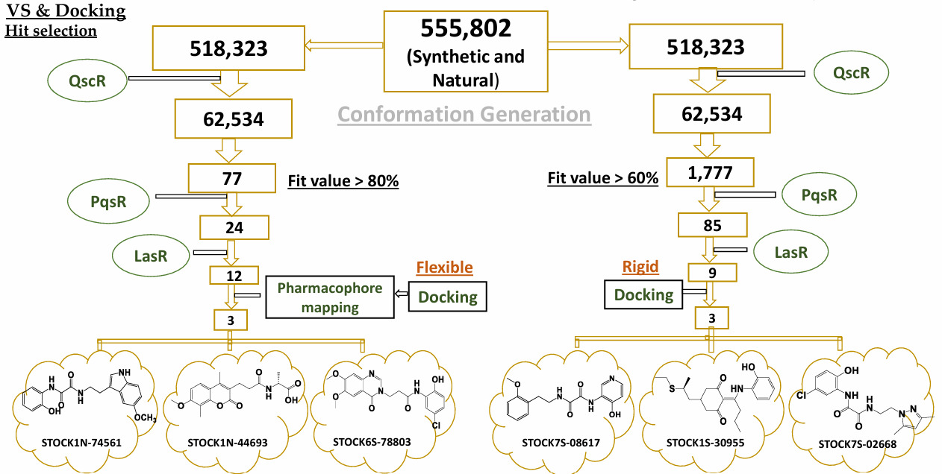
STL520011 STL546559 STK649448 STK935680 STK833517 STK934876
Figure 5. Stepwise workflow of virtual screening and docking applied to a compound library of 555,802 molecules. Two parallel strategies were employed: flexible docking (left) and rigid docking (right). Successive pharmacophore mappings against the QscR, PqsR, and LasR receptors, combined with fit-value thresholds, progressively reduced the candidate pool. Final refinement identified six promising hits, three from each pathway, highlighting the efficiency of dual‑approach screening in prioritizing quorum-sensing modulators. Upper and Lower codes are catalog numbers on screen.com and vitasmlab.biz, respectively.
3.5 Comprehensive Interaction Mapping of LasR
To assess the inhibitory potential of selected compounds against LasR, molecular docking simulations were conducted for three prioritized ligands: STK649448 [STOCK6S-78803], STK935680[ STOCK7S-08617], and STL546559 [STOCK1N-44693].
STK649448 demonstrated a robust interaction profile, forming multiple hydrogen bonds with ARG61 and THR75, and engaging in hydrophobic contacts with VAL76, CYS79, and LEU125. Additionally, it exhibited π–π stacking with TYR64 and π–alkyl interactions with LEU40 and ALA50, contributing to its binding stability and specificity.
STK935680 displayed a comparable interaction pattern, including conventional and carbon-hydrogen bonds with TYR56, TRP60, and ASP73, as well as aromatic stacking with TRP88 and PHE101. These interactions suggest a well-oriented binding pose capable of disrupting LasR activity.
STL546559 engaged in hydrogen bonding with TYR56 and LEU125, and showed extensive hydrophobic and π–alkyl interactions involving LEU36, ILE52, VAL76, and ALA127. This broad contact interface supports its potential as a stable and effective LasR antagonist.
The detailed interaction profiles for each compound are summarized in Table 2, and visualized in Figure 6, which presents both the 3D binding poses of the ligand–LasR complexes. These findings reinforce the structural basis for LasR inhibition and support the continued evaluation of these compounds as quorum-sensing modulators.
Table 2: Summary of molecular interactions between LasR and three ligands STK649448, STK935680, and STL546559 based on docking simulations. The table includes binding energies, interaction types, number of bonds, and the specific amino acid residues involved in each interaction.
Target | Drug | Type of Interaction | Number of Bonds | Amino Acids Involved in the Interaction
LasR | STK649448 | Conventional Hydrogen Bond | 3 | ARG61 (2), THR75
LasR | STK649448 | Pi-Anion | 1 | ASP73
LasR | STK649448 | Pi-Donor Hydrogen Bond | 1 | TYR56
LasR | STK649448 | Pi-Sigma | 1 | TRP88
LasR | STK649448 | Pi-Pi Stacked | 1 | TYR64
LasR | STK649448 | Pi-Pi T-shaped | 1 | TYR47
LasR | STK649448 | Alkyl | 3 | VAL76, CYS79, LEU125
LasR | STK649448 | Pi-Alkyl | 5 | TYR47, LEU40, ALA50, VAL76, LEU125
LasR | STK935680 | Attractive Charge | 1 | ASP73
LasR | STK935680 | Conventional Hydrogen Bond | 3 | TYR56, TRP60, ASP73
LasR | STK935680 | Carbon Hydrogen Bond | 1 | ASP73
LasR | STK935680 | Pi-Pi Stacked | 2 | TRP88
LasR | STK935680 | Pi-Pi T-shaped | 1 | PHE101
LasR | STK935680 | Amide-Pi Stacked | 1 | GLY38
LasR | STK935680 | Pi-Alkyl | 5 | ALA105, LEU110, ALA50, VAL76, ALA127
LasR | STL546559 | Conventional Hydrogen Bond | 1 | TYR56
LasR | STL546559 | Carbon Hydrogen Bond | 1 | LEU125
LasR | STL546559 | Pi-Anion | 1 | ASP73
LasR | STL546559 | Pi-Sigma | 3 | LEU36, TYR64, TRP88
LasR | STL546559 | Pi-Pi Stacked | 1 | TYR64
LasR | STL546559 | Alkyl | 5 | ALA127, LEU36, ILE52, VAL76, CYS79
LasR | STL546559 | Pi-Alkyl | 5 | VAL76, ALA127, ALA50

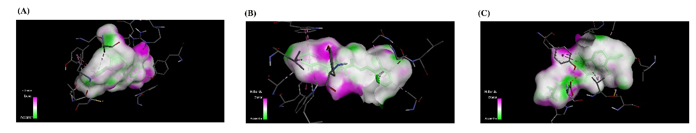
Figure 6. Molecular docking visualizations of LasR complexes with three selected ligands. (A): STK649448 bound within the LasR active site, stabilized by hydrogen bonds and hydrophobic contacts. (B): STK935680 forming charge-based and aromatic interactions, notably with ASP73 and TRP88. (C): STL546559 occupying a hydrophobic cavity, supported by extensive alkyl and π–alkyl interactions contributing to binding stability.
3.6 Molecular Docking Analysis of QscR–Ligand Complexes
To evaluate the binding potential of selected compounds against the QscR receptor, molecular docking simulations were performed for STK649448 (CID: 39335391), STK935680 (CID: 51043572), and STL546559 (CID: 124385561). All three ligands demonstrated favorable Libscores, indicating strong receptor engagement and potential for quorum-sensing modulation.
STK649448 formed a diverse array of non-covalent interactions. These included two conventional hydrogen bonds with SER38 and LYS63, a π-anion interaction with ASP75, and three π-donor hydrogen bonds involving SER38 and TYR66. Aromatic stabilization was supported by π–π stacking with TYR66 and a T-shaped π–π contact with PHE54. Hydrophobic contributions included an alkyl interaction with ILE77 and three π–alkyl contacts with TRP90 and LYS63.
STK935680 showed a rich interaction profile. It engaged ASP75 through both attractive charge and π-anion interactions and formed a carbon-hydrogen bond with ILE125. Aromatic contacts included π–π stacking with TYR66 and TRP90, a T-shaped π–π interaction with TYR52, and an amide–π stacking interaction with SER126. Hydrophobic stabilization was achieved via four π–alkyl interactions involving VAL78, MET127, ALA105, and ILE110.
STL546559 formed two conventional hydrogen bonds with GLY40 and ILE125, and two π-anion interactions with ASP75. Additional stabilization was provided by three π-donor hydrogen bonds and a π-sigma contact, all involving SER38 and TYR66. Aromatic stacking included π–π interactions with TYR66 and a T-shaped π–π contact with TYR58. Hydrophobic contacts included an alkyl interaction with ILE77 and three π–alkyl interactions with PHE54 and TRP90.
The interaction profiles of the QscR–ligand complexes are summarized in Table 3 and illustrated in Figure 7, which depicts the 3D binding conformations. These results confirm the structural compatibility of all three compounds with QscR and highlight their potential as quorum-sensing modulators. Notably, STL546559 and STK935680 exhibited the most diverse and robust interaction networks, reinforcing their candidacy as promising lead compounds for further development.
Table 3: Overview of docking-derived molecular interactions between QscR and the ligands STK649448, STK935680, and STL546559. The table reports binding energies, interaction categories, bond counts, and the amino acid residues participating in each contact.
Target | Drug | Type of Interaction | Number of Bonds | Amino Acids Involved in the Interaction
QscR | STK649448 | Conventional Hydrogen Bond | 2 | SER38, LYS63
QscR | STK649448 | Pi-Anion | 1 | ASP75
QscR | STK649448 | Pi-Donor Hydrogen Bond | 3 | SER38, TYR66 (2)
QscR | STK649448 | Pi-Pi Stacked | 1 | TYR66
QscR | STK649448 | Pi-Pi T-shaped | 1 | PHE54
QscR | STK649448 | Alkyl | 1 | ILE77
QscR | STK649448 | Pi-Alkyl | 3 | TRP90 (2), LYS63
QscR | STK935680 | Attractive Charge | 1 | ASP75
QscR | STK935680 | Carbon Hydrogen Bond | 1 | ILE125
QscR | STK935680 | Pi-Anion | 1 | ASP75
QscR | STK935680 | Pi-Pi Stacked | 2 | TYR66, TRP90
QscR | STK935680 | Pi-Pi T-shaped | 1 | TYR52
QscR | STK935680 | Amide-Pi Stacked | 1 | SER126
QscR | STK935680 | Pi-Alkyl | 4 | VAL78, MET127, ALA105, ILE110
QscR | STL546559 | Conventional Hydrogen Bond | 2 | GLY40, ILE125
QscR | STL546559 | Pi-Anion | 2 | ASP75 (2)
QscR | STL546559 | Pi-Donor Hydrogen Bond | 3 | SER38, TYR66 (2)
QscR | STL546559 | Pi-Sigma | 1 | TYR66
QscR | STL546559 | Pi-Pi Stacked | 1 | TYR66
 |  | Pi-Pi T-shaped | 1 | TYR58
 |  | Alkyl | 1 | ILE77
 |  | Pi-Alkyl | 3 | PHE54, TRP90 (2)

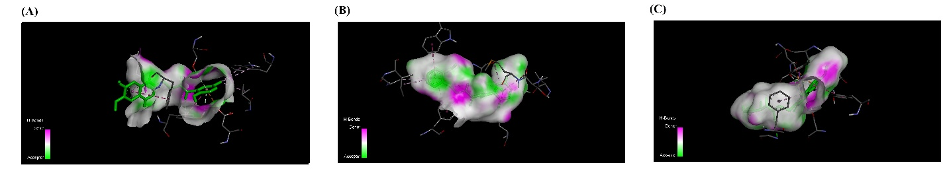
Figure 7. Molecular docking visualizations of QscR complexes with three candidate ligands. (A): STK649448 bound within the QscR active site, stabilized by hydrogen bonds, π–π stacking, and hydrophobic contacts. (B): STK935680 forming electrostatic and aromatic interactions, including π–π stacking and π–alkyl contacts across a broad residue interface. (C): STL546559 exhibiting a diverse interaction network with QscR, including multiple hydrogen bonds, π-anion contacts, and aromatic stacking, highlighting its strong binding potential.
3.7 Molecular Docking Analysis of PqsR–Ligand Complexes
To investigate the binding potential of selected compounds against the PqsR receptor, molecular docking simulations were performed for STK649448 (CID: 39335391), STK935680 (CID: 51043572), and STL546559 (CID: 124385561).
STK649448 showed a diverse array of interactions. These included two conventional hydrogen bonds with TYR258 and an intramolecular contact (UNK1), a carbon-hydrogen bond with LEU208, and a π–sigma interaction with ILE236. Aromatic stabilization was provided by a T-shaped π–π contact with TYR258, while hydrophobic contributions included alkyl interactions with ILE186 and LEU189, and three π–alkyl contacts involving TYR258, ALA168, and VAL211.
STK935680 formed two conventional hydrogen bonds with TYR258 and UNK1, a carbon-hydrogen bond with LEU207, and two π–sigma interactions with VAL211 and ILE236. Aromatic stacking was observed through a T-shaped π–π contact with TYR258, while hydrophobic stabilization was supported by π–alkyl interactions with ILE149 and ALA168.
STL546559 formed three conventional hydrogen bonds with LEU197, LEU208, and UNK1, and a carbon-hydrogen bond with LEU208. Additional interactions included a π–sigma contact with ILE236, alkyl interactions with ALA168, ILE236, and ILE263, and π–alkyl contacts with ILE236 and ILE263.
Table 4 and Figure 8 present molecular interaction details for the PqsR–ligand complexes, including three-dimensional binding orientations. The data demonstrate that all three compounds exhibit strong structural complementarity with the PqsR receptor, underscoring their promise as candidates for quorum-sensing inhibition.
Table 4: Summary of molecular docking interactions between PqsR and the ligands STK649448, STK935680, and STL546559. The table details binding energies, interaction types, the number of bonds formed, and the specific amino acid residues involved.
Target | Drug | Type of Interaction | Number of Bonds | Amino Acids Involved in the Interaction
PqsR | STK649448 | Conventional Hydrogen Bond | 2 | TYR258, UNK1 (intramolecular)
PqsR | STK649448 | Carbon Hydrogen Bond | 1 | LEU208
PqsR | STK649448 | Pi-Sigma | 1 | ILE236
PqsR | STK649448 | Pi-Pi T-shaped | 1 | TYR258
PqsR | STK649448 | Alkyl | 2 | ILE186, LEU189
PqsR | STK649448 | Pi-Alkyl | 3 | TYR258, ALA168, VAL211
PqsR | STK935680 | Conventional Hydrogen Bond | 2 | TYR258, UNK1 (intramolecular)
PqsR | STK935680 | Carbon Hydrogen Bond | 1 | LEU207
PqsR | STK935680 | Pi-Sigma | 2 | VAL211, ILE236
PqsR | STK935680 | Pi-Pi T-shaped | 1 | TYR258
PqsR | STK935680 | Pi-Alkyl | 2 | ILE149, ALA168
PqsR | STL546559 | Conventional Hydrogen Bond | 3 | LEU197, LEU208, UNK1 (intramolecular)
PqsR | STL546559 | Carbon Hydrogen Bond | 1 | LEU208
PqsR | STL546559 | Pi-Sigma | 1 | ILE236
PqsR | STL546559 | Alkyl | 3 | ALA168, ILE236, ILE263
PqsR | STL546559 | Pi-Alkyl | 2 | ILE236, ILE263

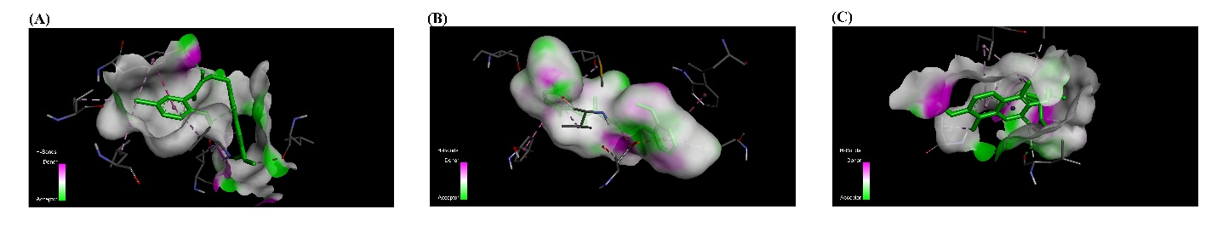
Figure 8: presents the 3D binding poses for each PqsR–ligand complex: (A) STK649448 embedded in the PqsR binding pocket, stabilized by hydrogen bonding and hydrophobic contacts. (B) STK935680 forms electrostatic and aromatic interactions across a compact residue interface. (C) STL546559 exhibits a broad interaction network, with multiple hydrogen bonds and hydrophobic contacts reinforcing its binding stability.

4.Discussion
The discovery of multitarget anti-virulence compounds against Pseudomonas aeruginosa offers a promising alternative to conventional antibiotics, as they disarm the pathogen rather than killing it. These agents act on quorum-sensing (QS) regulators such as LasR, QscR, and PqsR, thereby reducing biofilm formation, toxin production, and motility, which are central to pathogenicity. By targeting multiple virulence pathways simultaneously, such compounds minimize the likelihood of resistance development and can synergize with existing antibiotics to enhance therapeutic outcomes (13, 14). Natural products and synthetic derivatives have shown significant activity in inhibiting QS-regulated phenotypes at sub-inhibitory concentrations, highlighting their potential as scaffolds for drug design (15). However, challenges remain in optimizing pharmacokinetics, specificity, and delivery systems to ensure clinical applicability. Overall, multitarget anti-virulence strategies represent a sustainable approach to managing multidrug-resistant P. aeruginosa infections and reducing the global burden of antimicrobial resistance (16, 17).
Compared with other studies, the interaction profiles observed here closely align with those reported for LasR inhibitors. For example, Bhardwaj et al. identified thiazole derivatives as LasR antagonists, noting strong hydrogen bonding and π–π stacking with TYR64 and TRP60, similar to those observed with STK935680 and STL546559 (18). Chowdhury et al. reported compounds 26529 and 22498 as potent LasR inhibitors, with binding stabilization driven by hydrogen bonds with ASP73 and π–cation interactions with TRP882 (19). These findings parallel the current results, where STK935680 and STL546559 also exploited ASP73 and TRP88 for enhanced binding. Additionally, FDA-approved drug screening against LasR has highlighted the importance of hydrophobic contacts with residues such as LEU36 and VAL76, which were similarly engaged by STL546559 (20).
Comparable findings have been reported in previous studies, where QscR inhibitors often rely on hydrogen bonding and aromatic stacking to disrupt receptor signaling. For example, Li et al. (2022) demonstrated that small-molecule inhibitors targeting QscR frequently exploit π–π interactions with tyrosine residues to stabilize binding (21). Similarly, Pan et al. (2024) identified cinnamoyl hydroxamates as quorum-sensing inhibitors, noting the importance of hydrogen bonding with polar residues and hydrophobic contacts for receptor engagement. The interaction profile of STL546559 aligns with these observations, reinforcing its potential as a multi-contact inhibitor that modulates QscR activity (16, 22).
Comparable findings have been reported in studies of PqsR inhibitors, in which ligands often exploit hydrophobic residues, such as ILE236 and VAL211, to achieve stable binding. For example, Li et al. (2022) highlighted the role of hydrophobic contacts in stabilizing PqsR antagonists, while Pan et al. (2024) demonstrated that cinnamoyl hydroxamates rely on hydrogen bonding and π interactions to disrupt PQS signaling (14, 21). Similarly, Hanot et al. (2024) described indazole–quinolone hybrids that engage both polar and hydrophobic residues within PqsR, reinforcing the importance of multi-contact binding strategies. The interaction profile of STL546559 aligns with these observations, supporting its potential as a candidate quorum-sensing inhibitor (22).

5.Conclusion
This study employed a structure-based pharmacophore modeling and docking pipeline to identify and evaluate potential quorum-sensing modulators targeting the LasR, QscR, and PqsR receptors of Pseudomonas aeruginosa. Pharmacophore models captured receptor-specific spatial and chemical features, and retrospective validation confirmed their predictive reliability, particularly for QscR and LasR. Docking simulations further demonstrated that candidate ligands, including STL546559, STOCK1N-74561, and related scaffolds, interact with critical residues via diverse hydrogen bonding, aromatic stacking, and hydrophobic interactions. These multi-contact binding profiles are consistent with previously reported quorum-sensing inhibitors and highlight the potential of these compounds to attenuate virulence without exerting bactericidal pressure.
Collectively, the findings underscore the value of integrating pharmacophore-guided screening with docking refinement to discover multitarget inhibitors that can disrupt quorum-sensing pathways. Such agents may provide a sustainable strategy to combat multidrug-resistant P. aeruginosa by reducing pathogenicity and limiting the emergence of resistance. Future work should focus on molecular dynamics simulations, in vitro validation, and optimization of pharmacokinetic properties to advance these candidates toward therapeutic application.
Data Availability
All data included in the manuscript
References
1. Elfadadny A, Ragab RF, AlHarbi M, Badshah F, Ibáñez-Arancibia E, Farag A, et al. Antimicrobial resistance of Pseudomonas aeruginosa: navigating clinical impacts, current resistance trends, and innovations in breaking therapies. Front Microbiol. 2024;15:1374466.
2. Giovagnorio F, De Vito A, Madeddu G, Parisi SG, Geremia N. Resistance in Pseudomonas aeruginosa: A Narrative Review of Antibiogram Interpretation and Emerging Treatments. Antibiotics (Basel). 2023;12(11).
3. Fleitas Martínez O, Cardoso MH, Ribeiro SM, Franco OL. Recent Advances in Anti-virulence Therapeutic Strategies With a Focus on Dismantling Bacterial Membrane Microdomains, Toxin Neutralization, Quorum-Sensing Interference and Biofilm Inhibition. Front Cell Infect Microbiol. 2019;9:74.
4. Zhang H, Zhang Z, Li J, Qin G. New Strategies for Biocontrol of Bacterial Toxins and Virulence: Focusing on Quorum-Sensing Interference and Biofilm Inhibition. Toxins (Basel). 2023;15(9).
5. Zhou S, Liu B, Zheng D, Chen L, Yang J. VFDB 2025: an integrated resource for exploring anti-virulence compounds. Nucleic Acids Res. 2025;53(D1):D871-d7.
6. Rizvi SMD, Abu Lila AS, Moin A, Syed S, Fatima D, Khafagy E-S, et al. Repositioning of fluoxetine as anti-virulence agent against Pseudomonas aeruginosa. Future Journal of Pharmaceutical Sciences. 2025;11(1):83.
7. Li Q, Mao S, Wang H, Ye X. The Molecular Architecture of Pseudomonas aeruginosa Quorum-Sensing Inhibitors. Mar Drugs. 2022;20(8).
8. Nejabat M, Hadizadeh F, Karav S, Kesharwani P, Sahebkar AJPB. Recent advances in copolymeric systems for Curcumin delivery: enhancing solubility and bioavailability. Polymer Bulletin. 2026;83(3):151.
9. Nejabat M, Hadizadeh F, Karav S, Kesharwani P, Sahebkar AJIJoP. Enhancing curcumin's efficacy with zinc oxide nanoparticles: A dynamic duo in combatting disease. International Journal of Pharmaceutics. 2025;681:125889.
10. Hauser AR. The type III secretion system of Pseudomonas aeruginosa: infection by injection. Nature Reviews Microbiology. 2009;7(9):654-65.
11. Abdollahi Z, Abnous K, Kalani MR, Taghdisi SM, Soltani S, Nejabat M, et al. Design, Synthesis, and Biological Evaluation of a Novel Series of Thiazolidinediones as Dual GSK-3ß and Tau Aggregation Inhibitors. Medicinal Chemistry. 2025.
12. Atapour-Mashhad H, Soukhtanloo M, Golmohammadzadeh S, Chamani J, Nejabat M, Hadizadeh FJA-CAiMC-A-CA. Synthesis and molecular dynamic simulation of novel cationic and non-cationic pyrimidine derivatives as potential G-quadruplex-ligands. Anti-Cancer Agents in Medicinal Chemistry. 2024;24(15):1126-41.
13. Touati A, Ibrahim NA, Tighilt L, Idres T. Anti-QS Strategies Against Pseudomonas aeruginosa Infections. Microorganisms. 2025;13(8).
14. Liao C, Huang X, Wang Q, Yao D, Lu W. Virulence factors of Pseudomonas aeruginosa and antivirulence strategies to combat its drug resistance. Frontiers in cellular and infection microbiology. 2022;12:926758.
15. Lima EMF, de Almeida FA, Pinto UM. Exploring the antivirulence potential of phenolic compounds to inhibit quorum sensing in Pseudomonas aeruginosa. World Journal of Microbiology and Biotechnology. 2025;41(2):32.
16. Pan D, Wu H, Li J-J, Wang B, Jia A-Q. Two cinnamoyl hydroxamates as potential quorum sensing inhibitors against Pseudomonas aeruginosa. Frontiers in Cellular and Infection Microbiology. 2024;14:1424038.
17. Kristensen R, Andersen JB, Rybtke M, Jansen CU, Fritz BG, Kiilerich RO, et al. Inhibition of Pseudomonas aeruginosa quorum sensing by chemical induction of the MexEF-oprN efflux pump. Antimicrobial Agents and Chemotherapy. 2024;68(2):e01387-23.
18. Bhardwaj S, Nagarajan K, Mustafa Elagib H, Anwar S, Zeeshan Najm M, Bhardwaj T, et al. Molecular simulation-based investigation of thiazole derivatives as potential LasR inhibitors of Pseudomonas aeruginosa. PLoS One. 2025;20(4):e0320841.
19. Chowdhury S, Kumar M, Rawat S, Singh S, Kaur P. From code to cure: computational identification of LasR inhibitors to combat quorum sensing in P. aeruginosa. Molecular Diversity. 2025:1-20.
20. Sadiq S, Rana NF, Zahid MA, Zargaham MK, Tanweer T, Batool A, et al. Virtual screening of FDA-approved drugs against LasR of Pseudomonas aeruginosa for antibiofilm potential. Molecules. 2020;25(16):3723.
21. Li Q, Mao S, Wang H, Ye X. The molecular architecture of Pseudomonas aeruginosa quorum-sensing inhibitors. Marine drugs. 2022;20(8):488.
22. Hanot M, Duplantier M, Dalle C, Ren Y, Da Nascimento S, Becker J-P, et al. Indazole–Quinolone Hybrids as Anti-Virulence Agents against Pseudomonas aeruginosa. Drugs and Drug Candidates. 2024;3(3):512-36.

