**Single-phase direct cooling optimization of power electronics**

Power electronics play a key role in the energy transition by enabling the efficient use of renewable energy sources. It is crucial for converting, controlling, and distributing electrical energy in applications such as photovoltaic systems, wind power plants, and battery storage systems. Modern power electronics improve the integration of volatile energy sources into the power grid by adjusting frequencies, regulating voltages, and minimizing losses.

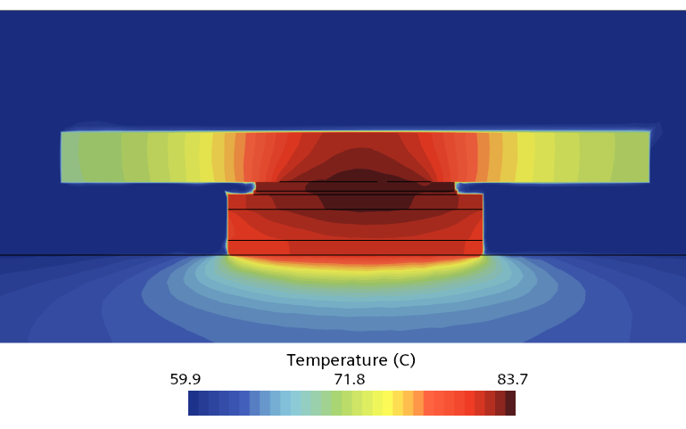To increase the dematerialization and recyclability of converters, the size of the components must be reduced. At the same time, their performance needs to be enhanced, leading to a significantly higher heat flux density. Since conventional air cooling reaches its limits under these conditions, a single-phase direct cooling system will be employed to cool the electronic components directly. In this process, heat is removed from the heat sources through evaporation and condensation of a coolant.

In order to increase the cooling efficiency and the service life of the components, an optimization study shall be carried out, taking into account production-related boundary conditions. The focus is on both the thermal-hydraulic design of a single unit cell and the optimization of a power module consisting of several such cells. The aim is to achieve the most efficient cooling possible with minimal pressure losses.

**Tasks**

* Conduct a literature review on existing optimization techniques for single-phase direct cooling systems in power electronics
* Set up a three-dimensional flow simulation of the cooling channel containing a single unit cell and power modules in Simcenter Star-CCM+
* Conduct parametric design studies and an adjoint simulation to determine efficient designs.
* Analyze the simulation results