Project Brief
Reproducing Burr Spring-Back (Inward Bending) in an Abaqus/Explicit Simulation of Deformational Cutting of Polyamide 6 (PA6)
Scope: Abaqus simulation work only (external freelance task)

1. Summary
I have a 3D thermo-mechanical Abaqus/Explicit model (Coupled Eulerian-Lagrangian, CEL) of deformational cutting of PA6 with a user-defined material (VUMAT). In the real experiment, the burrs left on the machined surface bend inward toward the groove after the tool has passed (viscoplastic recovery / spring-back). In my simulation this does not happen: the burrs do not bend inward, no matter which settings I have tried.
What I need: a working simulation that reproduces this inward bending of the burr, matching the experimental geometry within ±10 %. You are free to choose any method that is physically justified and reproducible.

2. Target: what the experiment looks like
The micrograph below (cross-section, scale bar 100 µm) shows the target. The burrs between the grooves are bent over the groove after cutting. The simulation must reproduce this shape.
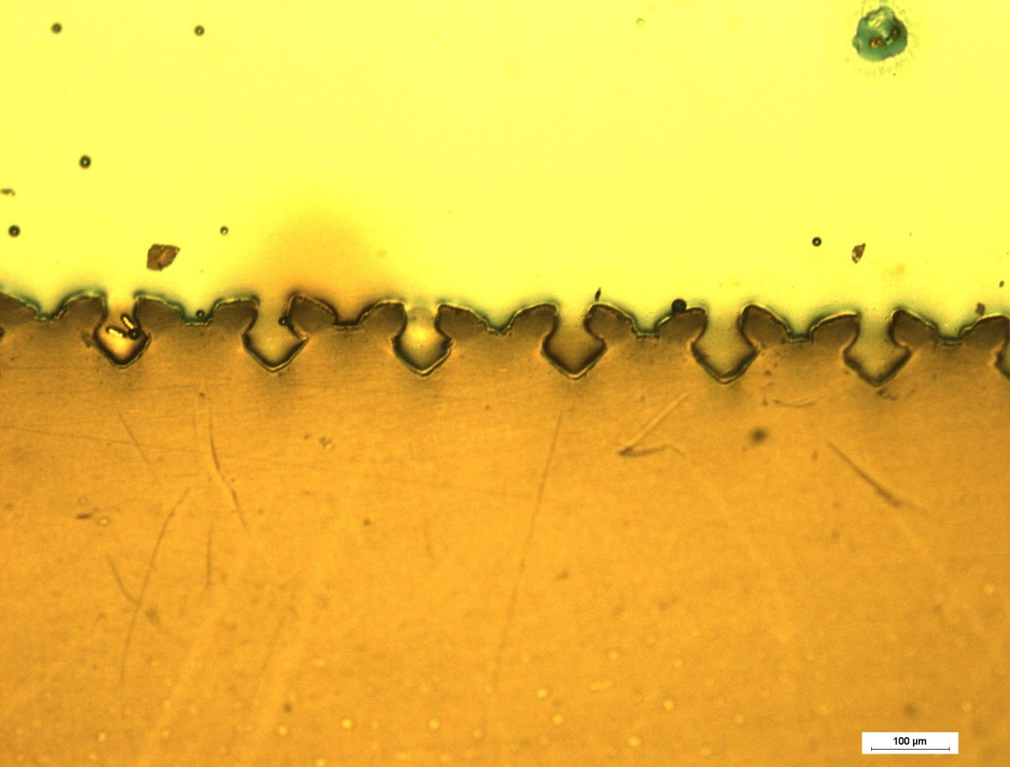
Figure 1: Experimental cross-section of the machined PA6 surface (scale bar: 100 µm).
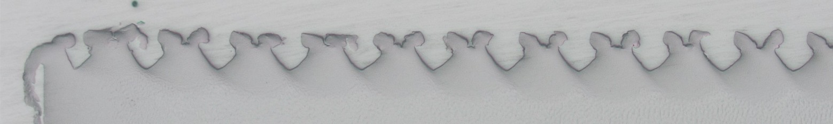
Figure 2: Overview cross-section (lower magnification, no scale bar). The groove pitch equals the feed (0.2 mm), which gives the scale.

2.1 Experimental conditions of the target samples
The targets are samples 1_1 of my pre-test series (PA6 disc, 25 mm diameter, wedge tool, no ultrasonic assistance).
Parameter | Sample 1_1
Material state | PA6 as delivered
Cutting speed Vc | 100 m/min
Feed f (groove pitch) | 0.2 mm
Depth of cut ap | 0.05 mm
Tool angle | 50° (half-angle 25°)
Ultrasonic frequency | 0 kHz (off)

2.2 Target geometry to be matched (quantitative)
Values were measured from Figure 1 (scale bar 98 px = 100 µm, about 1 µm per pixel). Reading uncertainty is about ±5 µm. Before the project starts I will re-measure with image software and confirm or correct the numbers; the acceptance tolerance applies to the confirmed values.
Quantity | Target value | Definition
Groove pitch | ≈ 190 µm | Distance between neighbouring groove centres (nominal feed 200 µm)
Groove depth | ≈ 75 µm (range 70–77) | Vertical distance from top of the burr to the groove bottom; larger than ap = 50 µm because of material pile-up
Inner groove width | ≈ 60–65 µm | Widest width inside the groove, below the burr tips
Neck opening | ≈ 30–40 µm | Gap between the two burr tips at the groove opening
Neck ratio | ≈ 0.5–0.6 | Neck opening divided by inner groove width (how far the burrs closed over the groove)
Inward lean of burr inner wall | ≈ 15–25° from vertical, inward | As cut, the tool flank leans outward by 25°; the burr wall therefore rotated by about 40–50° during recovery

The decisive qualitative feature: each burr tip points over the groove (overhang), so the groove opening is narrower than the groove interior. A simulation in which the burrs stand upright or lean outward does not meet the target.

3. Current model (summary)
Read from my current Abaqus/CAE 2022 model (PA6-CEL-3D_V6_VUMAT_Complete). The full model files will be provided.
Item | Current setting
Parts | DefCutTool (wedge tool, half-angle 25°), Eulerian domain, Workpiece
Step | Dynamic, Temp-disp, Explicit; time period 0.0002 s; NLgeom on; single step only
Mass scaling | Semi-automatic, target time increment 1e-10, workpiece set, throughout step, every 1 increment
Bulk viscosity | Linear 0.06, quadratic 1.2
Cutting speed | V3 = 1666 mm/s (≈ 100 m/min) on the tool reference point RP-4; tool is a rigid body
Workpiece material (PA6) | User material (VUMAT): 43 mechanical constants, 9 solution-dependent variables, hybrid incremental formulation. Density 1.26766e-9; temperature-dependent conductivity (0.263–0.28), specific heat (1.3e9–2.7e9), expansion table (7.1e-5–9.6e-5, ref. 298.15 K); inelastic heat fraction 0.75
VUMAT source | VUMAT_PA6_v8.f (about 1,000 lines): pressure-dependent thermo-elastic / thermo-viscoplastic model (Burzynski-Yagn yield surface, Zhang non-associated potential, G'Sell-Jonas flow stress, temperature- and rate-dependent modulus), based on a published PhD thesis. Unit system of the code: mm, N, MPa, tonne, s, K
Current VUMAT settings | Constants 41–43 (pressure scale, omega clamps) are 0, so the plastic flow is effectively pure J2 (von Mises) type; melt-softening between 180 and 230 °C with residual factor 0.05; expansion coefficient constant (31) is 0; the v8 element-deletion option is not active (needs 45 constants and at least 10 state variables)
Tool material | Elastic E = 1.05e10, ν = 0.1; density 3e-6; conductivity 2200; specific heat 5e8
Contact | General contact (Explicit), hard normal behaviour, penalty friction depending on temperature (0.3 at 298 K, 0.45 at 373 K, 0.15 at 453 K); heat generation default (1.0 / 0.5)
Thermal | Initial temperature 298.15 K (all); tool temperature BC 298.15 K; surface film coefficient 0.01, sink 298.15 K
Mesh | Eulerian EC3D8RT (thermally coupled hex), global size ≈ 0.004 mm; tool meshed with tetrahedra
Output | Field output every 5e-6 s (S, PE, TEMP, NT, SDV, STATUS, EVF, HFL, ...); history output of energies (ALLAE, ALLIE, ALLKE, ETOTAL, ...)

4. Findings so far and open points

4.1 From reading the VUMAT source and the model (please confirm)
- No recovery mechanism in the material model. The VUMAT contains no back-stress, no viscoelastic network and no time-dependent recovery term. After unloading the material can only return elastically; inelastic strain stays frozen. Above the melt-softening onset the stress falls to a small residual value, so the hot burr keeps almost no stored elastic state. This is my main suspect for the missing spring-back.
- Thermal strain is probably inactive. For a user material in Abaqus/Explicit, thermal expansion must be handled inside the VUMAT. The model has an *Expansion table, but the VUMAT constant for the expansion coefficient (31) is 0, and the code header says *Expansion must not be defined in addition. Thermal contraction during cooling therefore appears not to act at all.
- No relaxation time. The only step ends at 0.0002 s. At 100 m/min the tool travels about 0.33 mm, and there is no step after the tool has left the material, so nothing can recover or cool.
- Unit inconsistency in the tool properties. In the VUMAT unit system (mm, tonne, s, MPa), E = 1.05e10 for the tool is about 10,000 times too high for diamond (about 1.05e6 MPa), and density 3e-6 is about 1,000 times too high (about 3.5e-9). The tool is rigid, so the mechanical effect is small, but density times specific heat also controls heat flow into the tool.
- Deactivated items. The boundary conditions WP-fix-X and X-sym are deactivated; the element-deletion feature of v8 is not enabled in the model.

4.2 Hypotheses still to be checked
- Aggressive mass scaling (target 1e-10) may add artificial inertia and hide slow recovery; the energy balance (ALLAE vs ALLIE) must be checked.
- With Eulerian volume fractions and a 4 µm mesh, thin burrs may not be resolved or may smear; a Lagrangian approach with remeshing/element deletion could give a better final shape.
- Contact and heat settings (film coefficient 0.01, heat generation defaults, friction vs temperature) influence burr temperature and therefore softening and recovery.
- Dry versus as-delivered PA6 (samples 2_1 and 1_1) differ in moisture, which changes glass transition and modulus. The model needs a clear way to represent both states.

5. Scope of work
You are free to choose the approach. Possible directions (not mandatory):
- Add a relaxation/cooling step after tool exit (Explicit with reduced mass scaling, or transfer of the deformed state to Abaqus/Standard for time-dependent recovery).
- Extend or rewrite the VUMAT (Fortran) with a viscoelastic/viscoplastic recovery mechanism (e.g. back-stress or parallel viscoelastic network), active thermal strain, thermal softening and damage.
- Switch or compare formulations: CEL, Lagrangian with remeshing/element deletion, or other methods (e.g. particle-based) if justified.
- Use a simplified 2D plane-strain model for fast calibration, then transfer to 3D.
- Audit and correct the existing model (units, BCs, contact/thermal settings, mesh and mass-scaling sensitivity, energy balance, EVF quality).
Important: tuning parameters only to make the picture look right, without physical justification, is not acceptable. Every change must come with a technical reason, so that I can explain and defend the model.

6. Acceptance criteria
- After the tool has left the material and the recovery period has ended, the burrs bend inward over the groove, with a measurable inward lean.
- Groove depth, groove pitch, inner groove width, neck opening/ratio and inward lean of the burr wall match the confirmed values of Section 2.2 within ±10 %.
- The result is reproduced for both target samples, 1_1 (as delivered) and 2_1 (dried), with the same cutting parameters and the appropriate material state. If the material data for one state are not sufficient, the contractor says so early and proposes how to represent it.
- The simulation is numerically sound: artificial energy (ALLAE) is small compared with internal energy (ALLIE), and the result is not mesh-dependent beyond an agreed limit (short mesh sensitivity check).
- The model is reproducible: I can re-run it on my side and obtain the same result.
- The VUMAT passes a single-element verification (loading, unloading, relaxation, different temperatures).

7. Deliverables
- Corrected and working Abaqus model (.cae and .inp) with clean, commented settings.
- Updated VUMAT source code (Fortran) with comments and a description of all parameters and state variables.
- Result files (.odb) and key output data for both target samples.
- Short technical report (PDF/Word): cause of the missing spring-back, list of all changes with reasons, verification and validation results, and a comparison with the experimental images.
- Step-by-step instructions to reproduce the results (software version, compiler, job commands).
- Optional: Python script for extracting burr geometry, temperature and residual stress from the ODB.

8. What I will provide
- Abaqus model files (.cae / .inp).
- VUMAT source (VUMAT_PA6_v8.f) with a detailed header; documentation of the 43 constants and 9 state variables.
- Material test data available for calibration (tension/compression, loading-unloading, relaxation, different temperatures; dry/humid if available).
- Experimental micrographs of samples 1_1 and 2_1 with their cutting parameters (Section 2).
Files are shared step by step: first this brief, then the model and data once I have reviewed your previous work and we have agreed on the scope.

9. Required skills and software
- Abaqus/Explicit: CEL, thermal-mechanical coupling, contact, mass scaling and stability.
- VUMAT programming in Fortran (compilation, debugging, verification).
- Constitutive modelling of thermoplastics (viscoelasticity, viscoplasticity, thermal softening, damage).
- Experience with machining or cutting simulation is a strong advantage.
Software access: The model is built in Abaqus/CAE 2022 and needs a compatible Fortran compiler. Either arrangement is acceptable: your own Abaqus license and compiler, or remote access arranged by me. Please state in your proposal which one you will use.

10. Timeline, budget and terms
- Duration: 4 weeks from the start date.
- Budget: 45–100 million Toman for the full scope (fixed price). Please quote within this range or explain if you need more.
- Start of work: work starts after I have reviewed samples of your previous work (similar Abaqus/VUMAT/simulation projects) and we have agreed on the scope and milestones.
- Milestones (proposal): week 1: model audit and short report on causes; weeks 2–3: improved material model/VUMAT and first working spring-back result; week 4: validation on samples 1_1 and 2_1, final documentation and handover. Payment per milestone.
- A small paid first task (model audit with short report) may be used as a trial before the full project.
- All delivered files, source code and documentation are handed over to me, with the right to use and modify them without restriction.
- Short progress updates at least once a week.

11. Please include in your proposal
- Samples of previous work (reports, screenshots, links or a short description of similar Abaqus/VUMAT or cutting-simulation projects).
- A short description of how you would approach the missing spring-back and which method you expect to work best.
- How you will access Abaqus and a Fortran compiler.
- Your timeline, price and milestones.
- Open questions or missing information you need from me.

