Task 1 – write class with the following functions for a fft data analysis and execute the functions at the end of the python file

1. read data from Test_data.txt file line by line with open() command

input: path to file, filename, sensor names list

output: data array

additional information:   
read all sensors if sensor names list is empty

in datafile tab-delimiter is used

format of data array:

data array [sensor number X][0] - times

data array [sensor number X][1] - values

data array [sensor number X][2][0] – sensor name

1. make fft of data array with numpy fft.rfft/fft.rfftfreq

input: data array, start time ,frequency resolution, time interval for averaging  
output: output data array

format of output data array:

output data array [sensor number X][0] - frequencies

output data array [sensor number X][1] - values

output data array [sensor number X][2] - angles

output data array [sensor number X][3][0] – sensor name

1. write plot with matplotlib.pyplot  
   input: output data array, output folder, output file name  
   optional input: xlabel, ylabel, xticks, yticks, xlim, ylim

output: lineplot in png format for each sensor in output data array saved in output folder with name “output file name.png”

Task 2 – write a function within the python file Machine_modelling_Tool.py within the class Coil(Main_collection) based on the existing old classes insulation_calc() and Coil_calc_2D()

1. function geometry_2d(self)  
   **input:**

*machine data - lamination*  
self. l_Z2_bn slot width

self. l_Z2_hn slot height

*machine data - coil*

n_parallels_v number of parallel strands in vertical direction (currently 1)

n_parallels_h number of parallel strands in horizontal direction

n_W_turns number or turns of the strands

l_slot_clearance_v not usable slot height

l_slot_clearance_h not usable slot width

l_copper_wX copper width of strand number X (relative values, sum(l_copper_wX) is 100% of available copper width)

*insulation data matrix*

self.coil_insulation_system

**output:**

the following output is calculated for pressed and unpressed condition

*for each strand:*   
variable:  
copper height, insulated strand height, copper rounding radius

array[horizontal strand number]:  
copper area, copper width, insulated strand width

*for whole coil:*

variable:   
consolidated/insulated/protected coil height/width

consolidated/insulated/protected coil area

slot area

filling factor copper/insulated coil area, filling factor copper/slot area

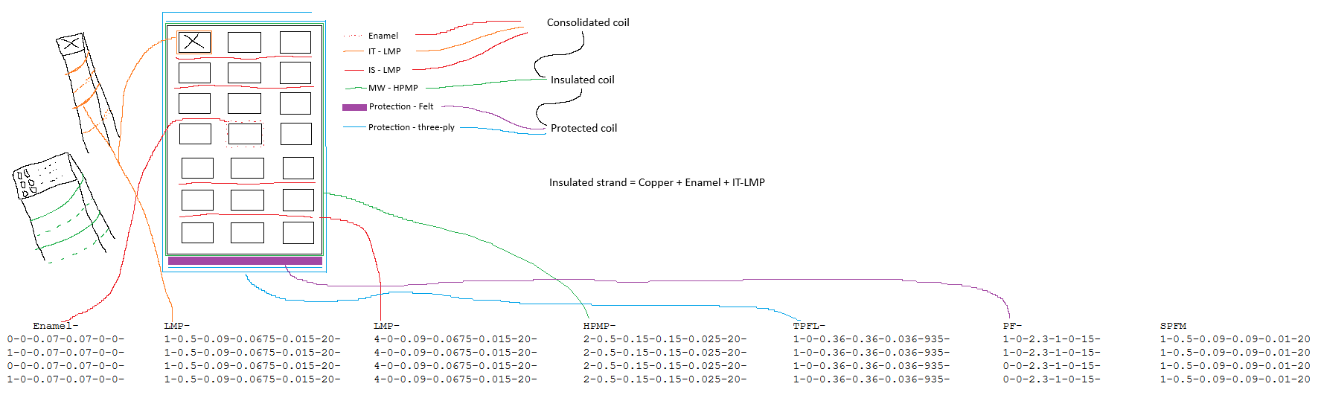

Task 3 – write a function within the python file Machine_modelling_Tool.py within the class Coil(Main_collection) based on parts of the existing old class Coil_calc_3D()

1. function geometry_3d(self)  
   **input:**

required machine data can be retrieved as described in Task2  
self. l_fe active part length

self. l_str_ew straight length outside the active part region before bending

self. l_terminal winding terminal (straight part outside active region+ending)

insulation data matrix can be retrieved as described in Task2

material data properties

self.mat_X_Y X material name, Y material property

e.g. self.mat_Copper_gamma20

variables created in the function geometry 2d(self) as self.new_variable can be retrieved the same way in the new function

**output:**

*for each strand:*   
array[horizontal strand number]:

copper length, resistance

*for whole coil:*   
variable:

resistance

