Question 1

The figure below shows a double flash power plant setup.
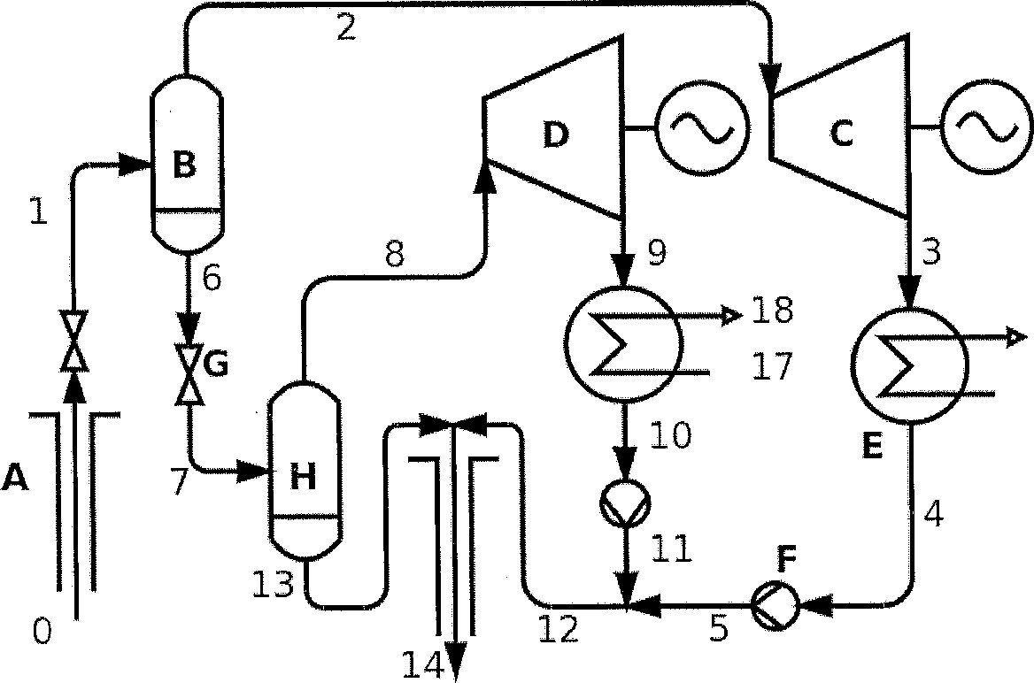
16
15
- Name all components shown in the figure, with a short notice on their purpose (one sentence each). Refer to the capital letters on the figure, A-H.
- Draw a schematic T-s diagram (pressure entropy) of the power cycle. Use the numbers in the figure to indicate operating points on the diagram.
- Draw a T-H diagram of the process in the condensers. Note that H denotes the specific enthalpy multiplied with mass flow.
- If the mass flows and specific enthalpies are known in points 5 and 11, show how to calculate the mass flow and enthalpy in point 12.
- Indicate how the first law efficiency should be calculated for this power plant.
- Describe one other setup for a double flash power plant.
Question 2

The figure below shows a gas extraction system connected to a single flash power plant.
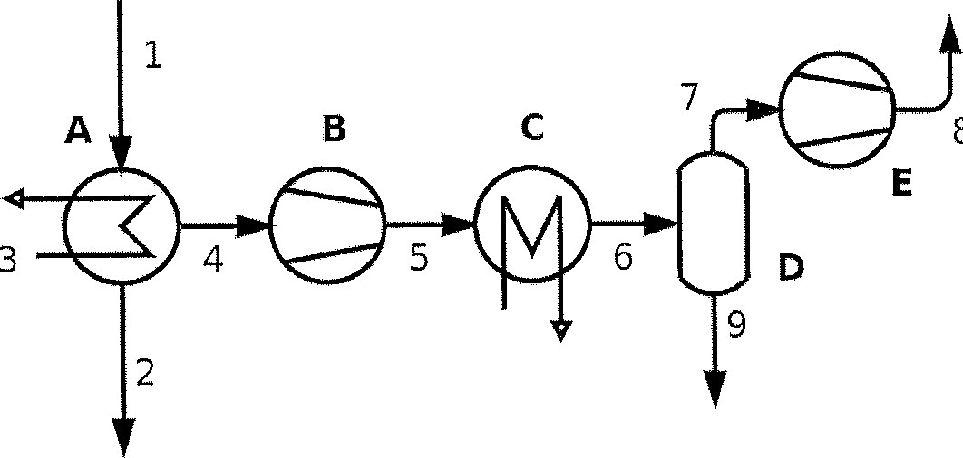
8
- Name all components shown in the figure and describe their purpose.
- At what temperature should gases be extracted from a condenser, in relation to the saturation temperature in the condenser? How does this temperature affect the efficiency of the extraction?
- Which typical types of gases need to be extracted? How does the type of gas affect the extraction performance when comparing same mass flow for two gases?

Question 3
- (10%) Your task is to select the optimum pipe diameter for water pumping between X to Y. Describe the optimization procedure. Keywords: Installation cost, maintenance cost, pressure drop, electricity cost and present value of future payments. Use imaginary numbers and graphical presentation as needed.
- (10%) Describe and discuss different piping layout arrangements, using one big steam separation station or using one separator at each well head. Name advantages and disadvantage of different arrangements. Keywords: Separator, brine tank, well pad level, separator station level, piping, re-injection, pumping, wells with different enthalpy, wells with different fluid chemistry etc.
- (5%) Describe basic function of a horizontal gravity drum separator and a vertical cyclone separator. Use schematic drawings and sketches as needed.
d, (5%) Describe different ways of removing non-condensable gas from a condenser of a geothermal power plant and explain the importance of the gas cooling section of the main condenser.
e. (5%) Provide a short description and comparison on different cold end (condenser and cooling tower) options for geothermal power plants.
Question 4
- (10%) Describe the main phases of geothermal development project (from beginning of exploration and into the operational period). Include and discuss cost- and risk distribution for the project lifetime. Keywords: Exploration, feasibility, Construction, Operation
- (10%) Describe the main cost items in a geothermal power plant. Both capital and operational cost. Identify and discuss the main influential parameters of the cost. Keywords: Electrical- and Mechanical Components, Well field, Engineering, Maintenance.
Question 5
a. (5%) Describe how an electricity tariff (energy price) is determined, based on full development of a geothermal project. Discuss the influential factor on the electricity tariff. Keywords: Cash flow, CAPEX, OPEX Equity, Debt, Lifetime
b, (5%) Describe how a project financial analysis model can be used to estimate potential electricity tariff (energy price) for a geothermal project. Discuss the influential factor on the electricity tariff. Keywords: Cash flow elements, funding, profitability indicators.

