“The Economic Roots of Crime:

Exploring Youth Unemployment Across Nations”

Emran Ahmadi

Supervisor: Prof. Dr. Ferdinand Rauch

1. Abstract

This paper investigates the economic roots of crime, particularly focusing on the impact of youth unemployment across different nations. Utilizing various data types and methodologies, this paper seeks to resolve and find the roots of inconsistencies in the relationship between unemployment and crime rates reported in previous literature. The analysis includes national time series, cross-sectional data, regional panel data, and individual-level data to establish causality through econometric approaches like instrumental variables (IV), difference-in-differences (DID), and regression discontinuity designs (RDD). The findings highlight the significance of data richness and methodology in determining the unemployment-crime link, with notable differences observed in Judicial system and employment system between countries such as France and Brazil. In France, youth unemployment significantly affects property crimes while having mixed effects on violent crimes, as analyzed through IV methods. Conversely, in Brazil, dynamic treatment effect models and causal forest methods reveal a robust relationship between job loss and increased crime rates, moderated by unemployment insurance and other socioeconomic factors. This paper concludes that the causal relationship between unemployment and crime is context-dependent, influenced by judicial and employment systems, labor market regulations, and the specificity of available data. The study reveals the necessity for tailored policy interventions to mitigate crime driven by economic distress. Finally, this paper summarizes the causal relationship between crime and unemployment in different countries but, the focus is on France and Brazil because of the different judicial systems and different types of government , in addition both of case studies, are well-known as a crime-prone country in Latin America and Europe.

1. Introduction

Crime has been a major issue of humanity from the beginning. The estimated aggregate burden of Crime in the United States is $4.71 - $5.76 trillion annually without consideration of welfare movements (*David A. Anderson (2021) The Journal of Law and Economics*). Throughout history there exist two main streams for the relationship between unemployment and crime rate. Criminologists focus on the supply of victims and they believe that any person in a suitable situation can be a criminal. Still, Economists Focus on the supply of criminals and try to include the vital role of economic and socioeconomic factors in the behavior of offenders and criminals because they believe that Human nature is virtuous and pure. Many economists tried to explain the roots of the behavior of potential criminals, although the economic theory of criminal behavior is on dept of the effort of Gary Becker, several of Becker’s ideas were not original and were predicted by Jeremy Bentham, the British ethic philosopher. Bentham was not considered an economist but developed several concepts that would later establish the theory of “Criminal Behavior:” The profit of the crime is the force which urges man to delinquency: the pain of the punishment is the force employed to restrain him from it. If the first forces are greater, the crime will be committed; if the second, the crime will not be committed.” (*Jeremy Bentham, An Introduction to the Principles of Morals and Legislation 1781*). This paper aims to address the main problems of the causal relationship of Unemployment and Crime rates in methodology and compare this issue across different countries. Many studies try to compare the different studies in economics of crime literature, for example: In a survey of unemployment and crime literature, *Box (1987)* reports 35 reliable studies in different countries on this topic, 20 of which find a positive relationship between unemployment and crime, with the remainder unable to find any such relationship. For instance, Öster, A., & Agell, J. (2007) JEEA utilized panel data to investigate the impact of unemployment shocks on crime rates, focusing on property crimes for Sweden and they establish that there was no clear relationship between unemployment and violent crime, and youth unemployment did not predict crime. On the other hand, Rege, M., Skardhamar, T., Telle, K., & Votruba, M. (2019), Journal of Labour Economics, estimates the effect of job displacement in Norway on criminal behavior among young adult Norwegian men who were separated from their plant of employment during a mass layoff and they establish that job displacement has a significant causal impact on increasing criminal behavior among young adult Norwegian men, with both economic and psychological factors contributing to this effect. Hence the inconsistency in this literature is considerable or, To address the potential endogeneity of labor market conditions in US Gould, E. D., Weinberg, B. A., & Mustard, D. B. (2002) use an IV strategy inspired by Bartik (1991) and Blanchard and Katz (1992) initial industrial composition of each state and they establish that There is a strong causal link between lower wages for non-college-educated men and higher rates of property crimes .In this paper, I aim to find a reliable answer for this inconsistency in results across different countries. The next section describes the vital role of the richness of the data set in the results. Section IV addresses the potential problems of the Causal Approaches in different country cases. Section V discusses the results of this issue in different countries and finally final section suggests the potential roots of these differences.

1. The Role of Data Set

The availability and accessibility of the data can influence the results of the studies. Research on the connection between Crime rate especially Property crime rate and Unemployment usually relies on four types of data: national time series data, cross-sectional data, regional panel data, or individual-level data. Studies using the first two types often indicate a causal relationship, as seen in early research by Ehrlich (1975), Leveson (1976), Chapman (1976), Brenner (1978), Narayan and Smyth (2004), Scorcu and Cellini (1998), Despite their attempts to account for other factors, these studies may still miss important variables and some of them used Granger causality test which is not a true causality and it is a prediction. Regional panel data can help reduce this issue, and evidence from such studies shows different results for causal relationships based on the country and assumptions of the authors. For example, Entorf and Spengler (1998) found that unemployment had "small, often insignificant and ambiguous effects but, *Fougère, Kramarz, and Pouget* (2009) used Bartik instruments to establish that unemployment had a strong causal relationship with Most of the properties crimes or Dell, Feigenberg, Teshima (2019) used panel data and IV to address the same relationship in Mexico. Most of the Studies implement an IV or Dif-in-Dif approach to establish causality but in both cases, there are some problems. For example, generally, this kind of study concludes that crime rate at the county level or department level has a positive relation with Unemployment but average data across counties cannot detect precisely the determinants of not usual phenomena like crimes because criminals and offenders make up a little portion of the whole society and this portion for Violent crime is even smaller. Finally, the studies that use individual-level data because of the richness of the data set can reveal more exact relations and some of them found another causal pathway of Unemployment and Crime rate Bennett and Ouazad (2019) for Norway case, Rose (2018) for Columbia Case and Britto, Pinotti and Sampaio (2022) for Brazil case. This category of papers used RDD and Difference-in-Difference to address the causality between unemployment and crime rate and because of the high-resolution data set and availability of the Unemployment benefit data Britto, Pinotti and Sampaio (2022) established that there are some intermediate stages between unemployment and Crime rate like liquidity constrain and psychological factors which are not mentioned in the Becker model.

1. Causal Approach

In econometrics, major approaches to establish causality include randomized controlled trials (RCTs), natural experiments, instrumental variables (IV), difference-in-differences (DID), and regression discontinuity designs (RDD). RCTs randomly assign subjects to treatment or control groups, minimizing selection bias. Natural experiments exploit events or policies that affect some individuals but not others, mimicking randomization. The IV approach which is the most frequent in this literature uses external instruments to isolate exogenous variation in the explanatory variable, addressing endogeneity issues in this case endogeneity is a reverse causality between unemployment and crime rate. Difference-in-Difference compares changes over time between treated and untreated groups, controlling for confounding trends but by using Difference-in-Difference in this literature because the individuals do not receive the treatment simultaneously, we cannot use standard DID and most of the studies use Staggered DID. Lastly, RDD identifies causal effects at cutoffs where treatment assignment changes discontinuously, assuming smoothness in other variables around the threshold. RDD assumes that the relationship between the running variable and the outcome is smooth around the cutoff point, excluding the treatment effect. If this assumption is violated, for instance, due to other discontinuities or omitted variables at the threshold, the causal interpretation can be compromised. Moreover, the results are typically local to the cutoff and may not generalize well to other settings or populations. In this paper, I will discuss the causal approach of two main papers in this literature first, Fougre, Pouget, and Kramarz (2009) JEEA. Second, Britto, Pinotti and Sampaio (2022) Econometrica. In this part, I discuss the important parts of each of them in details.

* *Instrumental Variables Approach in France*

In the first step, *Fougre, Pouget, and Kramarz (2009)* divide the crime rate into two subcategories of Property crimes and violent crimes then they constructed the share of unemployed people among the group 15 to 24 years old, rather than the unemployment rate, in each department. UNS provides a better measure of the relative size of low human capital in France's economy. This measure is much better than UNR for young groups because excludes all information about agents making active human capital investments. In the case of UNR(g), an increase in students which will reduce crime both immediately and over time can be accompanied by a reduction in the total labor force which pushes up the unemployment rate as measured by UNR. Hence biases down the effect of UNR on crime.

*UNS(g) = (number unemployed of age g) / [(labor force of age g) + (student of age g) + (others of age g)]*

*UNR(g) = (Number unemployed of age g) / (labor force of age g)*

This new measurement is inspired by Ehrlich's (1973) theory which said that investing in human capital has 2 effects on the crime rate one of them is immediate and one of them is with lag. The logic behind these effects is that when you are investing in human capital you have less time to engage in criminal activity and for lagged effect is that you become wiser and this leads to committing less crime (Ehrlich, 1973). In the next step, they use the typical regression analysis for the first step.

Ln (CRit) = Xit + Uit +i + t + it (1)

Where CR denotes the crime rate in department (i) at date t, X denotes observed characteristics of the population, and characteristics of the urban structure, and U denotes the share of unemployed in the population. Most of the time, we include time indicators and département fixed-effects. Finally, the last term of equation (1) is a statistical residual (white noise). All regressions include socio-demographic controls: a fraction of foreigners coming from North Africa, of other foreigners, a fraction of people aged 15 to 24, 25 to 49, of men living alone, of individuals in single-parent families, of individuals without any diploma, of high school graduates, of those living in rural areas, of those living in cities having between 20,000 and 200,000 inhabitants, of those living in cities with more than 200,000 inhabitants, and finally those living in Paris and its suburbs. Département populations are used as weights (Fougère, 2009).

*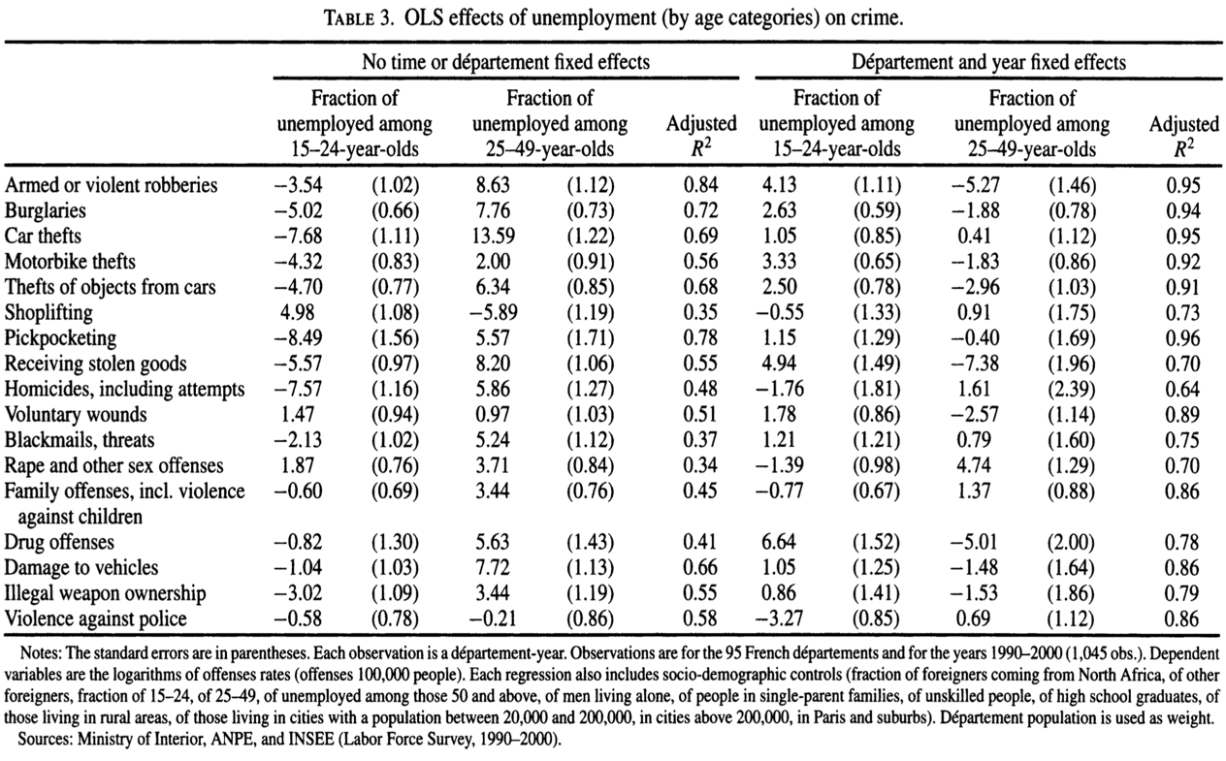*

By focusing on the estimates with département fixed effects, we see that youth unemployment is positively associated with most crimes whereas unemployment for the two other age categories has a negative association with most crimes. This set of results is much more in agreement with the popular view of crime, but also with a simple choice model of crime activity. Indeed, those categories of crime for which the coefficient on youth unemployment is negative or not significantly different from zero—car thefts, homicides, pickpocketing, shoplifting, blackmail, rape, and family offenses—are not youth-specific in contrast to, say, drug offenses, motorbike thefts, or burglaries. The main challenge in analyzing the relationship between youth unemployment and crime is the potential endogeneity of unemployment in crime regression. Endogeneity arises because crime could deter firms from investing in high-crime areas or relocating, leading to higher unemployment. This creates a bidirectional causality where unemployment influences crime, and crime influences unemployment. The IV technique is used to isolate the causal impact of youth unemployment on crime by addressing the endogeneity problem. This method involves using instruments that are correlated with youth unemployment but uncorrelated with the error term in the crime equation. The instruments used in the study are based on predicted employment growth by age, sex, and education, derived from initial industry structure and aggregate industry growth (GROW15-24, GROW25-49 for the first set, and GROWlow-Educ males, GROWlow-Educ females and their square for the second set of the instruments). These instruments are expected to be exogenous and not directly affected by crime rates. But there is some doubt. At first, I reveal the logic behind these instruments then I criticize them. The IVs are derived from the initial industrial composition of each department. This initial composition is considered exogenous to changes in crime rates. the logic is that the initial industry mix of a department (e.g., percentage of employment in manufacturing vs. services) influences future employment trends in a way that is not directly related to crime rates. National trends in industry employment are used to predict changes in employment in each department. These trends are also considered exogenous to local crime rates, for example, if the service sector is growing nationally while the manufacturing sector is declining, these trends are used to predict similar changes in employment at the departmental level. The authors use changes in the demographic composition (age, sex, and education) within industries at the national level to further refine their instruments, this involves looking at how the age, sex, and education composition of workers within industries changes over time and using these patterns to predict similar changes within departments.

*The potential Problems of the Bartik IVs*

They are highly influenced by American literature which means that this reverse causality is the case in the US with a low Employment Protection Index not in France which is the second highest in this Index. In addition, This Reverse causality is the case in countries with an At-will Employment system in which employees can be discharged without any cause but in France, Workers have the full support of the government. Based on (Dewit, Görg 2018) Bigger companies have less tendency to relocate because of higher sunk costs and more employers. In addition, they ignore the importance of worker mobility which has a higher probability of relocating because of the High Crime and they tolerate lower costs (Engelhardt, B., Rocheteau, G., & Rupert, P. (2008) Journal of Public Economics). In addition, In France, a very high concentration of economic activity is carried out by a small number of companies. In an economy containing over 3.7 million companies in 2013, nearly 6,000 of these (0.15% of the total) represent at least half of each of the main indicators: 51% of jobs, 56% of added value, and 64% of turnover. Each with over 250 employees, these enterprises are intermediate-sized enterprises (5,300) and large companies (274). (AFEP 2022). Hence, big companies drive the France economy and jobs and based on the reasons that I mentioned the reverse causality between Unemployment and Crime is not the case here. The other problem that they do not mention is the reverse causality of the deterrence variables with crime FU, WOLPIN, Review of Economic Studies 2018) and Bun, M.J.G., Kelaher, R., Sarafidis, V. et al. Crime, deterrence, and punishment revisited. Empirical Economic. Hence, the instruments should adapt more to the French economy. Based on the results of the IVs Most test statistics support the (statistical) quality of the instruments. In particular, the instruments are deemed satisfactory in all crimes but six: motorbike thefts, homicides for the two instruments, voluntary wounds, violence against police, blackmails, and illegal weapon ownership for one of the two. Hence, for only two crimes, our IV estimates are not statistically reliable. These IV results confirm previous estimates. Youth unemployment has a clear (positive) effect on most economic crimes: robberies, burglaries, car thefts, thefts from cars, pickpocketing, drug offenses, and damage to vehicles. However, it has a negative effect on four types of violent crimes, namely blackmail and threats, family offenses (including violence against children), illegal weapon ownership, and violence against the police.

For better visualization, I draw the Causal diagram. We can see that the causality is unidirectional and it is from youth unemployment to violent and property crime.

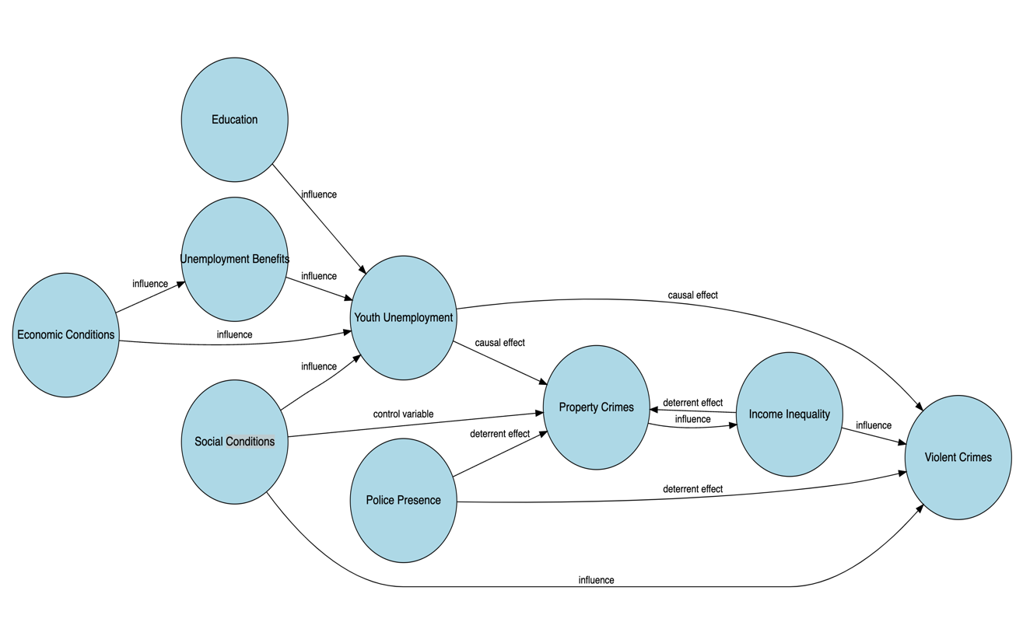

Causal diagram (France Case) Figure 1

* *Britto, Pinotti, and Sampaio (2022): DID, RDD, and Causal Forest Approach in Brazil*

this paper aims to compare the individual-level employment records of Brazilian workers to their criminal records and welfare registries. The rich data set able them to nuanced analysis between job loss and crime rate. The methodological approach includes the dynamic treatment effect model and the causal forest method which is an advanced machine-learning method inspired by the random forest approach. The study also employs a regression discontinuity design to assess the impact of UI eligibility on crime, providing a robust analysis of how temporary financial support can influence post-displacement behavior. They analyzed the following topics: Increase in crime post-displacement, Impact of Unemployment insurance, Heterogeneity of effect on the treatment group, and spillover effect. For the dynamic treatment effect model, they implemented a Difference-in-Difference strategy which the treatment group consists of workers who were displaced between 2012 and 2014, male and employed in private non-agricultural sectors in Brazil. The control group includes workers not displaced in the same calendar year and they matched based on 9 characteristics. The analysis focuses on mass layoffs to minimize selection bias but they Could not address the measurement error due to the high proportion of informality in Brazil. In 2020 41.4% of Brazil's labor force was engaged in Informal Jobs (EBC,2020). In addition, they did not address the people who resigned voluntarily. The Equation is following:

Yit = + Treati + t (Treati \* Timet) + t Timet + it. (2)

Workers are identified by the subscript I, and Treati is a dummy indicating that the worker belongs to the treatment group. Time is a dummy identifying years since layoff, which we can define very precisely because the exact dates of layoffs and criminal prosecutions are reported in our data. The coefficient { $δt$} thus identifies dynamic treatment effects. Finally, Timet fixed effects absorb time-varying shocks. One potential problem of this DID is that the Timing of criminal behavior might not be perfectly aligned with the job loss dates due to reporting delays. The placebo test aims to ensure, that the change in criminal behavior after dismissal is fully due to job loss. One other potential problem of this DID is that the individuals in the treatment group do not receive the treatment (here Job loss) simultaneously. This time-varying can cause two major problems, The first is Bias in Estimators which happens because of the Use of already-treated units as control for later-treated units. Second is the Weighted Average which means that the estimated treatment effect in staggered DID is weighted by two major factors time and size of the group. Hence, they used staggered Difference-in-Difference to address these problems and they used non-treated observations to provide a consistent control group to help establish a consistent baseline for comparison of the results. In addition, including non-treated units ensures that the parallel trend assumption is held too. Based on the results of Figure 2 after job loss income declined by 70% and the crime rate especially economically motivated crimes grew rapidly. in Table 1, the quantified average effect of job loss changes over the 4 years after dismissal are available.

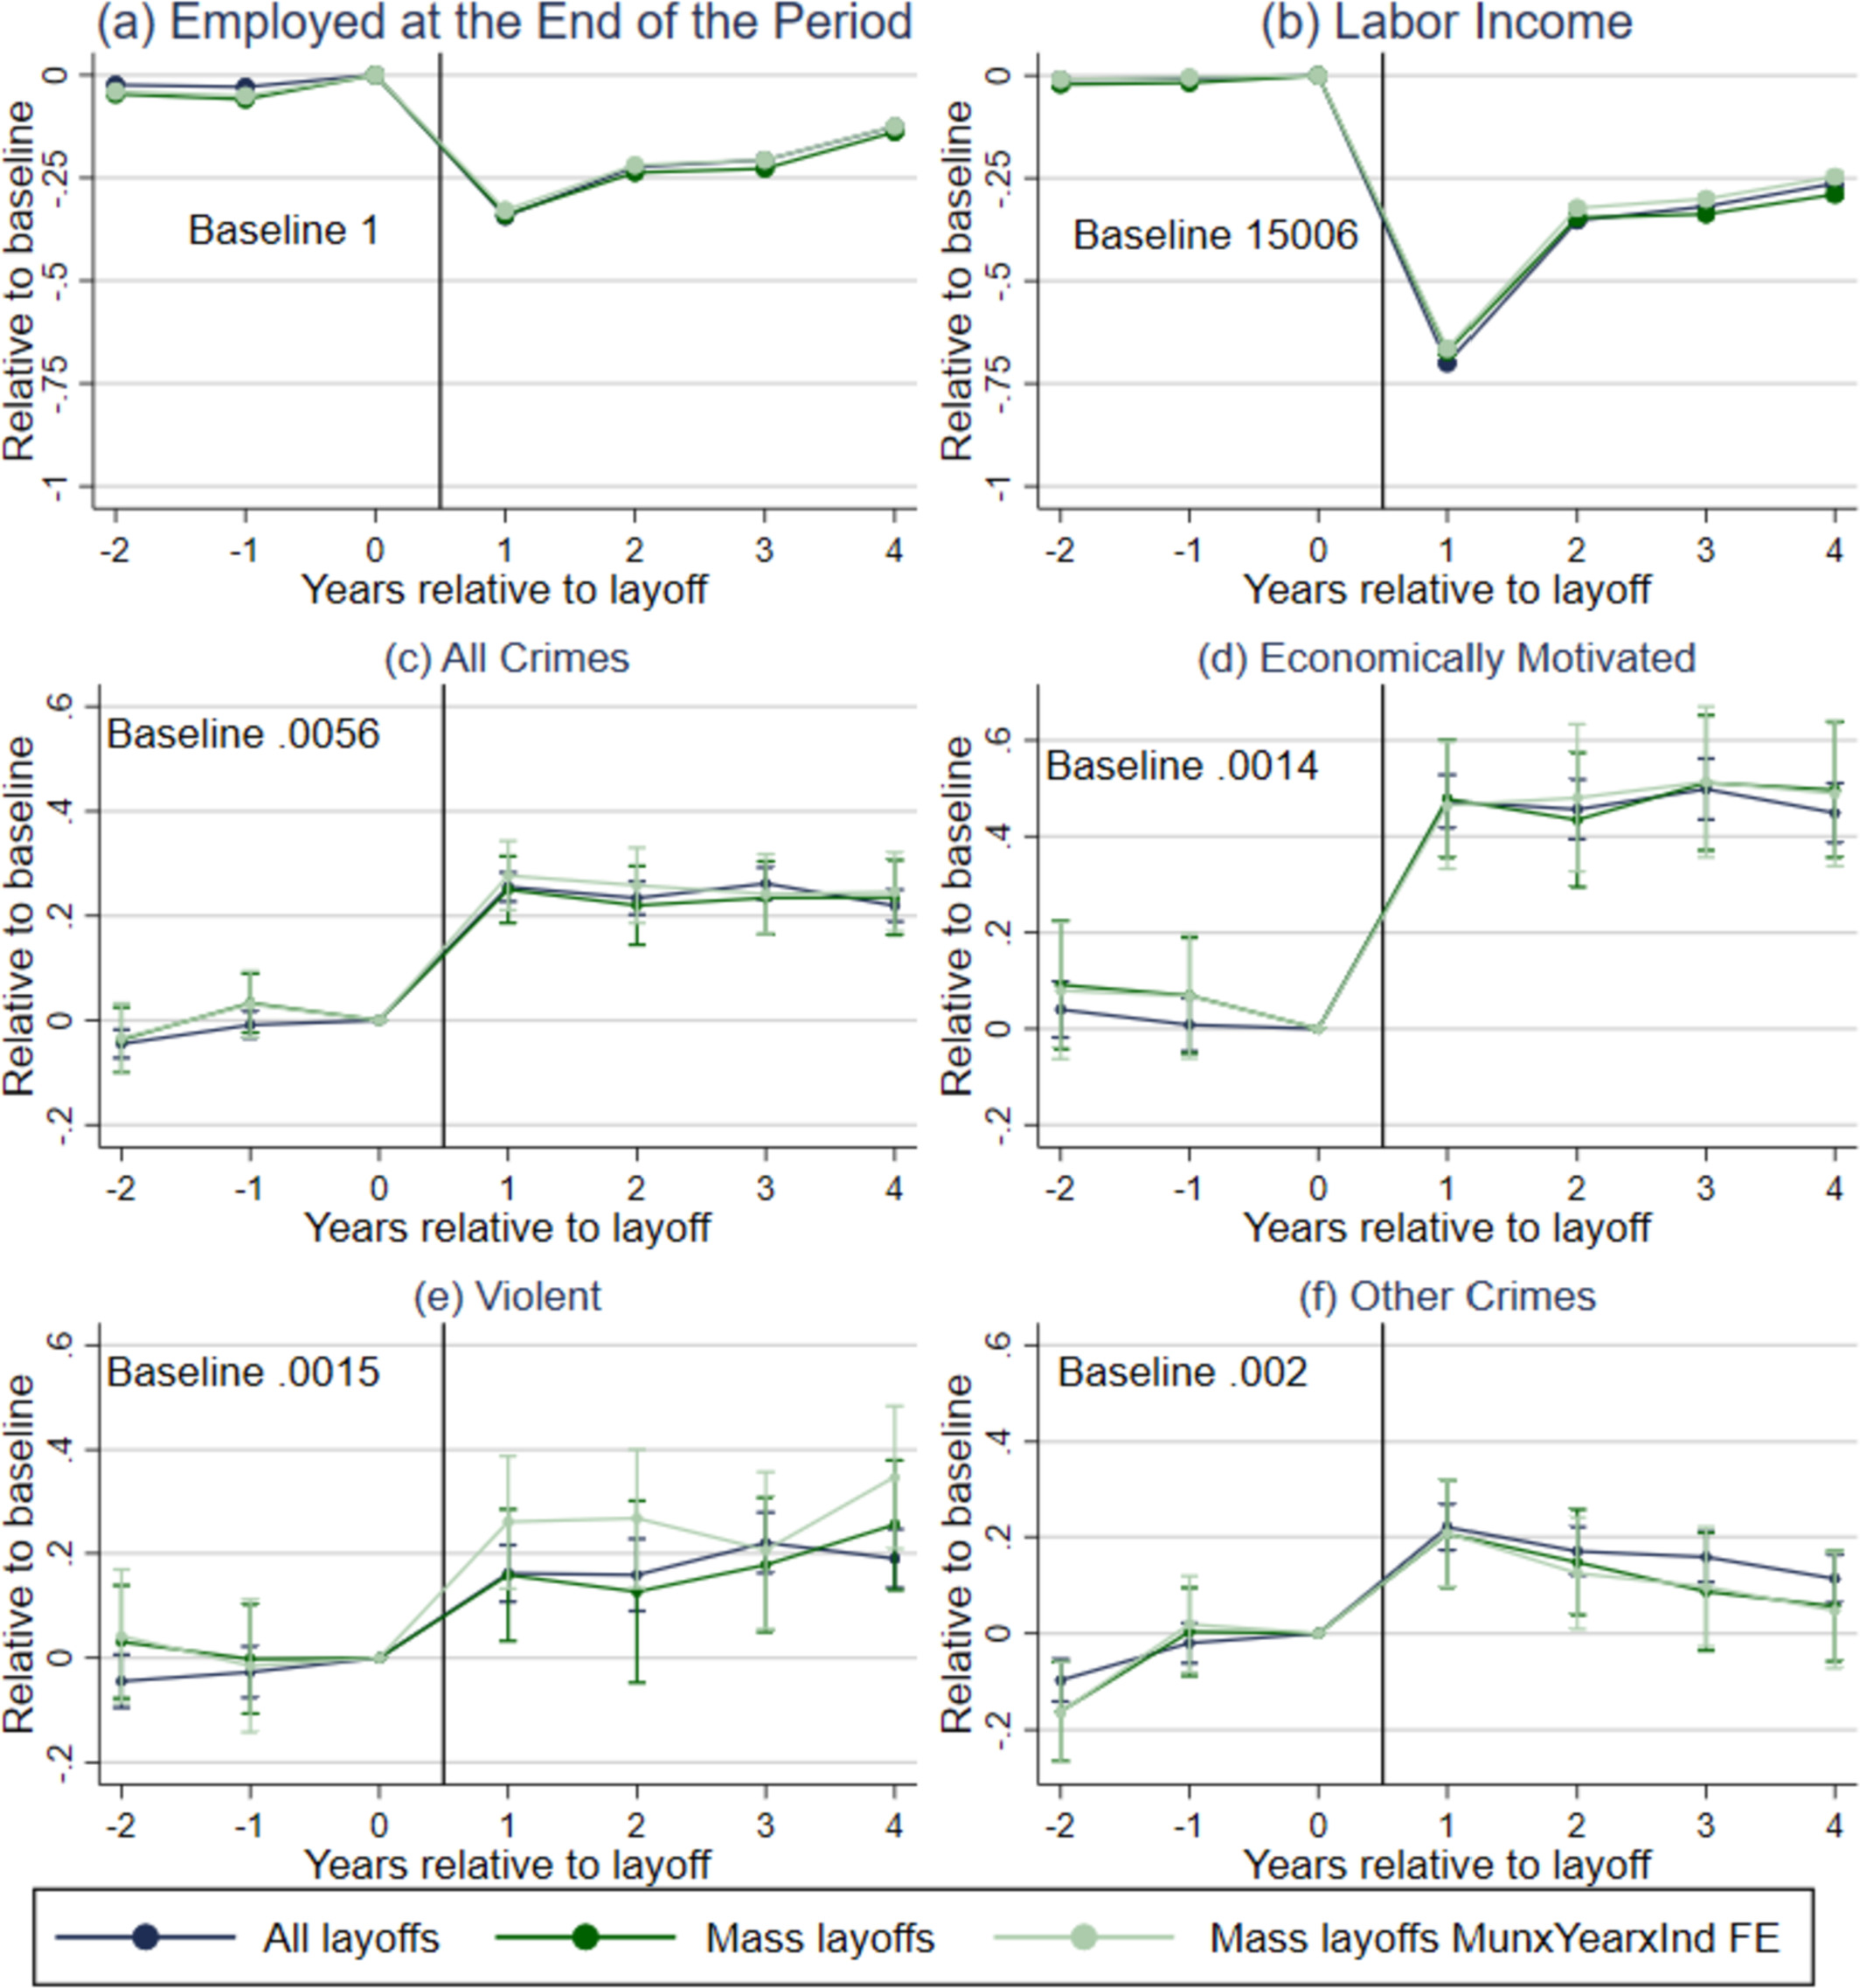

Figure 2

in Table 1, the quantified average effect of job loss changes over the 4 years after dismissal are available. Job loss increases the probability of criminal prosecution by 0.12% and the only causality relation here is from job loss to Crime (all kinds of Crime). Violent Crimes are highly affected by Job loss (around 17%) in contrast with the Becker model.

* *Two Potential Problems in Empirical Studies of Crime*

1. A large proportion of the crimes are not reported. (Soares, Journal of Development Economics, 2004)
2. ensure that the higher probability of prosecution after job loss reflects an actual increase in criminal activity, rather than just an increased likelihood of being prosecuted. For Example, police might target unemployed individuals more intensively, leading to higher prosecution rates independent of actual crime rates. However, most of the studies in this literature didn’t address these two problems.

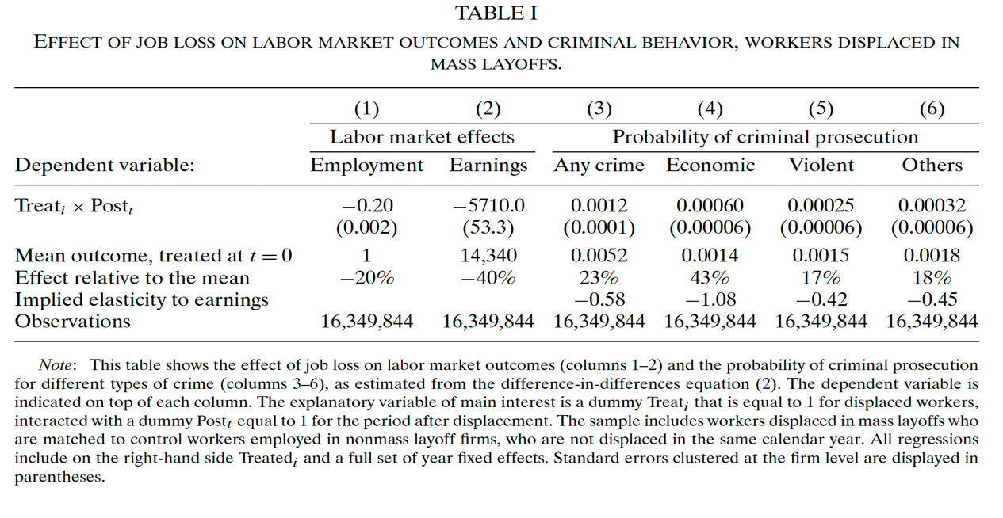

Table 1

* *Heterogeneous Treatment Effects By using Causal Forest analysis*

The importance of the heterogeneous effect of treatment on different individuals in the control group is not deniable. One of the most advanced approaches to address this issue is Causal Forest which able us to identify the most vulnerable subgroups. Causal forests are an extension of random forests, designed specifically for causal inference. They help estimate conditional average treatment effects (CATE) subgroups based on 9 characteristics. This method relies on decision trees to partition the data into subgroups and estimate the treatment effect within each subgroup. The causal forest estimator is used to capture high-dimensional nonlinearities while avoiding overfitting through, the use of both training and estimation samples. This approach is referred to as the “honest approach”. the estimator helps in identifying subpopulations that are more and less affected by job loss in terms of their propensity to commit crimes. For Each individual in the estimation sample, the CATE is predicted by averaging the treatment effects from all the trees in which that individual appears. This gives a tailored estimate of how job loss affects criminal behavior for individuals with specific characteristics. In Figure 3 the results of CATEs based on different characteristics are available.

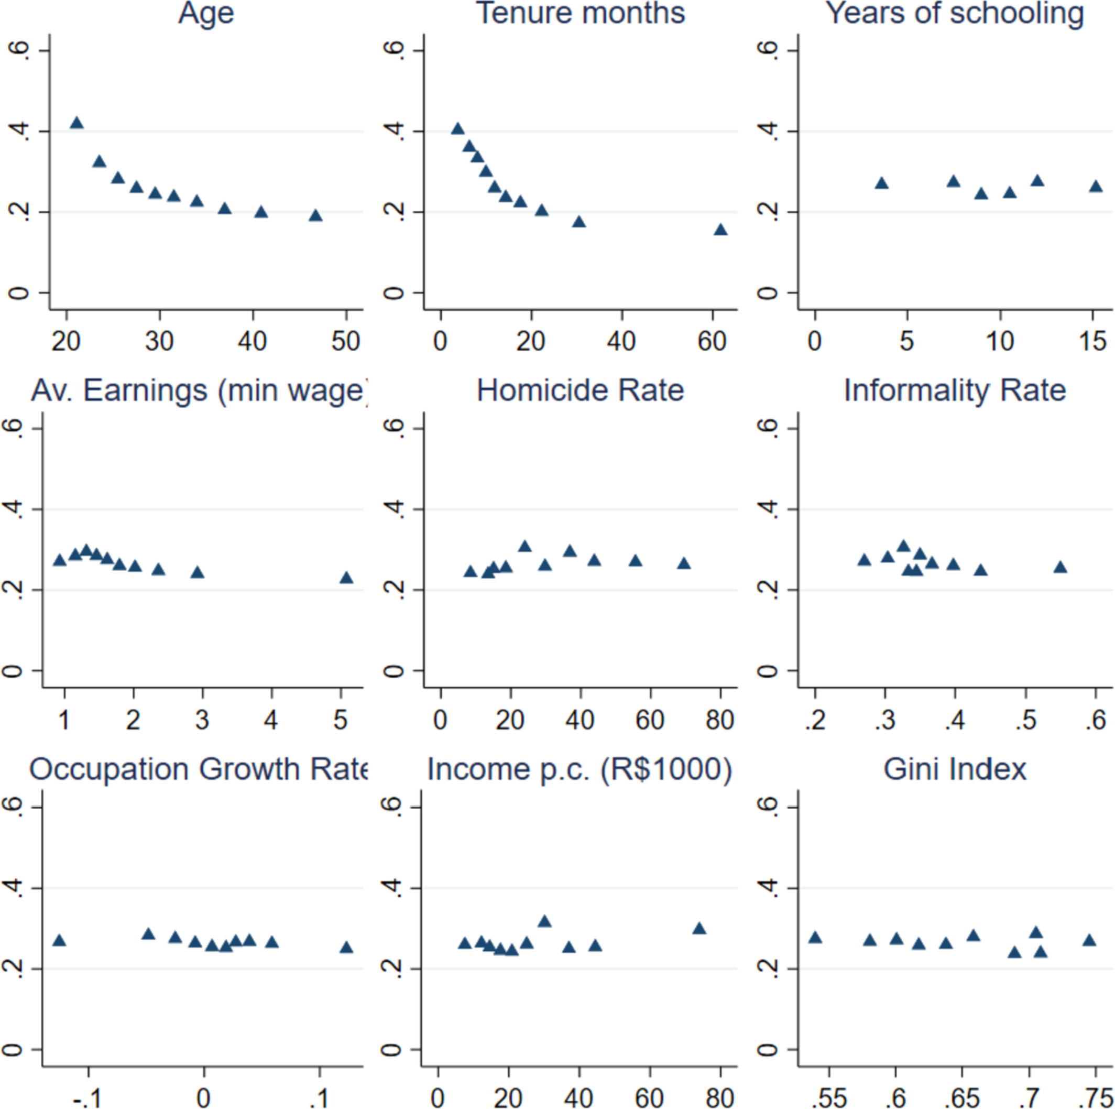

Figure 3

These figures illustrate the heterogeneity in treatment effects. For example, they may show that younger workers or those with shorter job tenure have a higher increase in criminal behavior post-job loss compared to older with younger people with more liquidity Constraints also less generous unemployment benefits. (the importance of liquidity constraints) Age and tenure are the key dimensions of heterogeneity. CATE is flat over other factors in Brazil! In contrast with other countries like Germany and Italy.

* *The Effect of Unemployment Insurance on Crime*

One of the reasons that this paper is so prestigious is that it analyzes the missing part of this literature in detail. Unemployment insurance is the main policy for supporting displaced workers and his paper used the RDD approach to analyze the causal relationship between Unemployment insurance and the crime rate.

Yi= + f (Xi) + i (3)

The main estimates are based on a local linear model with a narrow bandwidth of 60 days (To avoid extrapolation) they did some robust tests to ensure the best bandwidth and 60 days demonstrates the best results. In addition, they Restrict the Sample to Dismissed workers for whom the 16-month eligibility cutoff is binding, workers with at least 6 months of continuous employment at the time of dismissal. The results are available in Figure 4.

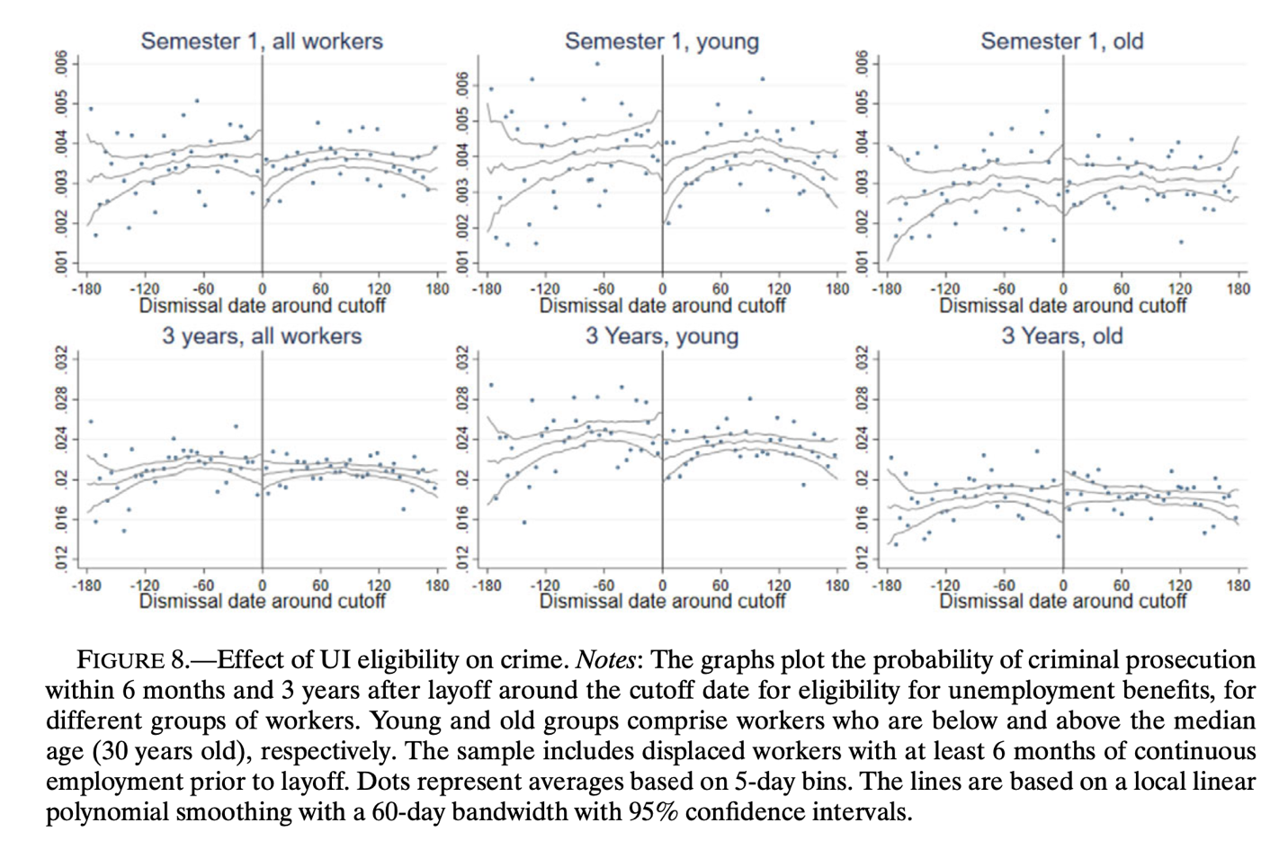

Figure 4

Based on Figure 4 The authors find that unemployment insurance significantly reduces the likelihood of criminal behavior among displaced workers. The crime reduction is particularly notable in the short term, immediately following the job loss. In addition, the reduction in crime rates due to UI is most pronounced within the first six months after job loss. The effect diminishes over time and is less pronounced after the UI benefits expire and the impact of UI on crime is more significant among younger workers and those with lower levels of income or education, suggesting that these groups are more susceptible to economic shocks and benefit more from the financial support provided by UI. In Figure 5 they demonstrate the effect of UI eligibility on crime before and after the layoff, by 6 month period, and demonstrate that the impact of unemployment insurance eligibility on crime is most significant immediately after the layoff, particularly for younger workers. This effect diminishes over time, with the estimates becoming statistically insignificant beyond the initial post-layoff period.

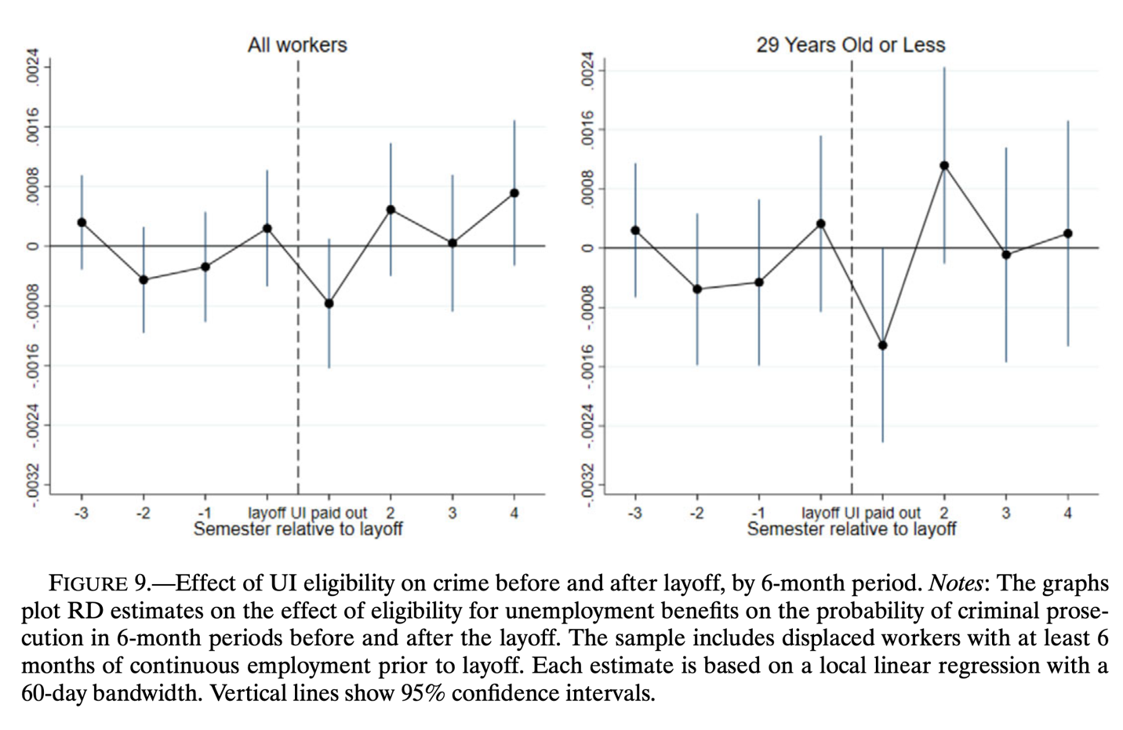

Figure 5

* *The Alternative Mechanism of Crime and Unemployment*

In conclusion, most studies, focus on Economic Mechanisms (Antonello E. Scorcu and Roberto Cellini, 1998), (Britto, Pinotti, Sampaio, 2022), (Bennett and Ouazad, 2019), (Clemens 2021), (*Fougre, Pouget, and Kramarz 2009)* in this type of studies the reduction in the opportunity cost of crime is matter like original Becker model and famous theory of Criminal activity which proposed by Becker 1968 and Ehrlich 1973 “*Displaced workers have more leisure time, and thus a higher probability of engaging criminal activities or Incapacitation effect of employment.”* But there are two other mechanisms too, first, liquidity Constraints and second, Noneconomical explanation. Based on (Britto, Pinotti, and Sampaio, 2022) eligible workers for UI commit fewer crimes than non-eligible till they receive the UI, in contrast with the Becker model which does not mention anything about Unemployment Insurance and the effects of that. The Unemployment Benefits can influence the opportunity cost of crime in two pathways, first, UI reduces the payoff of formal work, and second, the UI is not canceled if you commit a crime. In addition, liquidity constraints are a main factor that is underestimated in this literature, and this issue causes the higher crime rate after job loss for 2 reasons, first, the negative effect of UI eligibility on the probability of committing crimes based on the results in previous section and timing effect of UI. figure 6 demonstrates the summary of the relationships.

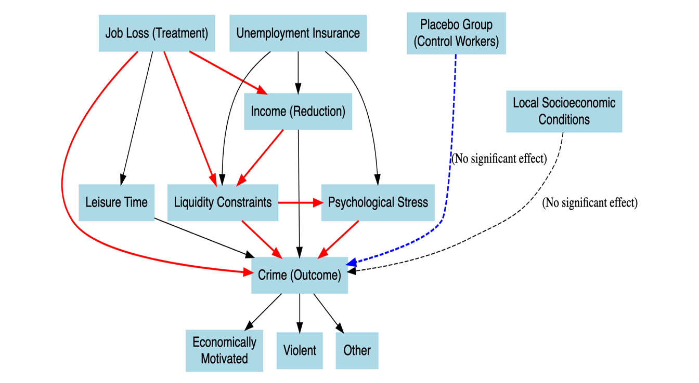

Figure 6

For noneconomical crimes, there are some papers but this part of the literature is immature (Kuhn, Lalive, and Zweimüller (2009), Charles and DeCicca (2008), Zimmer (2021). One of the other problems of the previous studies in this literature is that they mask the Labour regulations. We can divide the different labor regulations into 4 types: At-Will Employment, Just Cause Employment, Fixed-Term Contracts, and Collective Bargaining Agreements. The *United States* isPredominantly at-will, with exceptions in certain states for public policy, implied contracts, and covenants of good faith. *Europe (e.g., UK, Germany, France)* hasJust cause is required, with mandatory severance pay and fair process. *Japan has* Just cause, where dismissals need to be objectively reasonable and follow a fair process. In addition, the employment system in Japan is mostly influenced by the Keiretsu structure.

* *Result*

*In conclusion in most countries, the Becker model is valid and we can say that the causal relationship between youth unemployment and Crime rates is dependent on the Judicial system, employment system, the type of data that is available, the Unemployment insurance system of countries and the different definition of the crime.* For example, A person found with a few grams of Marijuana in Rio de Janeiro might be referred to a drug education program and not punished (under Law No. 11,343, passed in 2006) but a person caught with a small amount of cannabis in Paris might be fined Up to 3750 euro or up to one year sentence. (can be found under Article L3421-1 of the Code of Public Health (Code de la santé publique). (in Brazil you can make excuses for drug trafficking but in France is not possible).

* Bibliography

1. Britto, D. G. C., Pinotti, P., & Sampaio, B. (2022). The Effect of Job Loss and Unemployment Insurance on Crime in Brazil. *Econometrica, 90*(4), 1393-1423.
2. Becker, G. S. (1968). Crime and Punishment: An Economic Approach. *Journal of Political Economy, 76*(2), 169-217.
3. Fougère, D., Pouget, J., & Kramarz, F. (2009). Youth Unemployment and Crime in France. *Journal of the European Economic Association, 7*(5), 909-938.
4. Khanna, G., Medina, C., Nyshadham, A., Tamayo, J., & Torres, N. (2023). Formal Employment and Organised Crime: Regression Discontinuity Evidence from Colombia. *The Economic Journal, 133*(654), 2427-2448.
5. Dix-Carneiro, R., Soares, R. R., & Ulyssea, G. (2018). Economic Shocks and Crime: Evidence from the Brazilian Trade Liberalization. *American Economic Journal: Applied Economics, 10*(4), 158-195.
6. Dell, M., Feigenberg, B., & Teshima, K. (2019). The Violent Consequences of Trade-Induced Worker Displacement in Mexico. *AER: Insights, 1*(1), 43-58.
7. Öster, A., & Agell, J. (2007). Crime and Unemployment in Turbulent Times. *Journal of the European Economic Association, 5*(4), 752-775.
8. Rege, M., Skardhamar, T., Telle, K., & Votruba, M. (2019). Job Displacement and Crime: Evidence from Norwegian Register Data. *Labour Economics, 61*, 101761.
9. Goldsmith-Pinkham, P., Sorkin, I., & Swift, H. (2019). Bartik Instruments: What, When, Why, and How. *National Bureau of Economic Research Working Paper Series*. No. 24408.
10. Baker, A. C., Larcker, D. F., & Wang, C. C. Y. (2021). How Much Should We Trust Staggered Difference-In-Differences Estimates? *Harvard Business School Working Paper*, No. 21-112.
11. Cantor, D., & Land, K. C. (1985). Unemployment and Crime Rates in the Post-World War II United States: A Theoretical and Empirical Analysis. *American Sociological Review, 50*(3), 317-332.
12. Clemens, M. A. (2021). Violence, development, and migration waves: Evidence from Central American child migrant apprehensions. *Journal of Urban Economics, 124*, 103355.
13. Altindag, D. T. (2012). Crime and Unemployment: Evidence from Europe. *International Review of Law and Economics, 32*(2), 145-157.
14. Soares, R. R. (2004). Development, Crime, and Punishment: Accounting for the International Differences in Crime Rates. *Journal of Development Economics, 73*(1), 155-184.
15. Bennett, P., & Ouazad, A. (2019). Job Displacement, Unemployment, and Crime: Evidence from Danish Microdata and Reforms. *Journal of the European Economic Association*.
16. Britto, D. G. C., Pinotti, P., & Sampaio, B. (2022). The Effect of Job Loss and Unemployment Insurance on Crime in Brazil. *Econometrica, 90*(4), 1393-1423.
17. Gould, E. D., Weinberg, B. A., & Mustard, D. B. (2002). Crime Rates and Local Labor Market Opportunities in the United States: 1979-1997. *The Review of Economics and Statistics, 84*(1), 45-61
18. Entorf, H., & Spengler, H. (2000). Socioeconomic and Demographic Factors of Crime in Germany: Evidence from Panel Data of the German States. *International Review of Law and Economics, 20*(1), 75-106.
19. Scorcu, A. E., & Cellini, R. (1998). Economic Activity and Crime in the Long Run: An Empirical Investigation on Aggregate Data from Italy, 1951–1994. International Review of Law and Economics, 18(3), 279-292.
20. Lee, D. Y., & Holoviak, S. J. (2006). Unemployment and Crime: An Empirical Investigation. *Applied Economics Letters, 13*(12), 805-810.
21. Papps, K., & Winkelmann, R. (2000). Unemployment and Crime: New Evidence for an Old Question. *New Zealand Economic Papers, 34*(1), 53-71.
22. Torruam, J. T., & Abur, C. C. (2014). The Relationship between Unemployment, Inflation, and Crime: An Application of Cointegration and Causality Analysis in Nigeria. *Journal of Economics and Sustainable Development, 5*(4), 131-137.
23. Torres-Tellez, J., & Montero Soler, A. (2023). After the Economic Crisis of 2008: Economic Conditions and Crime in the Last Decade for the Case of Spain. *American Journal of Economics and Sociology, 82*(3), 223-239.