Supplementary Information for
Detailed modeling of particle separation by microsieving in a rotating belt filter: explicit effect of particle size, mesh size, and polymer dose

Furqan Ahmad Khan ^{a,c}, Pankaj Chowdhury ^{b,c} , Francesca Giaccherini ^{a,c}, Anthony Gerald Straatman ª and Domenico Santoro ^{b,c*}

ª Department of Mechanical & Materials Engineering, Western University, London, Ontario, Canada, N6A 5B9
^{b} Department of Chemical and Biochemical Engineering, Western University, London, Ontario, Canada, N6A 5B9
^{c} Trojan Technologies, London, ON, N5V4T7, Canada

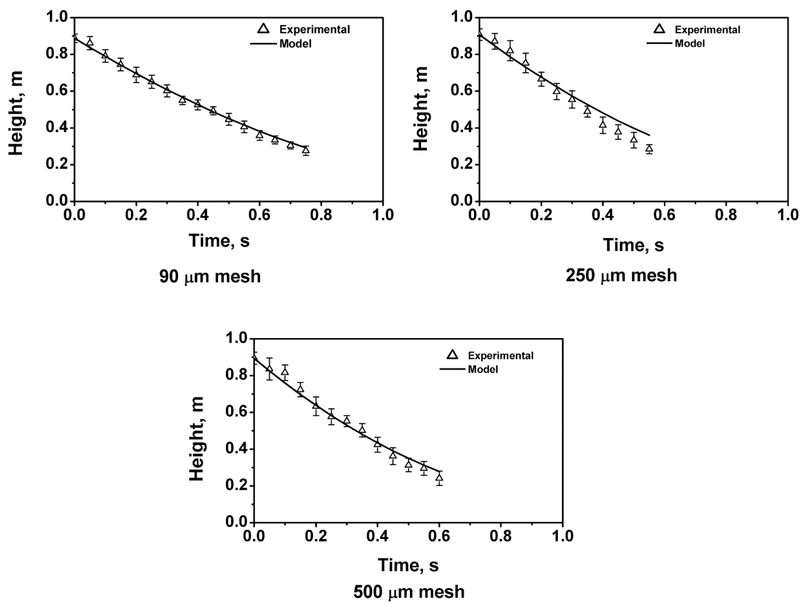
Fig. SI1. Clean water drainage column tests for 90, 250, and 500 µm mesh sizes with model predictions.

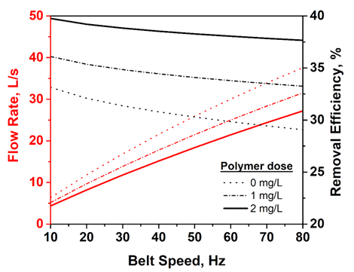
Fig. SI2. Predicted flow rates and $TSS$ removal efficiency as a function of belt speed and polymer.

Table SI1. SF2000 Details
Belt length | 0.85 m
Belt width | 0.48 m
Linear belt velocity | 0.015 – 0.247 m/s (5 – 80 Hz)
Size of the equipment (L x W x H) | 2 m x 1.7 m x 1.3 m

Table SI2. Experimental Summary Table
Dataset Name | Objective | Validation range | Quantity
CWDC | mesh resistance evaluation | mesh size (µm): 54, 90, 158, 250, 350, 500, 840  ${TSS}_{in}$ (${mg}/L$): 0 | 70 total experiments with 10 replicates for each mesh size
WWDC-1 | cake resistance evaluation | mesh size (µm): 158, 250, 350  ${TSS}_{in}$ (${mg}/L$): 183, 200, 264, 324, 533 | 29 total experiments with multiple replicates for different mesh size and ${TSS}_{in}$ combinations
WWDC-2 |  | mesh size (µm): 54, 158, 350  ${TSS}_{in}$ (${mg}/L$): 152, 221 | 11 total experiments with multiple replicates for different mesh size and ${TSS}_{in}$ combinations
WWS | TSS_{out} coefficients evaluation | mesh size (µm): 54, 90, 158, 250, 350  ${TSS}_{in}$ (${mg}/L$): 152, 161, 191, 211, 242 | 25 total experiments for different mesh size and ${TSS}_{in}$ combinations
PC | cake resistance and TSS_{out} coefficients calibration | mesh size (µm): 350  ${TSS}_{in}$ (${mg}/L$): 207-350  polymer dose (${mg}/L$): 0-6  belt speed (Hz): 8-72 | 50 sampling points with SF2000
PV | model validation | mesh size (µm): 350  ${TSS}_{in}$ (${mg}/L$): 169-300  belt speed (Hz): 13-80 | 1623 sampling points with SF2000
Korea | cake resistance and TSS_{out} coefficients calibration against pilot data at three international locations | mesh size (µm): 150  ${TSS}_{in}$ (${mg}/L$): 196-445  belt speed (Hz): 15-99 | 47 sampling points  with SF1000
USA |  | mesh size (µm): 350  ${TSS}_{in}$ (${mg}/L$): 104-1046  belt speed (Hz): 40-80 | 183 sampling points  with SF1000
Australia |  | mesh size (µm): 250, 350  ${TSS}_{in}$ (${mg}/L$): 132-946  belt speed (Hz): 5-80 | 49 sampling points  with SF1000
Table SI3. Retrieved model coefficients error for sampling scenario 1 against base value of coefficients given as: B_{o} = 0.728 $L/{mg}$, b_{t} = 0.345, k = 0.01 $L/{mg}$, γ = 0.499 ${m^{2}}/{m^{3}}$. The model was simulated by adding a 20% random error to the artificial pilot data (obtained from BSM2 both for flow and influent TSS).
Sampling duration (h) | Retrieved coefficients error (%)
 | B_{o} | b_{t} | k | γ
1 | 232.4 | 5.5 | 10.2 | 33.0
2 | 260.0 | 31.0 | 29.8 | 84.1
4 | 185.0 | 21.1 | 23.9 | 61.9
8 | 20.0 | 3.7 | 6.5 | 14.2
16 | 17.3 | 6.4 | 3.1 | 7.6
32 | 16.3 | 6.4 | 4.4 | 11.3
64 | 12.4 | 4.7 | 3.3 | 10.2
128 | 10.3 | 4.4 | 3.3 | 9.5

Table SI4. Retrieved model coefficients error for sampling scenario 2 against base value of coefficients given as: B_{o} = 0.728 $L/{mg}$, b_{t} = 0.345, k = 0.01 $L/{mg}$, γ = 0.499 ${m^{2}}/{m^{3}}$. The model was simulated by adding a 20% random error to the artificial pilot data (obtained from BSM2 only for influent TSS. Refer to Table 1 for flow pattern details).
Coefficient | Sampling duration (h) | Retrieved coefficients error (%)
 |  | Pattern-1 | Pattern-2 | Pattern-3 | Pattern-4 | Pattern-5
B_{o} | 1 | 172.4 | 286.1 | 150.4 | 185.3 | 333.5
 | 2 | 386.7 | 142.8 | 108.1 | 68.7 | 25.1
 | 3 | 283.6 | 98.8 | 25.2 | 3.9 | 21.3
 | 4 | 360.9 | 16.8 | 29.3 | 12.4 | 18.7
 | 5 | 157.1 | 24.2 | 8.8 | 17.3 | 19.6
b_{t} | 1 | 6.2 | 17.2 | 9.7 | 6.9 | 46.6
 | 2 | 59.4 | 10.8 | 3.7 | 18.3 | 5.4
 | 3 | 30.6 | 7.7 | 5.3 | 0.1 | 7.5
 | 4 | 53.8 | 0.1 | 10.4 | 3.5 | 6.0
 | 5 | 21.5 | 4.3 | 2.6 | 6.3 | 7.8
k | 1 | 27.8 | 3.7 | 30.3 | 32.2 | 36.7
 | 2 | 24.3 | 33.0 | 34.9 | 18.7 | 8.2
 | 3 | 21.2 | 37.5 | 14.6 | 3.9 | 2.9
 | 4 | 29.8 | 23.9 | 3.5 | 1.9 | 4.6
 | 5 | 15.0 | 13.3 | 2.1 | 3.9 | 6.1
γ | 1 | 87.2 | 3.4 | 87.2 | 93.4 | 98.0
 | 2 | 71.2 | 90.5 | 88.0 | 45.7 | 21.3
 | 3 | 64.7 | 93.0 | 35.6 | 11.5 | 8.5
 | 4 | 83.1 | 55.1 | 7.2 | 5.4 | 14.8
 | 5 | 40.9 | 33.1 | 7.9 | 11.5 | 18.1

