1: H₂O
A- Basic information of materials
(Crystal structure, molecular formula, molecular name, etc.)
It is better to provide the structure file in .cif format or lattice constant atomic coordinates.
1. Water molecule (H₂O)
2. Zinc sulfate Heptahydrate (ZnSO₄·7H₂O)

B- Calculation content
What specific content do you want to calculate, such as material properties, reactions, etc., can be listed in sections:
1. Binding energy
a. The binding energy between O atom of H₂O with Zn²⁺. Connection type: Zn²⁺···O (in H₂O).
b. The binding energy between different H₂O molecules. Connection type: H (in H₂O)···O (in H₂O).
Note: In the aqueous electrolyte that is composed of 2 mol/L ZnSO₄·7H₂O and aqueous solvent (100 vol.% H₂O), there are six H₂O molecules in the primary solvent sheath of Zn²⁺ ions.[1]
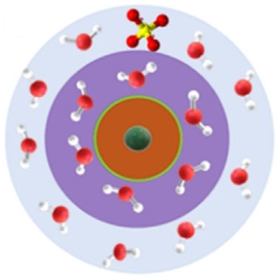

References:
[1] Hao, J., Yuan, L., Ye, C., et al.: Boosting Zn electrode reversibility in aqueous electrolyte using low-cost antisolvents. Angew. Chem. Int. Ed. 60, 2-12 (2021). https://doi.org/https://doi.org/10.1002/anie.202016531

