Assignment:
- Create a MS Word document in a portrait format. Make the margins: Left 3, top and bottom 1,5, left – 1 см
- Copy the body test from the document acrticle_text.docx
- Title the text The Ecopolitical Post-Trump Covid-19 Landscape of the United States from a Global Perspective
- Format the body text
  - Font type: Times New Roman
  - Font size: 14
  - Interlineal interval: 1,2
  - The first line indent: 1,25
  - Body text is justified.
- Format the headers: Times New Roman, 14, bold, center alignment
- The author of the text has put an extra space before the percent sign (%). Delete the space it using find and replace function. Tell me how many replacement did the program make.
- Add page numbers – centers in the bottom of the page.
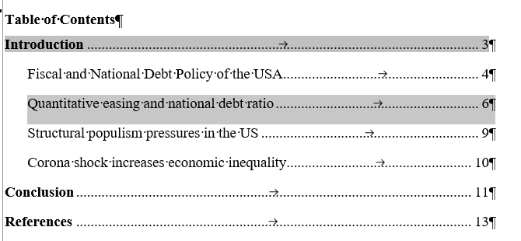
- Add in the text “Figure 1” and add after this paragraph picture 1. Title it “Long-term nominal interest rates (government bonds) in the US, the Eurozone, Germany and the UK”. Do the same with Figure 2, name it Absolute US GDP IMF growth forecasts relative to 2017 GDP. Make sure that you have wrap text to top and bottom around the pictures.
- Create the following automatic table of content (mind that page numbers will be different)
- Draw the following table. Add it to where the author mentions table