Groundwater and contaminant flow
Project 2: groundwater extraction
Group 18

Javad Gholizadehledari

Table of contents

Table of contents 3
1 4
1.1 4
Attachments 4
References 4

Introduction
The objective of this assignment is to analyze a construction pit in which groundwater is extracted in order to prevent instability at the base of the excavation. Such instability arises from excessive equipotential heads between two impermeable layers, resulting in a high upward hydraulic pressure in the confined aquifer that may cause uplift or heave of the soil. To mitigate this risk, the groundwater level is lowered to ensure a stable and dry working environment.
This drawdown is achieved by installing a system of extraction wells, each with a diameter of $20 cm$. The reduction of the groundwater table depends on several parameters, including the pumping capacity, local topography, and the radius of influence of each well. The radius of influence is of particular importance for the subsequent analysis.
An initial configuration of the extraction wells positioned around the perimeter of the excavation is shown in Figure 2. The center of each well is located at a distance of 1 m from the edge of the construction pit. The objective is to optimize this layout such that the required drawdown is achieved with the minimum number of wells, thereby ensuring an economically efficient design. Figure 1 presents the dimensions of the construction pit, expressed in centimeters, together with the relevant soil layers and their corresponding hydraulic conductivities.

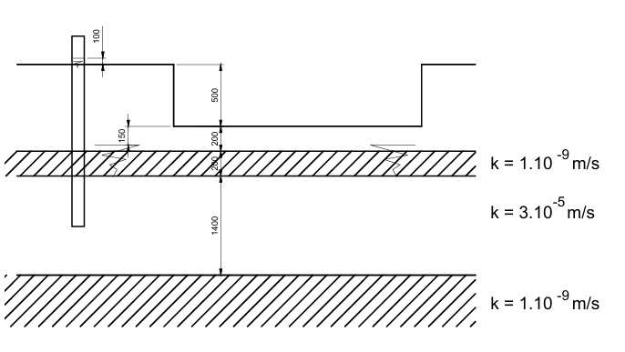
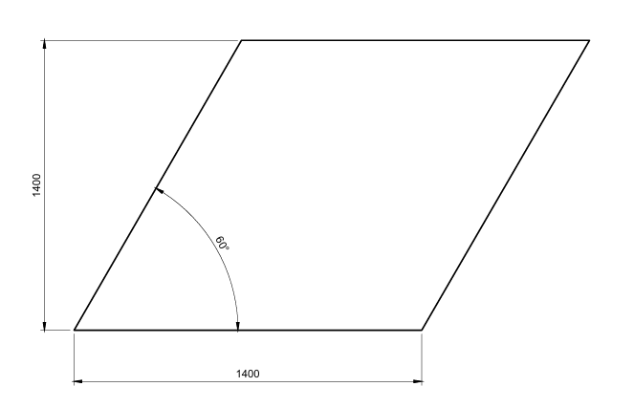

Reduction of the equipotential height
To ensure stability, the hydraulic pressure within the confined layer must be reduced. The upward and downward hydraulic pressures are imposed as boundary conditions in the model. The following values are adopted for the determination of these parameters:
$$h_{sand}=2 m$$
$$r_{sand,dry}=1600\frac{kg}{m^{3}}*10\frac{N}{kg}=16\frac{kN}{m^{3}}$$
$$h_{clay}=2 m$$
$$r_{clay}=2000\frac{kg}{m^{3}}*10\frac{N}{kg}=20\frac{kN}{m^{3}}$$
The downward pressure equals to:
$$p_{down}=\left(h_{sand}*r_{sand,dry}+h_{clay}*r_{clay}\right)=56\frac{kN}{m^{2}}$$

Conversely, the upward hydraulic pressure is governed by the equipotential head, denoted by $h_{a}$.
$$p_{up}=10\frac{kN}{m^{3}}*h_{a}$$

The bottom of the confined layer is taken as the reference datum. Initially, as illustrated in Figure 1, the equipotential head in Equation (2) equals 24 m. To prevent uplift of the soil at the base of the excavation, the hydraulic pressure must remain lower than the stabilizing pressure due to gravity. To account for additional safety, safety factors are applied, whereby the downward pressure is multiplied by 0.9 and the upward pressure is increased by a factor of 1.1.

$$0.9*p_{down}>1.1*p_{up}$$

In addition, a reduction of 0.5 m is applied to the hight to account for uncertainties related to the permeability and homogeneity of the soil. Furthermore, a height of 14 m is added to account for the adopted reference plane.

$$h_{a}<\frac{0.9}{1.1}*\frac{56\frac{kN}{m^{2}}}{10\frac{kN}{m^{3}}}-0.5 m+14 m=18.08 m$$

Preliminary layout of the extraction wells
Since the number of extraction wells is not specified in the project description, an initial layout is proposed. An initial configuration consisting of six extraction wells is assumed, as this number is expected to be more than sufficient to ensure a reduction of the equipotential head. This configuration is subsequently optimized by systematically reducing the number of wells while maintaining stability.

Critical point
A critical point is defined as a location at which the influence of the extraction wells is minimal. Along the perimeter of the construction pit, a total of six such critical points are expected to occur. Their positions are determined by evaluating the product of the distances between an initially unknown critical point ($x_{crit}, y_{crit}$) and the surrounding extraction wells located at ($x_{i}, y_{i}$). Critical points correspond to the locations where this distance product attains a maximum.

$$f\left(x,y\right)=\prod_{i=1}^{6}{\sqrt{{\left(x_{crit}-x_{i}\right)}^{2}+{\left(y_{crit}-y_{i}\right)}^{2}}}$$

In the initial proposed configuration, the most critical point is identified at the coordinates ($18, 14$).
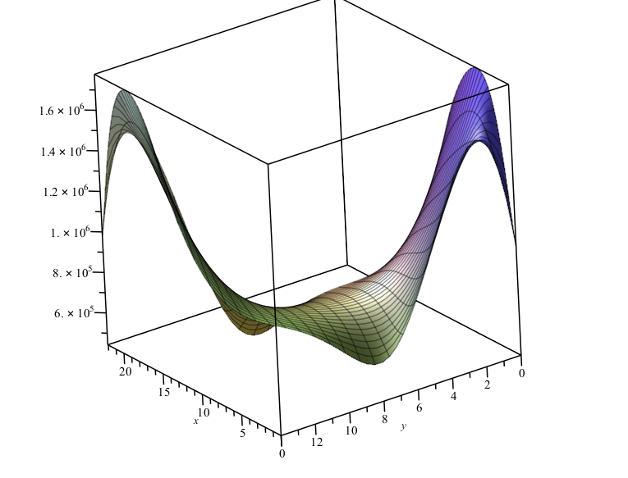

Values on y=14
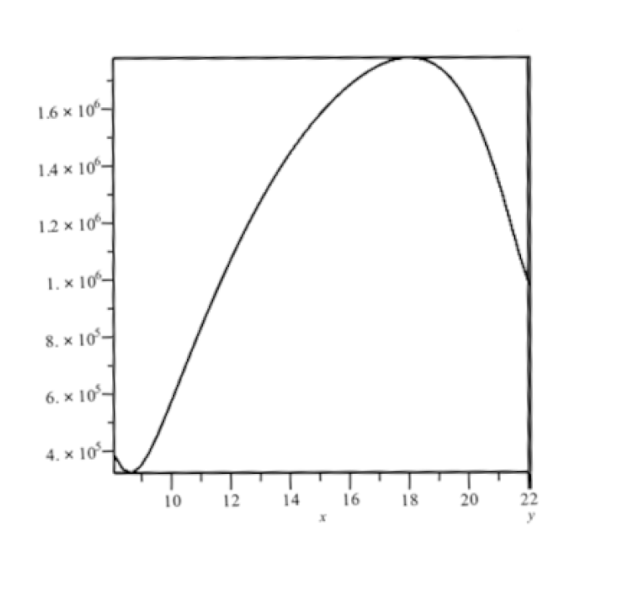

Determination of the required discharge and verification of the maximum admissible discharge
For the proposed initial configuration consisting of six extraction wells, the required pumping discharge is determined assuming radial flow in a confined aquifer. The aquifer is characterized by a hydraulic conductivity of $k=3*{10}^{-5}\frac{m}{s}$ and a constant thickness $D=14 m$. The initial equipotential head is equal to $H=24 \text{m}$, while the maximum allowable equipotential head at the critical point along the pit boundary is $h_{a}=18.08 \text{m}$.

The radius of influence of each well $R_{i}$is calculated using the empirical relation

$$R_{i}=3000 (H-h_{i})\sqrt{k}$$
where $h_{i}$ denotes the equipotential head in well $i$. This relation is combined with the principle of superposition to formulate a system of governing equations.

For the critical point along the boundary of the building pit, the following equation is written:
$$H-h_{a}=\frac{Q}{2*π*k*D}*\left[\ln\left(\prod_{i=1}^{6}{R_{i}}\right)-\ln\left(\prod_{i=1}^{6}{r_{A,i}} \right)\right]$$
where $r_{A,i}$ represents the distance between the critical point and well $i$.

In addition, an equation is formulated for each individual well to determine the drawdown inside the wells. Based on superposition, this yields
$$h_{a}-h_{i}=\frac{Q}{2*π*k*D}*\left[\ln\left(\prod_{i=1}^{6}{r_{A,j}}\right)-\ln\left(\prod_{i=1}^{6}{r_{i,j}} \right)\right]$$
with $r_{i,j}$the distance between well $i$ and well $j$. For $i=j$, this distance is taken equal to the well radius ($r_{ii}=r_{w}=0.1 \text{m}$) in order to avoid logarithmic singularities

The resulting non-linear system of seven equations with seven unknowns ($Q,h_{1},…,h_{6}$) is solved numerically using Maple.

The solution yields a required discharge of

$$Q=1.09*{10}^{-3}\frac{m^{3}}{s}$$
with equipotential heads in the wells ranging between approximately $16.38 \text{m}$ and $17.00 \text{m}$. The smallest of these values governs the verification of the maximum admissible discharge.

The maximum admissible discharge per well is calculated as

$$Q_{max⁡,i}=\frac{2*π*h_{min}*\sqrt{k}}{15}$$
Using the minimum equipotential head ($h_{min}=16.38 \text{m}$), the following value is obtained:

$$Q_{max}≈3.76⋅{10}^{-2} {\text{m}}^{3}/\text{s}.$$
Since the required discharge satisfies $Q≪Q_{max}$, the proposed configuration is hydraulically feasible and the extraction wells operate well within their allowable capacity. Consequently, the initial configuration with six extraction wells is sufficient and provides a suitable basis for further optimisation by reducing the number of wells.

optimisation
Since Q << Q_max for the 8-well configuration, the number of wells can be reduced to find the most economical solution. The optimization is performed by systematically reducing the number of wells while ensuring Q < Q_max.

5.1 Configuration with 6 Wells
Parameter | Value
Required Q | 1.0949 L/s
h_min | 16.56 m
Q_max | 7.60 L/s
Status | ✓ Valid

5.2 Configuration with 5 Wells
Parameter | Value
Required Q | 1.3098 L/s
h_min | 16.18 m
Q_max | 7.43 L/s
Status | ✓ Valid

5.3 Configuration with 4 Wells
Parameter | Value
Required Q | 1.5885 L/s
h_min | 15.71 m
Q_max | 7.21 L/s
Status | ✓ Valid

5.4 Configuration with 3 Wells (OPTIMAL)
Parameter | Value
Required Q | 2.1372 L/s
Total Q (3 wells) | 6.41 L/s
h_min | 14.83 m
Q_max | 6.80 L/s
Q/Q_max | 31.41%
Status | ✓ OPTIMAL
The 3-well configuration is selected as the optimal solution, providing the minimum number of wells while maintaining Q < Q_max with adequate safety margin.

6. Maple Analysis Results

6.1 Input Parameters (Maple)
# Maple Input Parameters
k:= 3*10^(-5); # Hydraulic conductivity [m/s]
D := 14; # Aquifer thickness [m]
H := 24; # Initial piezometric head [m]
h_A: = 18.08; Required head at critical point [m]
r_w: = 0.20; Well radius [m]
n:= 3;# Number of wells (optimal)

6.2 Well Positions (3-Well Optimal)
Well | X [m] | Y [m]
W1 | 9.333 | -1.000
W2 | 21.000 | 13.124
W3 | 3.801 | 8.583
Critical Point: A = (0.00, 0.00) m (Vertex V1)

6.3 Maple Solution Output
# Maple fsolve output:
Q = 2.1372e-03 m³/s = 2.14 L/s
h [1] = 15.42 m, R [1] = 140.93 m
h [2] = 15.08 m, R [2] = 146.57 m
h [3] = 14.83 m, R[3] = 150.67 m
h_min = 14.83 m
Q_max = 6.80 L/s
Verification: Q < Q_max

8. Visualizations
Figure 1: All Well Configurations Overview
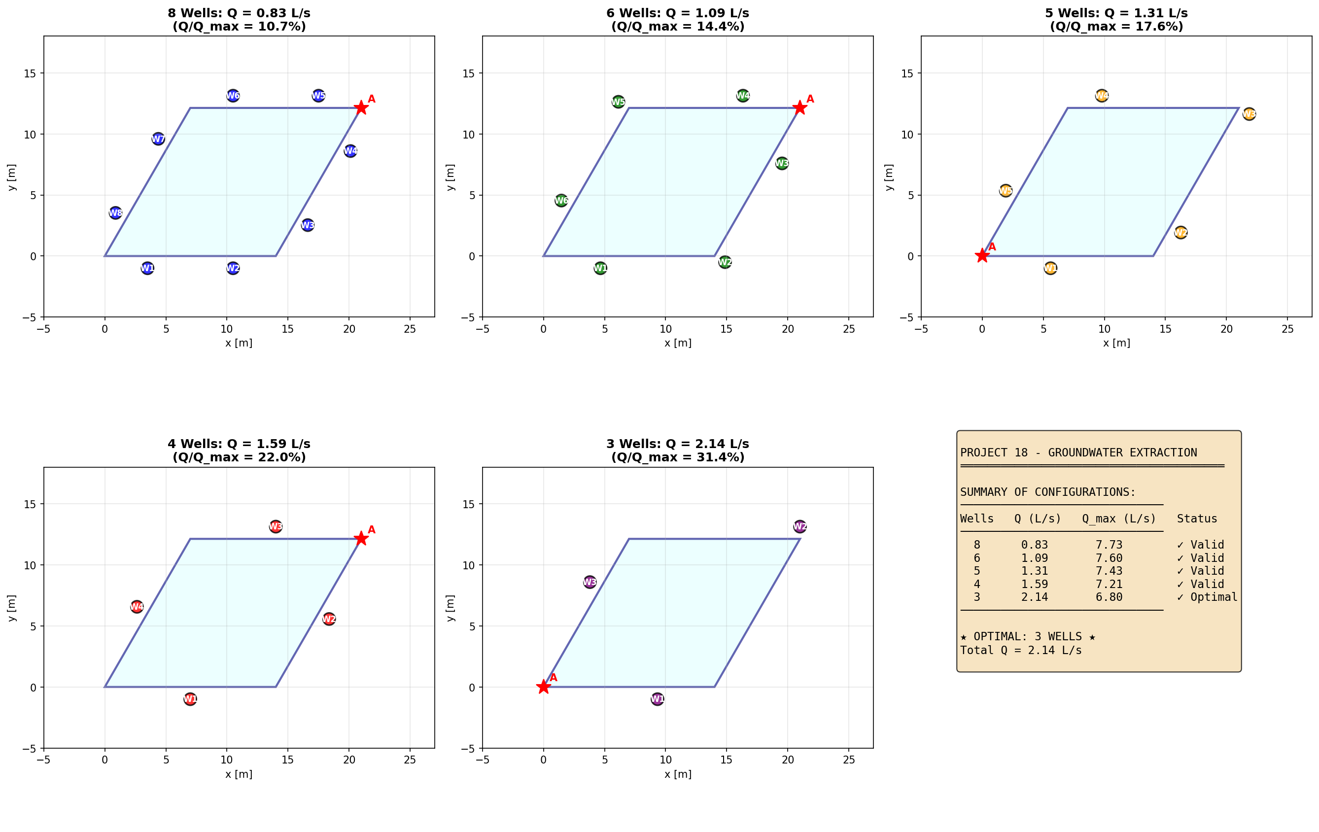

Figure 2: Optimal 3-Well Configuration Detail
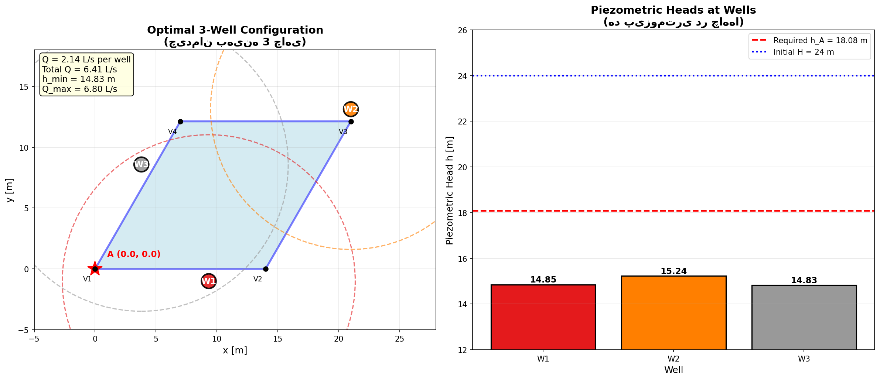
Figure 3: 3D Piezometric Surface and Contours
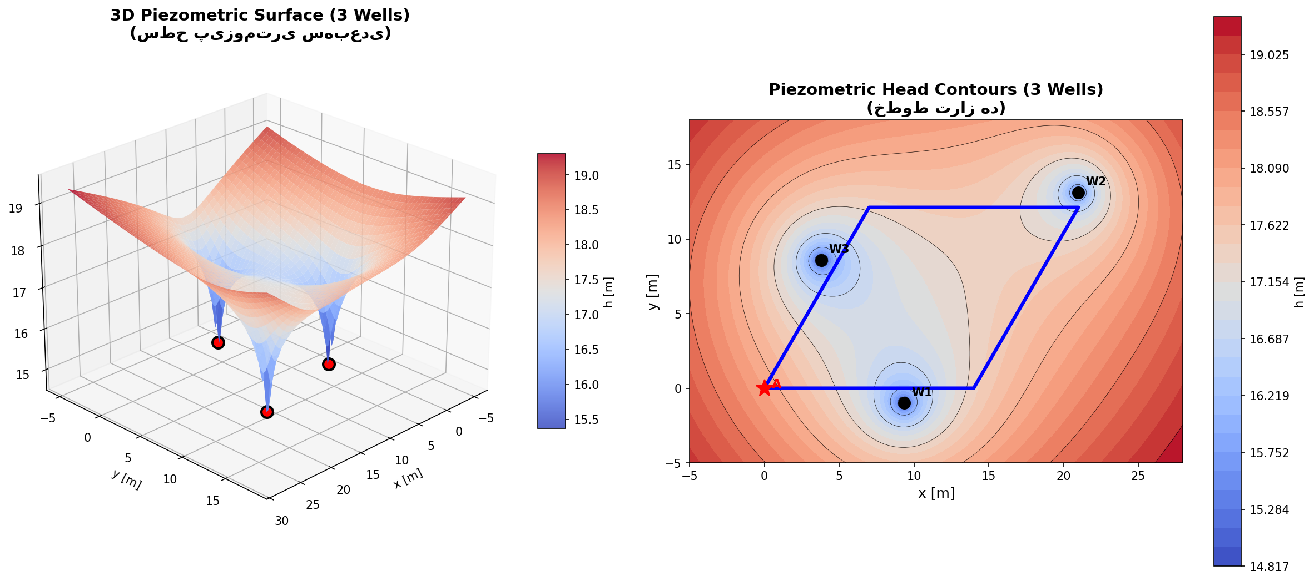

Figure 4: Cross-Sectional View of Piezometric Surface
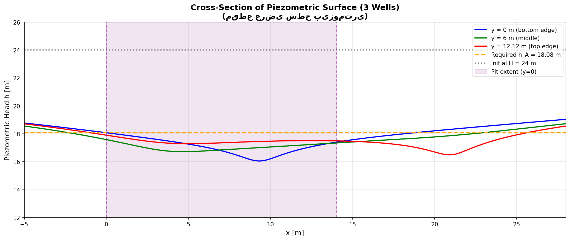
Figure 5: Optimization Analysis (Q vs Number of Wells)
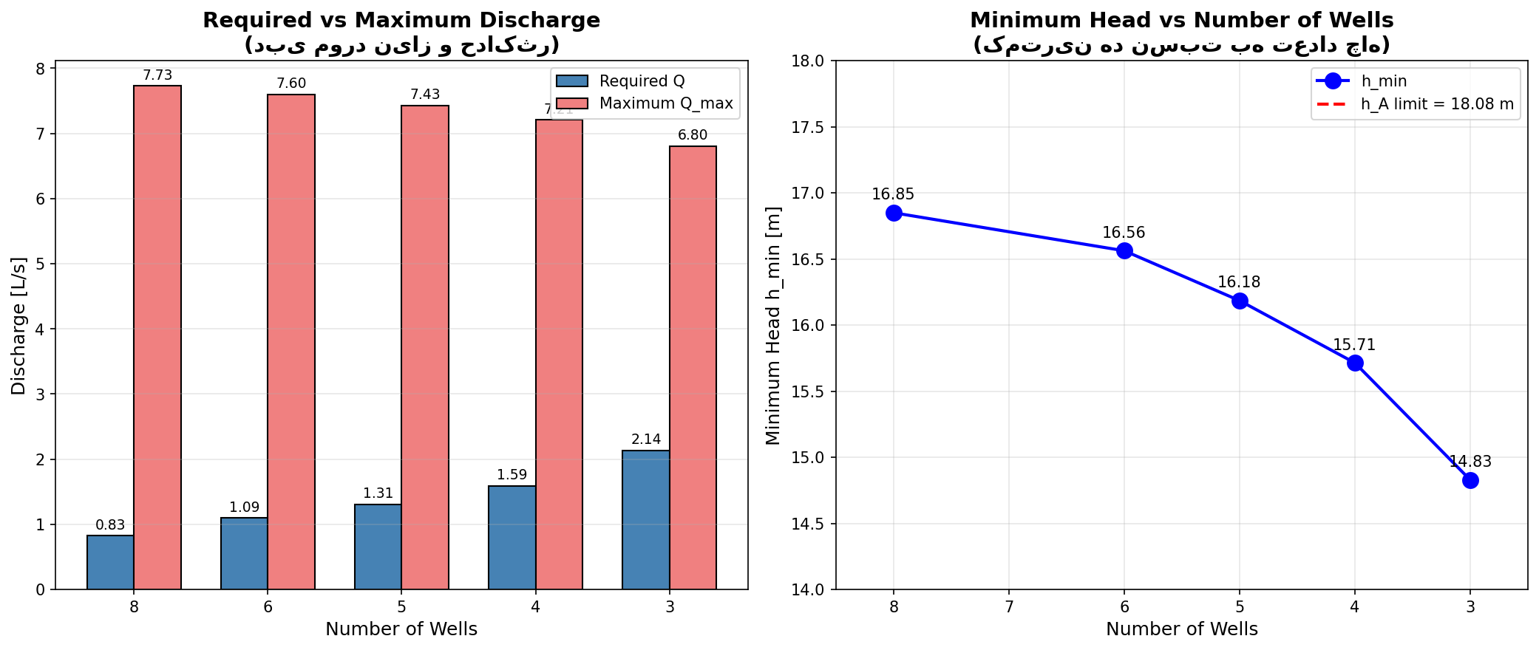

Figure 6: Critical Point Analysis
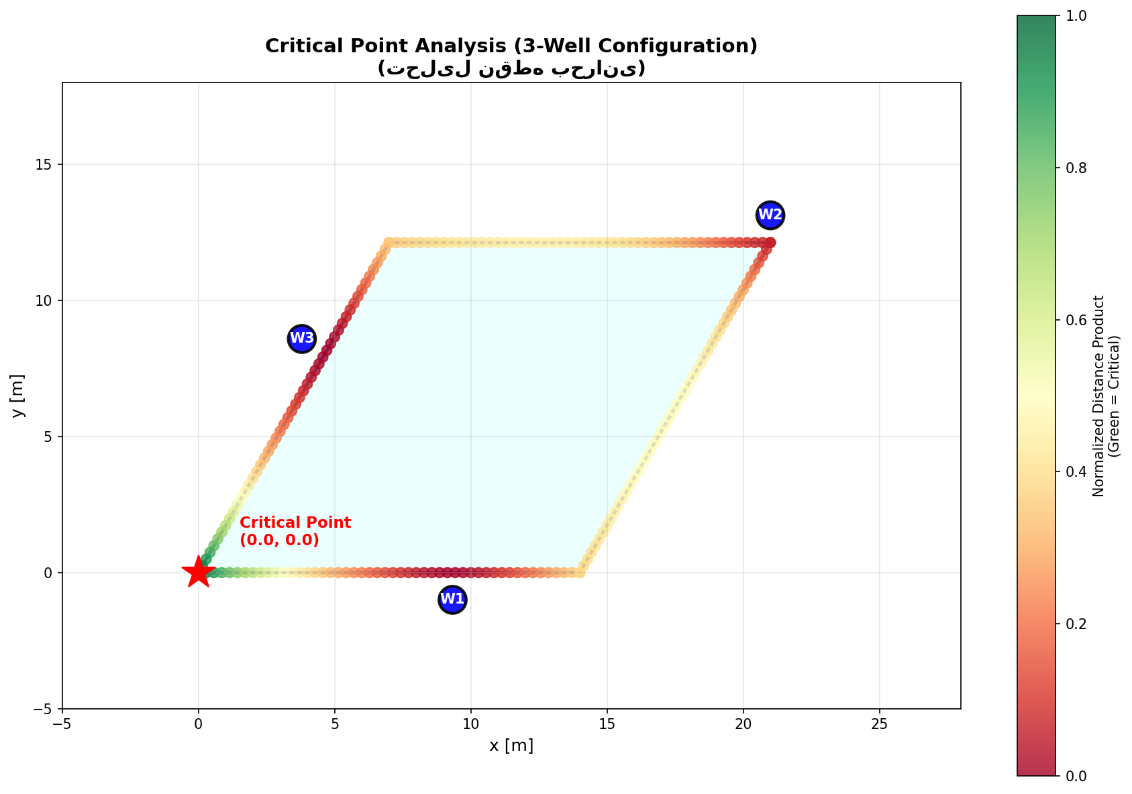

9. Summary of Results
Wells | Q [L/s] | h_min [m] | Q_max [L/s] | Q/Q_max | Status
8 | 0.83 | 16.85 | 7.73 | 10.7% | ✓
6 | 1.09 | 16.56 | 7.60 | 14.4% | ✓
5 | 1.31 | 16.18 | 7.43 | 17.6% | ✓
4 | 1.59 | 15.71 | 7.21 | 22.0% | ✓
3 | 2.14 | 14.83 | 6.80 | 31.4% | ★

conclusion
Based on the comprehensive numerical analysis using Maple, an optimal configuration has been determined for the groundwater extraction system:
- The optimal solution consists of 3 extraction wells distributed evenly around the parallelogram building pit, with each well center located 1 m from the pit edge.
- The required extraction discharge is Q = 2.14 L/s per well (total 6.41 L/s), which is well below the maximum allowable discharge Q_max = 6.80 L/s.
- The piezometric head at the critical point (vertex V1 at origin) is reduced from the initial 24 m to below the required threshold of 18.08 m, ensuring stability.
- The safety margin is adequate (Q/Q_max = 31.4%), providing redundancy in case of pump malfunction or variations in soil properties.
- Maintaining 3 wells (minimum recommended) ensures system reliability and provides backup capacity if one well fails.
FINAL RECOMMENDATION: Install 3 extraction wells with total extraction flow of 6.41 L/s

Attachments
- :

References
.

